***version: 1.1***

CHAPTER

1. Partial Fractions

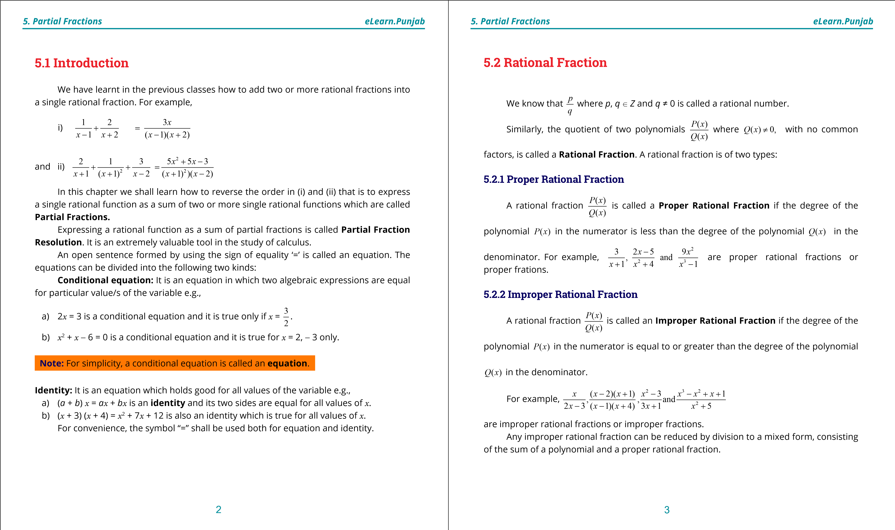

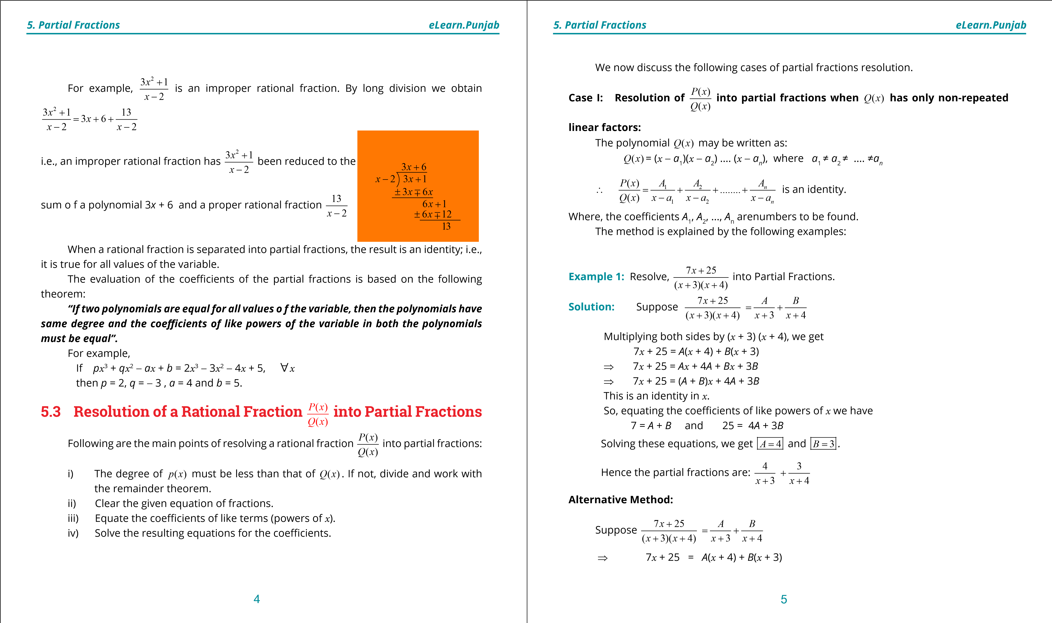

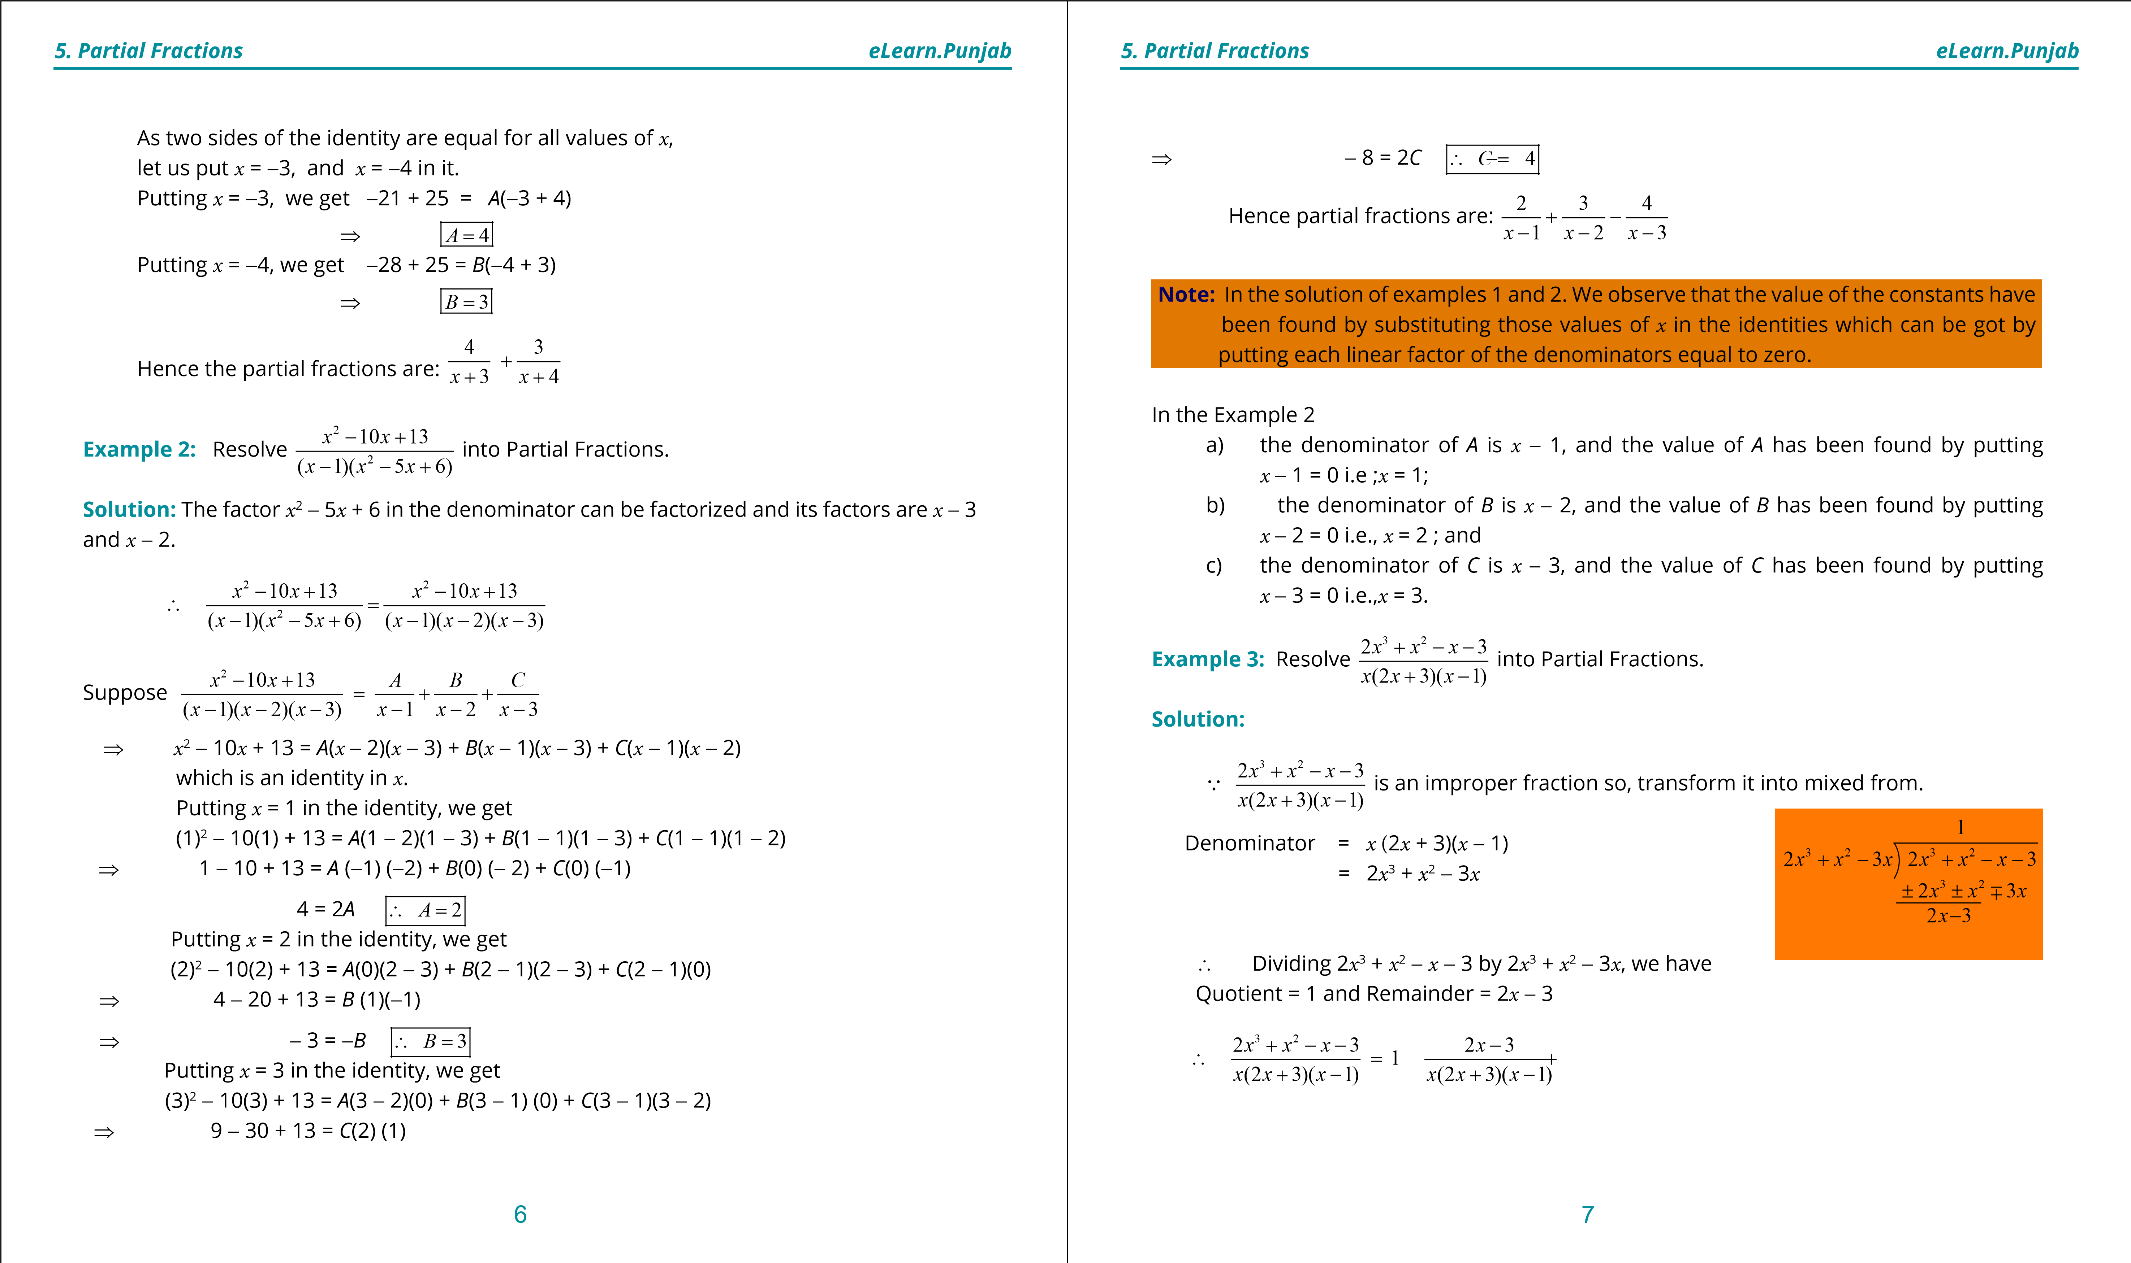

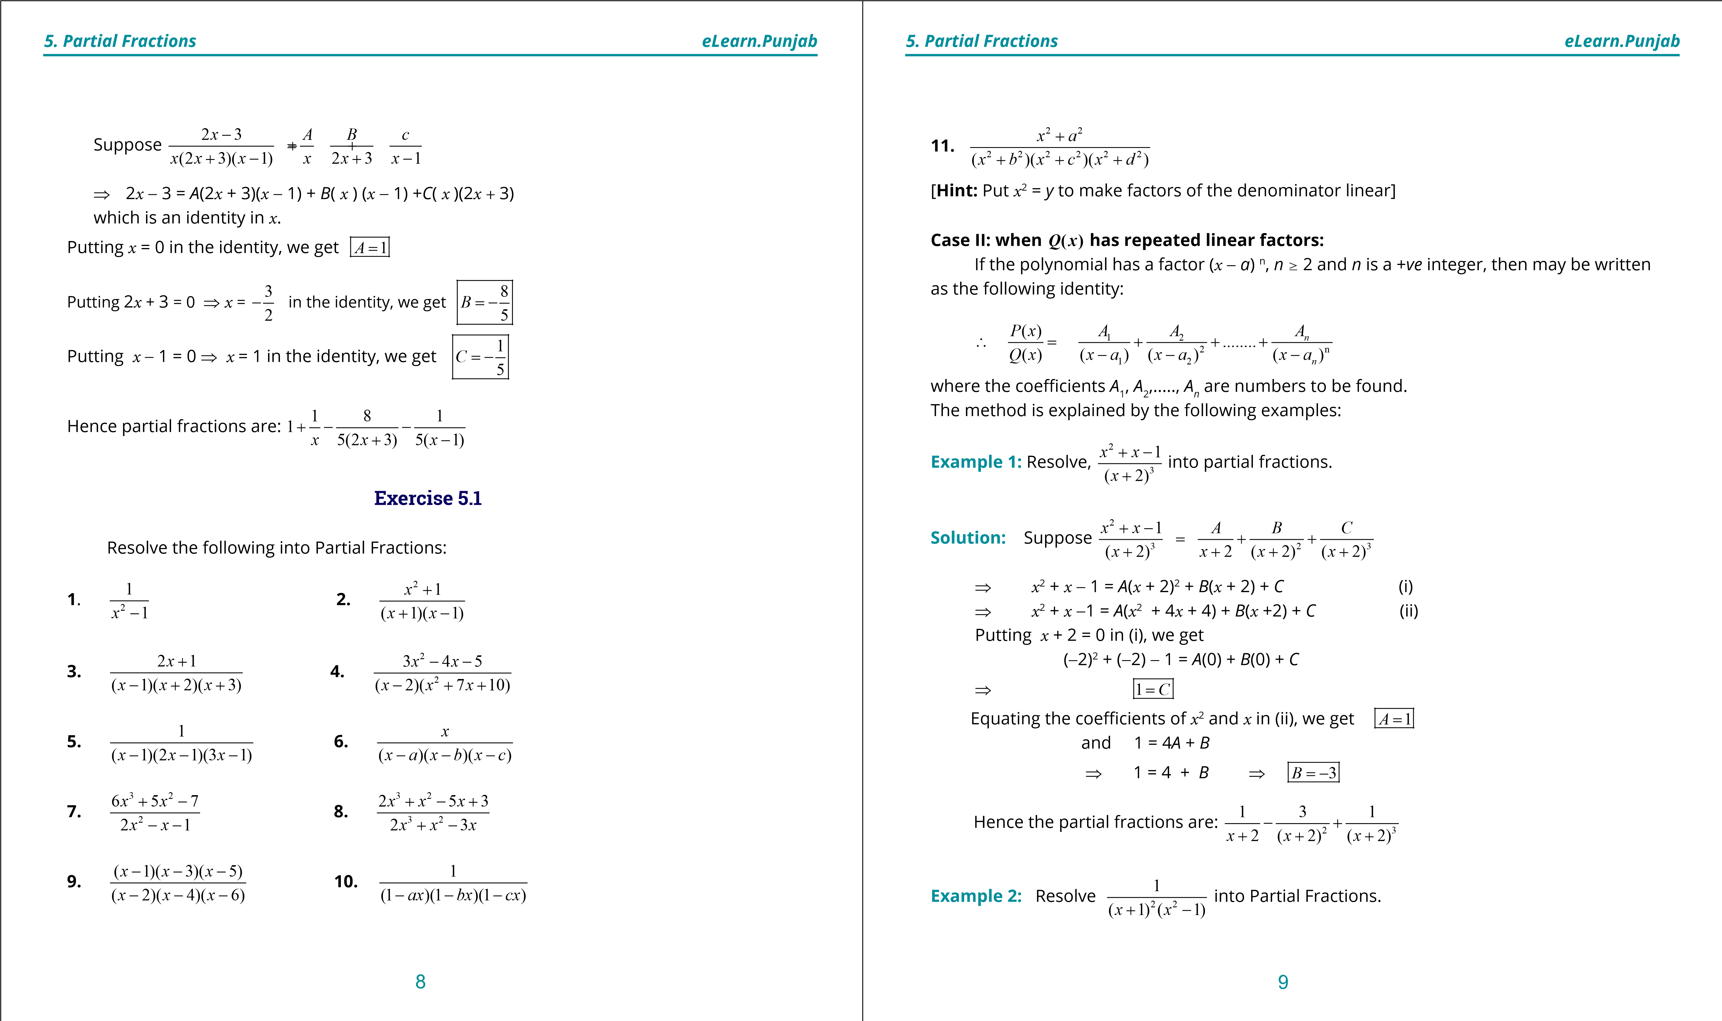

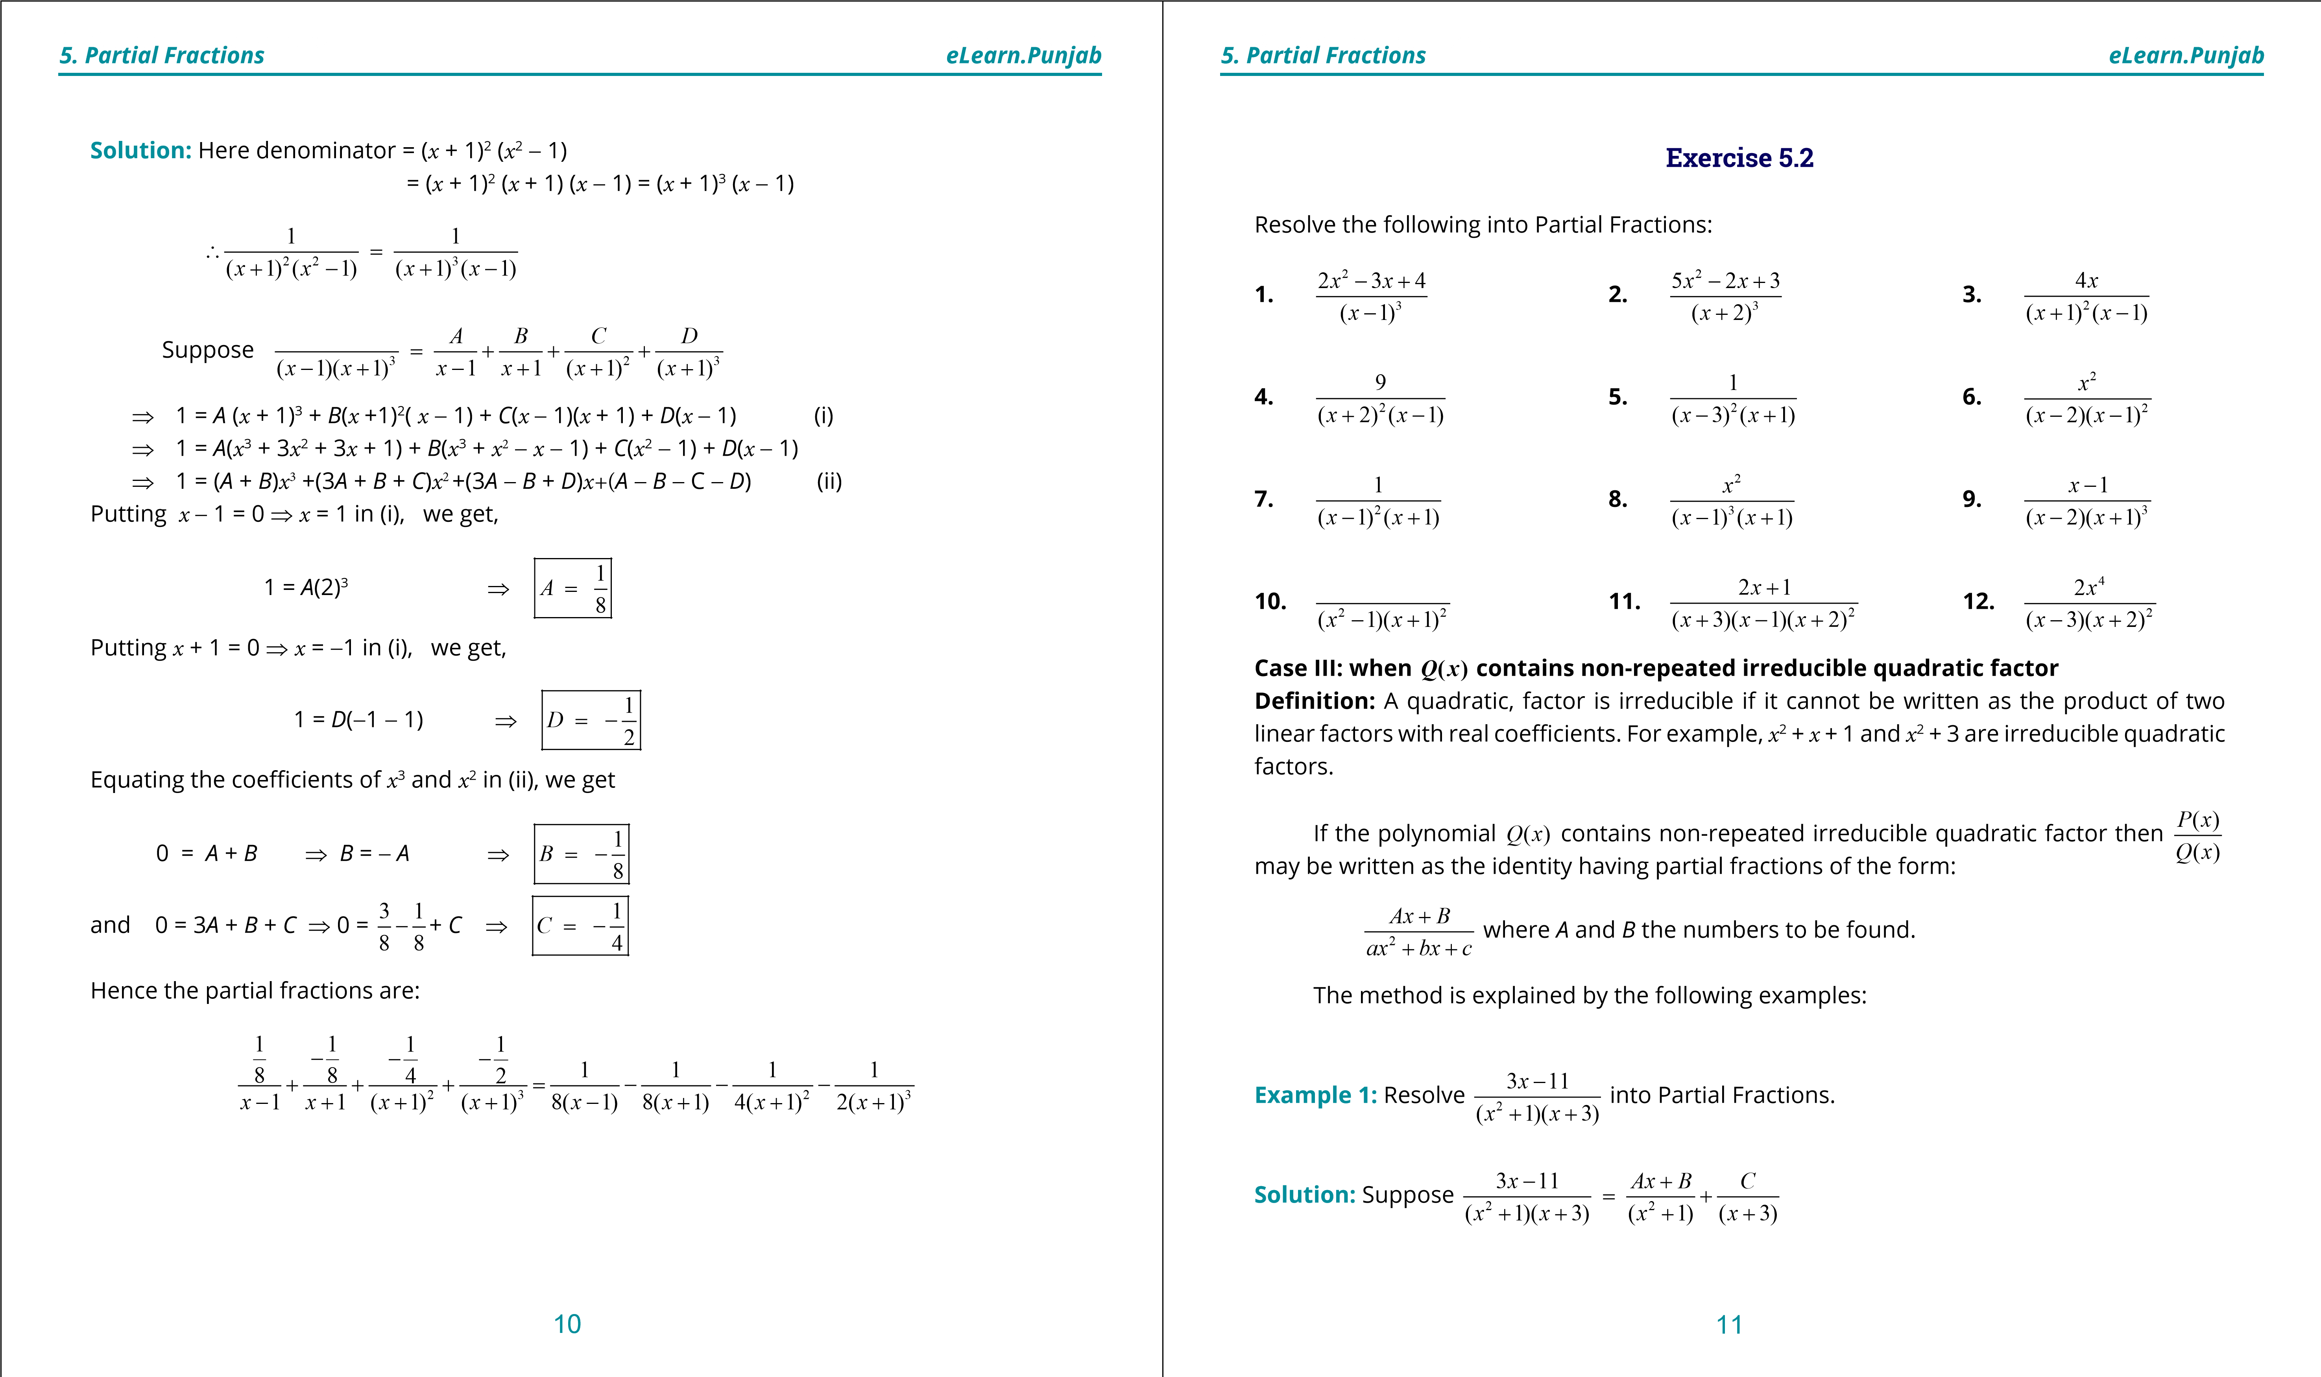

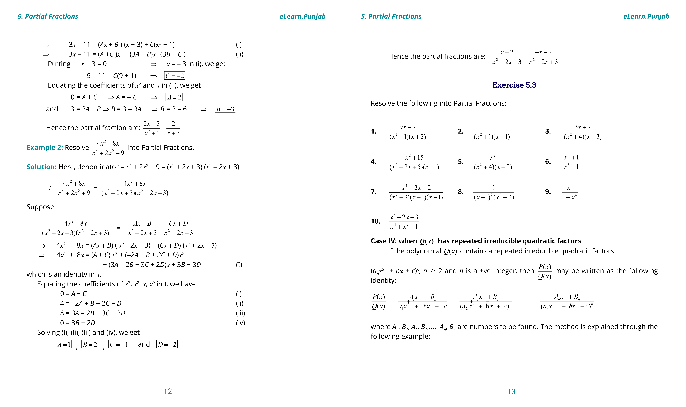

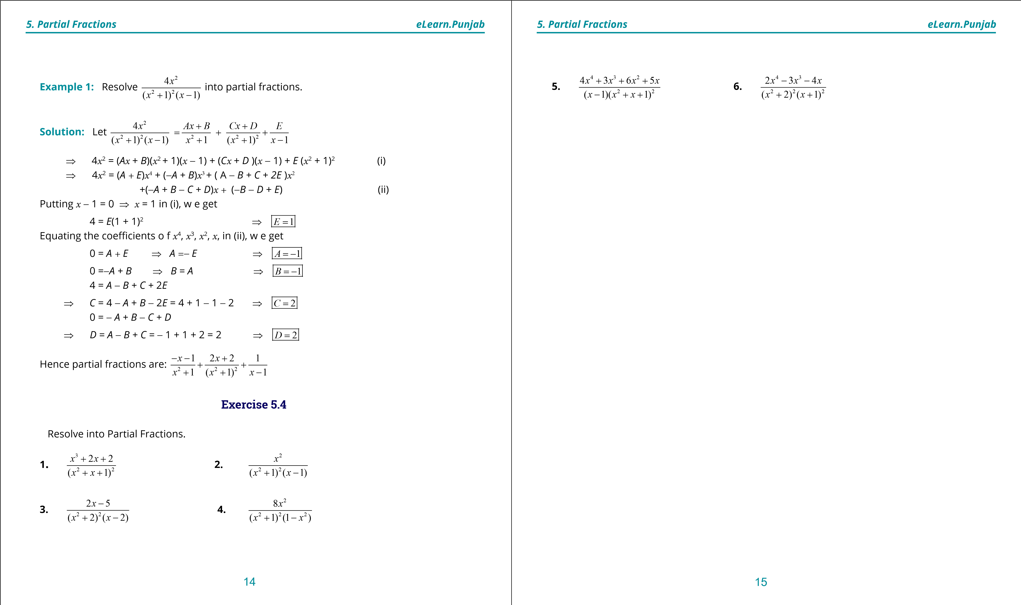

***version: 1.1***

CHAPTER

1. Sequences and Series

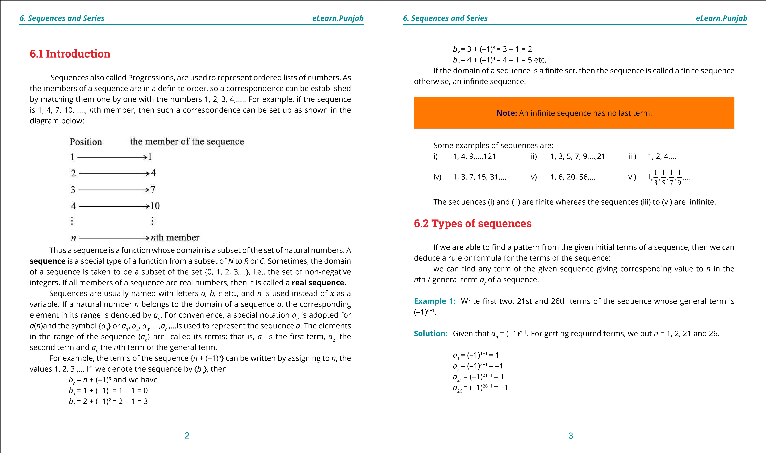

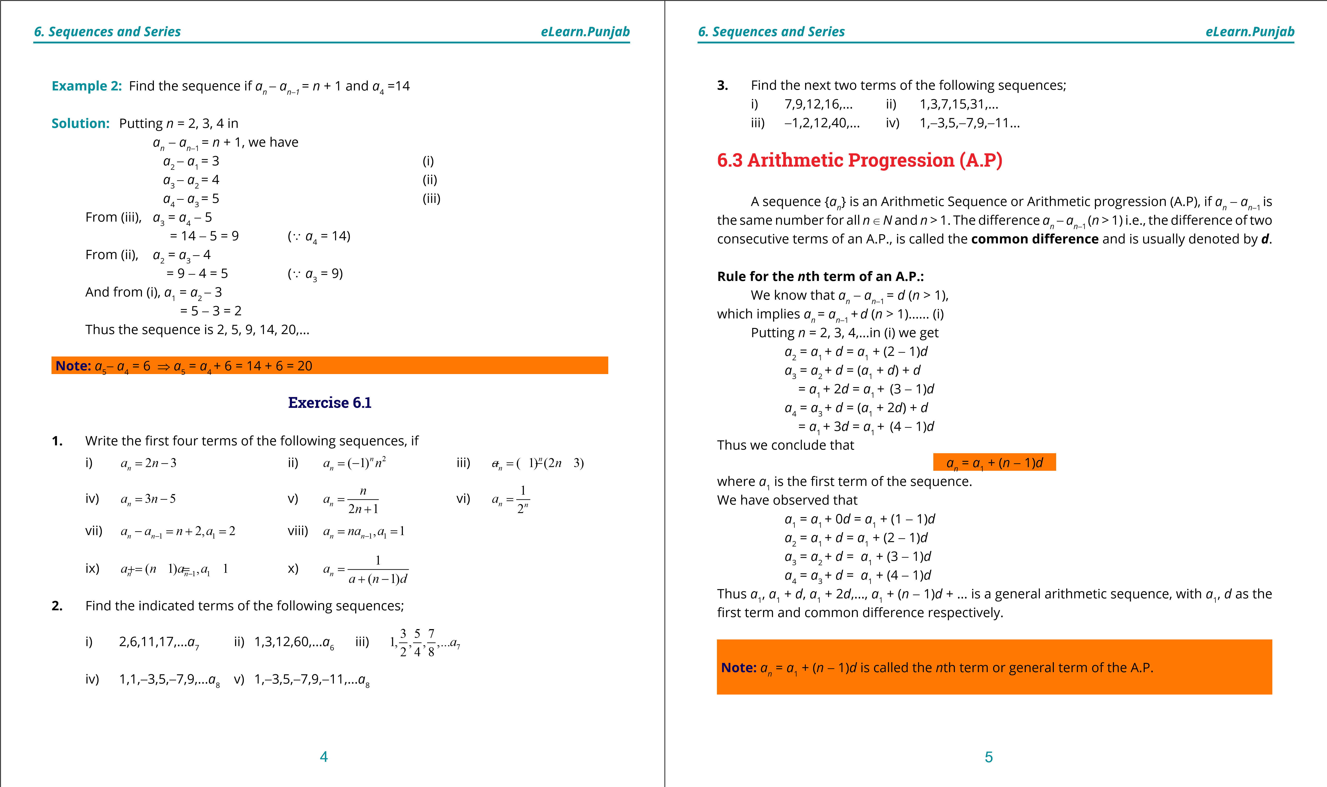

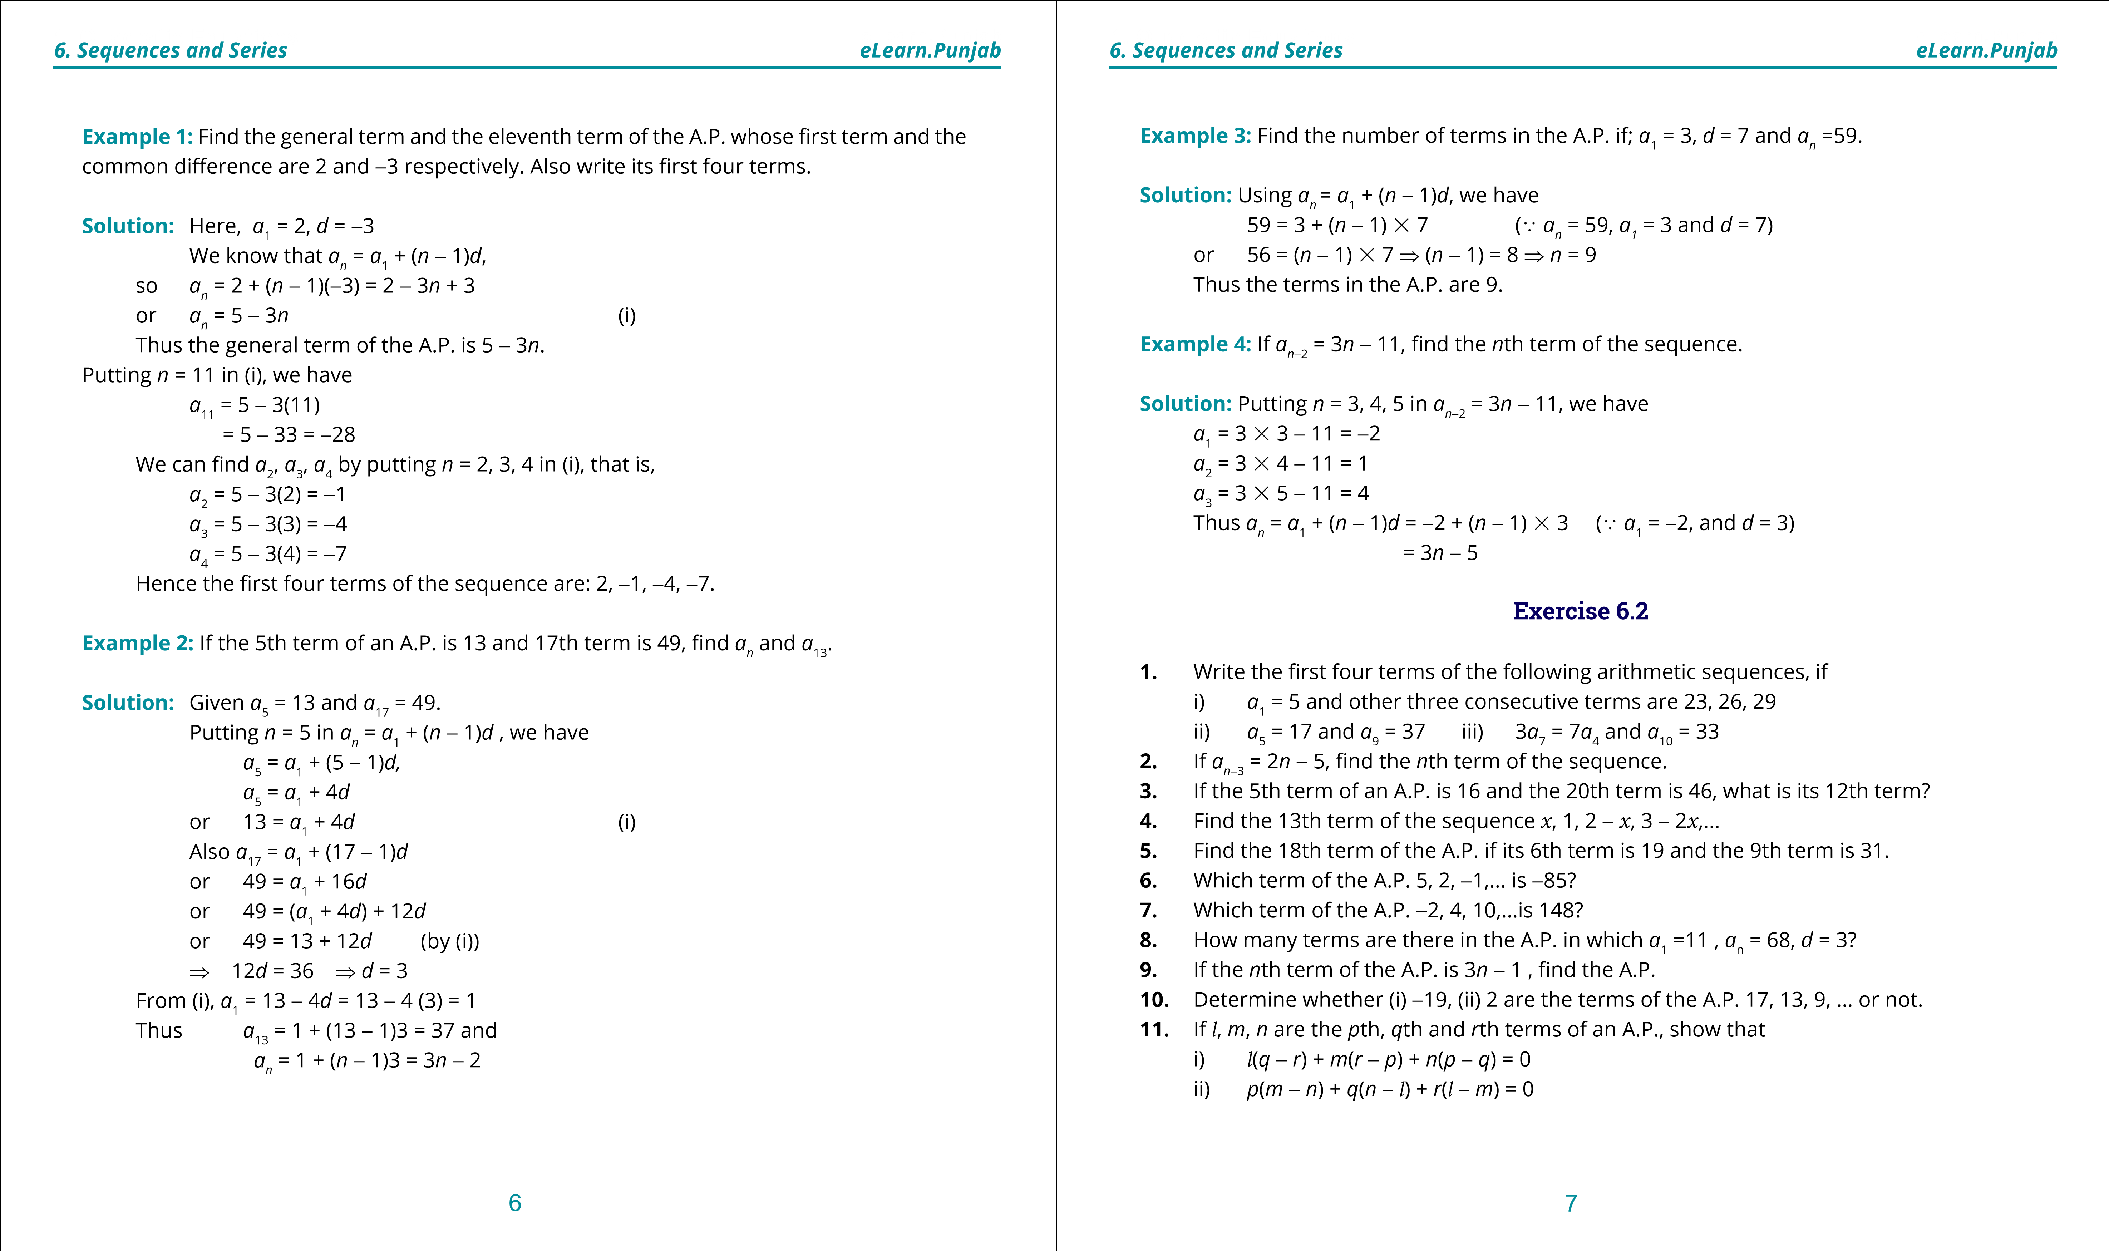

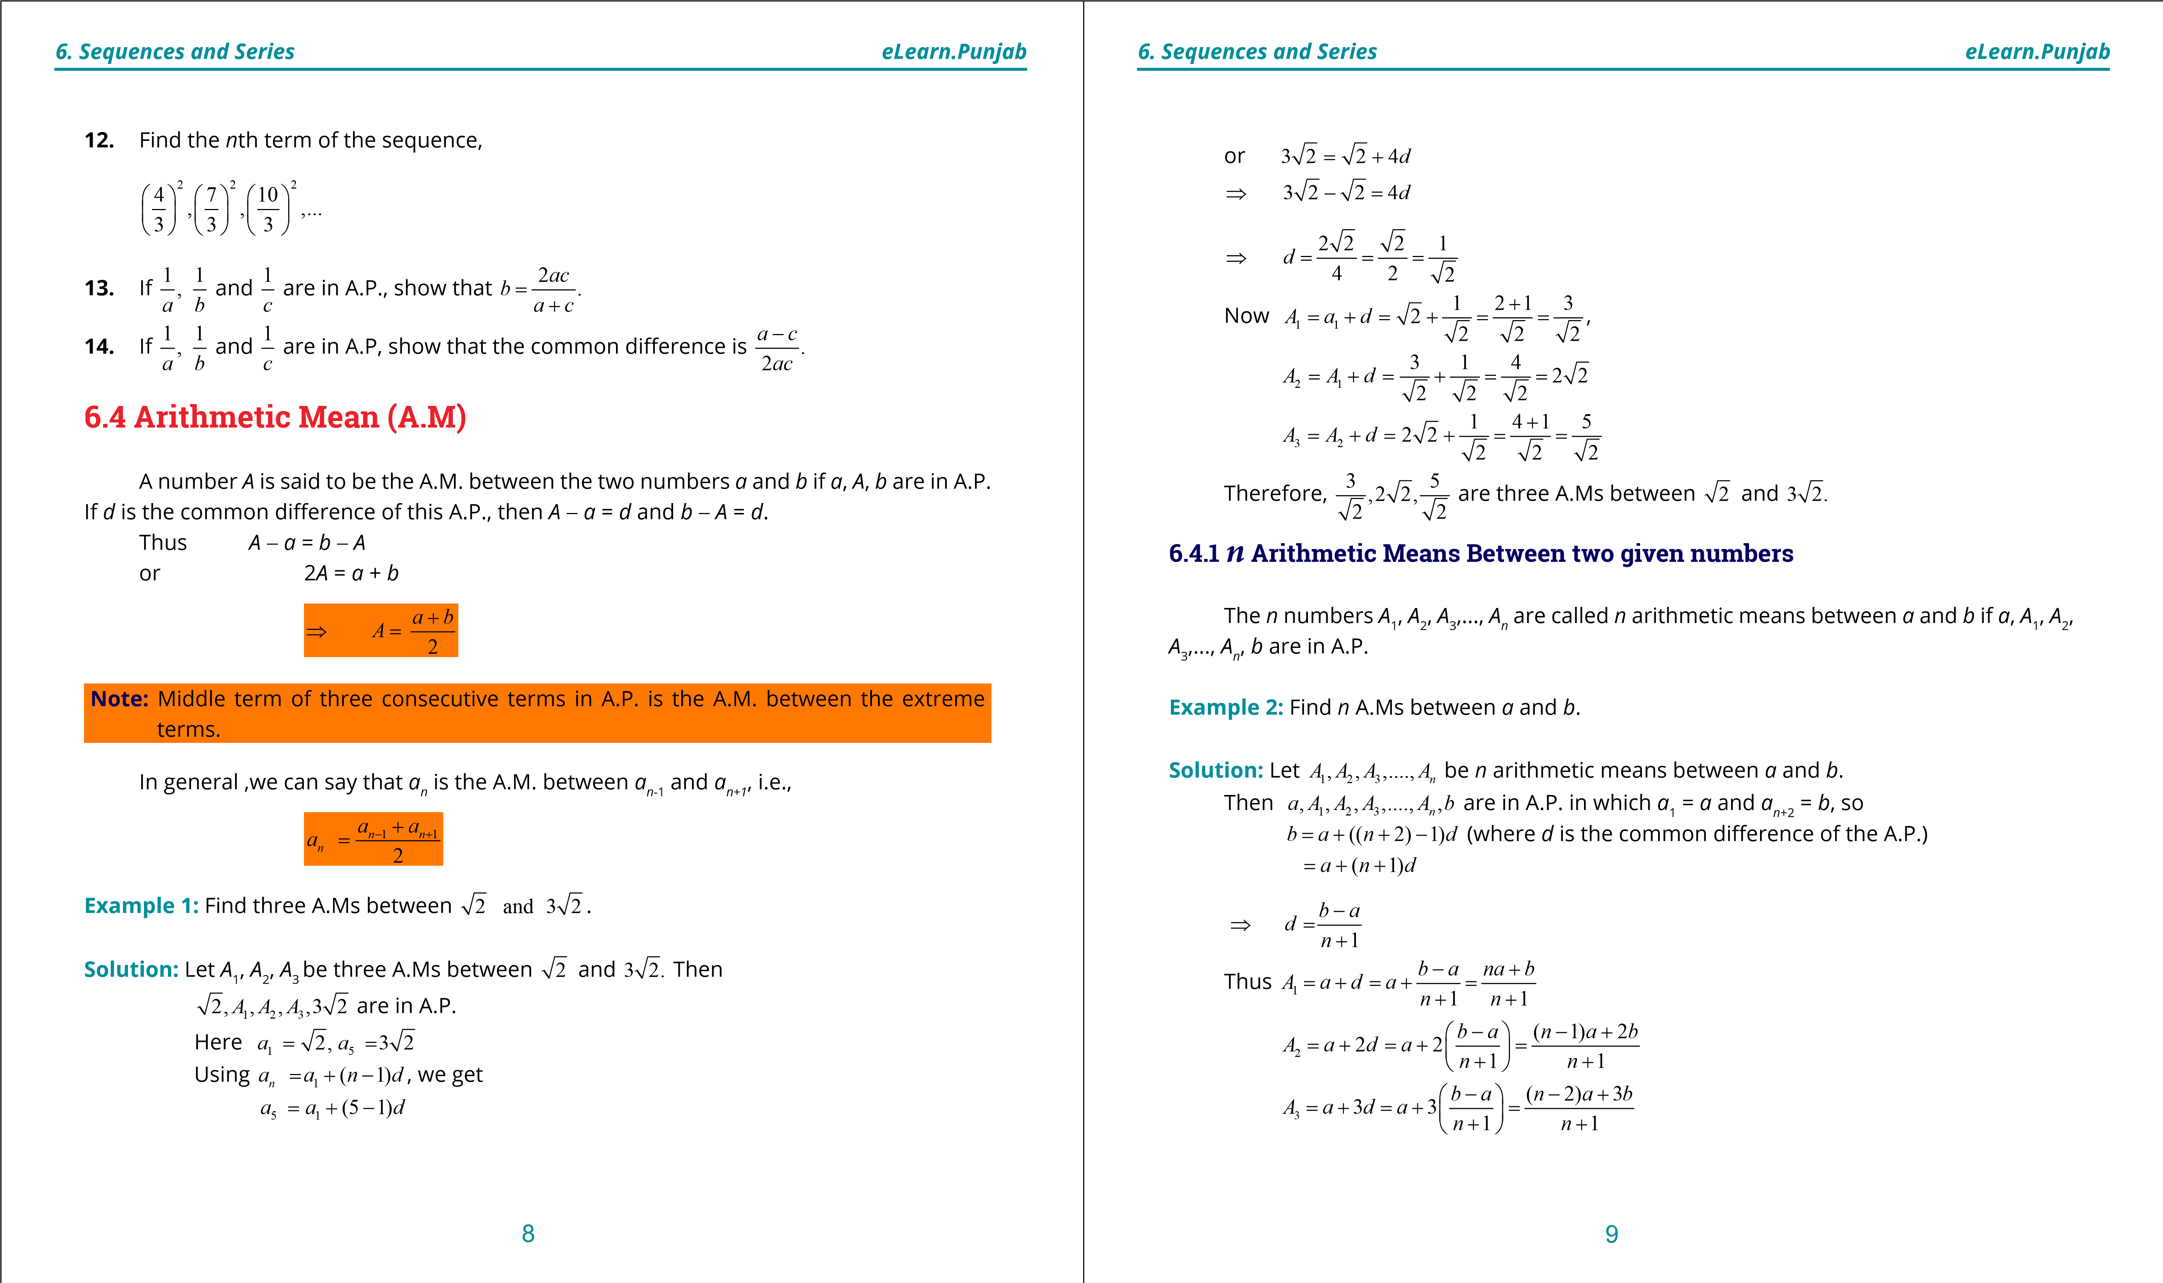

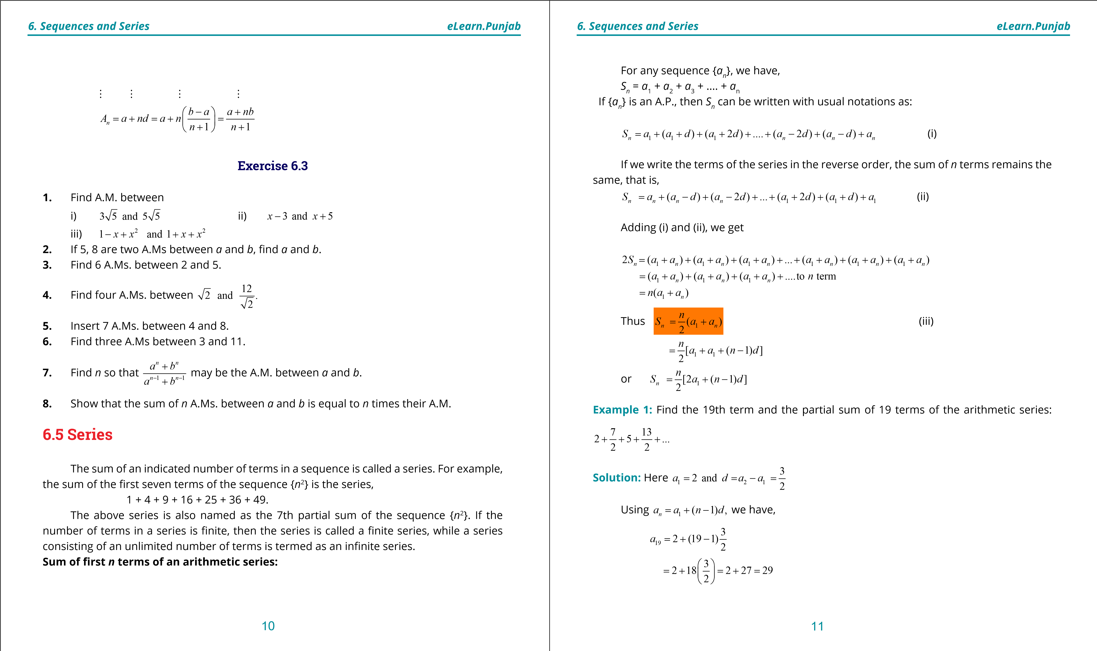

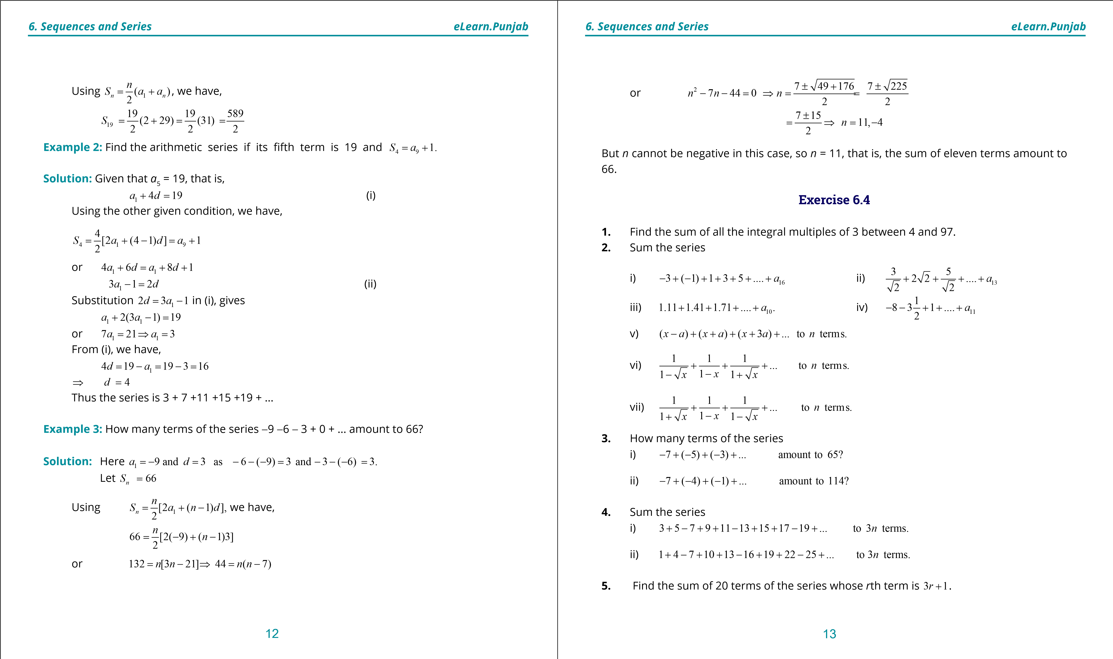

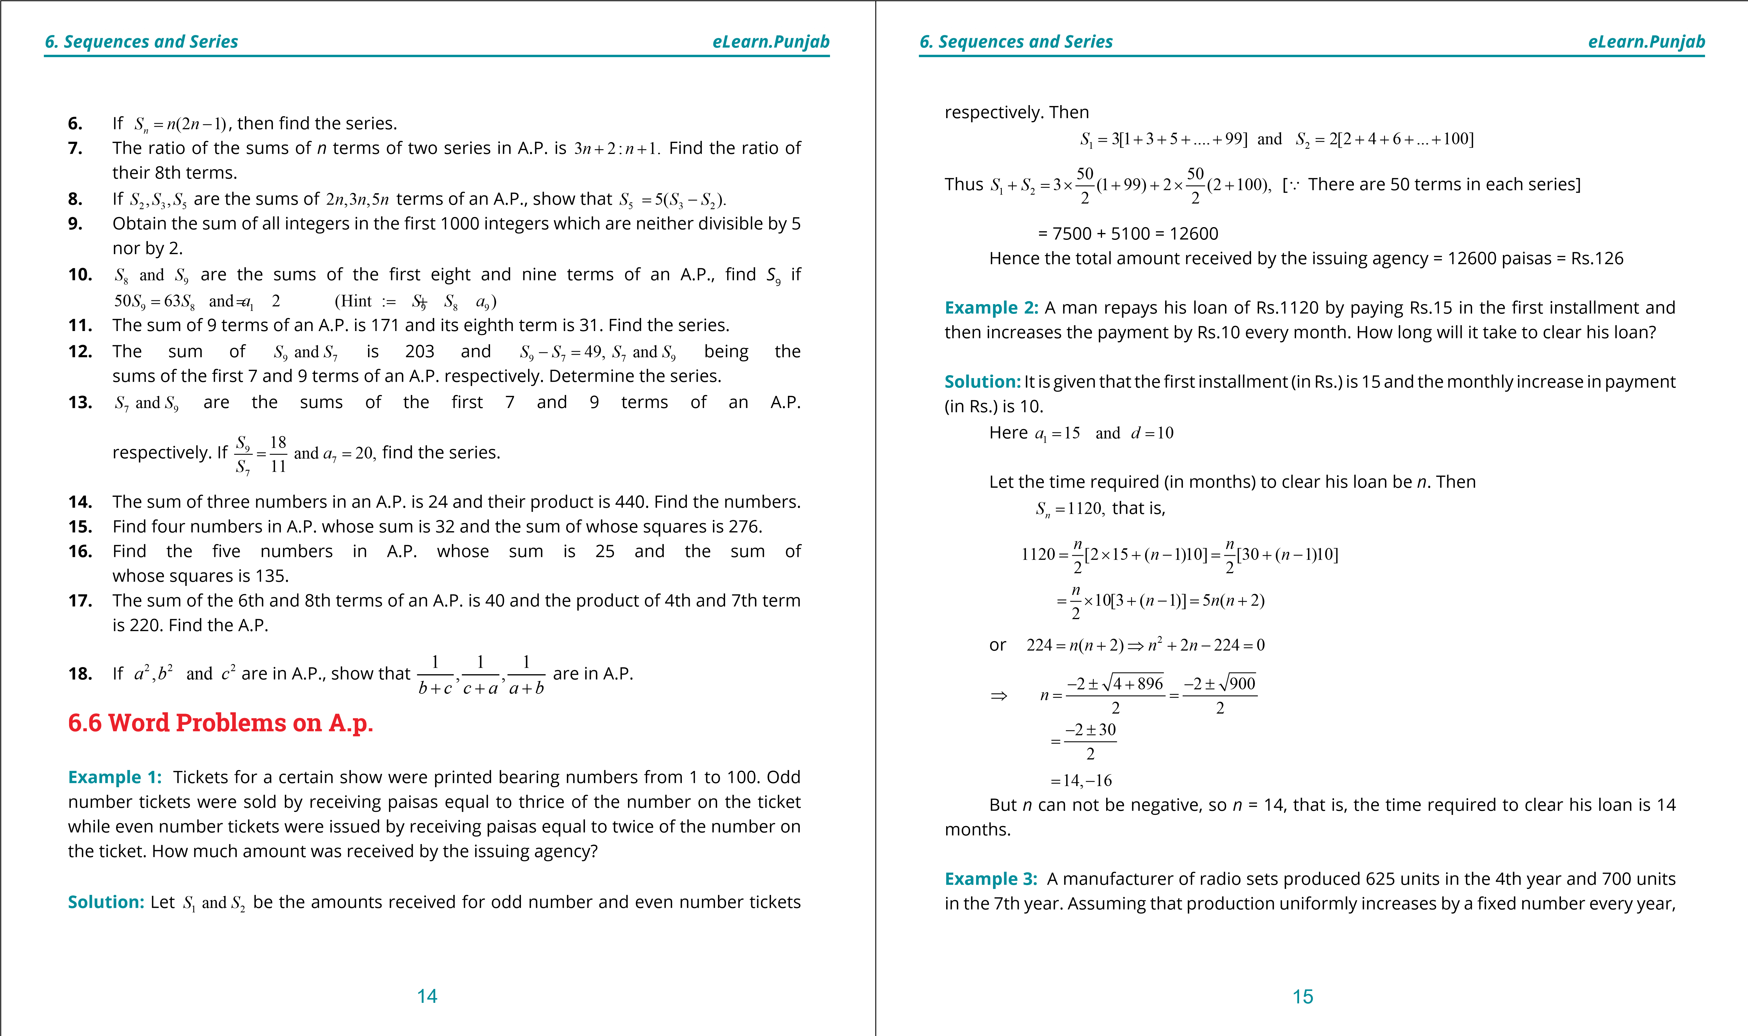

**1. Quadratic Equations eLearn.Punjab 1. Quadratic Equations eLearn.Punjab *6. Sequences and Series eLearn.Punjab 6. Sequences and Series eLearn.Punjab***

ind

i) The production in the irst year ii) The total production in 8 years iii) The production in the 11th year.

**Solution:** Let *a*1 be the number of units produced in the irst year and *d* be the uniform increase in production every year. Then the sequence of products in the successive years is

*a a*1, 1 + *d a*, 1 + 2 ,...*d*

By the given conditions, we have

*a*4 ==625 and *a*7 700, that is,

*a*1 + 3*d* = 625 (I) and *a*1 + 6*d* = 700(II)

Subtracting (I) from (II), we get

3*d* = 75 ⇒ *d* = 25

1. From (I), *a*1 + 3(25) = 625 ⇒ *a*1 = 625- 75 = 550

Thus the production in the irst year is 550 units.

1. *S*8 = [2×550 + (8-1)25]

= 4[1100 +175] = 4[1275] = 5100

Thus the production in 8 years is 5100 units.

1. *a*11 = *a*1 + (11 1)- *d*

=550 +10×25 = 550 + 250 = 800

Thus the production in the 11th year is 800 units.

**Exercise 6.5**

1. A man deposits in a bank Rs. 10 in the irst month; Rs. 15 in the second month; Rs. 20 in the third month and so on. Find how much he will have deposited in the bank by the 9th month.
2. 378 trees are planted in rows in the shape of an isosceles triangle, the numbers in successive rows decreasing by one from the base to the top. How many trees are there in the row which forms the base of the triangle?
3. A man borrows Rs. 1100 and agree to repay with a total interest of Rs. 230 in 14 installments, each installment being less than the preceding by Rs. 10. What should be his irst installment?
4. A clock strikes once when its hour hand is at one, twice when it is at two and so on. How many times does the clock strike in twelve hours ?
5. A student saves Rs.12 at the end of the irst week and goes on increasing his saving Rs.4 weekly. After how many weeks will he be able to save Rs.2100?
6. An object falling from rest, falls 9 meters during the irst second, 27 meters during the next second, 45 meters during the third second and so on.

i) How far will it fall during the ifth second? ii) How far will it fall up to the ifth second?

1. An investor earned Rs.6000 for year 1980 and Rs. 12000 for year 1990 on the same investment. If his earning have increased by the same amount each year, how much income he has received from the investment over the past eleven years?
2. The sum of interior angles of polygon having sides 3,4,5,...etc. form an A.P. Find the sum of the interior angles for a 16 sided polygon.
3. The prize money Rs. 60,000 will be distributed among the eight teams according to their positions determined in the match-series. The award increases by the same amount for each higher position. If the last place team is given Rs.4000, how much will be awarded to the irst place team?
4. An equilateral triangular base is illed by placing eight balls in the irst row, 7 balls in the second row and so on with one ball in the last row. After this base layer, second layer is formed by placing 7 balls in its irst row, 6 balls in its second row and so on with one ball in its last row. Continuing this process, a pyramid of balls is formed with one ball on top. How many balls are there in the pyramid?

8

2

16 17

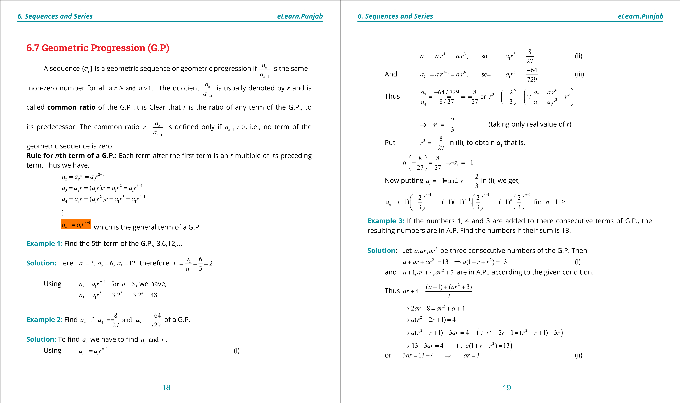

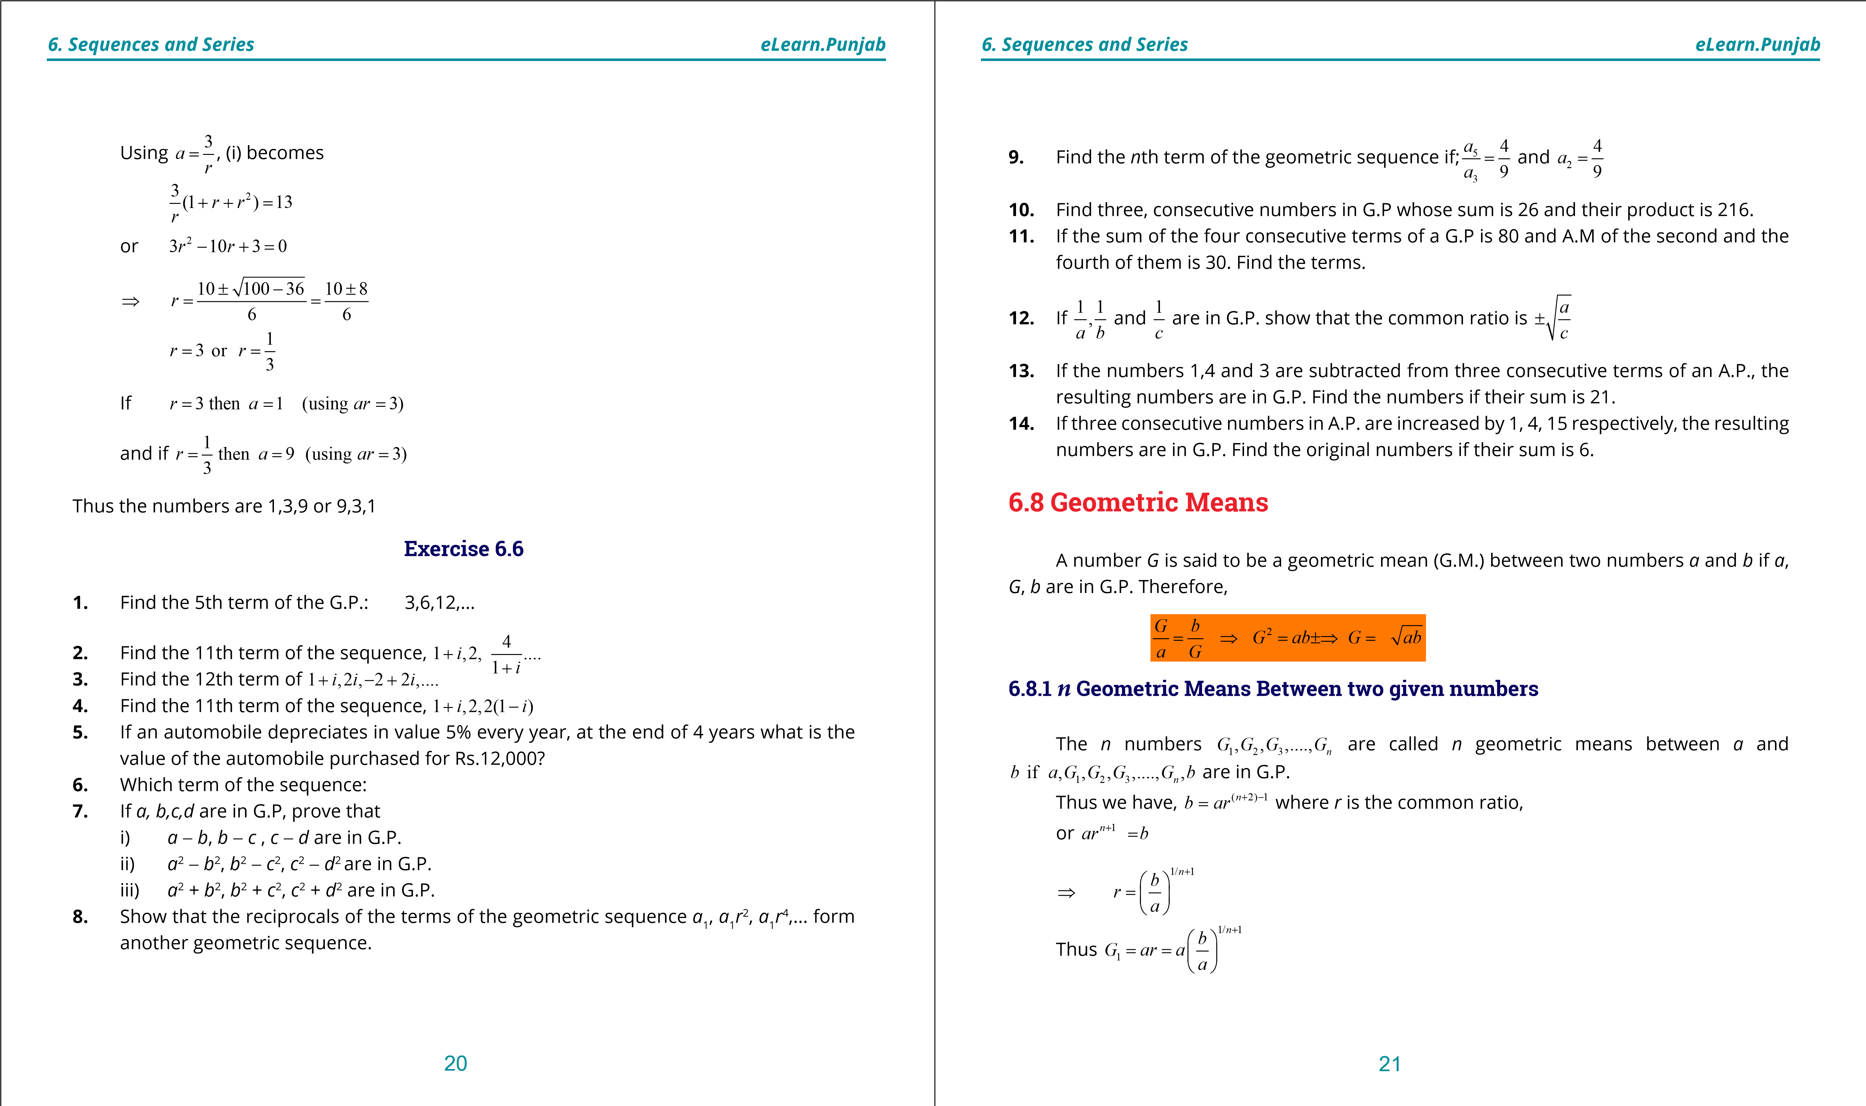

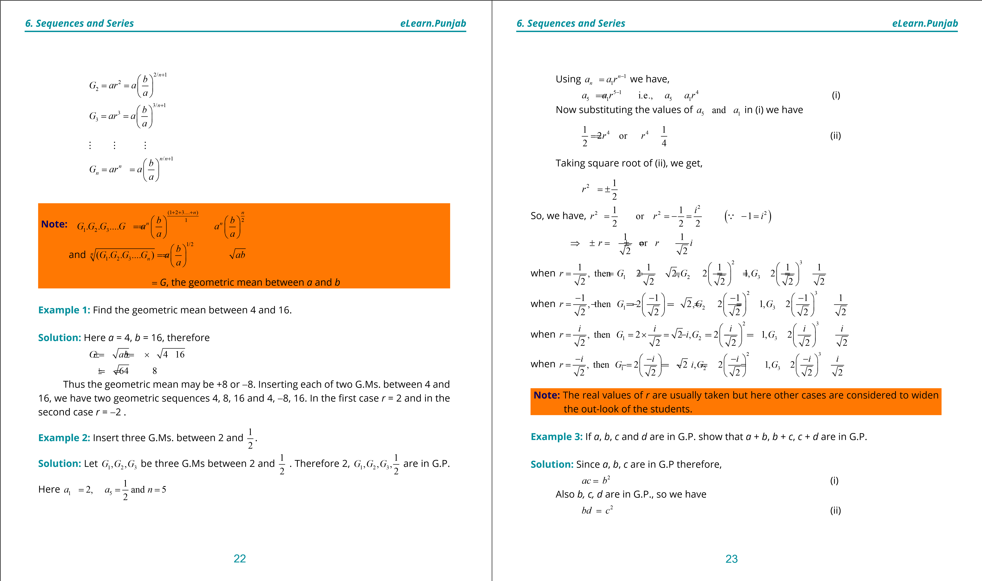

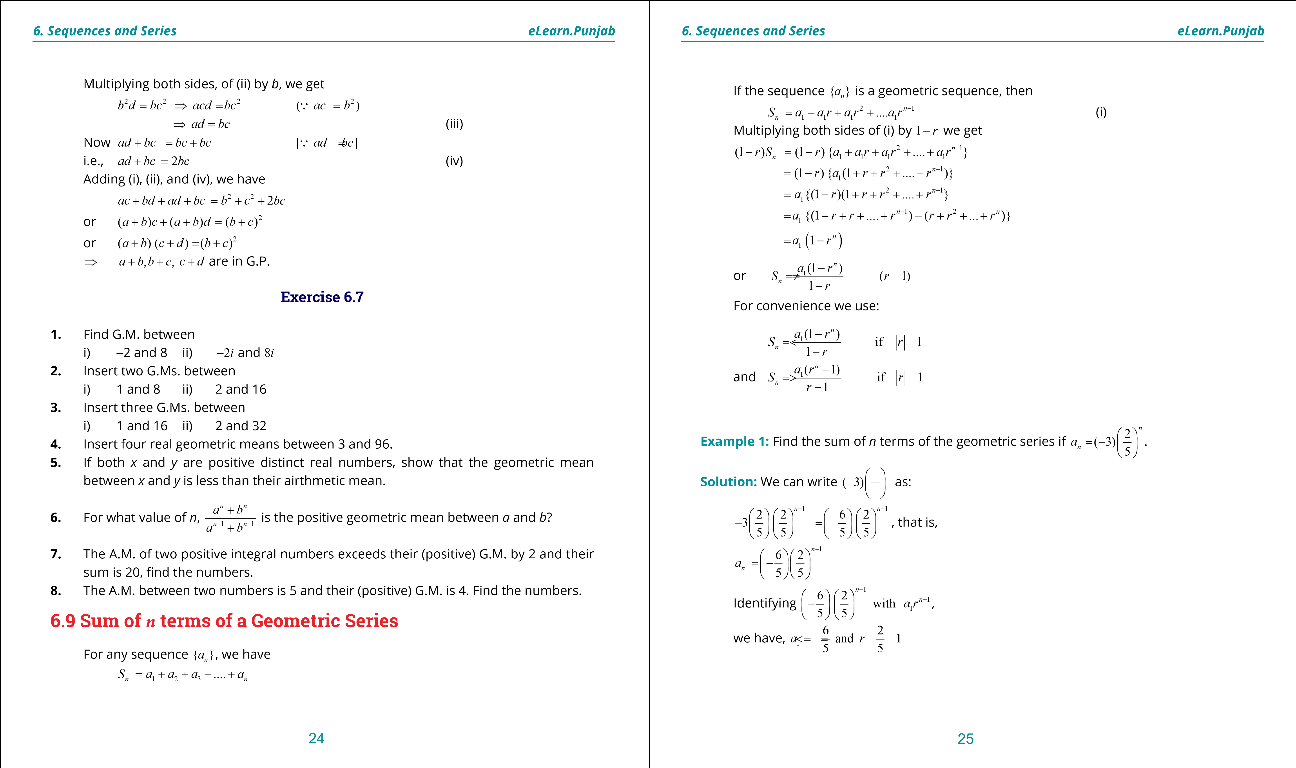

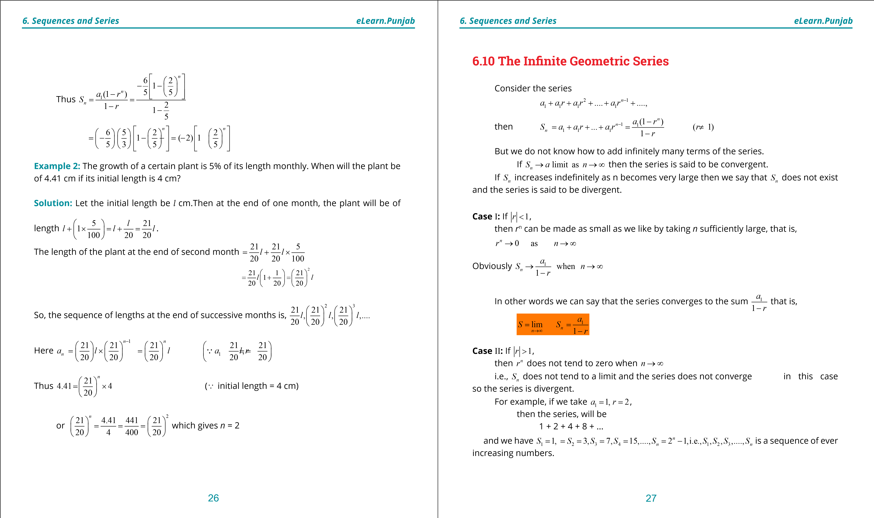

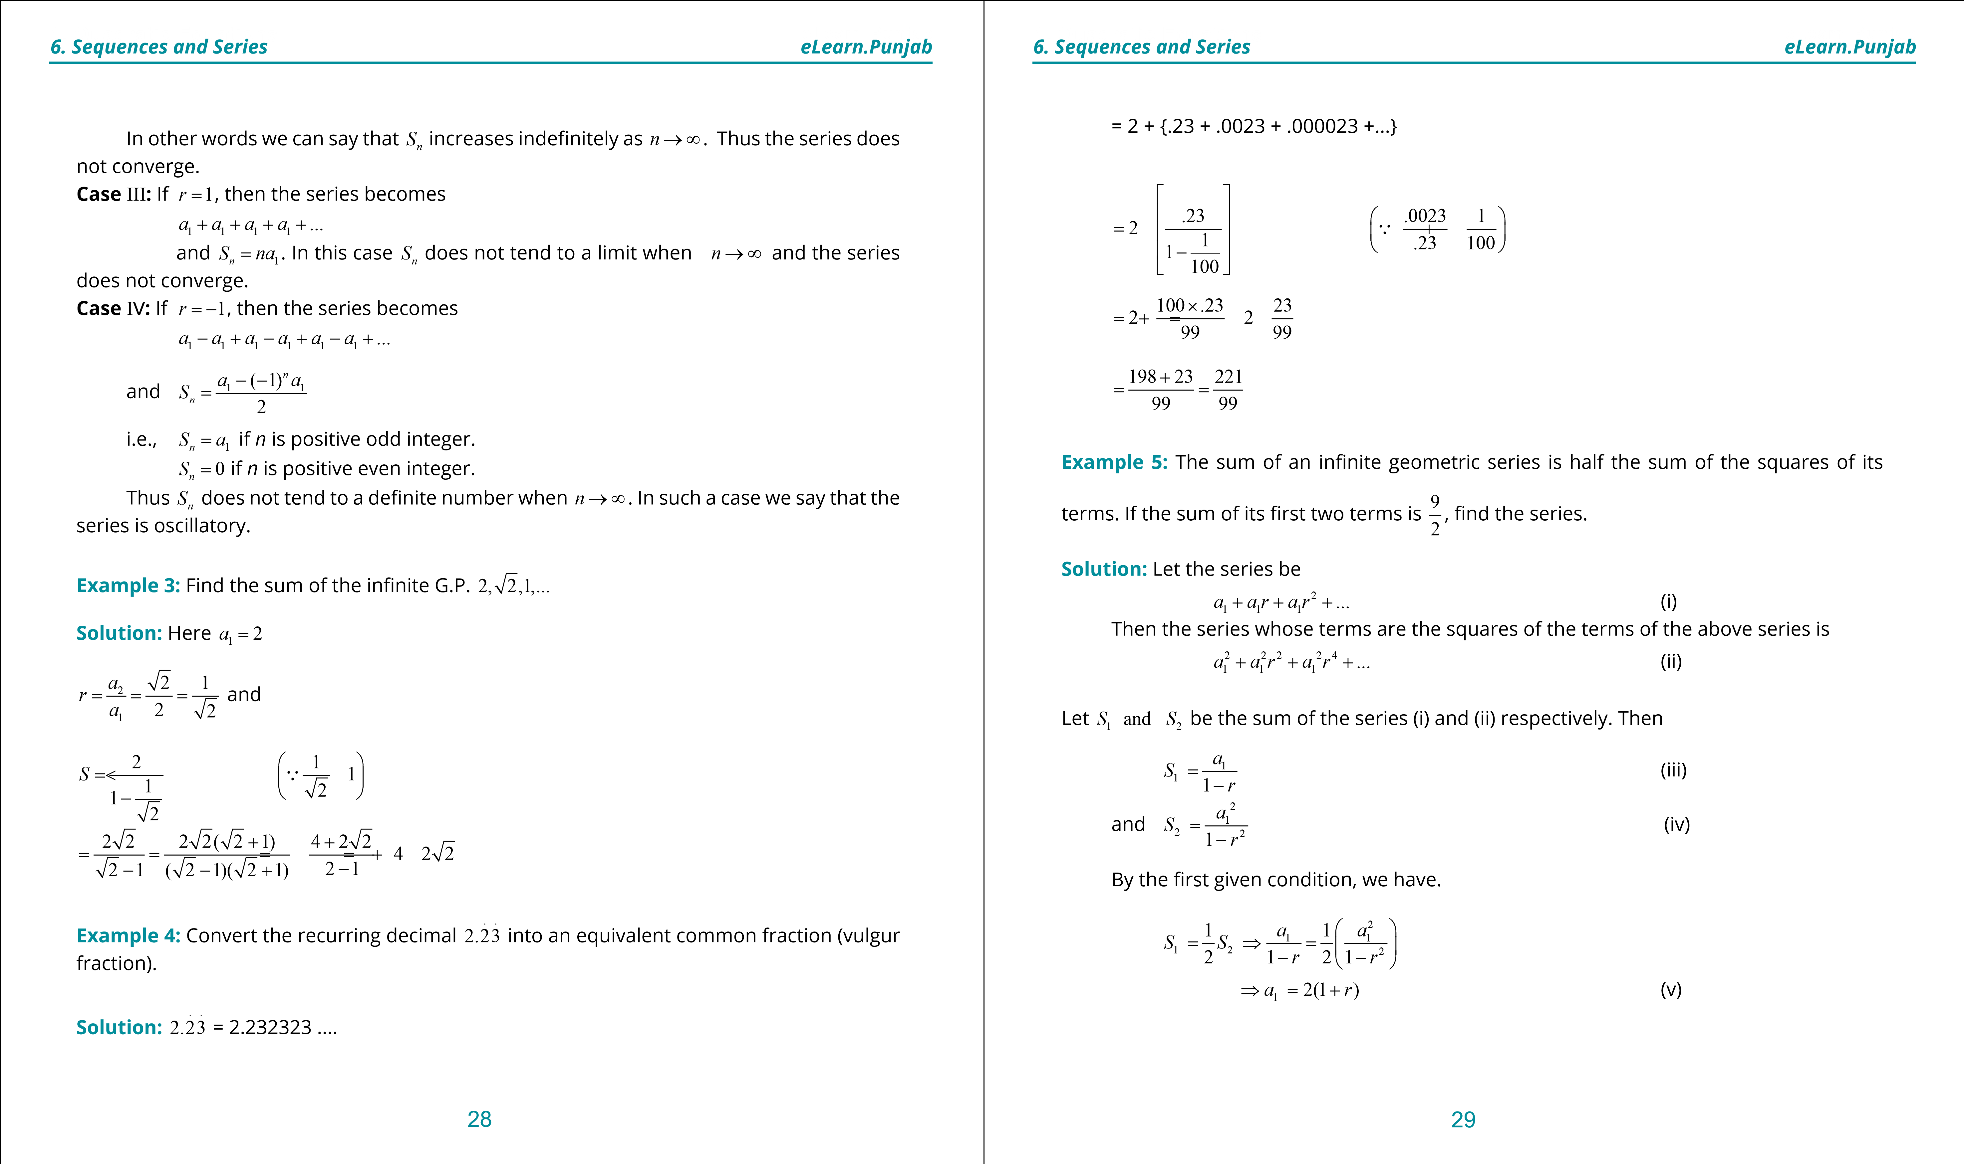

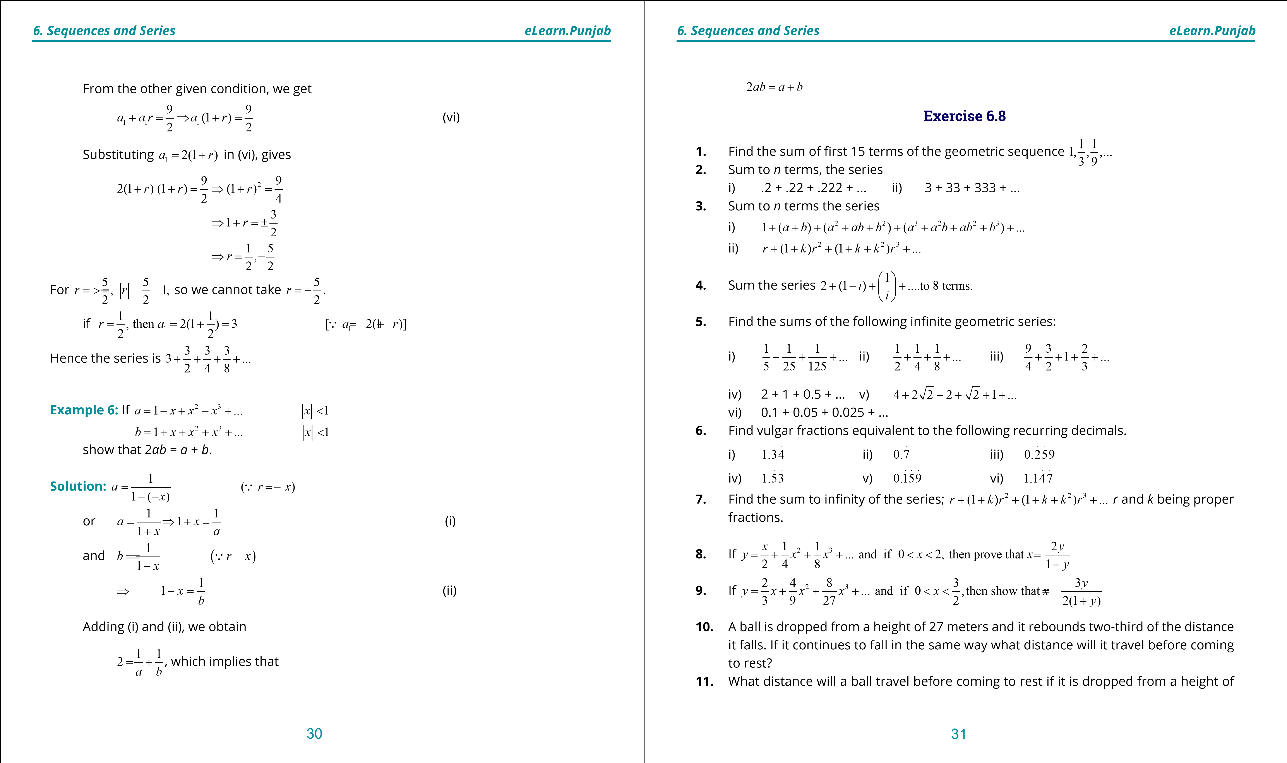

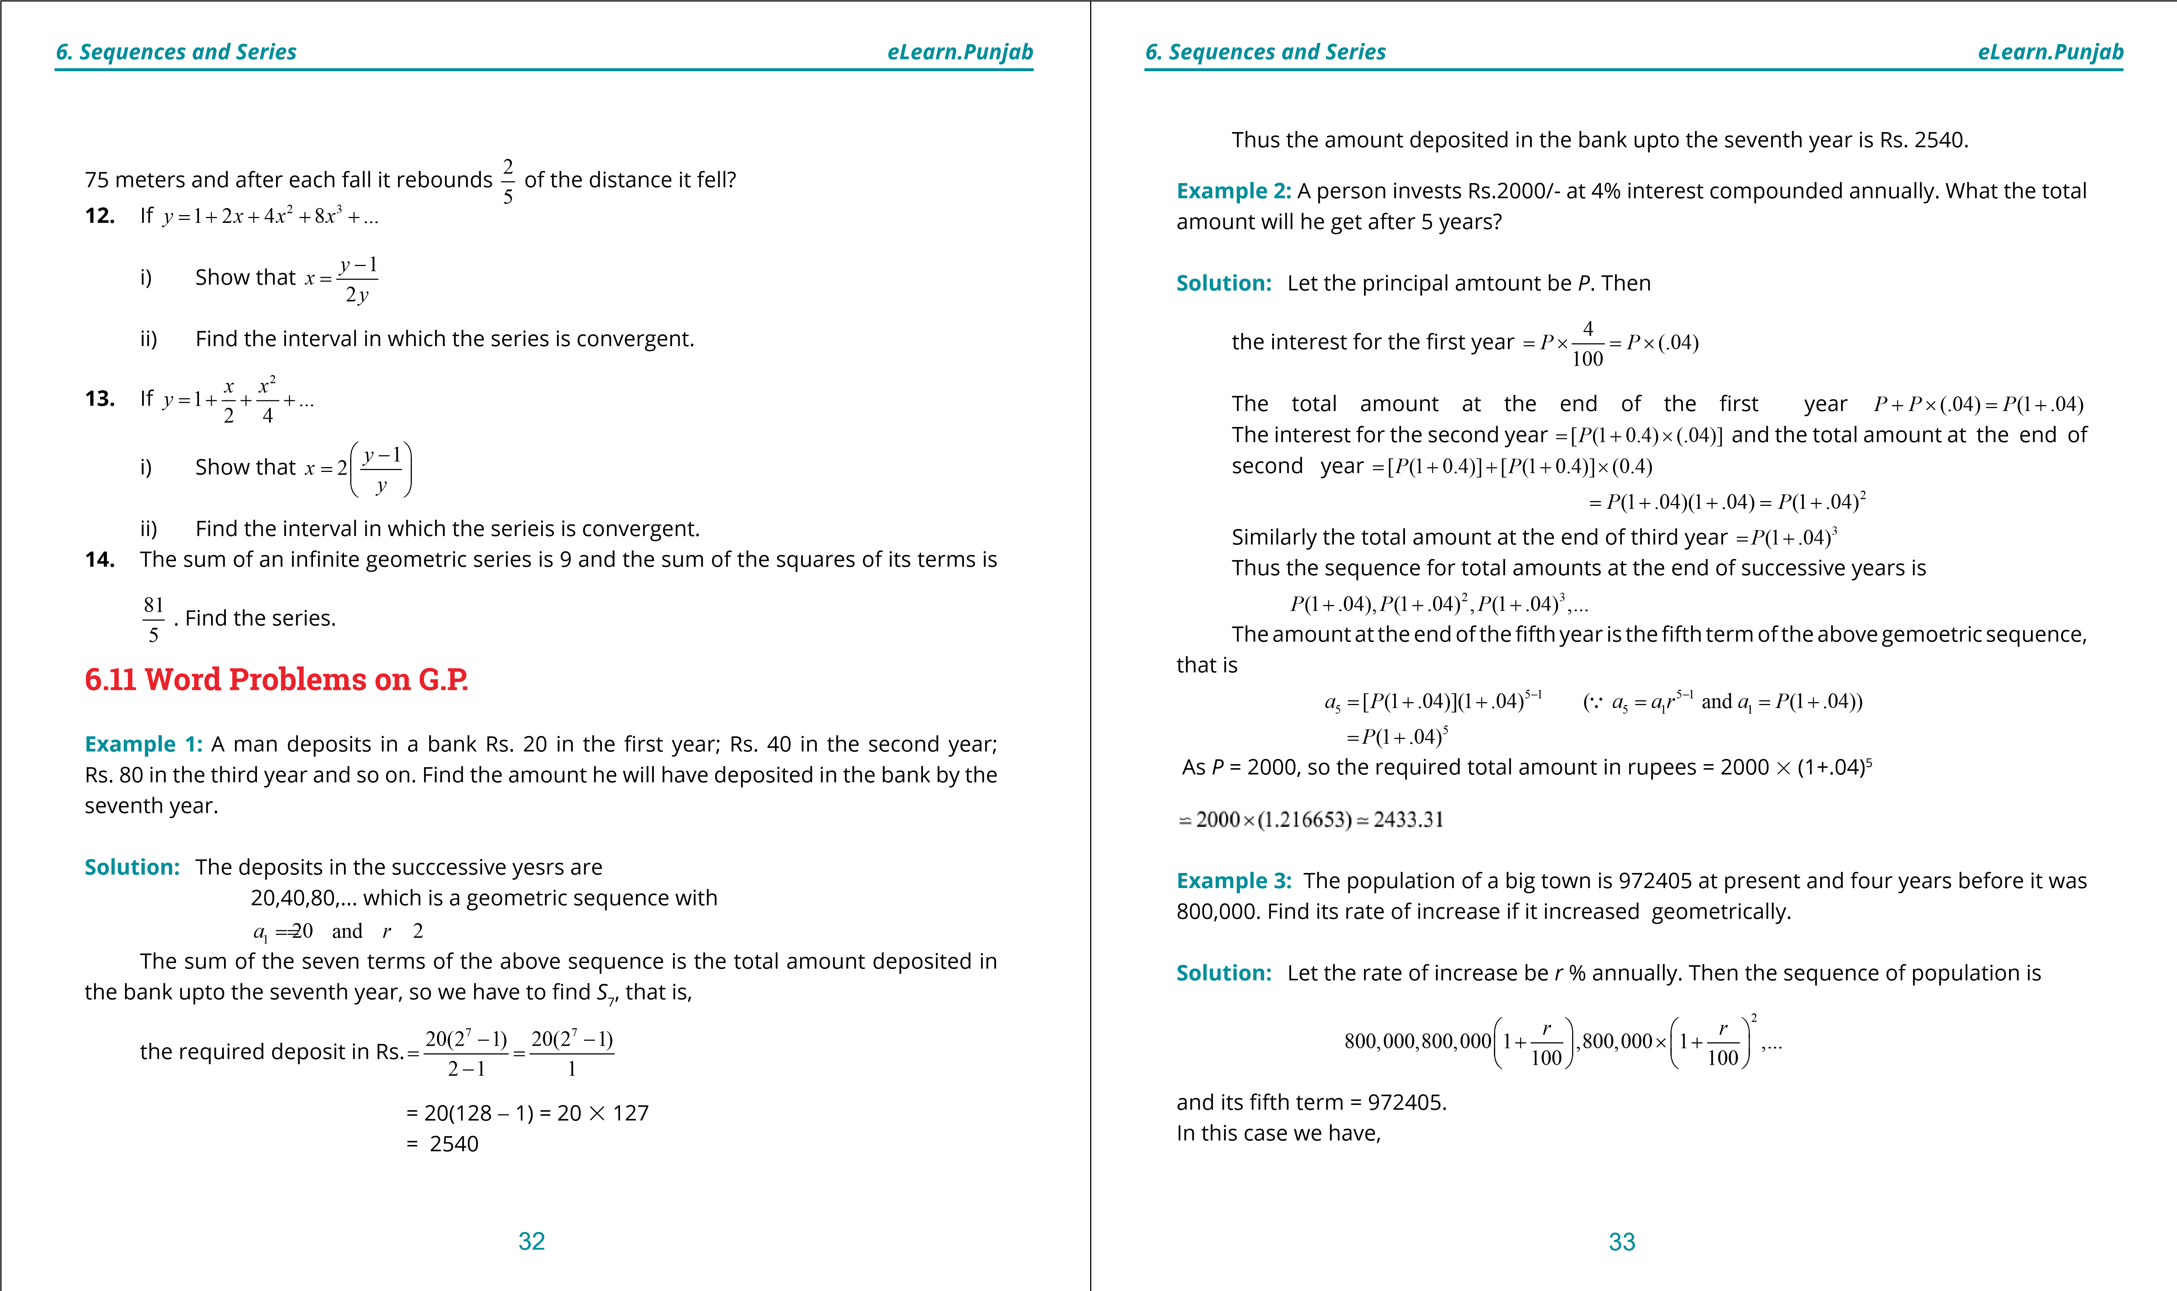

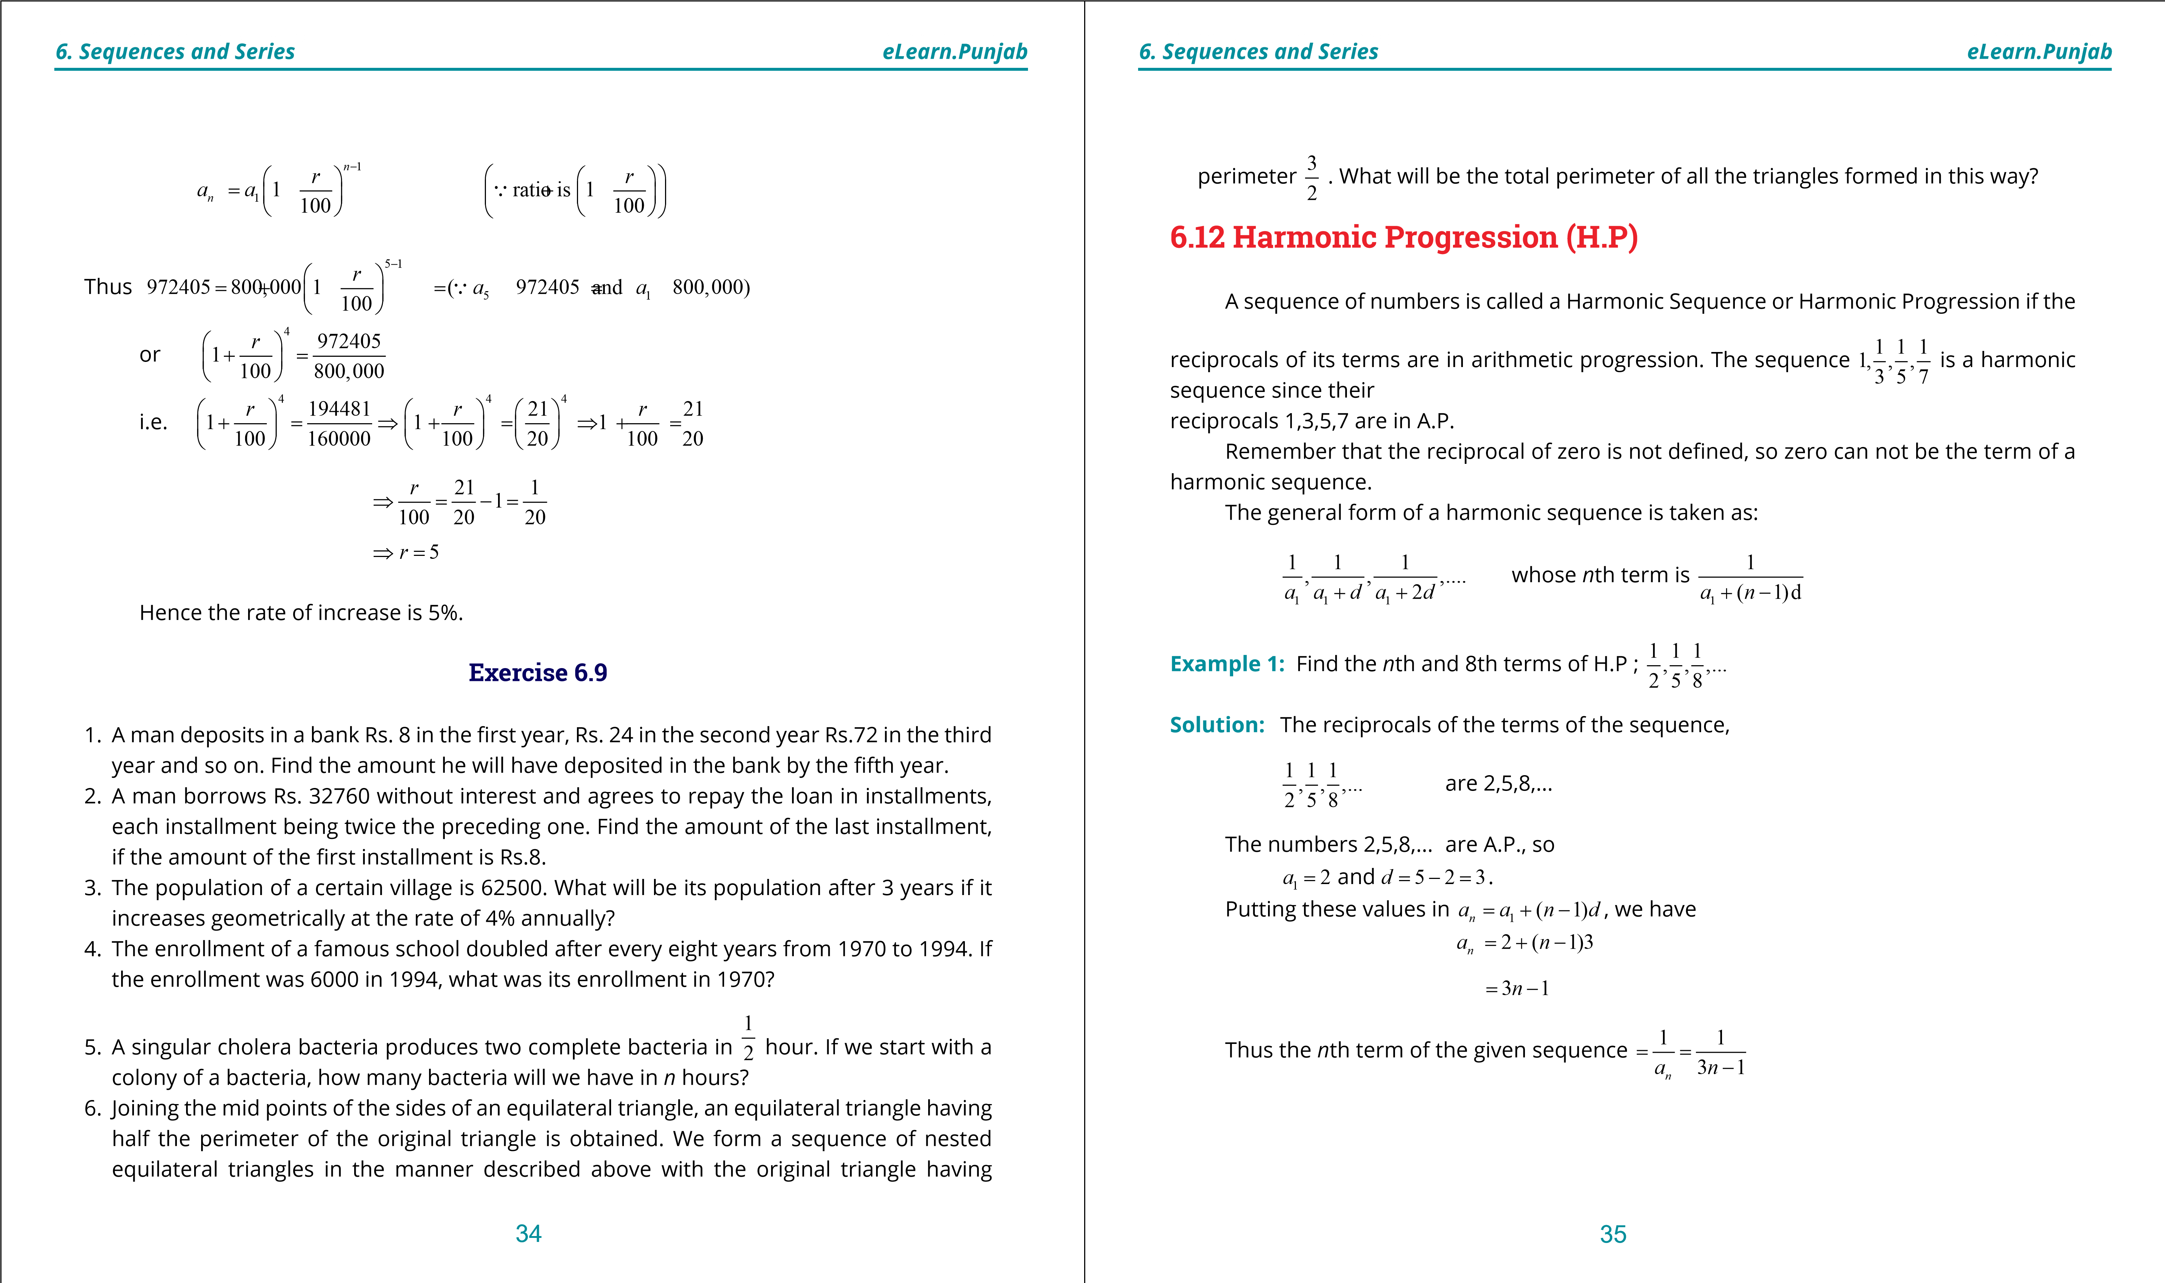

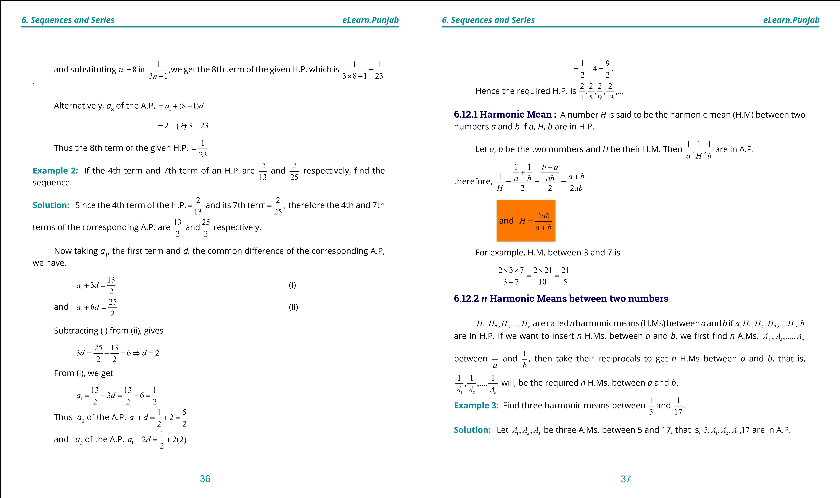

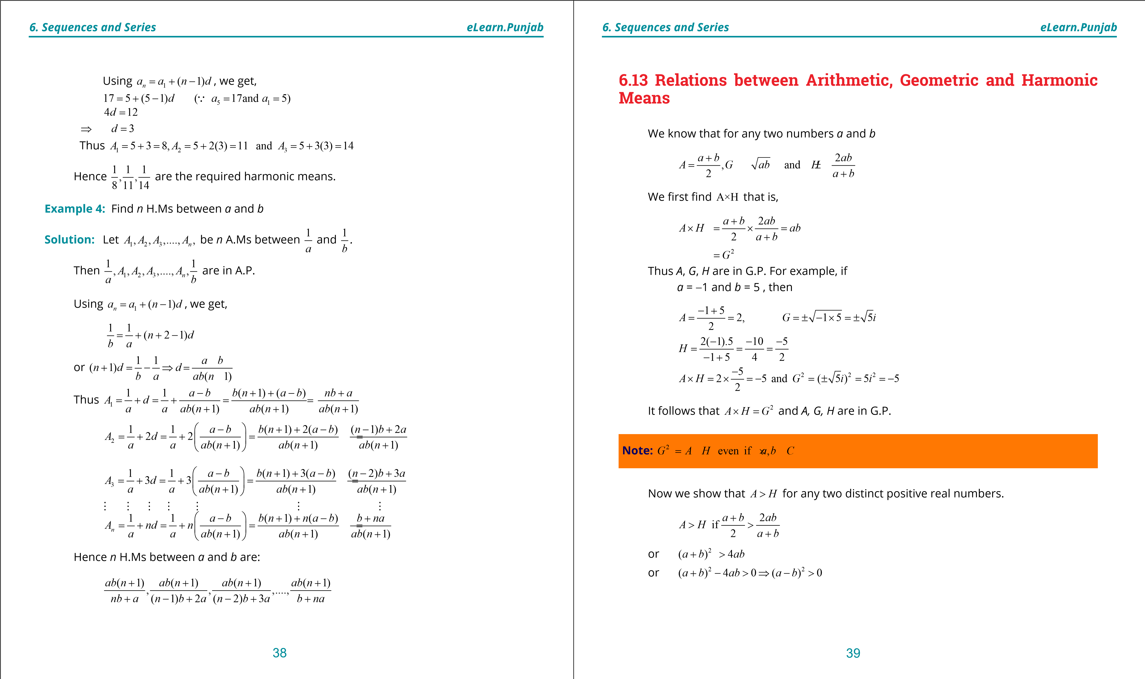

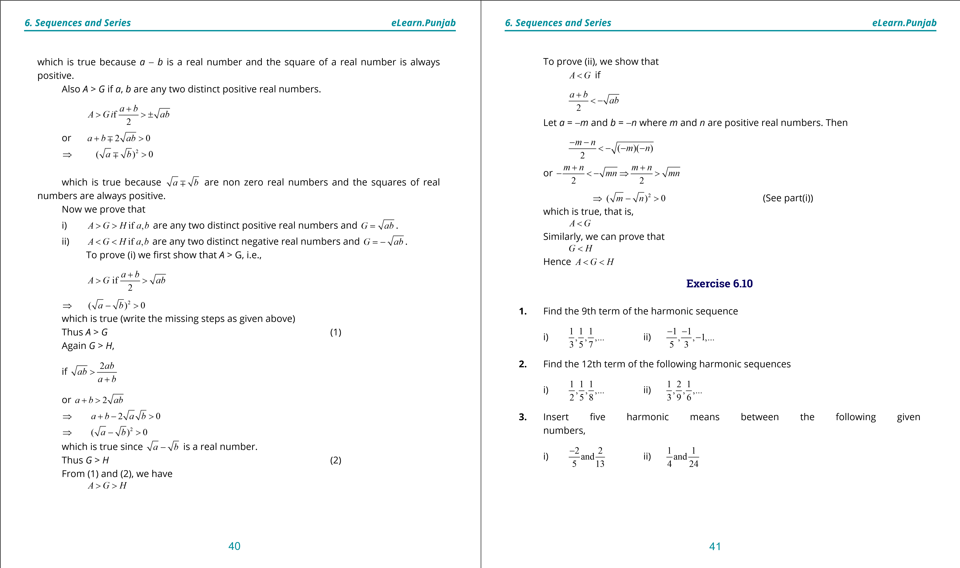

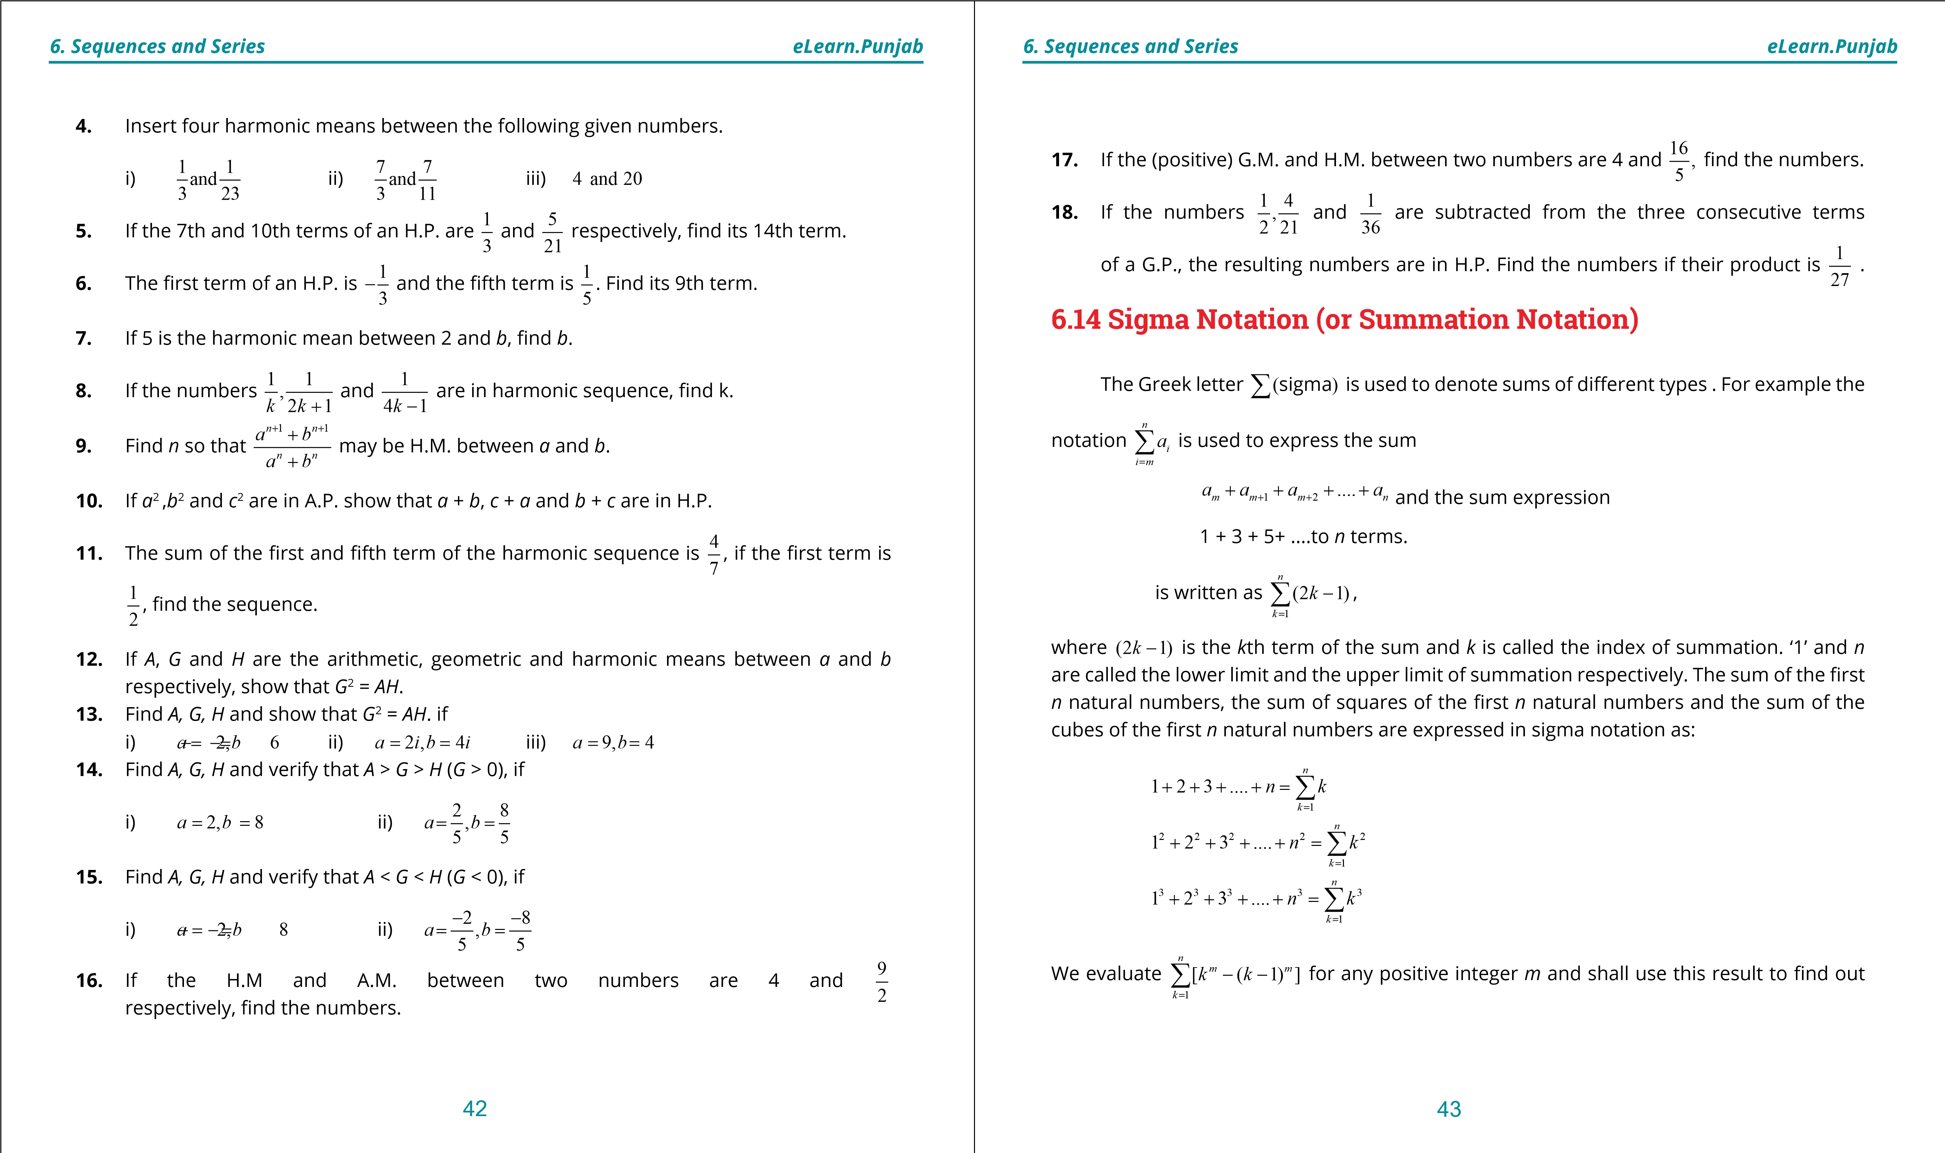

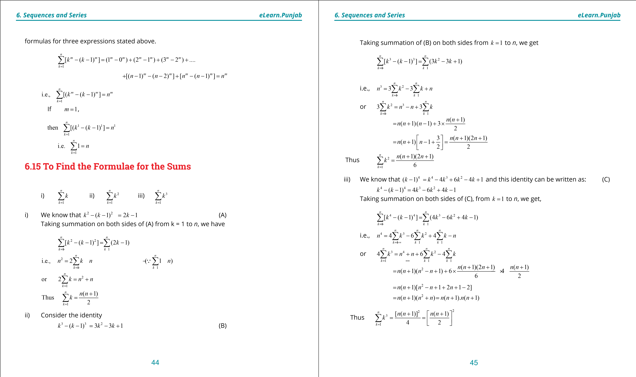

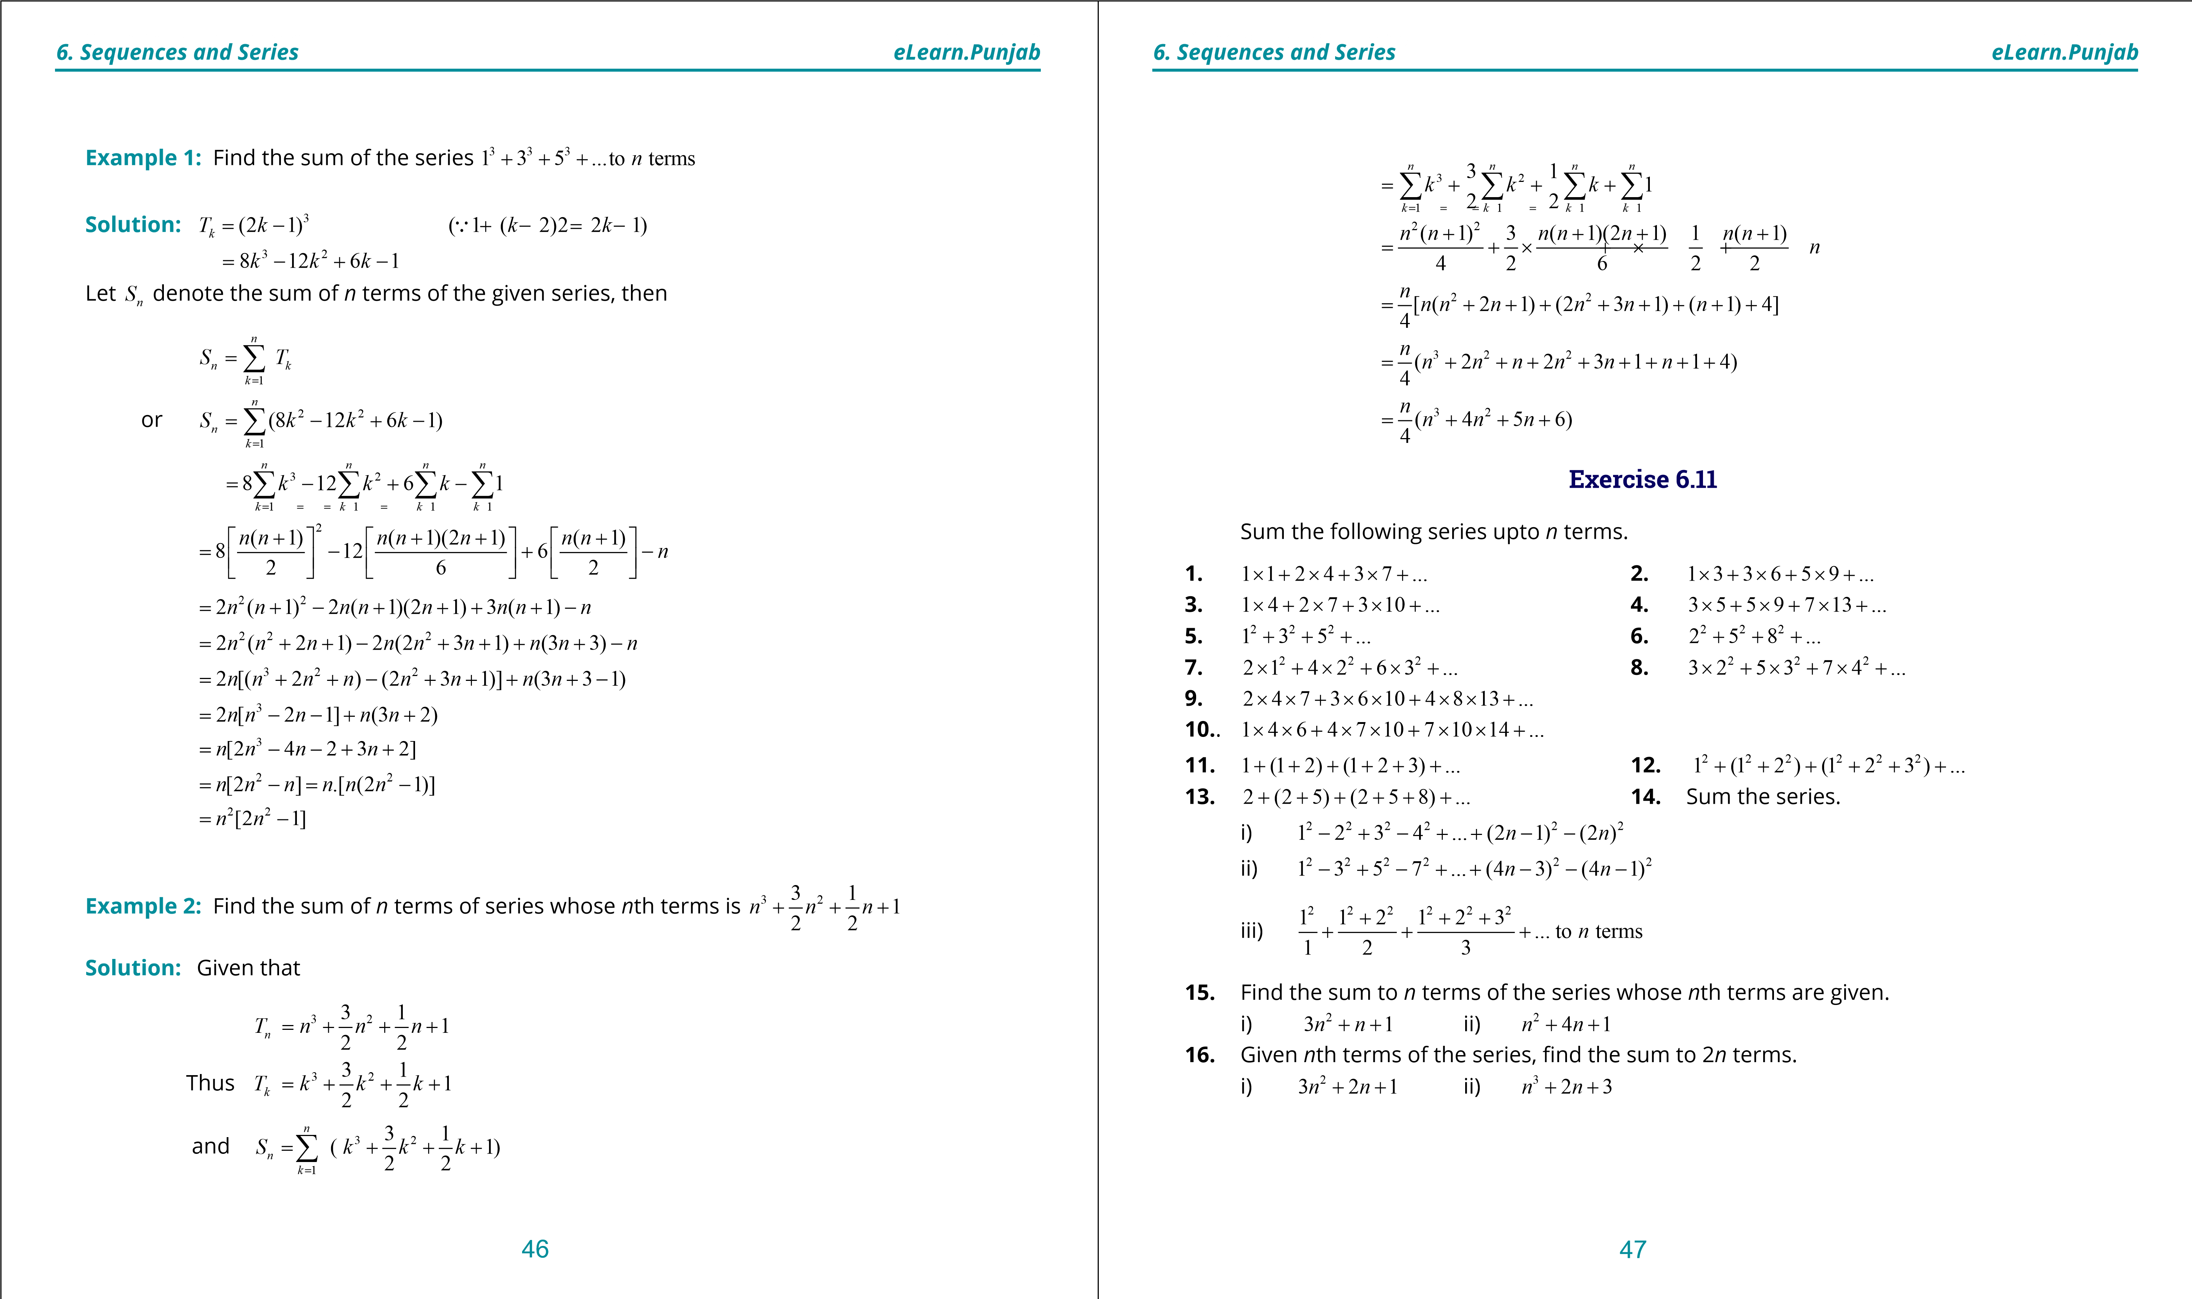

***version: 1.1***

CHAPTER

7 Permutation Combination and Probability

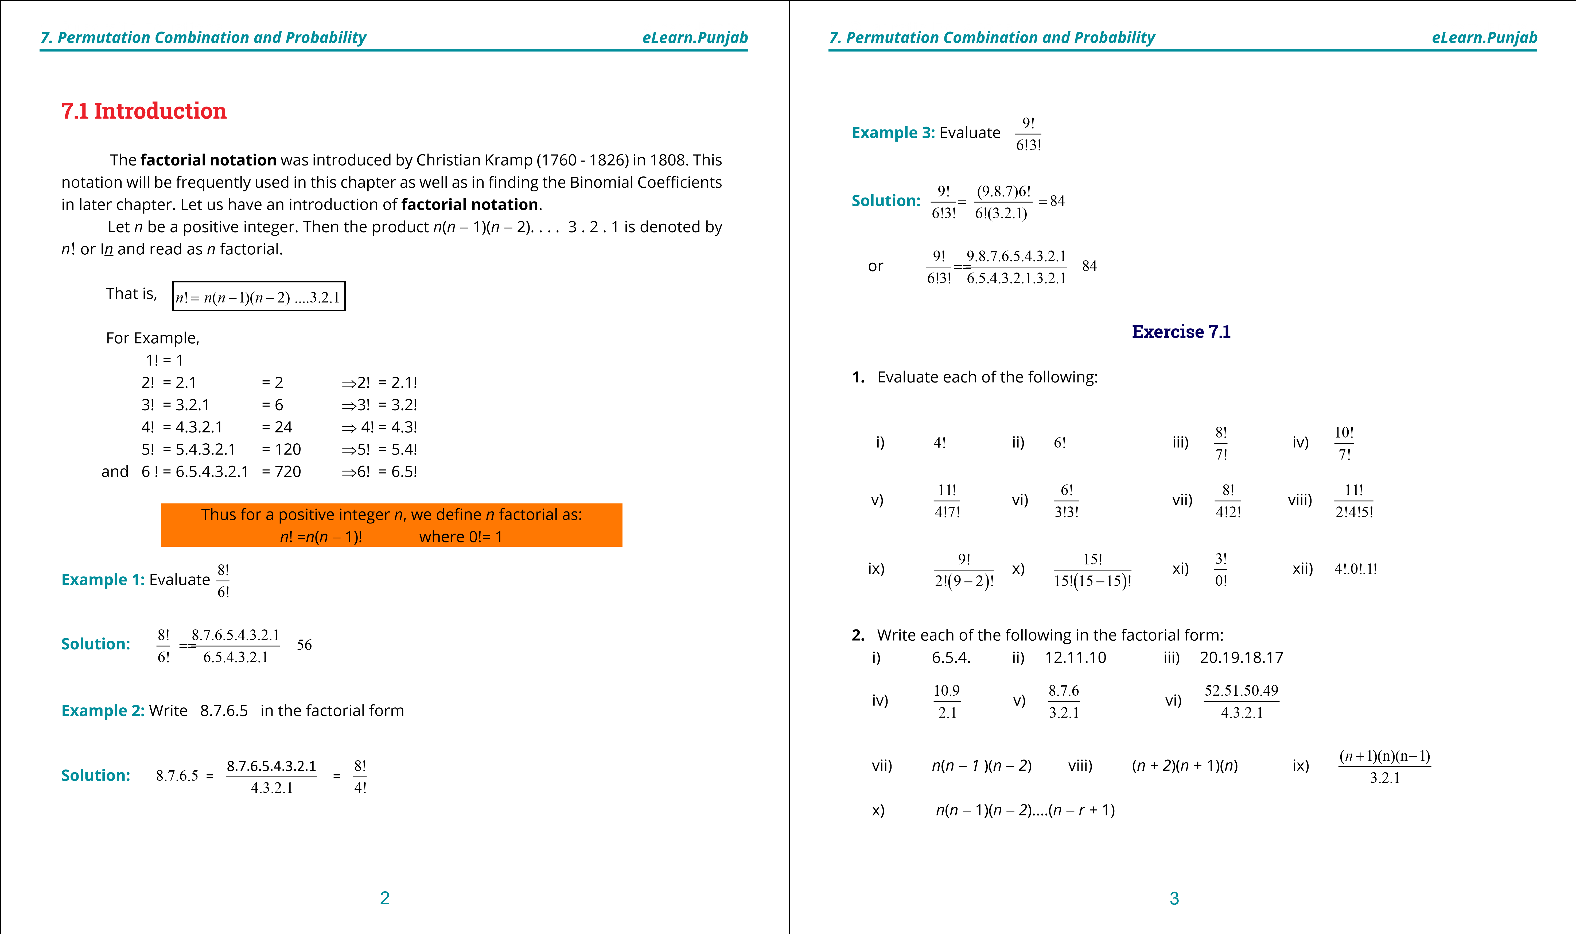

**1. Quadratic Equations eLearn.Punjab 1. Quadratic Equations eLearn.Punjab**

1. ***Permutation Combination and Probability eLearn.Punjab 7. Permutation Combination and Probability eLearn.Punjab***

**7.2 Permutation**

Suppose we like to ind the number of diferent ways to name the triangle with vertices *A*, *B* and *C*.

The various possible ways are obtained by constructing a tree diagram as follows:

To determine the possible ways, we count the paths of the tree, beginning from the start to the end of each branch. So, we get 6 diferent names of triangle.

*ABC, ACB, BCA, BAC, CAB, CBA.*

Thus there are six possible ways to write the name of the triangle with vertices *A, B* and *C.*

**Explanation:** In the igure, we can write any one of the three vertices *A, B, C* at irst place. After writing at irst place any one of the three vertices, two vertices are left. So, there are two choices to write at second place. After writing the vertices at two places, there is just one vertex left. So, we can write only one vertex at third place.

**Another Way of Explanation:**

Think of the three places as shown

Since we can write any one of the three vertices at irst place, so it is written in 3 diferent ways as shown. **3**

Now two vertices are left. So, corresponding to each way of writing at irst place, there are two ways of writing at second place as shown. **3 2**

Now just one vertex is left. So, we can write at third place only one vertex in one way as shown. **3 2 1**

The total number of possible ways (arrangements) is the product 3.2.1= 6. This example illustrates the fundamental principle of counting.

**Fundamental Principle of Counting:**

**Suppose *A* and *B* are two events. The irst event *A* can occur in *p* diferent ways. After *A* has occurred, *B* can occur in *q* diferent ways. The number of ways that the two events can occur is the product *p.q.***

This principle can be extended to three or more events. For instance, the number of ways that three events *A, B* and *C* can occur is the product *p.q.r*.

One important application of the Fundamental Principle of Counting is to determine the number of ways that *n* objects can be arranged in order. An ordering (arrangement) of *n* objects is called a **permutation** of the objects.

A **permutation** of *n*  diferent objects is an ordering (arrangement) of the objects such that one object is irst, one is second, one is third and so on.

According to Fundamental Principle of Counting:

i) Three books can be arranged in a row taken all at a time = 3.2.1 = 3! ways ii) Number of ways of writing the letters of the **WORD** taken all at a time = 4.3.2.1 = 4!

Each arrangement is called a permutation. Now we have the following deinition.  **A permutation of *n* diferent objects taken *r* (**7 ***n*) at a time is an arrangement of the *r* objects. Generally it is denoted by *nPr* or *P*(*n*,*r*).**

**Prove that:** *n pr* = *n n*( -1)(*n* - 2)....(*n* - *r* +1)= *n*!

(*n* - *r*)!

**Proof:** As there are *n* diferent objects to ill up *r* places. So, the irst place can be illed in *n* ways. Since repetitions are not allowed, the second place can be illed in (*n*-1) ways, the third place is illed in (*n*-2) ways and so on. The *r*th place has *n* - (*r* - 1) = n - *r* + 1 choices to be illed in. Therefore, by the fundamental principle of counting, *r* places can be illed by *n* diferent objects in *n*(*n* - 1)(*n* - 2) .... (*n* - *r* + 1) ways

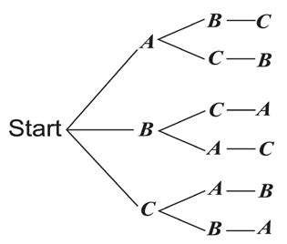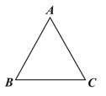

4 5

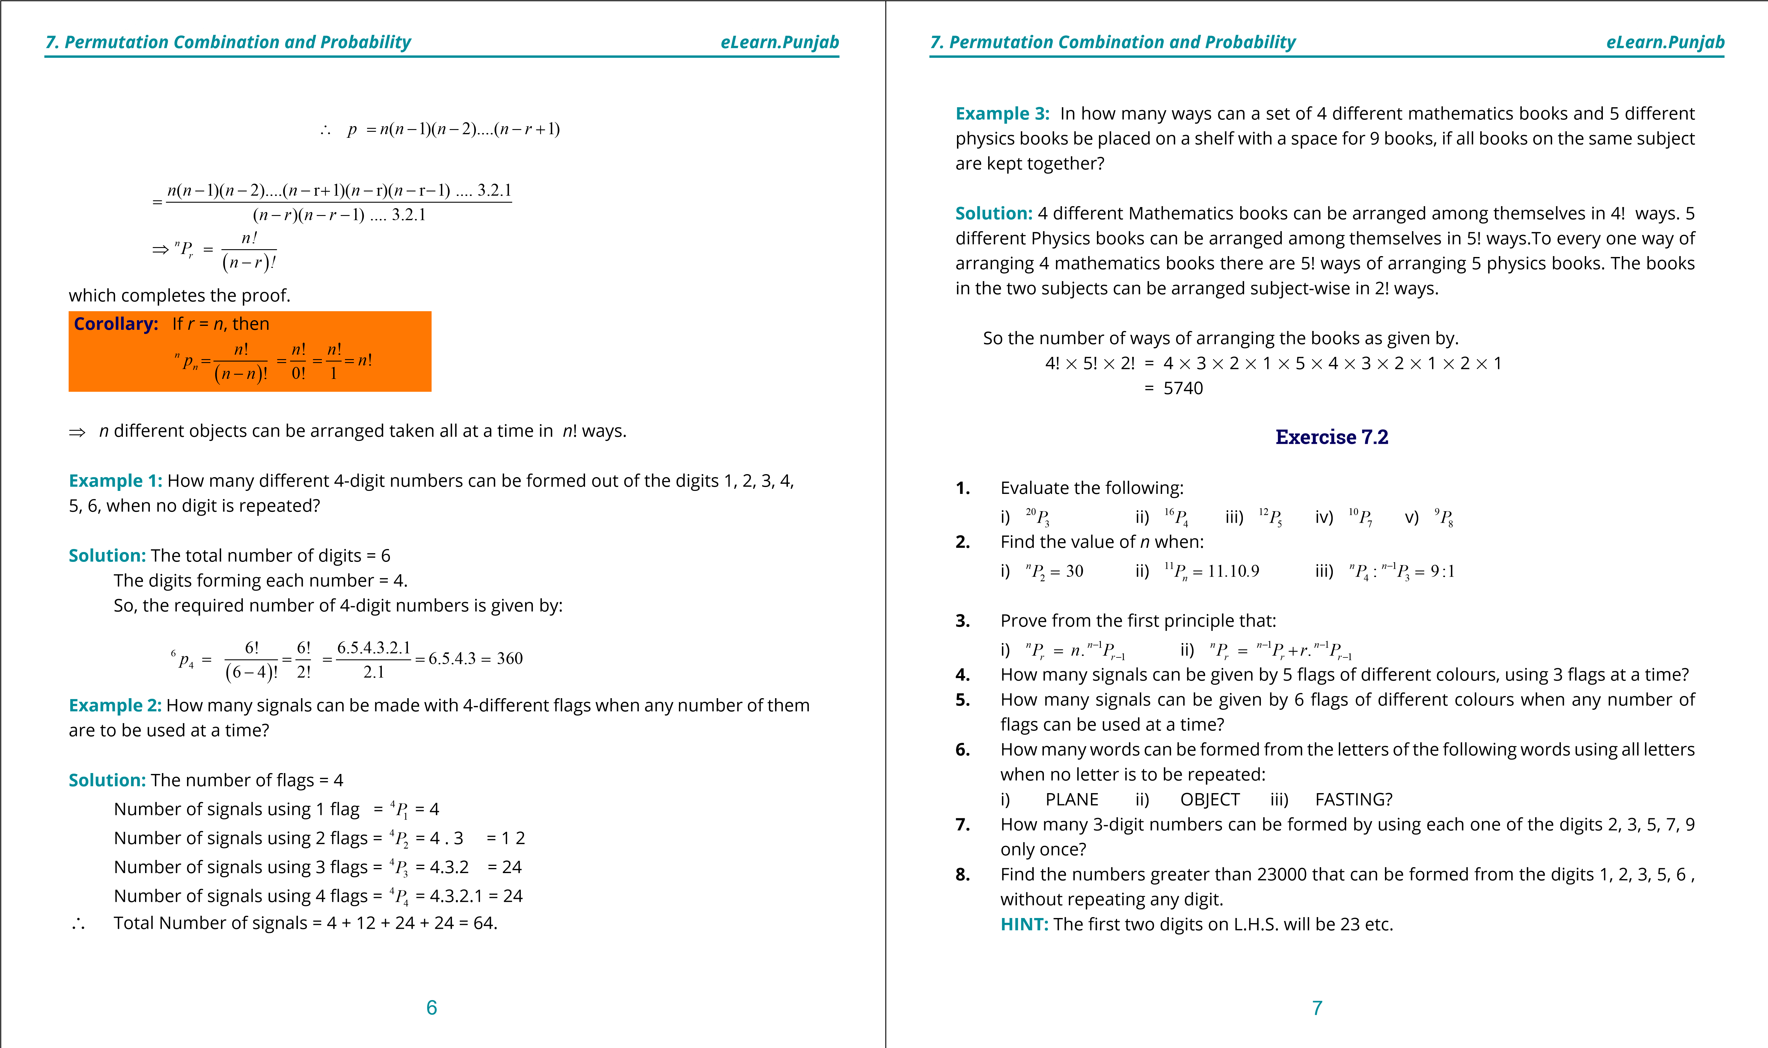

**1. Quadratic Equations eLearn.Punjab 1. Quadratic Equations eLearn.Punjab**

***7. Permutation Combination and Probability eLearn.Punjab 7. Permutation Combination and Probability eLearn.Punjab***

1. Find the number of 5-digit numbers that can be formed from the digits 1, 2, 4, 6, 8

(when no digit is repeated), but

i) the digits 2 and 8 are next to each other; ii) the digits 2 and 8 are not next to each other.

1. How many 6-digit numbers can be formed, without repeating any digit from the digits 0, 1, 2, 3, 4, 5? In how many of them will 0 be at the tens place?
2. How many 5-digit multiples of 5 can be formed from the digits 2, 3, 5, 7,9, when no digit is repeated.
3. In how many ways can 8 books including 2 on English be arranged on a shelf in such a way that the English books are never together?
4. Find the number of arrangements of 3 books on English and 5 books on Urdu for placing them on a shelf such that the books on the same subject are together.
5. In how many ways can 5 boys and 4 girls be seated on a bench so that the girls and the boys occupy alternate seats?

**7.2.1 Permutation of Things Not All Different**

Suppose we have to ind the permutation of the letters of the word BITTER, using all the letters in it. We see that all the letters of the word BITTER are not diferent and it has 2 Ts in it. Obviously, the interchanging of T*s* in any permutation, say BITTER, will not form a new permutation. However, if the two Ts are replaced by T1 and T2, we get the following two permutation of BITTER

BIT1T2ER and BIT2T1ER

Similarly, the replacement of the two Ts by T1 and T2 in any other permutation will give rise to 2 permutation.

Now, BIT1T2ER consists of 6 diferent letters which can be permuted among themselves in 6 ! diferent ways. Hence the number of permutation of the letters of the word BITTER taken all at a time

= 6! = 6.5.4.3.2.1= 360

2 2

This example guides us to discover the method of inding the permutation of *n* things all of which are not diferent. Suppose that out of *n* things, *n1* are alike of one kind and *n2* are alike of second kind and the rest of them are all diferent. Let *x* be the required number of permutation. Replacing *n1* alike things by *n1*diferent things and *n2* alike things by *n2* diferent things, we shall get all the *n* things distinct from each other which can be permuted among themselves in *n*! ways. As *n1* diferent things can be permuted among themselves in (*n1*)! ways and *n*2 diferent things can be arranged among themselves in (*n2*)! ways, so because of the replacement suggested above, *x* permutation would increase to *x* x (*n1*) ! % (*n2*)! number of ways.

∴ *x*×(*n*1)! (n )!× 2 = ( )!*n*

Hence *x*= ( )!*n* = *n* 

(*n*1)! (× *n*2)! *n n*1, 2

**Cor.** If there are *n*1 alike things of one kind, *n*2 alike things of second kind and *n*3 alike things of third kind, then the number of permutation of *n* things,taken all at a time is given by:

*n*!  *n* 

(*n* )! (× *n*2)! (× *n*3)! = *n nn*1, 2 3

1

**Example 1:** In how many ways can be letters of the word MISSISSIPPI be arranged when all the letters are to be used?

**Solution:** Number of letters in MISSISSIPPI = 11

In MISSISSIPPI,

I is repeated 4 times

S is repeated 4 times

P is repeated 2 times M comes only once.

Required number of permutation = 4,4,2,11 1

== (11)! 34650 ways

(4)! (4)! (2)! (1)!× × ×

8 9

**1. Quadratic Equations eLearn.Punjab 1. Quadratic Equations eLearn.Punjab**

***7. Permutation Combination and Probability eLearn.Punjab 7. Permutation Combination and Probability eLearn.Punjab***

**7.2.2 Circular Permutation**

So far we have been studying permutation of things which can be represented by the points on a straight line. We shall now study the permutation of things which can be represented by the points on a circle. The permutation of things which can be represented by the points on a circle are called **Circular Permutation**.

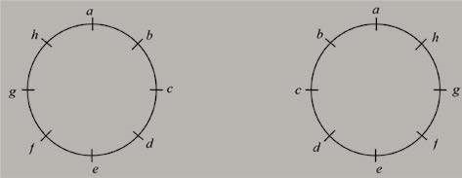

1

2

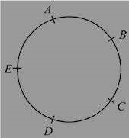

The method of inding circular permutation is illustrated by the following examples.

**Example 2:** In how many ways can 5 persons be seated at a round table.

**Solution:** Let *A, B, C, D, E* be the 5 persons One of the ways of seating them round a table is shown in the adjoining igure. If each person moves one or two or more places to the left or the right, they will, no doubt, be occupying diferent seats, but their positions relative to each other will remain the same.

So, when A occupies a certain seat, the remaining 4 persons will be permuting their seats among themselves in 4! ways.

Hence the number of arrangements = 4! = 24

**Example 3:** In how many ways can a necklace of 8 beads of diferent colours be made?

**Solution:** The number of beads = 8

The number of arrangements of 8 beads in the necklace will be like the seating of 8 persons round a table.

⇒ The number of such necklaces (ixing one of the beads) = 7!

Now suppose the beads are a, b, c, d, e , f g , h and the necklace is as shown in Fig. (i) below:

Figure (i)Figure (ii)

By lipping the necklace we get the necklace as shown in igure (ii). We observe that the two arrangements of the beads are actually the same.

Hence the required number of necklaces = = ×(7)! = 2520 **Exercise 7.3**

1. How many arrangements of the letters of the following words, taken all together, can be made:

i) PAKPATTAN ii) PAKISTAN ii) MATHEMATICS iv) ASSASSINATION?

1. How many permutation of the letters of the word PANAMA can be made, if P is to be the irst letter in each arrangement?
2. How many arrangements of the letters of the word ATTACKED can be made, if each arrangement begins with C and ends with K?
3. How many numbers greater than 1000,000 can be formed from the digits 0, 2, 2,2, 3,

4 ,4 ?

1. How many 6-digit numbers can be formed from the digits 2, 2, 3, 3, 4, 4? How many of them will lie between 400,000 and 430,000?
2. 11 members of a club form 4 committees of 3, 4, 2, 2 members so that no member is a member of more than one committee. Find the number of committees.
3. The D.C.Os of 11 districts meet to discuss the law and order situation in their districts. In how many ways can they be seated at a round table, when two particular D.C.Os insist on sitting together?
4. The Governor of the Punjab calls a meeting of 12 oicers. In how many ways can they be seated at a round table?

10 11

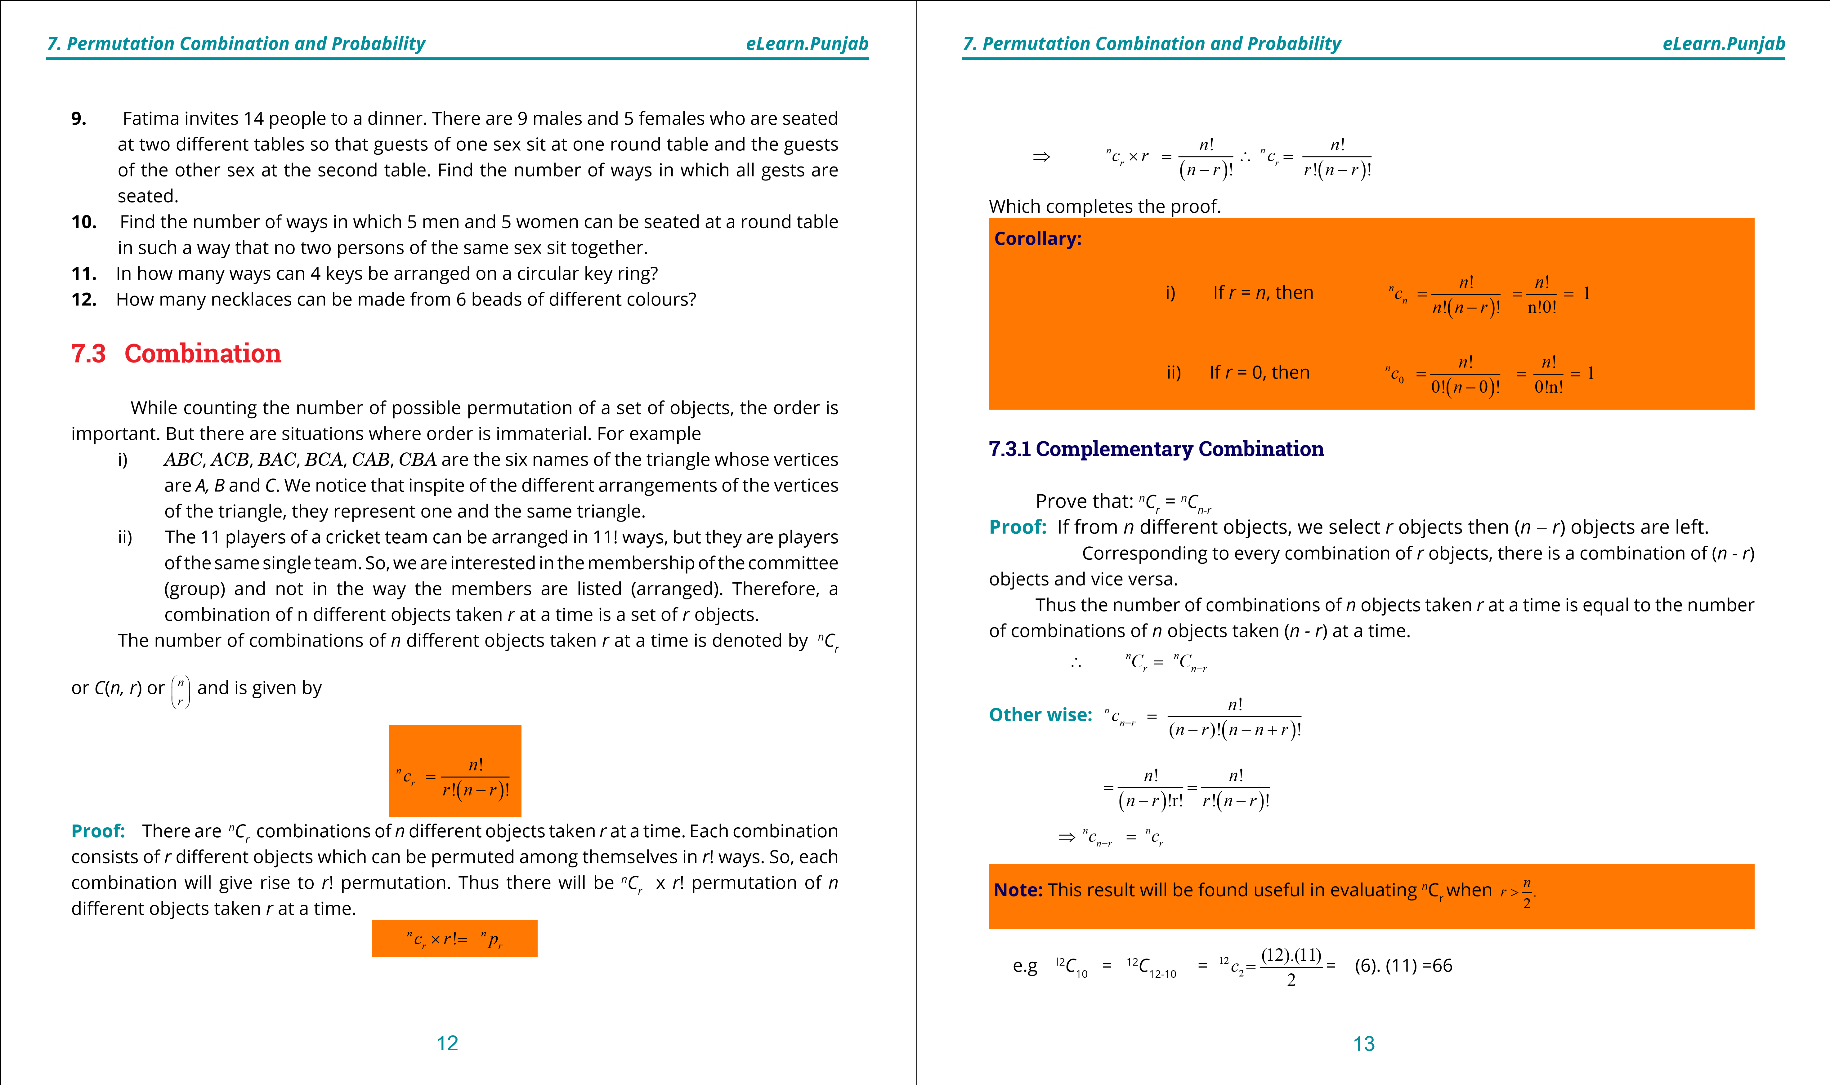

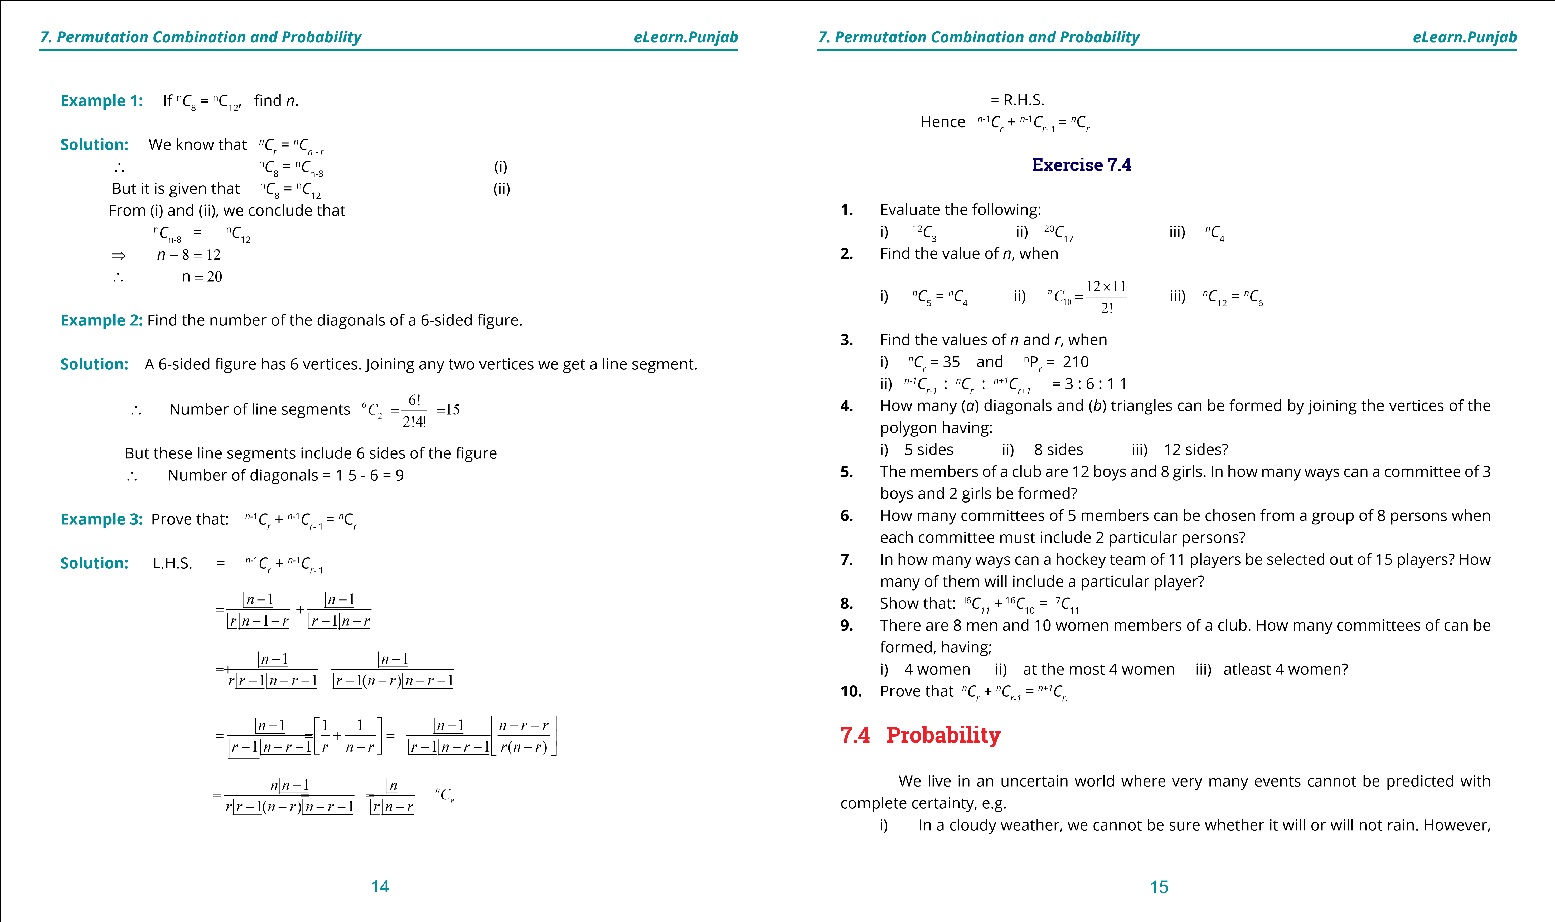

**1. Quadratic Equations eLearn.Punjab 1. Quadratic Equations eLearn.Punjab**

***7. Permutation Combination and Probability eLearn.Punjab 7. Permutation Combination and Probability eLearn.Punjab***

we can say that there is 1 chance out of 2 that the rain will fall.

ii) There are 6 theorems on circle out of which one theorem is asked in the Secondary School Examination. Evidently, there is **1 chance out of 6** that a particular theorem will be asked in the examination.

In simple situations, we are guided by our experience or intuition. However, we cannot be sure about our predictions. Nevertheless, in more complex situations, we cannot depend upon guess work and we need more powerful tools for analyzing the situations and adopting the safer path for the achievement of our goals.

In order to guide in solving complex problems of every day life, two French Mathematicians, BLAISE PASCAL (1623-62) and PIERRE DE FERMAT (1601 - 65), introduced **probability theory**. A very simple deinition of probability is given below:

**Probability is the numerical evaluation of a chance that a particular event would occur.**

This deinition is too vague to be of any practical use in estimating the chance of the occurrence of a particular event in a given situation. But before giving a comprehensive deinition of probability we must understand some terms connected with probability.

**Sample Space and Events:** The set S consisting of all possible outcomes of a given experiment is called the **sample space**. A particular outcome is called an **event** and usually denoted by *E*. An event *E* is a subset of the sample space *S*. For example,

1. In tossing a fair coin, the possible outcomes are a Head (*H*) or a Tail (*T*) and it is written as: *S* = {*H, T* }  ⇒ *n*(*S*) = 2.
2. In rolling a die the possible outcomes are 1 dot, 2 dots, 3 dots, 4 dots, 5 dots or 6 dots on the top.

∴ *S* = {1, 2, 3,4, 5, 6 } ⇒ *n*(*S*) =6

To get an even number 2, 4 or 6 is such event and is written as:

*E* = {2,4,6} ⇒ *n*(*E*) = 3

**Mutually Exclusive Events:** If a sample space S = {1, 3, 5, 7, 9} and an event *A* = {1, 3, 5} and another event *B* = {9}, then *A* and *B* are disjoint sets and they are said to be **mutually exclusive events**. In tossing a coin, the sample space *S* = {*H, T* }. Now, if event *A* = {*H* } and event *B* = {*T* }, then *A* and *B* are mutually exclusive events.

**Equally Likely Events:** We know that if a fair coin is tossed, the chance of **head** appearing on the top is the same as that of the **tail**. We say that these two events are **equally likely**. Similarly, if a die, which is a perfect unloaded cube is rolled, then the face containing 2 dots is as likely to be on the top as the face containing 5 dots. The same will be the case with any other pair of faces. In general, if two events A and B occur in an experiment, then ***A* and** ***B*** **are said to be equally likely events if each one of them has equal number of chances of occurrence.**

()

2

1

()

()

6

3

*nE*

*PE*

*nS*

∴

==

=

The following deinition of Probability was given by a French Mathematician, P.S. Laplace (1749 - 1827) and it has been accepted as a standard deinition by the mathematicians all over the world:

If a random experiment produces *m* diferent but equally likely out-comes and *n* outcomes out of them are favourable to the occurrence of the event *E*, then the probability of the occurrence of the event *E* is denoted by *P*(*E*) such that

*P E*( ) = *n* = *n E*( ) = no.of ways in which event occurs *m n S*( ) no.the elements of the sample space

Since the number of outcomes in an event is less than or equal to the number of outcomes in the sample space, the probability of an event must be a number between 0 and 1.

That is, 0 7 P(E) 71

i) If P{E) = 0, event E cannot occur and E is called an impossible event. ii) If P(E) = 1, event E is sure to occur and E is called a certain event.

**Example 1:** A die is rolled. What is the probability that the dots on the top are greater than 4?

**Solution:**  *S* = {1,2, 3 ,4 ,5 ,6 }  ⇒ *n*(*S*) = 6

The event E that the dots on the top are greater than 4 = {5, 6 }

⇒ *n*(*E*) = 2

**Example 2:** What is the probability that a slip of numbers divisible by 4 are picked from the slips bearing numbers 1, 2, 3, ......,10

**Solution:** *S* = {1, 2, 3 ,..., 10} ⇒ *n*(*S*) = 10

Let *E* be the event of picking slip with number divisible by 4.

16 17

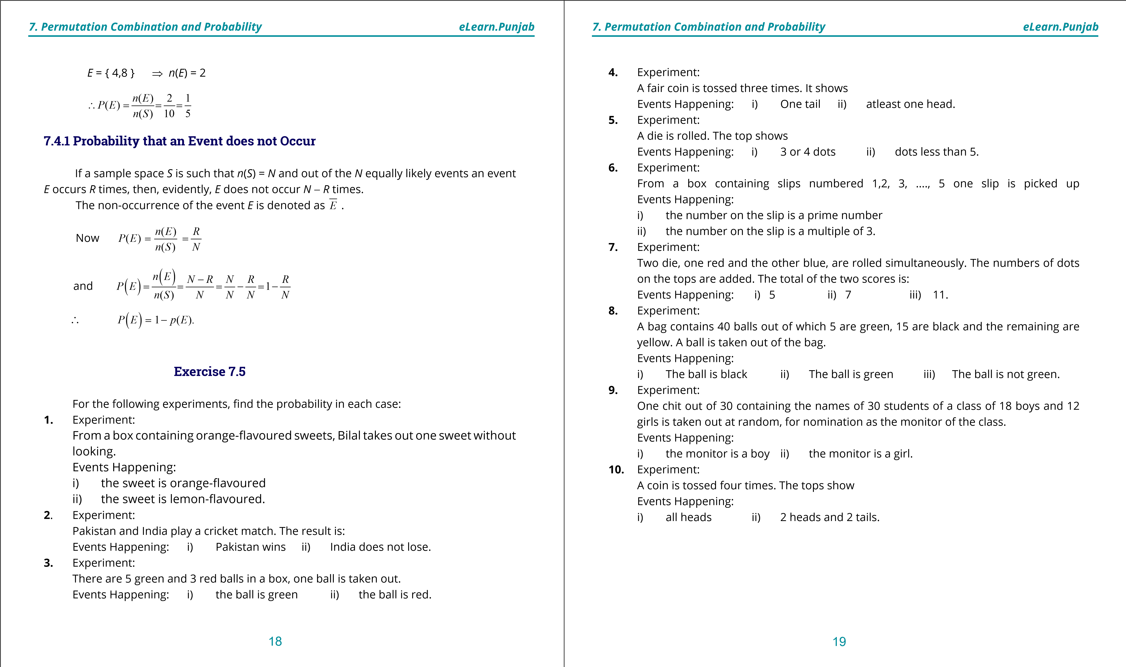

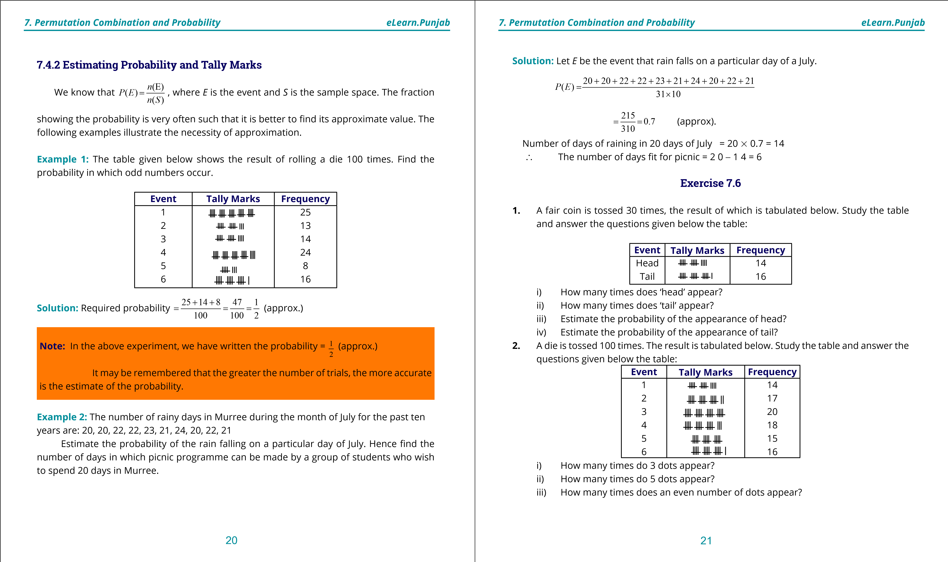

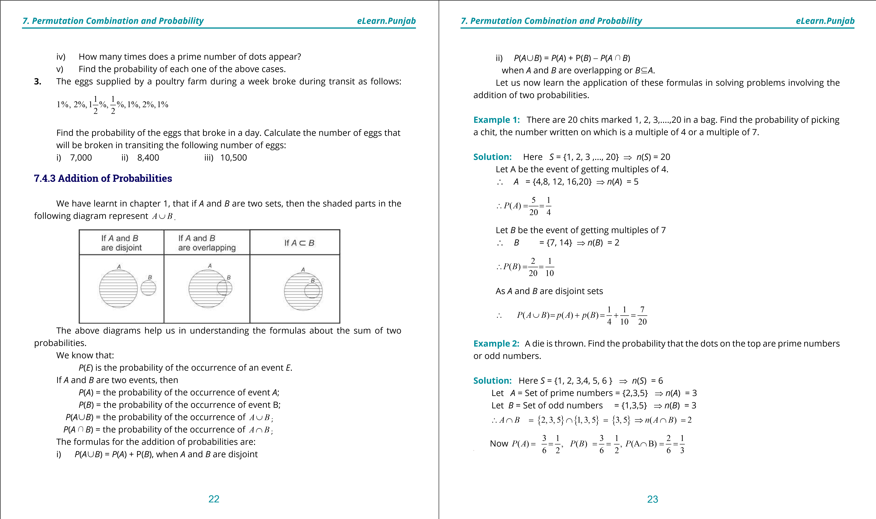

**1. Quadratic Equations eLearn.Punjab 1. Quadratic Equations eLearn.Punjab**

***7. Permutation Combination and Probability eLearn.Punjab 7. Permutation Combination and Probability eLearn.Punjab***

Since *A* and *B* are overlapping sets.

*P A*( ∪ *B*) = *P A*( ) + *P B*( ) - *P A*( ∩ *B*)

**Exercise 7.7**

1. If sample space= {1, 2, 3 , 9 } , Event *A* = {2, 4, 6, 8} and Event *B* = {1, 3, 5}, ind

*P A*( ∪ *B*) .

1. A box contains 10 red, 30 white and 20 black marbles. A marble is drawn at random. Find the probability that it is either red or white.
2. A natural number is chosen out of the irst ifty natural numbers. What is the probability that the chosen number is a multiple of 3 or of 5?
3. A card is drawn from a deck of 52 playing cards. What is the probability that it is a diamond card or an ace?
4. A die is thrown twice. What is the probability that the sum of the number of dots shown is 3 or 11?
5. Two dice are thrown. What is the probability that the sum of the numbers of dots appearing on them is 4 or 6 ?
6. Two dice are thrown simultaneously. If the event *A* is that the sum of the numbers of dots shown is an odd number and the event *B* is that the number of dots shown on at least one die is 3. Find *P A*( ∪ *B*) .
7. There are 10 girls and 20 boys in a class. Half of the boys and half of the girls have blue eyes. Find the probability that one student chosen as monitor is either a girl or has blue eyes.

**7.4.4 Multiplication of Probabilities**

We can multiply probabilities of **dependent** as well as **independent** events. But, in this section, we shall ind the multiplication of independent events only. Before learning the formula of the multiplication of the probabilities of independent events, it is necessary to understand that what is meant by independent events.

**Two events A and B are said to be independent; if the occurrence of any one of them does not inluence the occurrence of the other event.** In other words, regardless of whether event *A* has or has not occurred, if the probability of the event *B* remains the same, then *A* and B are independent events.

Suppose a bag contains 12 balls. If 4 balls are drawn from it twice in such a way that: i) the balls of the irst draw are not replaced before the second draw; ii) the balls of the irst draw are replaced before the second draw.

In the case (i), the second draw will be out of (12 - 4 = 8) balls which means that the out-comes of the second draw will depend upon the events of the irst draw and the two events will not be independent. However, in case (ii), the number of balls in the bag will be the same for the second draw as has been the case at the time of irst draw i.e. the irst draw will not inluence the probability of the event of second draw. So the two events in this case will be independent.

1

1

1

2

2

2

3

3

=+-=

**Theorem: If *A* and *B* are two independent events, the probability that both of them occur is equal to the probability of the occurrence of *A* multiplied by the probability of the occurrence of *B*. Symbolically, it is denoted as:**

*P A*( ∩ *B*) = *P A*( ). *P B*( )

**Proof:** Let event *A* belong to the sample space *S*1 such that

*m*1  *n*(*S*1) = *n*1 and *n*(*A*) = *m*1 ⇒ *P A*( ) = *n*1 Let event *B* belong to the sample space *S*2 such that

*n*(*S*2) = *n*2 and *n*(*B*) = *m*2 ⇒ *p B*( ) = *mn*22

a *A* and *B* are independent events

∴ Total number of combined outcomes of *A* and *B* = *n*1 *n*2  and total number of favourable outcomes = *m m*

1 2

∴ *P A*( ∩ *B*) = *m m*1 2 = *m*1 . *m*2 = *P A*( ). *P B*( ) *n n*1 2 *n*1 *n*

2

24 25

**1. Quadratic Equations eLearn.Punjab 1. Quadratic Equations eLearn.Punjab**

***7. Permutation Combination and Probability eLearn.Punjab 7. Permutation Combination and Probability eLearn.Punjab***

**Note:** The above proof of the formula holds good even if the sample spaces of *A* and *B* are the same. The formula *P A*( ∩ *B*) = *P A*( ). *P B*( )can be generalized as: *P A*( 1 ∩ *A*2 ∩ *A*3 ∩.....∩ *An*) = *P A*( 1). *P A*( 2). *P A*( 3)........ (*P An*) where *A*1*, A*2*, A*3*, ......, An* are independent events.

2

1

1

18

6

1

)

(

)

and (

36

36

2

6

*PE*

*PE*

==

==

∴

2

1

1

1

1

(

(

)

.

).

12

6

2

*PE*

*PE*

=

∴

2

1

3

1

)

(

36

12

*E*

*PE*

=

∩

∴

=

5

7

7

9

**Example 1** The probabilities that a man and his wife will be alive in the next 20 years are 0.8 and 0.75 respectively. Find the probability that both of them will be alive in the next 20 years.

**Solution:**  If *P*(*A*) is the probability that the man will be alive in 20 years and *P*(*B*) is the probability that his wife be alive in 20 years. a The two events are independent:

∴ *P*(*A*) = 0.8 *P*(*B*) = 0.75

The probability that both man and wife will be alive in 20 years is given by:

*P A*( ∩ *B*) = 0.8×0.75 = 0.6

**Example 2:** Two dice are thrown. *E*1 is the event that the sum of their dots is an odd number and *E*2 is the event that 1 is the dot on the top of the irst die. Show that *P E*( 1 ∩ *E*2) = *P E*( 1). *P E*( 2)

**Solution:** *E*1 = {(1,2), (1 ,4), (1, 6), (2, 3), (2, 5), (3,4), (3 ,6), (4, 3) (4, 5)

(5, 6), (2, 1), (4, 1), (6,1), (3, 2), (5, 2), (6, 3), (5, 4), (6, 5)}

⇒ *n*(*E*1) = 18

*E*2 = {(1, 1), (1, 2), (1, 3), (1, 4), (1, 5), (1, 6)}

⇒ *n*(*E*2) = 6 a *n*(*S*) = 6%6 = 36 a *E*1 and *E*2 are independent

Now *E*1 ∩ *E*2  = {(1,2), (1,4), (1,6)}

⇒ *n E*( 1 ∩ *E*2) = 3

Hence *P E*( 1 ∩ *E*2) = *P E*( 1). *P E*( 2)

**Exercise 7.8**

1. The probability that a person A will be alive 15 years hence is and the probability that

another person B will be alive 15 years hence is . Find the probability that both will be alive 15 years hence.

1. A die is rolled twice: Event *E*1 is the appearance of even number of dots and event *E*2 is the appearance of more than 4 dots. Prove that: *P E*( 1 ∩ *E*2) = *P E*( 1). *P E*( 2)
2. Determine the probability of getting 2 heads in two successive tosses of a balanced coin.
3. Two coins are tossed twice each. Find the probability that the head appears on the irst toss and the same faces appear in the two tosses.
4. Two cards are drawn from a deck of 52 playing cards. If one card is drawn and replaced before drawing the second card, ind the probability that both the cards are aces.
5. Two cards from a deck of 52 playing cards are drawn in such a way that the card is replaced after the irst draw. Find the probabilities in the following cases: i) irst card is king and the second is a queen.

ii) both the cards are faced cards i.e. king, queen, jack.

1. Two dice are thrown twice. What is probability that sum of the dots shown in the irst throw is 7 and that of the second throw is 11 ?
2. Find the probability that the sum of dots appearing in two successive throws of two dice is every time 7.

26 27

**1**

**. Quadratic Equations**

**eLearn.Punjab**

***7***

***. Permutation Combination and Probability***

***eLearn.Punjab***

28

**9.**

A fair die is thrown twice. Find the probability that a prime number of dots appear in

the irst throw and the number of dots in the second throw is less than 5.

**10.**

A bag contains 8 red, 5 white and 7 black balls, 3 balls are drawn from the bag. What

is the probability that the irst ball is red, the second ball is white and the third ball is

black, when every time the ball is replaced?

**HINT:**

8

5

7

20

20

20

























is the probability.

***version: 1.1***

CHAPTER

8 Mathematical Inductions and Binomial Theorem

**1. Quadratic Equations eLearn.Punjab 1. Quadratic Equations eLearn.Punjab**

1. ***Mathematical Inductions and Binomial Theorem eLearn.Punjab 8. Mathematical Inductions and Binomial Theorem eLearn.Punjab***

**8.1 Introduction**

Francesco Mourolico (1494-1575) devised the method of induction and applied this device irst to prove that the sum of the irst n odd positive integers equals *n*2. He presented many properties of integers and proved some of these properties using the method of *mathematical induction.*

We are aware of the fact that even one exception or case to a mathematical formula is enough to prove it to be false. Such a case or exception which fails the mathematical formula or statement is called a counter example.

The validity of a formula or statement depending on a variable belonging to a certain set is established if it is true for each element of the set under consideration.

For example, we consider the statement *S*(*n*) = *n*2 - *n* + 41 is a prime number for every natural number *n*. The values of the expression *n*2 - *n* + 41 for some irst natural numbers are given in the table as shown below:

***n*** 1 2 3 4 5 6 7 8 9 10 11

***S(n)*** 41 43 47 53 61 71 83 91 113 131 151

From the table, it appears that the statement *S*(*n*) has enough chance of being true. If we go on trying for the next natural numbers, we ind *n* = 41as a counter example which fails the claim of the above statement. So we conclude that to derive a general formula without proof from some special cases is not a wise step. This example was discovered by Euler (1707-1783).

3(

1)

2

*nn*

+

Now we consider another example and try to formulate the result. Our task is to ind the sum of the irst *n* odd natural numbers. We write irst few sums to see the pattern of sums.

*n* (The number of terms) Sum 1 --------------------------------------------------------------------1= 12

2 ------------------------------------------------------------1+3= 4 = 22  3 ----------------------------------------------------------1+3+5= 9=32  4 ------------------------------------------------------1+3+5+7=16=42

* + 1. -------------------------------------------------1+3+5+7+9=25 = 52
    2. ---------------------------------------------1+3+5+7+9+11=36= 62

The sequence of sums is (1)2, (2)2, (3)2, (4)2, ...

We see that each sum is the square of the number of terms in the sum. So the following statement seems to be true.

For each natural number *n*,

1 + 3 + 5 + ... . + (2*n* - 1) = *n*2 . . . . (i) (*a* *n*th term=1+(*n* - 1)2)

But it is not possible to verify the statement (i) for each positive integer *n*, because it involves ininitely many calculations which never end.

The method of mathematical induction is used to avoid such situations.Usually it is used to prove the statements or formulae relating to the set {1,2,3,...} but in some cases, it is also used to prove the statements relating to the set (0 ,1,2 ,3,...}.

**8.2 Principle of Mathematical Induction**

The principle of mathematical induction is stated as follows:

If a proposition or statement *S*(*n*) for each positive integer *n* is such that

* 1. *S*(1) is true i.e., *S*(*n*) is true for *n* = 1 and
  2. *S*(*k* + 1) is true whenever *S*(*k*) is true for any positive integer *k*, then *S*(*n*) is true for all positive integers.

**Procedure:**

1. Substituting *n* = 1, show that the statement is true for *n* = 1.
2. Assuming that the statement is true for any positive integer k, then show that it is true for the next higher integer. For the second condition, one of the following two methods can be used:

*M*1 Starting with one side of *S*(*k* +1), its other side is derived by using *S*(*k*). *M*2  *S*(*k* + 1) is established by performing algebraic operations on *S*(*k*).

**Example 1:** Use mathematical induction to prove that 3+ 6 + 9 +....+ 3*n* = for every positive integer *n*.

**Solution:** Let *S*(*n*) be the given statement, that is,

2 3

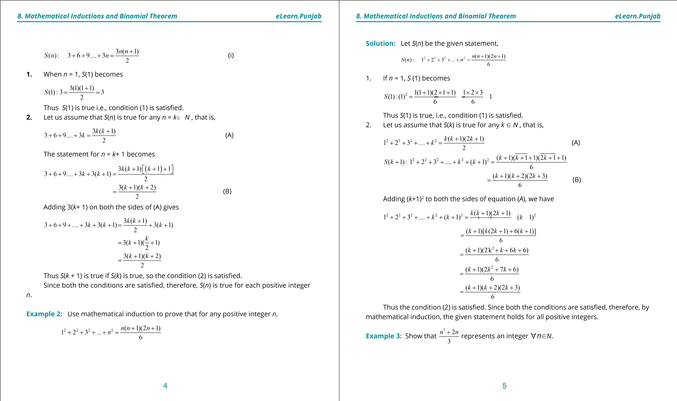

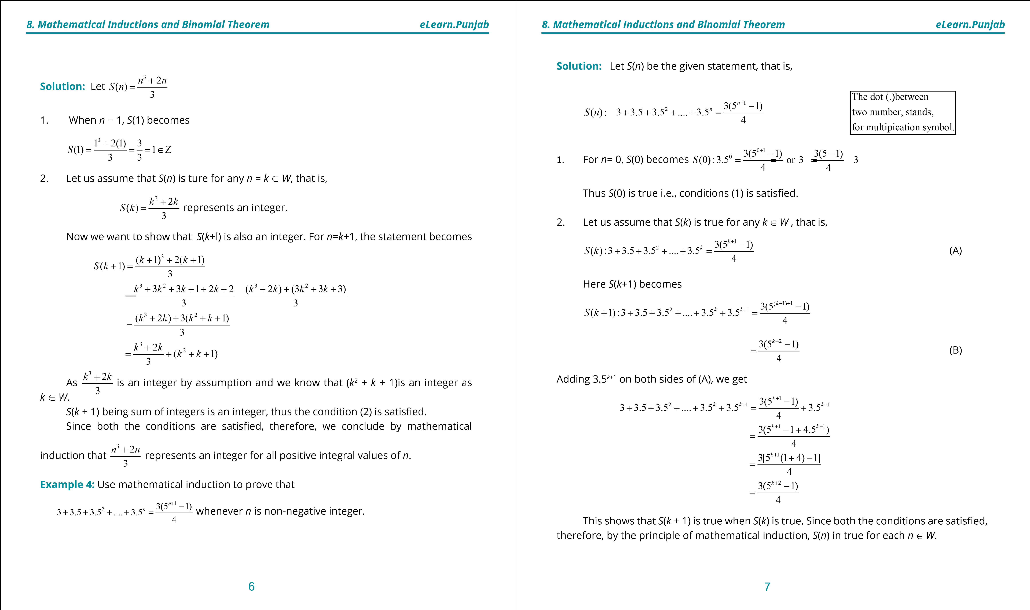

**1. Quadratic Equations eLearn.Punjab 1. Quadratic Equations eLearn.Punjab**

***8. Mathematical Inductions and Binomial Theorem eLearn.Punjab 8. Mathematical Inductions and Binomial Theorem eLearn.Punjab***

Care should be taken while applying this method. Both the conditions (1) and (2) of the principle of mathematical induction are essential. The condition (1) gives us a starting point but the condition (2) enables us to proceed from one positive integer to the next. In the condition (2) we do not prove that *S*(*k* + 1) is true but prove only that if *S*(*k*)is true, then *S*(*k* + 1) is true. We can say that any proposition or statement for which only one condition is satisied, will not be truefor all *n* belonging to the set of positive integers.

For example, we consider the statement that 3*n* is an even integer for any positive integer *n*. Let *S*(*n*) be the given statement.

Assume that *S*(*k*) is true, that is, 3*k* in an even integer for *n* = *k*. When 3*k* is even, then 3*k* + 3*k* + 3*k* is even which implies that 3*k* .3= 3*k* +1 is even.

This shows that *S*(*k* + 1 ) will be true when *S*(*k*) is true. But 31 is not an even integer which relects that the irst condition does not hold. Thus our supposition is false.

**Note:**- There is no integer *n* for which 3*n* is even.

Sometimes, we wish to prove formuIae or statements which are true for all integers *n* greater than or equal to some integer *i*, where *i* m1. In such cases, *S*(1) is replaced by *S*(*i*) and the condition (2) remains the same. To tackle such situations, we use the principle of extended mathematical induction which is stated as below:

**8.3 Principle of Extended Mathematical Induction**

Let *i* be an integer. If a formula or statement *S*(*n*) for *n*8*i* is such that

1. *S*(*i*) is true and
2. *S*(*k*+ 1) is true whenever *S*(*k*) is true for any integer *n*8*i*. Then S(*n*) is true for all integers *n*8*i.*

**Example 5:** Show that 1 + 3 + 5 + .. .. (2*n*+ 5) = (*n*+ 3)2 for integral values of *n*8*-*2.

**Solution:**

1. Let *S*(*n*) be the given statement, then for *n* = -2 , *S*(-2) becomes, 2(-2)+5=(-2+3)2,

i.e., 1 = (1)2 which is true.

Thus *S*(-2) is true i.e., the condition (1) is satisied

1. Let the equation be true for any *n* = *k*U*Z* , *k* 8-2 , so that

1+3+5+....+(2*k*+5)= (*k*+ 3)2 (A)

*S k*( +1): 1+ + +3 5 ....+ (2*k* +5) + (2*k* + +1 5) = (*k* + +1 3)2 = +(k 4)2 (B)

Adding (2*k* + +1 5) = (2*k* + 7)on both sides of equation (A) we get,

1 + 3 + 5+ .... + (2*k* + 5) + (2*k* + 7) = (*k* + 3)2 + (2*k* + 7)

= *k*2 + 6*k* + 9 + 2*k* + 7

= *k*2 + 8*k* + 16

= (*k* + 4)2

Thus the condition (2) is satisied. As both the conditions are satisied, so we conclude that the equation is true for all integers *n* 8- 2.

**Example 6:**  Show that the inequality 4*n* > 3*n* + 4 is true, for integral values of *n*82.

**Solution:** Let *S*(*n*) represents the given statement i.e., *S*(*n*): 4*n* > 3*n* + 4 for integral values of *n* 82.

1. For *n* = 2, *S*(2) becomes

*S*(2): 42 > 32 + 4 , i.e., 16 > 13 which is true.

Thus *S*(2) is true, i.e., the irst condition is satisied.

1. Let the statement be true for any *n* = *k*(82) U*Z* , that is

4*k* > 3*k* + 4 (A)

Multiplying both sides of inequality (A) by 4, we get or 4.4*k* > 4 (3*k* + 4) or 4*k*+1 > (3 + 1)3*k* +16

or 4*k*+1 > 3*k*+1 + 4 + 3*k* + 12

or 4*k*+1 > 3*k*+1 + 4 (*a*3*k* +12 > 0) (B)

The inequality (B), satisies the condition (2).

Since both the conditions are satisied, therefore, by the principle of extended mathematical induction, the given inequality is true for all integers *n*82.

**Exercise 8.1**

Use mathematical induction to prove the following formulae for every positive integer *n*.

**1.** 1+ 5+ 9 +....+ (4*n* -3) = *n*(2*n* -1)

1. 9

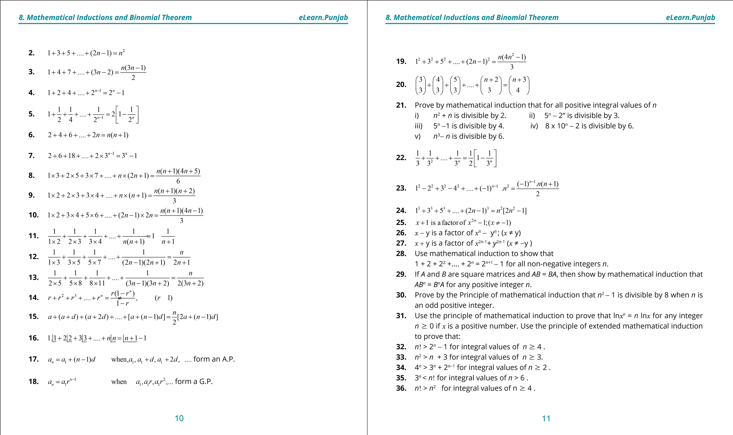

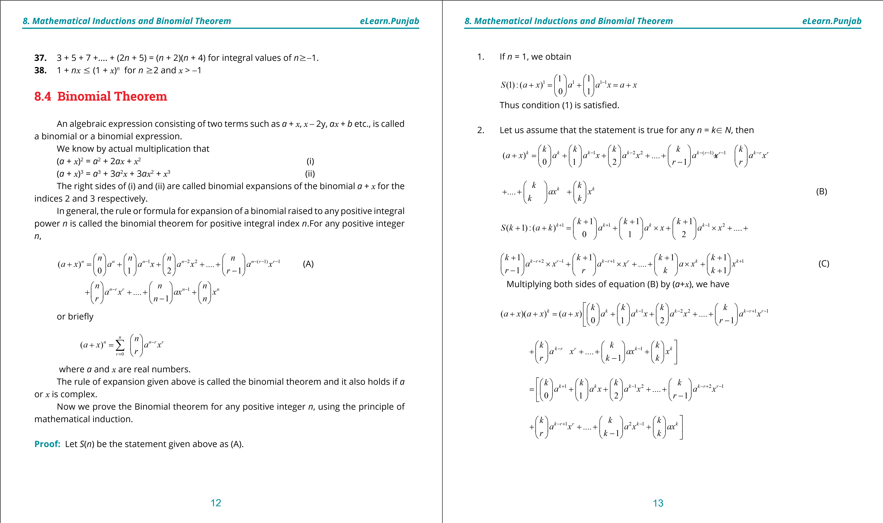

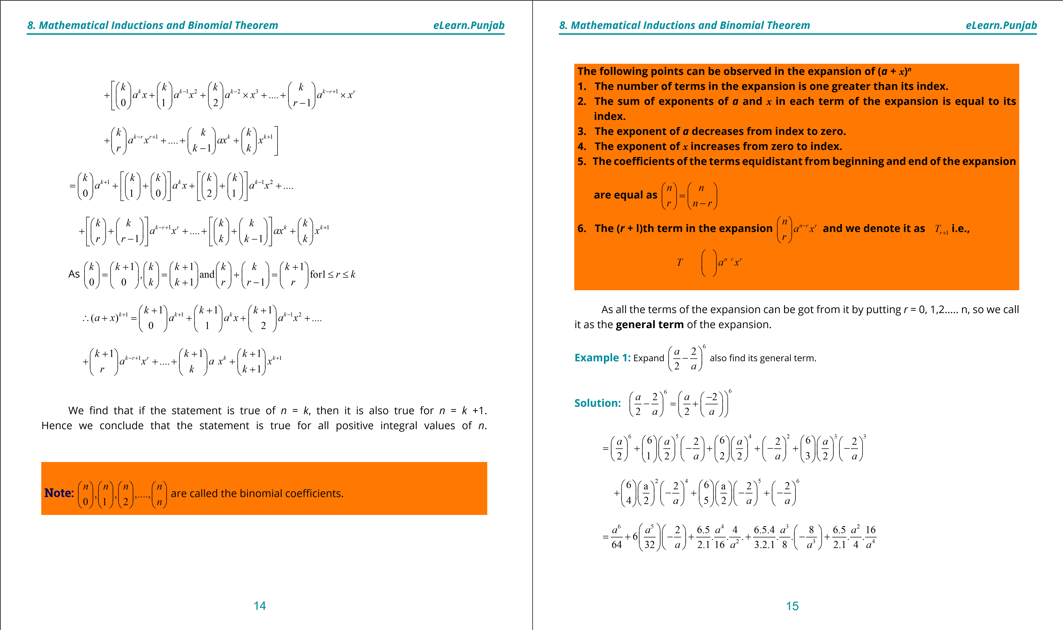

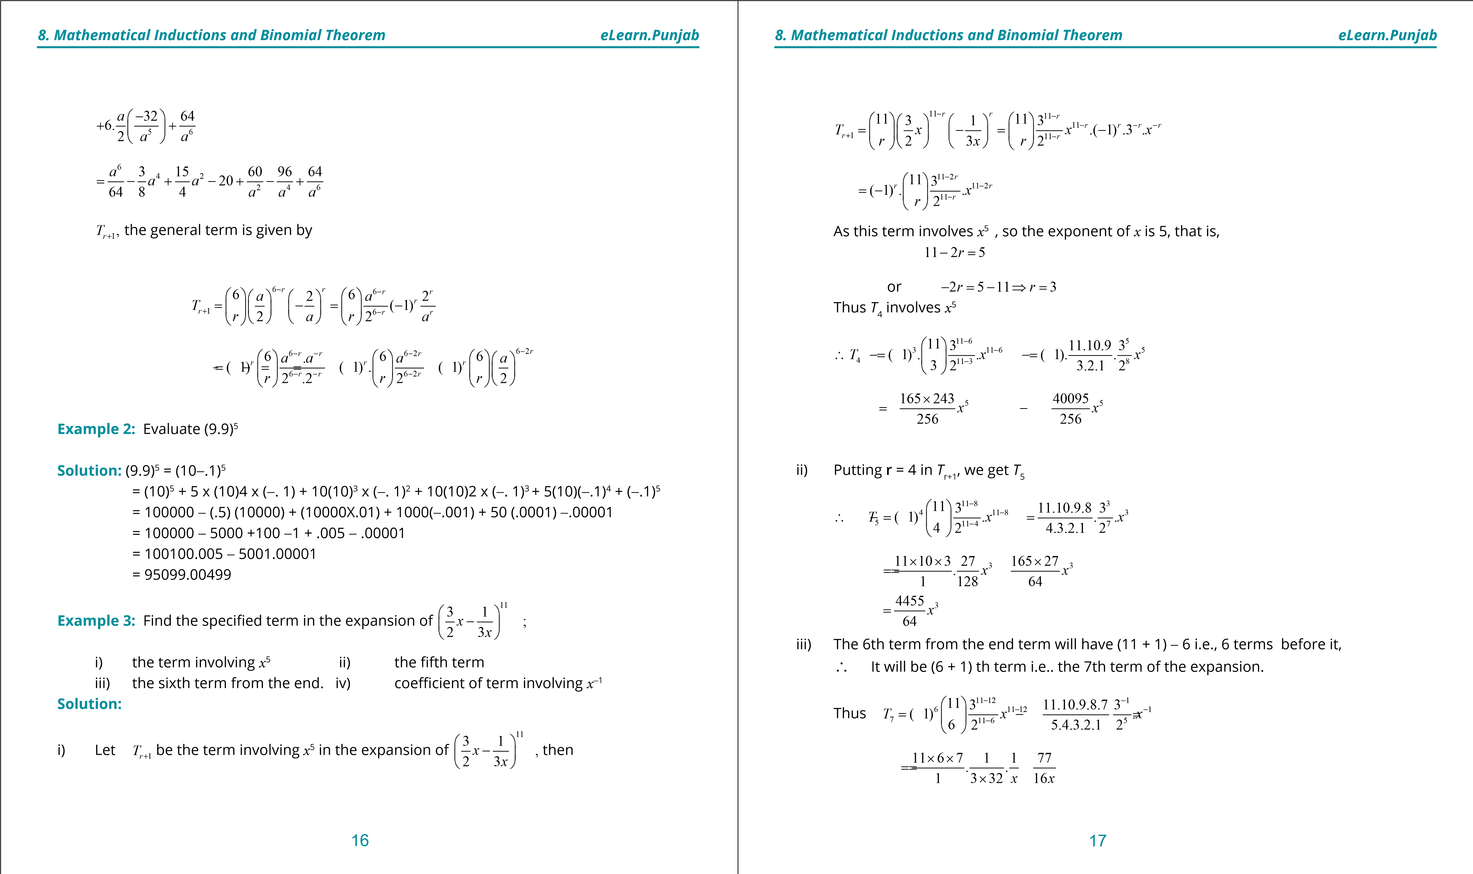

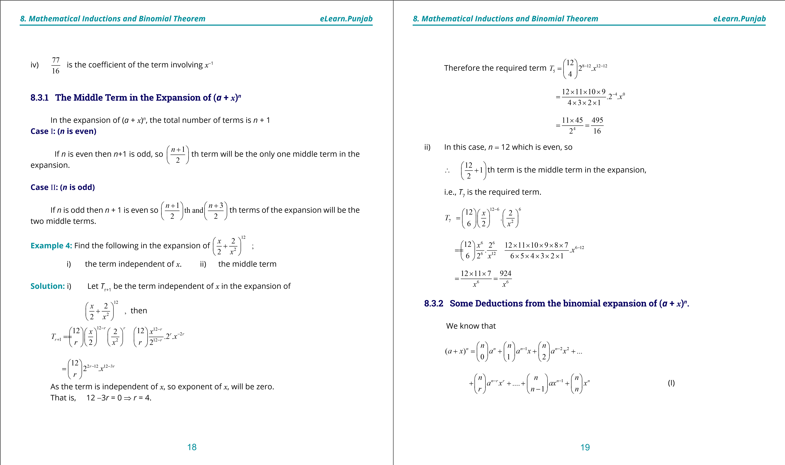

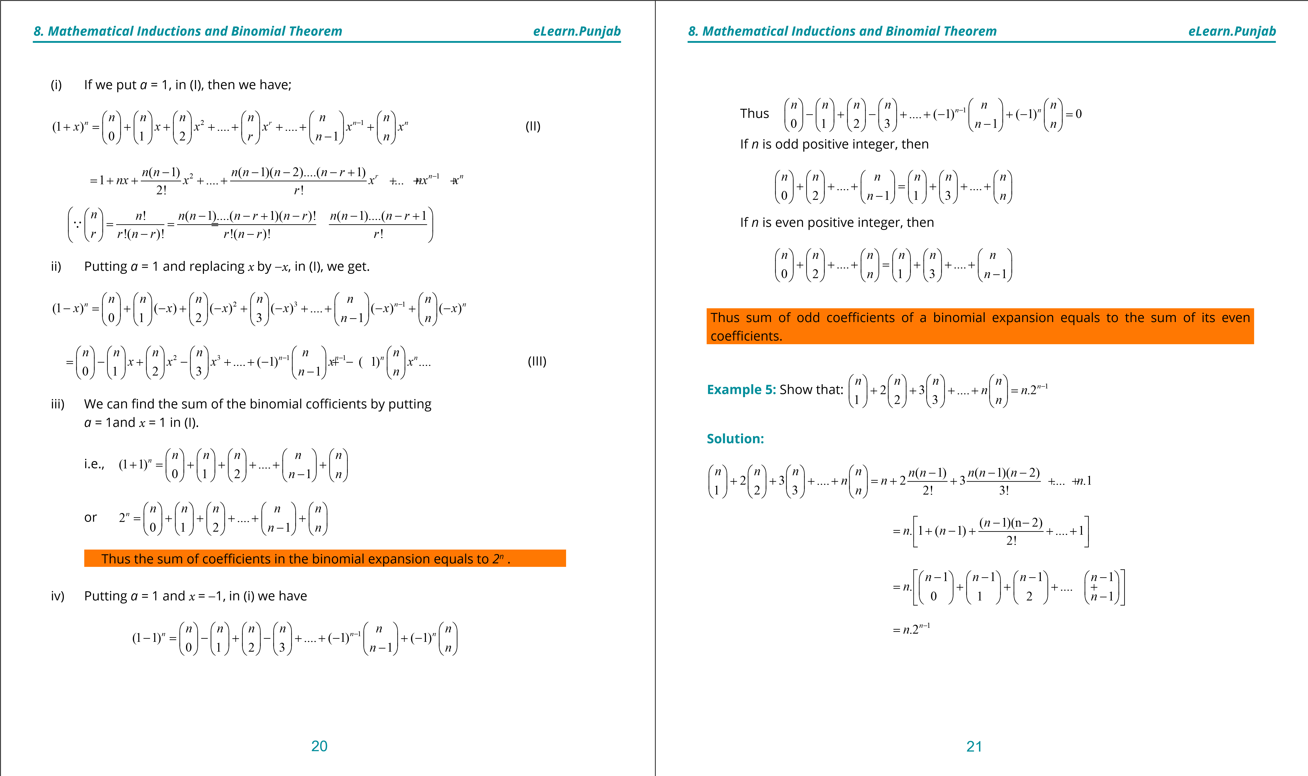

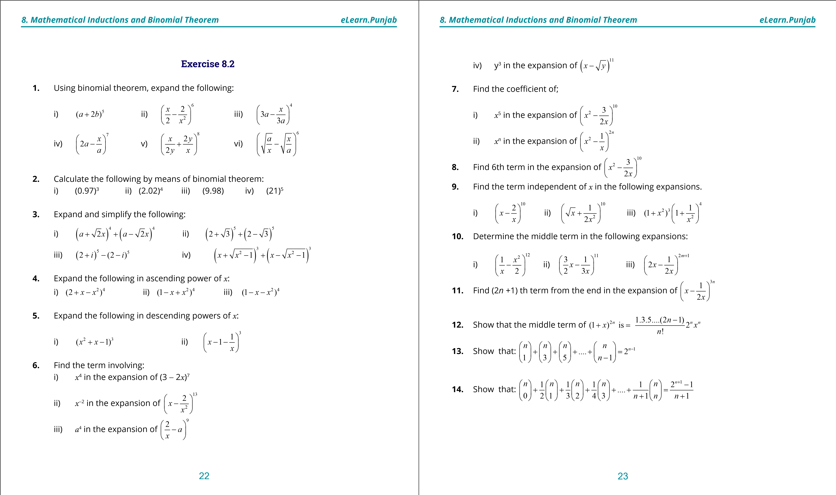

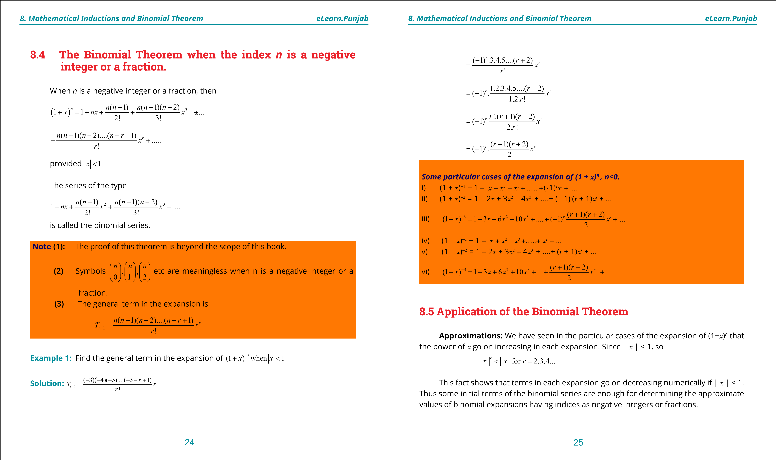

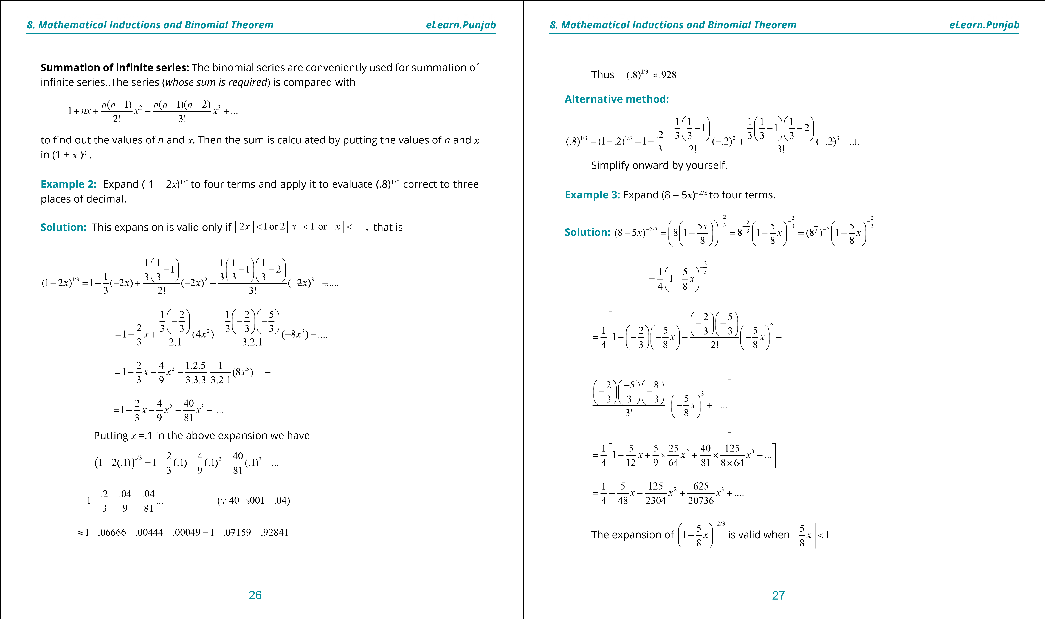

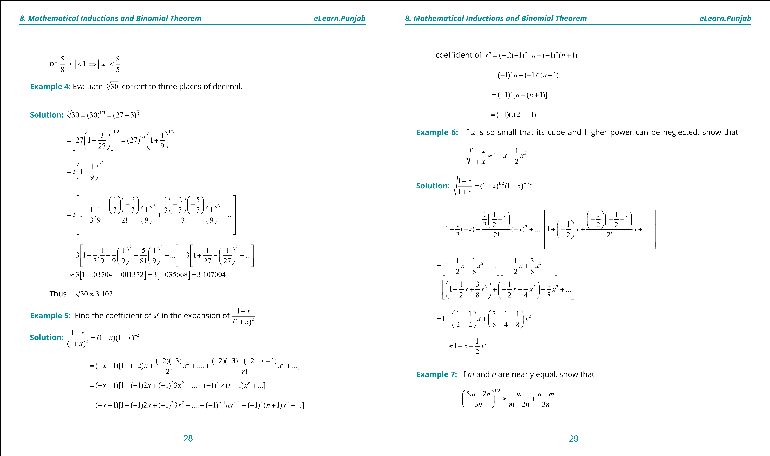

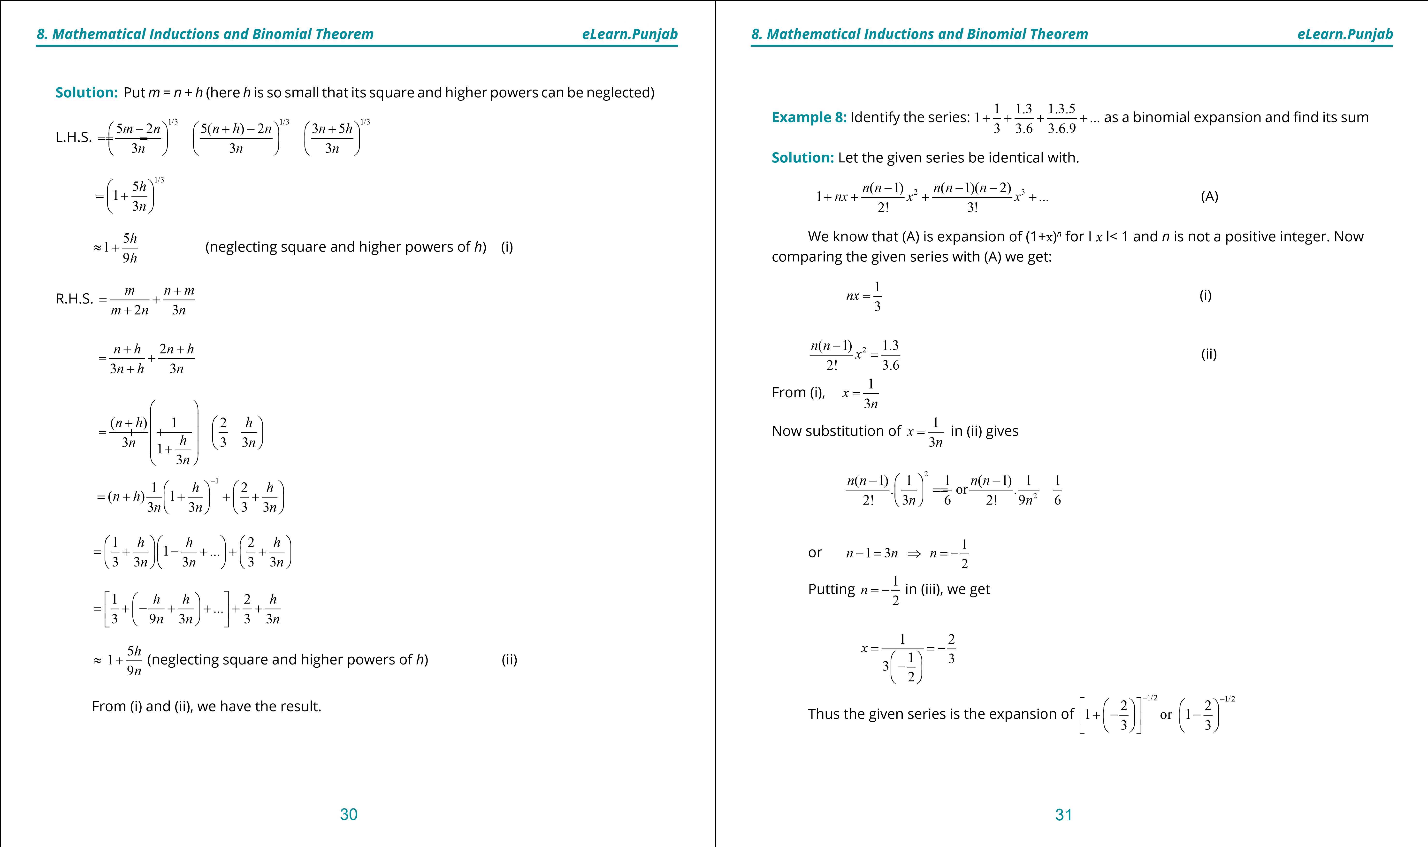

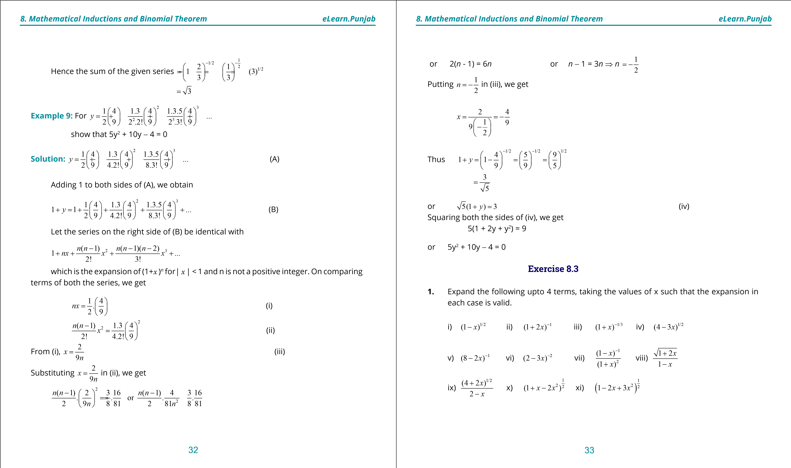

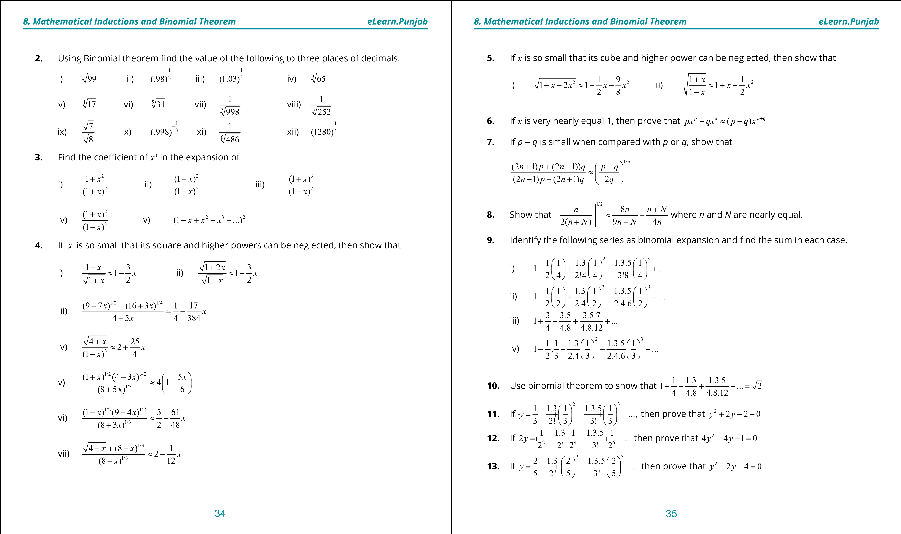

***version: 1.1***

CHAPTER

1. Fundamentals of

Trigonometry

**1**

**. Quadratic Equations**

**eLearn.Punjab**

**1**

**. Quadratic Equations**

**eLearn.Punjab**

***9***

***. Fundamentals of Trigonometry***

***9***

***. Fundamentals of Trigonometry***

***eLearn.Punjab***

***eLearn.Punjab***

2

3

**9.1**

**Introduction**

Trigonometry is an important branch of Mathematics. The word

**Trigonometry**

has been derived from three Greek words:

***Trei***

three),

(

***Goni***

(angles) and

***Metron***

measurement). Literally it means

(

**measurement of triangle.**

**For study of calculus it is essential to have a sound knowledge of trigonometry.**

It is extensively used in Business, Engineering, Surveying, Navigation, Astronomy,

Physical and Social Sciences.

**9.2**

**Units of Measures of Angles**

**Concept of an Angle**

Two rays with a common starting point form an angle. One of the rays of angle is called

initial side and the other as terminal side. The angle is identiied by showing the direction of

rotation from the initial side to the terminal side.

An angle is said to be positive/negative if the rotation is anti-clockwise/clockwise. Angles

are usually denoted by Greek letters such as

a

alpha),

(

b

beta),

(

g

gamma),

(

q

theta) etc.

(

In igure 9.1

*AOB*

∠

is positive and

*COD*

∠

is negative.

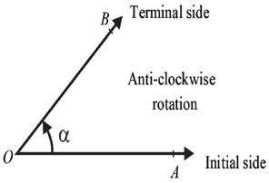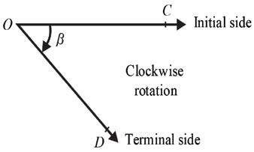

igure 9.1

There are two commonly used measurements for angles:

**Degrees and Radians.**

which

are explained as below:

**9.2.1.**

**Sexagesimal System:**

).

Degree, Minute and Second

(

If the initial ray

*OA*



rotates in anti-clockwise direction in such a way that it coincides

with itself, the angle then formed is said to be of 360 degrees (360°).

One rotation (anti-clockwise) = 360°

1

2

rotation (anti-clockwise) = 180° is called a straight angle

1

4

rotation (anti-clockwise) = 90° is called a right angle.

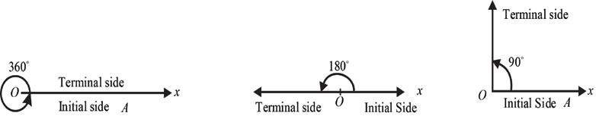

1 rotation =360°

1

2

rotation = 180°

1

4

rotation = 90°

1

degree (1°) is divided into 60 minutes

(

60

′

and 1 minute ( 1’) is divided into 60 seconds

)

(

60

′′

. As this system of measurement of angle owes its origin to the English and because 90,

)

are multiples of 6 and 10, so it is known as English system or Sexagesimal system.

60

Thus 1 rotation (anti-clockwise)

=

360°.

One degree (1°)

60’

=

One minute (

1

′

=

)

60”

**. Conversion**

**9.2.2**

**from**

*D*

°

*M’*

*S*

*”*

**to**

**a**

**decimal**

**form**

**and**

**vice**

**versa.**

(

i)

1

30

0.5)

1630

16.5

(

As

2

′

′

=

=

=

□

□

□

□

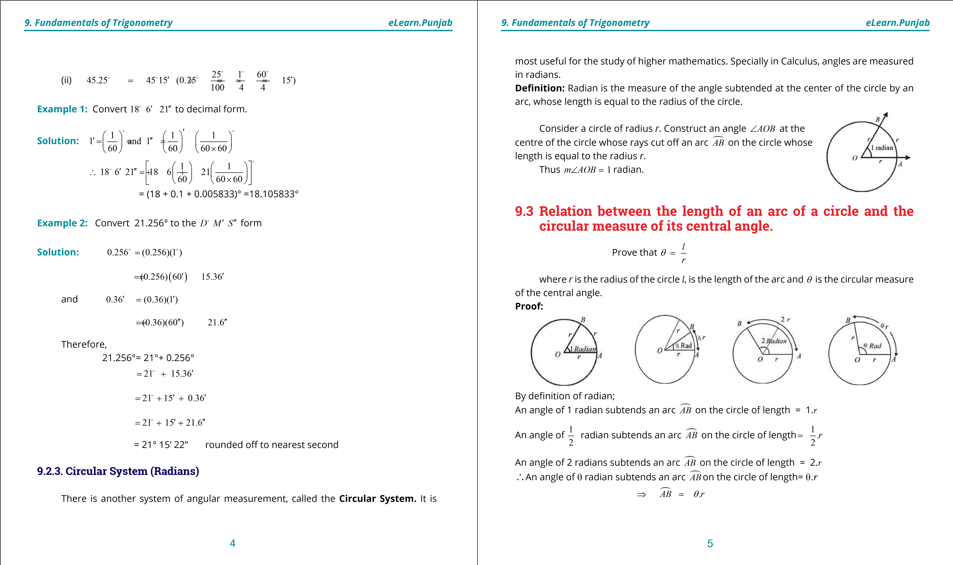

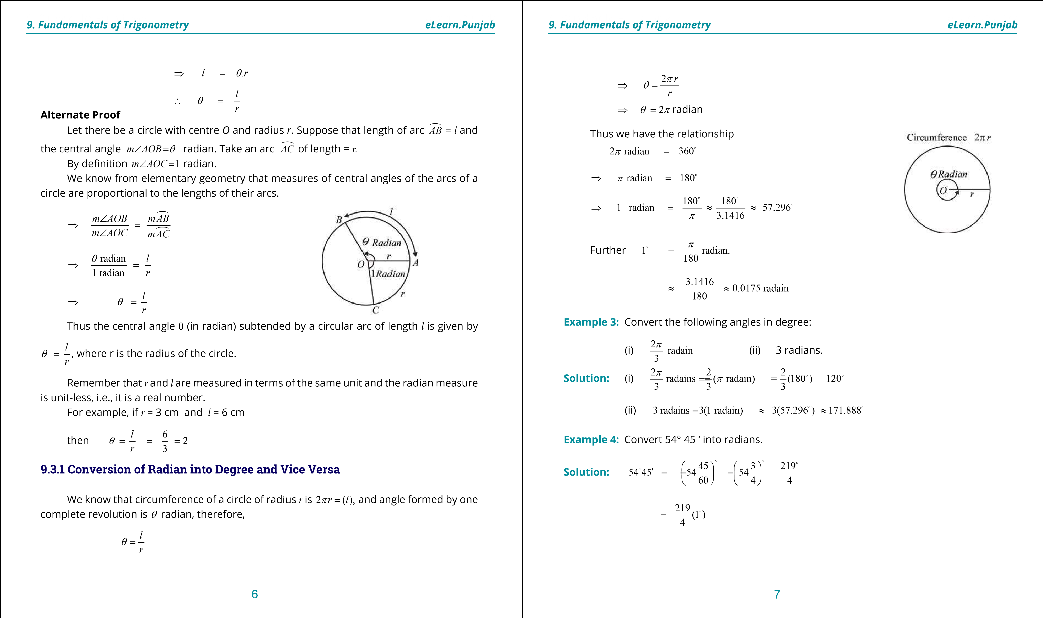

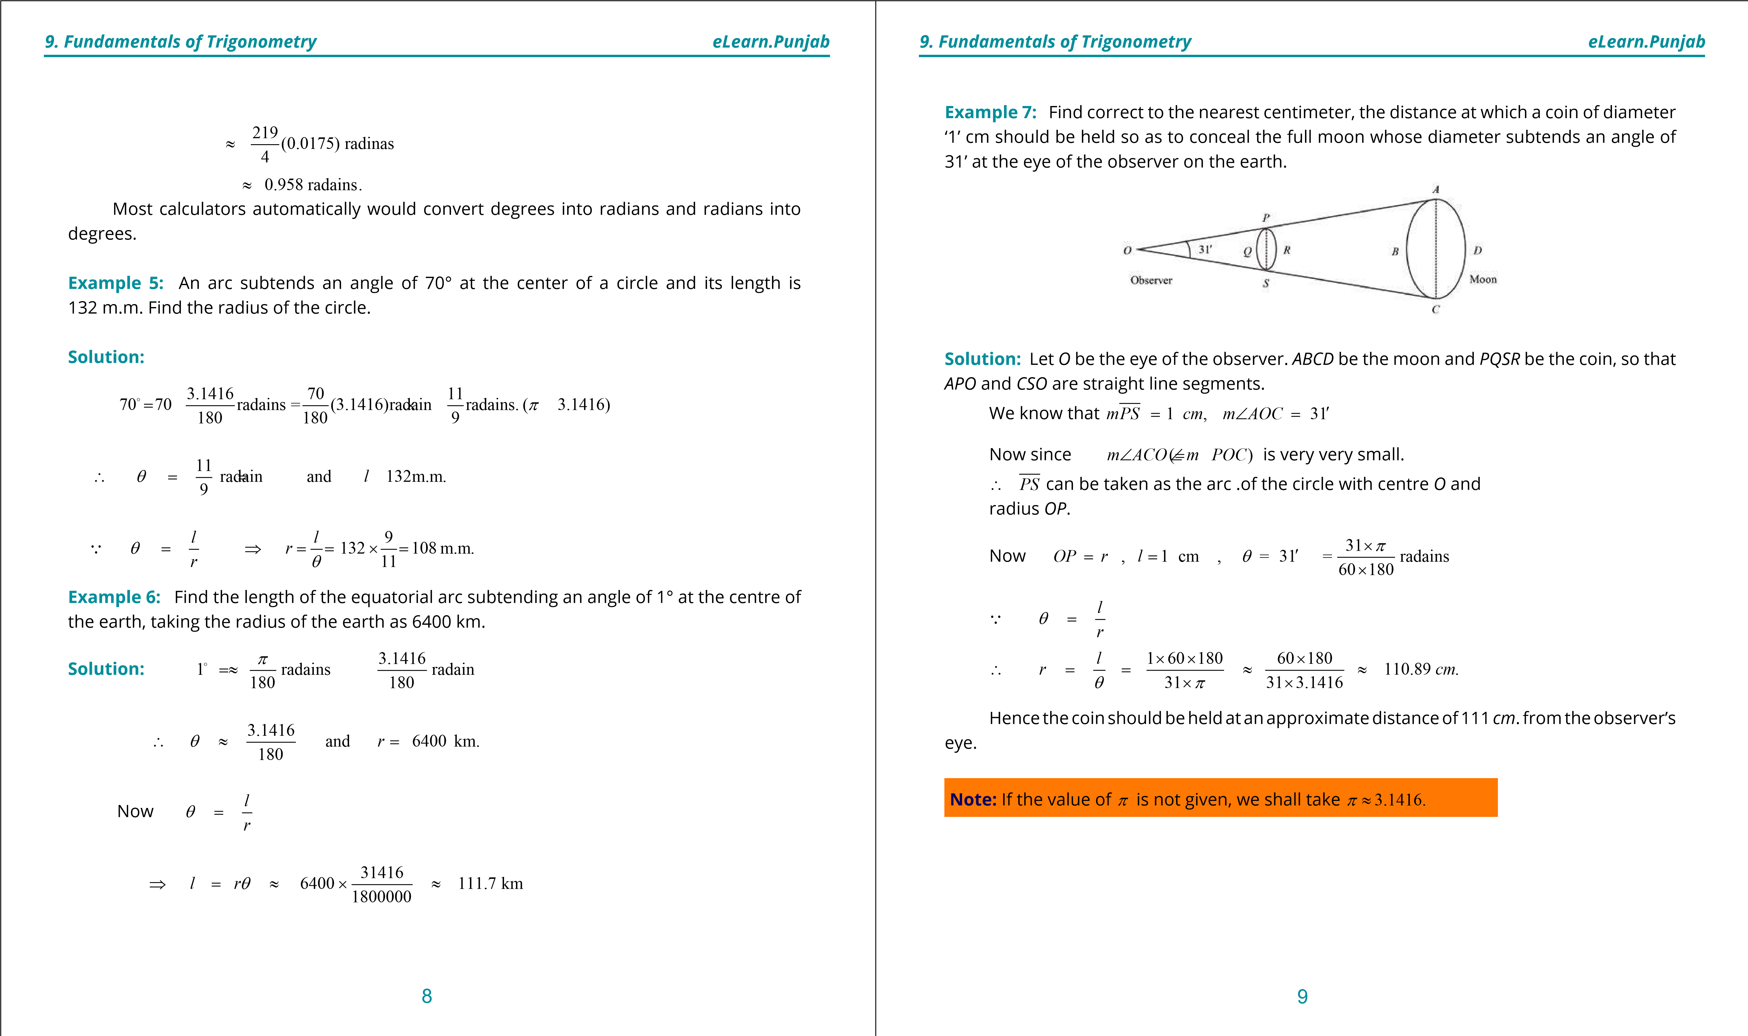

**1. Quadratic Equations eLearn.Punjab 1. Quadratic Equations eLearn.Punjab**

***9. Fundamentals of Trigonometry eLearn.Punjab 9. Fundamentals of Trigonometry eLearn.Punjab***

**Exercise 9.1**

1. Express the following sexagesimal measures of angles in radians:
   1. 30° ii) 45° iii) 60° iv) 75°

v) 90° vi) 105° vii) 120° viii) 135° ix) 150° x) 10 15□ ′xi) 35 20□ ′xii) 75 6 30□ ′ ′′ xiii) 120 40′ ′′ xiv) 154 20□ ′′ xv) 0° xvi) 3′′

1. Convert the following radian measures of angles into the measures of sexagesimal system:
   1. p ii) p iii) p iv) p v) p

8 6 4 3 2

vi) 2p vii) 3p viii) 5p ix) 7p x) 9p

3 4 6 12 5

xi) 11p xii) 13p xiii) 17p xiv) 25p xv) 19p

27 16 24 36 32

1. What is the circular measure of the angle between the hands of a watch at 4 *O*’clock?
2. Find q, when:
   1. *l* = 1.5 cm, *r =* 2.5cm ii) *l* = 3.2m, *r =* 2m **5.** Find *l*, when:

i) q p= randains, *r =* 6cmii) q= 65 20□ ′*r =* 18mm

1. Find *r*, when:
   * 1. *l* = 5 cm, q = radian

* + 1. *l* = 56 cm, q = 45□

1. What is the length of the arc intercepted on a circle of radius 14 cms by the arms of a central angle of 45°?
2. Find the radius of the circle, in which the arms of a central angle of measure 1 radian cut of an arc of length 35 cm.
3. A railway train is running on a circular track of radius 500 meters at the rate of 30 km per hour. Through what angle will it turn in 10 sec.?
4. A horse is tethered to a peg by a rope of 9 meters length and it can move in a circle with the peg as centre. If the horse moves along the circumference of the circle, keeping the rope tight, how far will it have gone when the rope has turned through an angle of

1

2

70°?

1. The pendulum of a clock is 20 cm long and it swings through an angle of 20° each second. How far does the tip of the pendulum move in 1 second?
2. Assuming the average distance of the earth from the sun to be 148 x 106 km and the angle subtended by the sun at the eye of a person on the earth of measure 9.3 x 10-3 radian. Find the diameter of the sun.
3. A circular wire of radius 6 cm is cut straightened and then bent so as to lie along the circumference of a hoop of radius 24 cm. Find the measure of the angle which it subtends at the centre of the hoop.
4. Show that the area of a sector of a circular region of radius *r* is 1 *r*2q, where q is the circular measure of the central angle of the sector. 2
5. Two cities *A* and *B* lie on the equator such that their longitudes are 45°*E* and 25°*W* respectively. Find the distance between the two cities, taking radius of the earth as

6400 kms.

1. The moon subtends an angle of 0.5° at the eye of an observer on earth. The distance of the moon from the earth is 3.844 x 105 km approx. What is the length of the diameter of the moon?
2. The angle subtended by the earth at the eye of a spaceman, landed on the moon, is 1° 54’. The radius of the earth is 6400 km. Find the approximate distance between the moon and the earth.

**9.4 General Angle (Coterminal Angles)**

There can be many angles with the same initial and terminal sides. These are called

 

coterminal angles. Consider an angle ∠*POQ* with initial side *OP*and terminal side *OQ*with

10 11

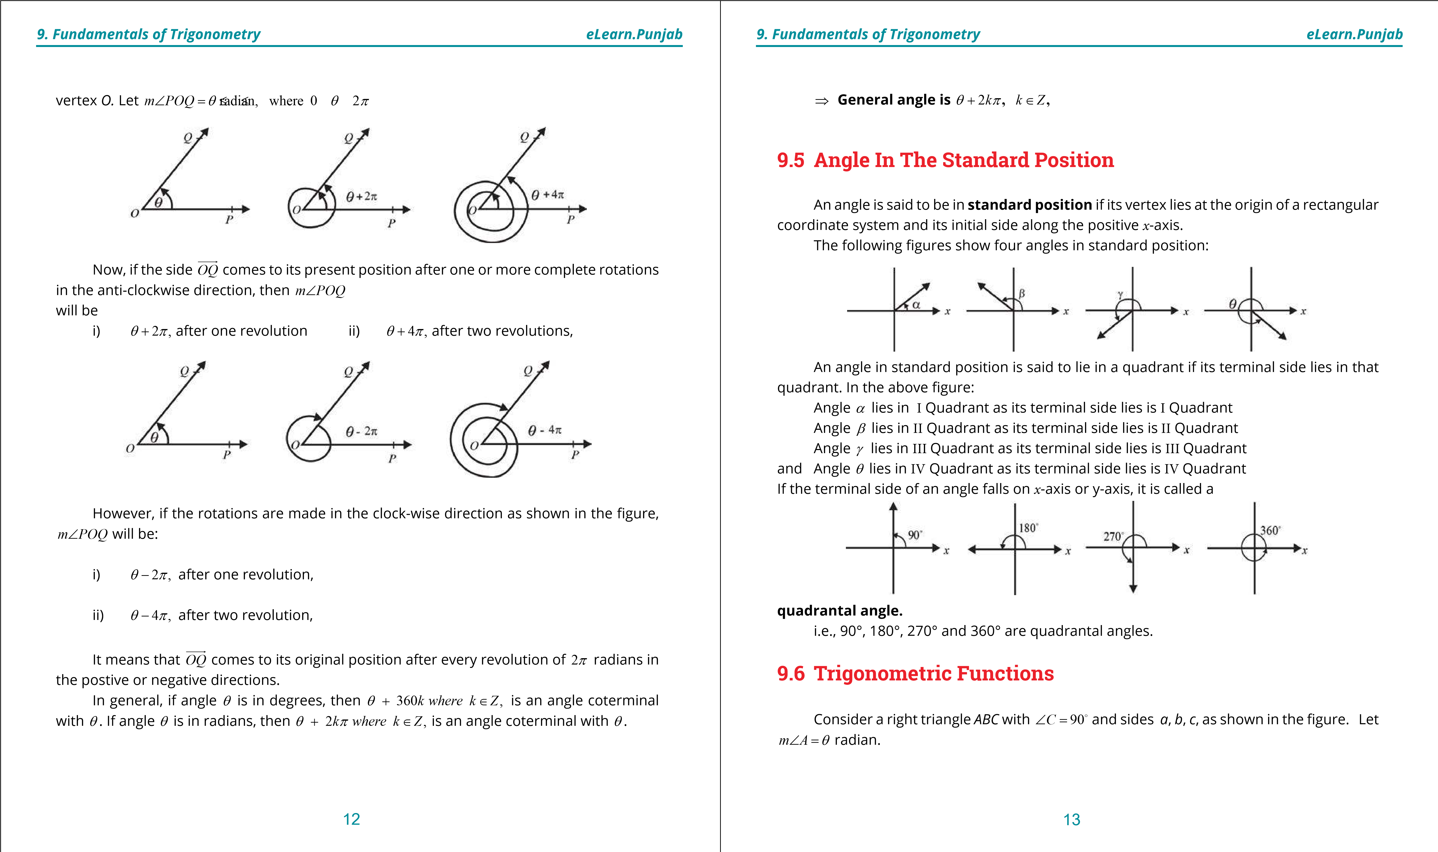

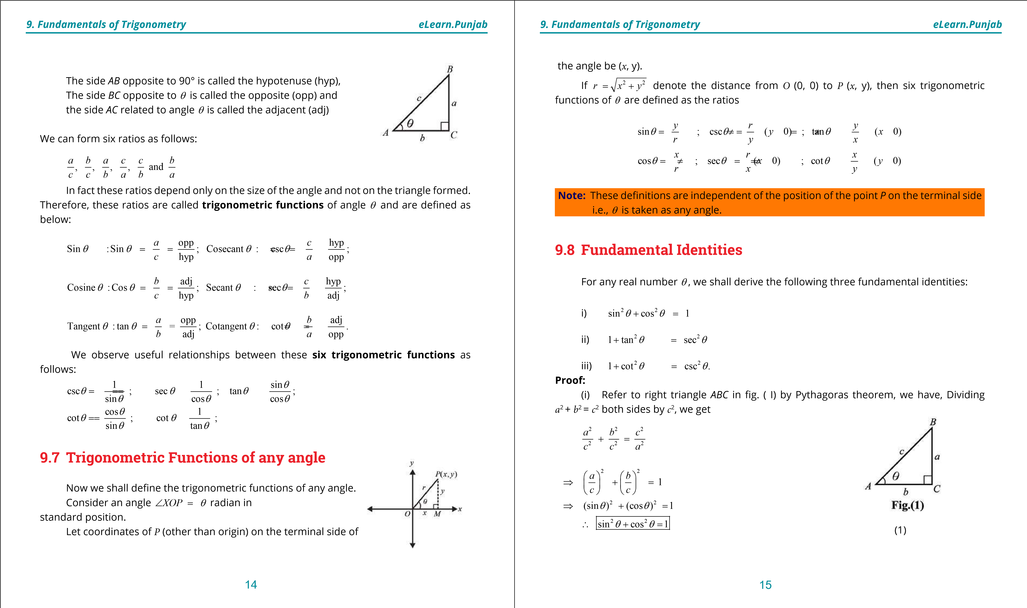

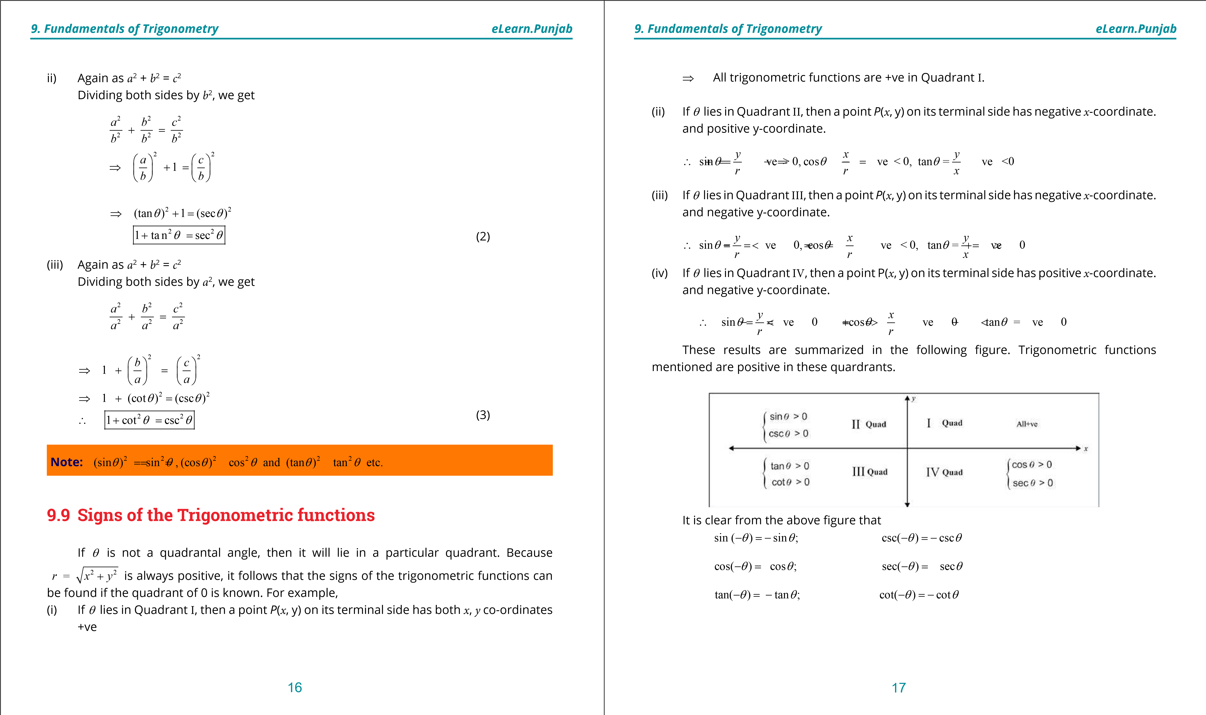

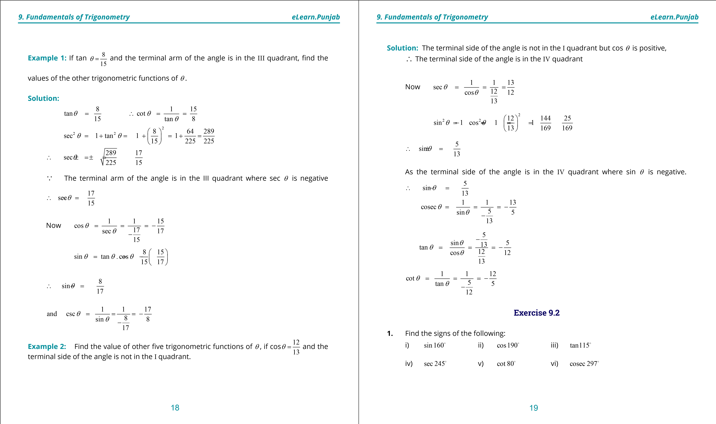

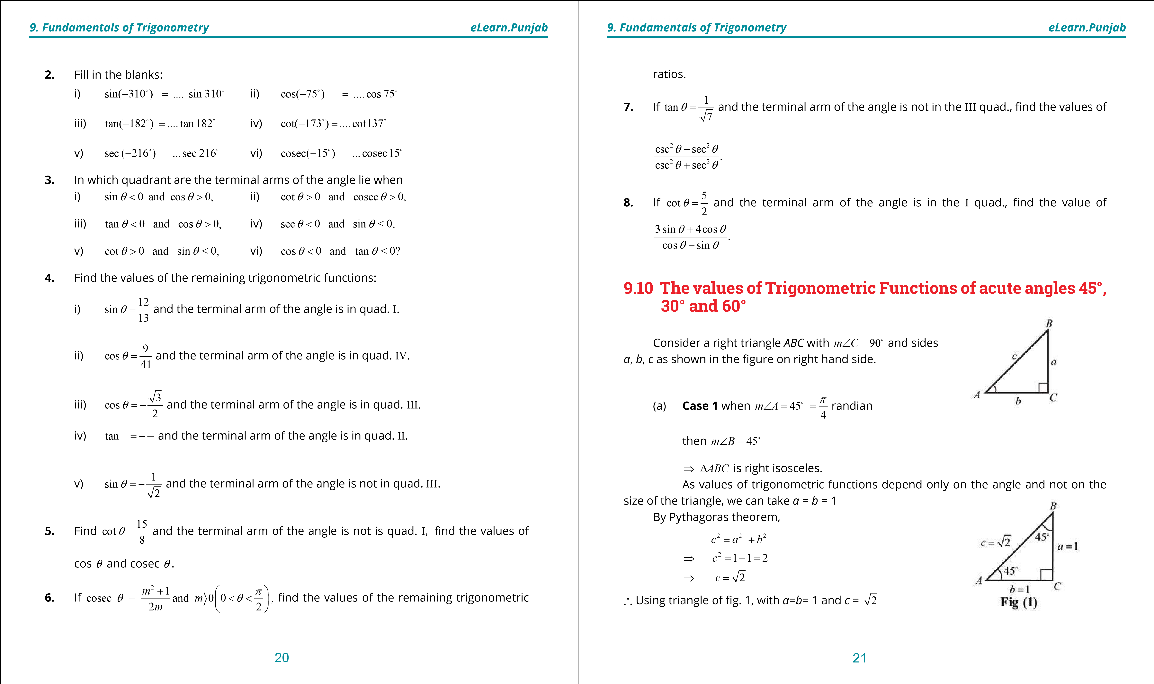

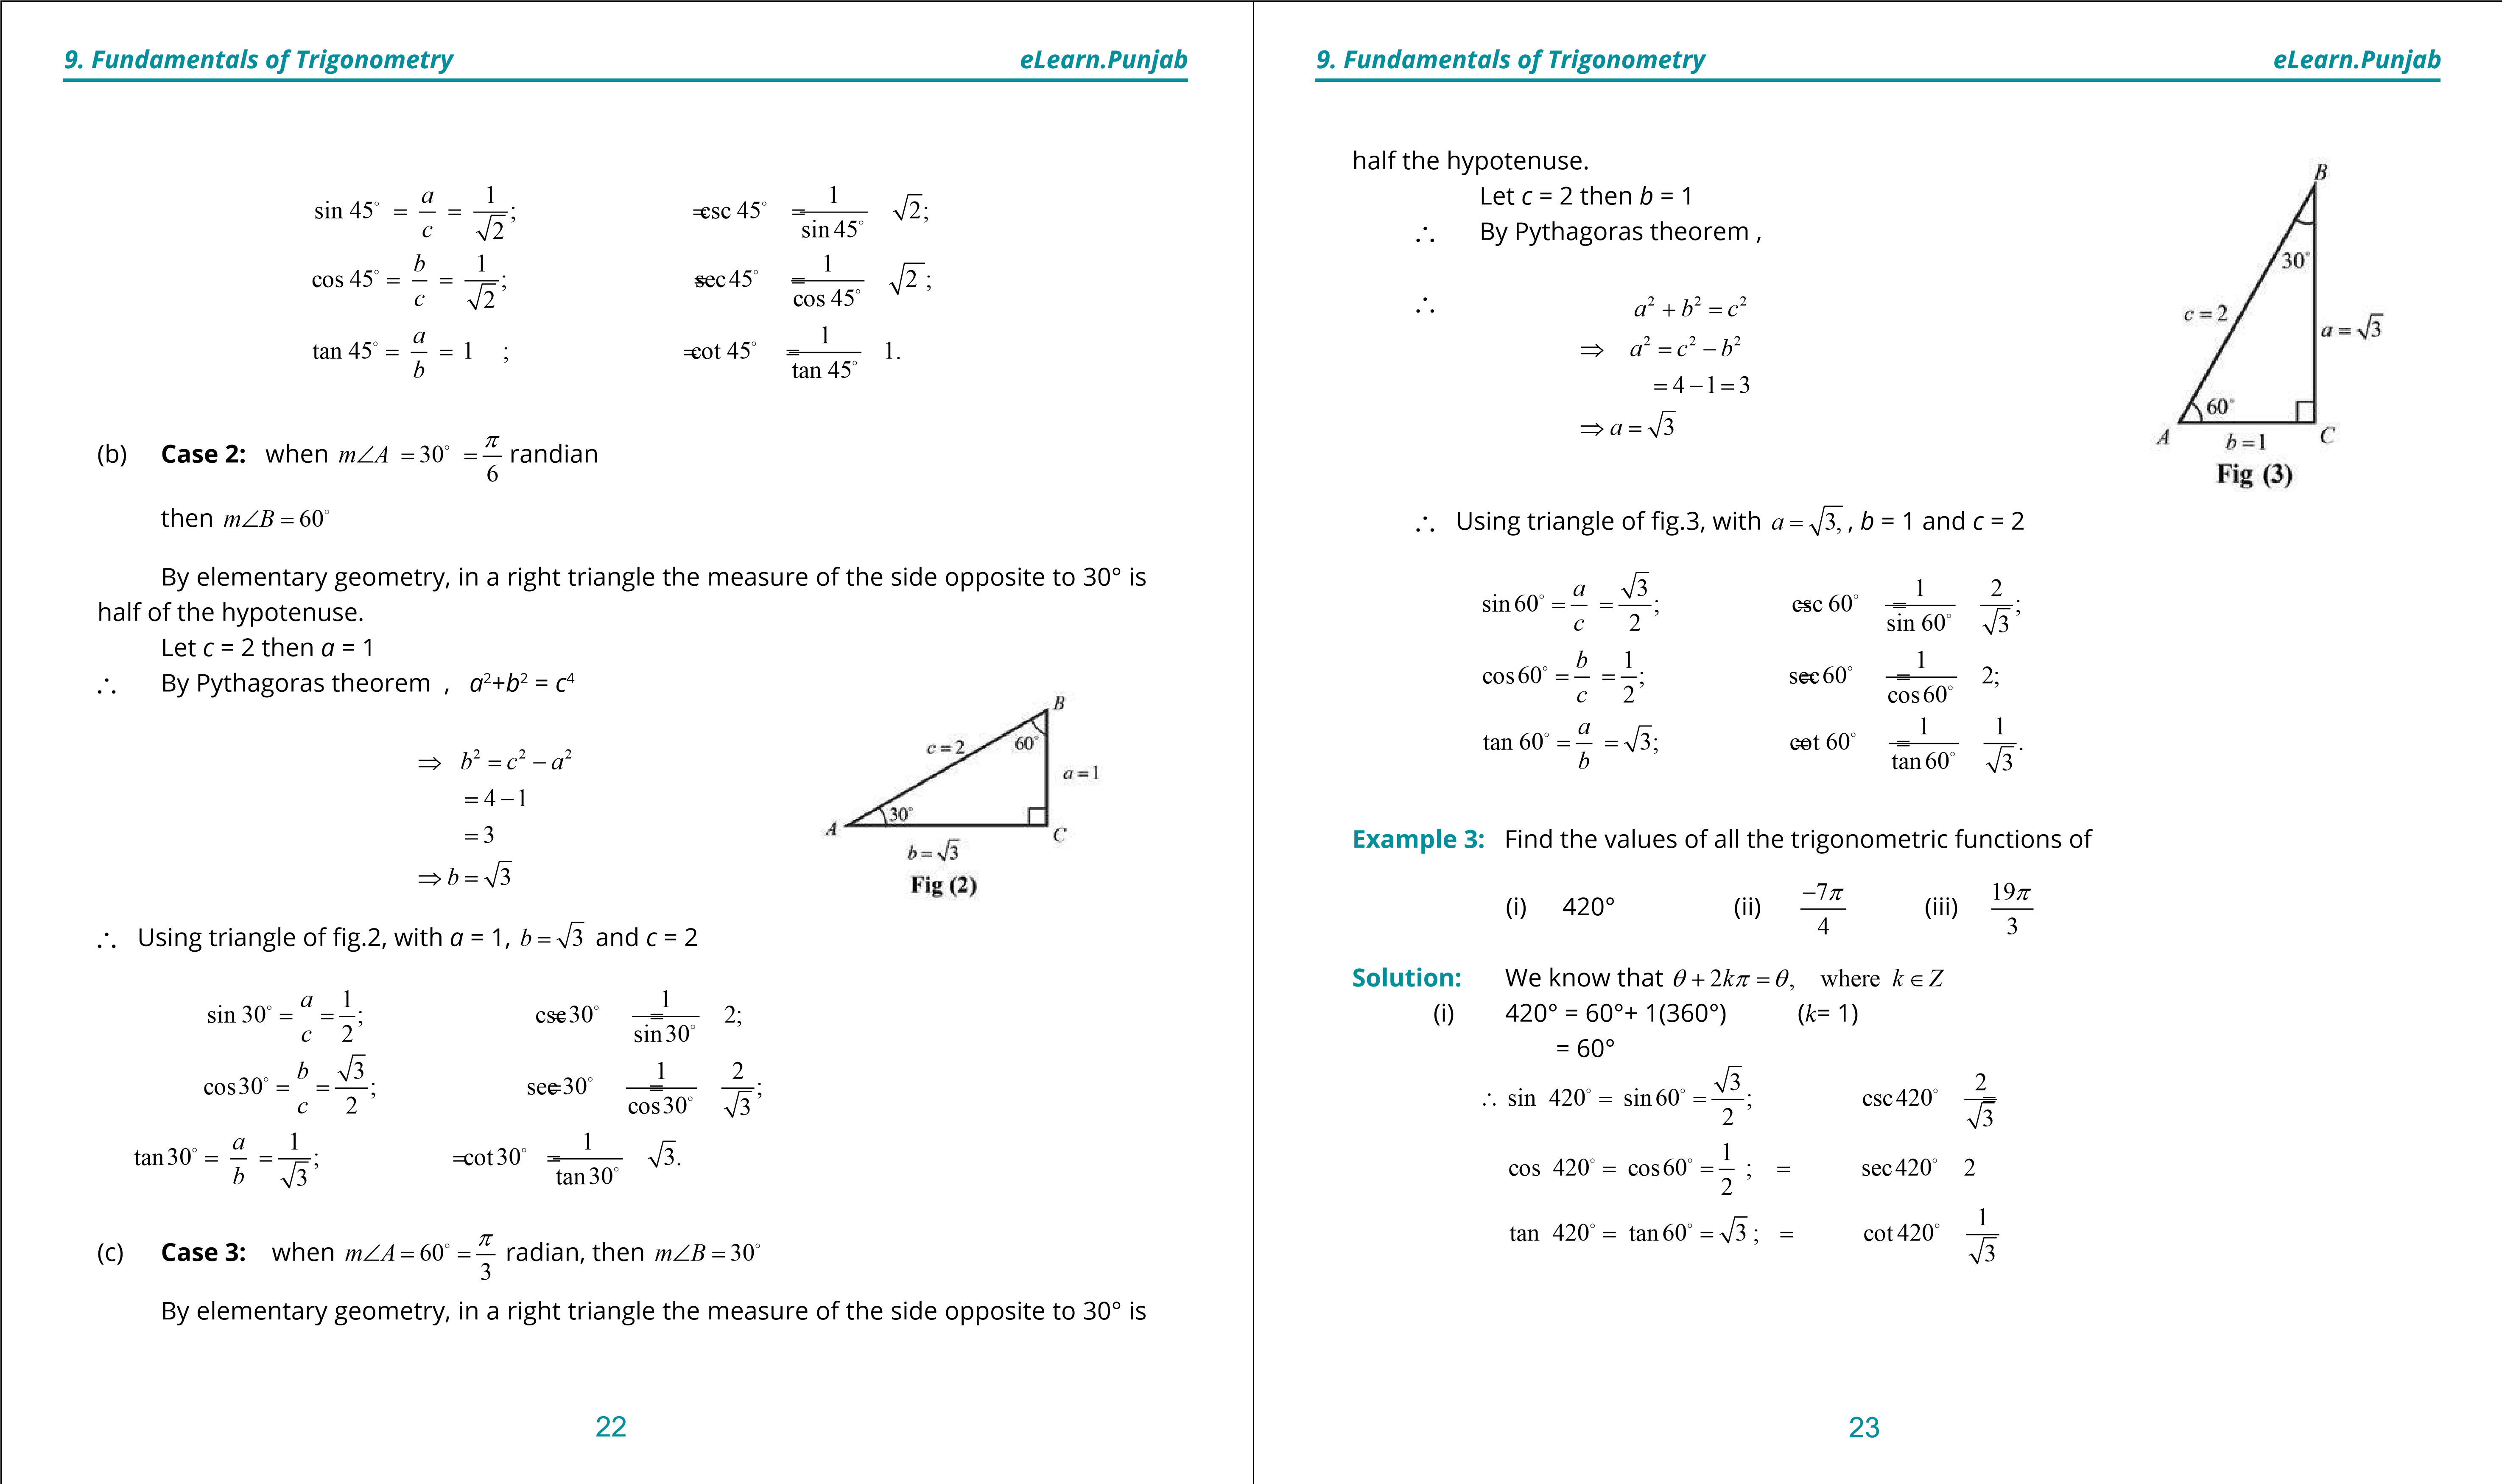

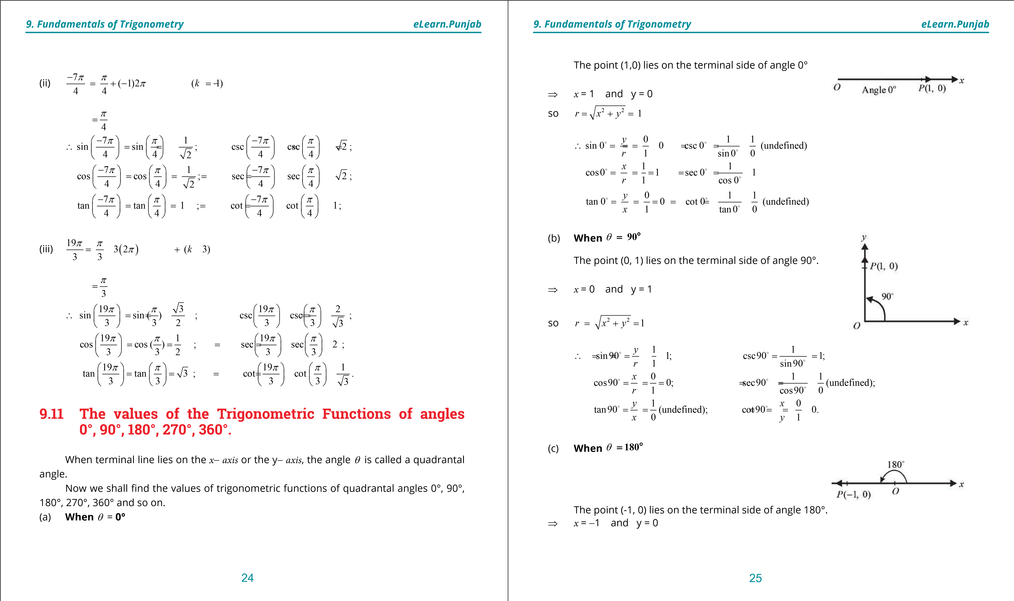

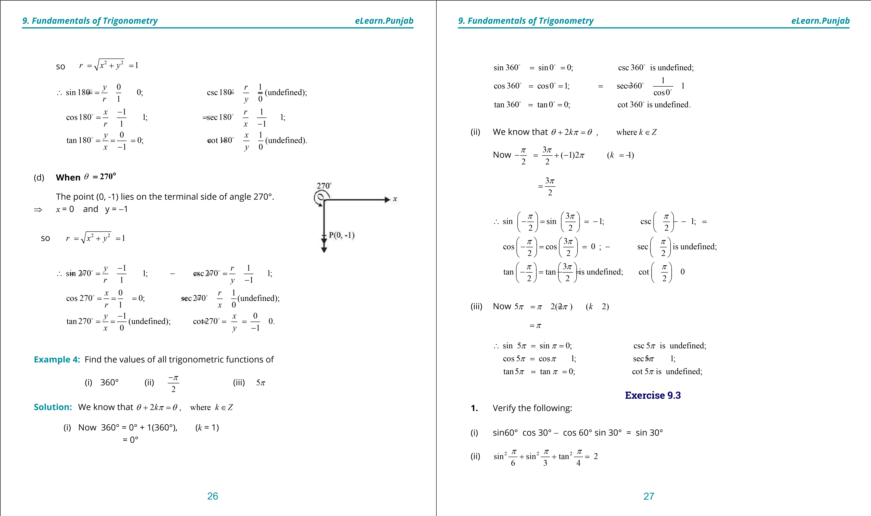

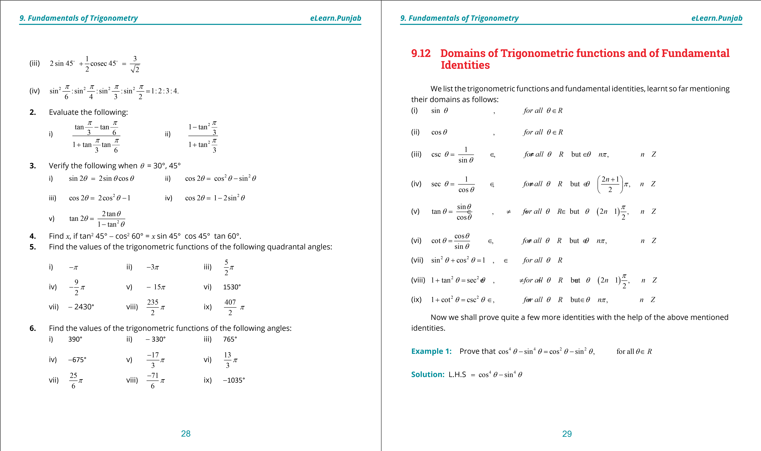

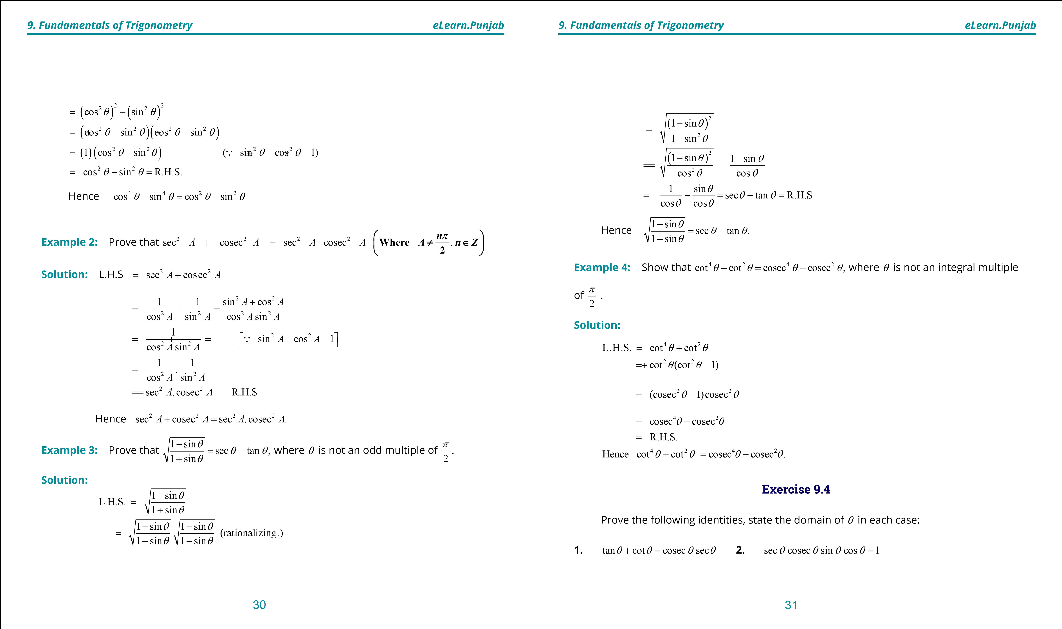

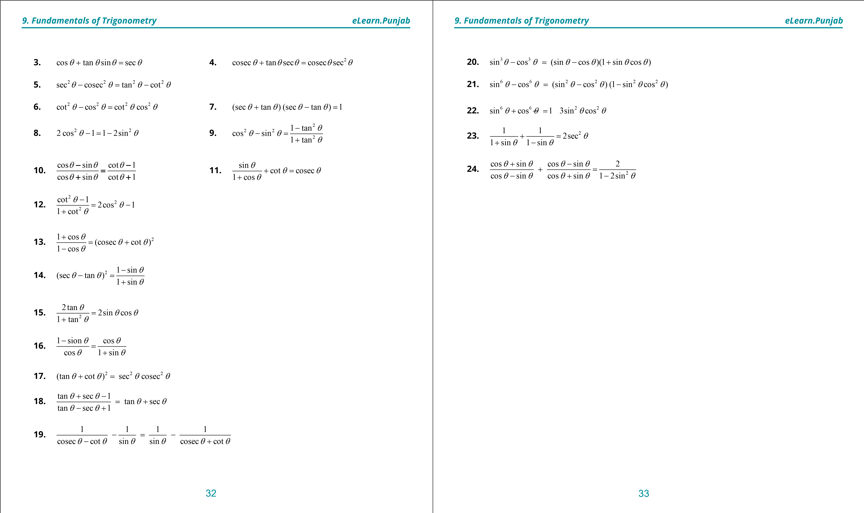

***version: 1.1***

CHAPTER

1. Trigonometric

Identities

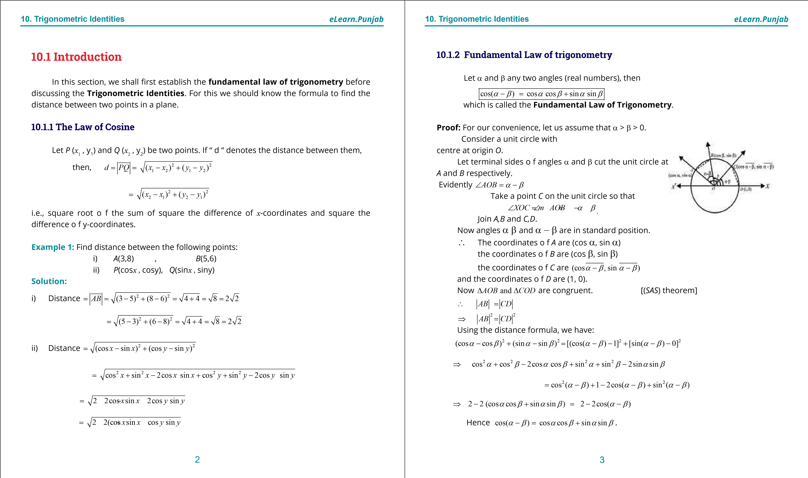

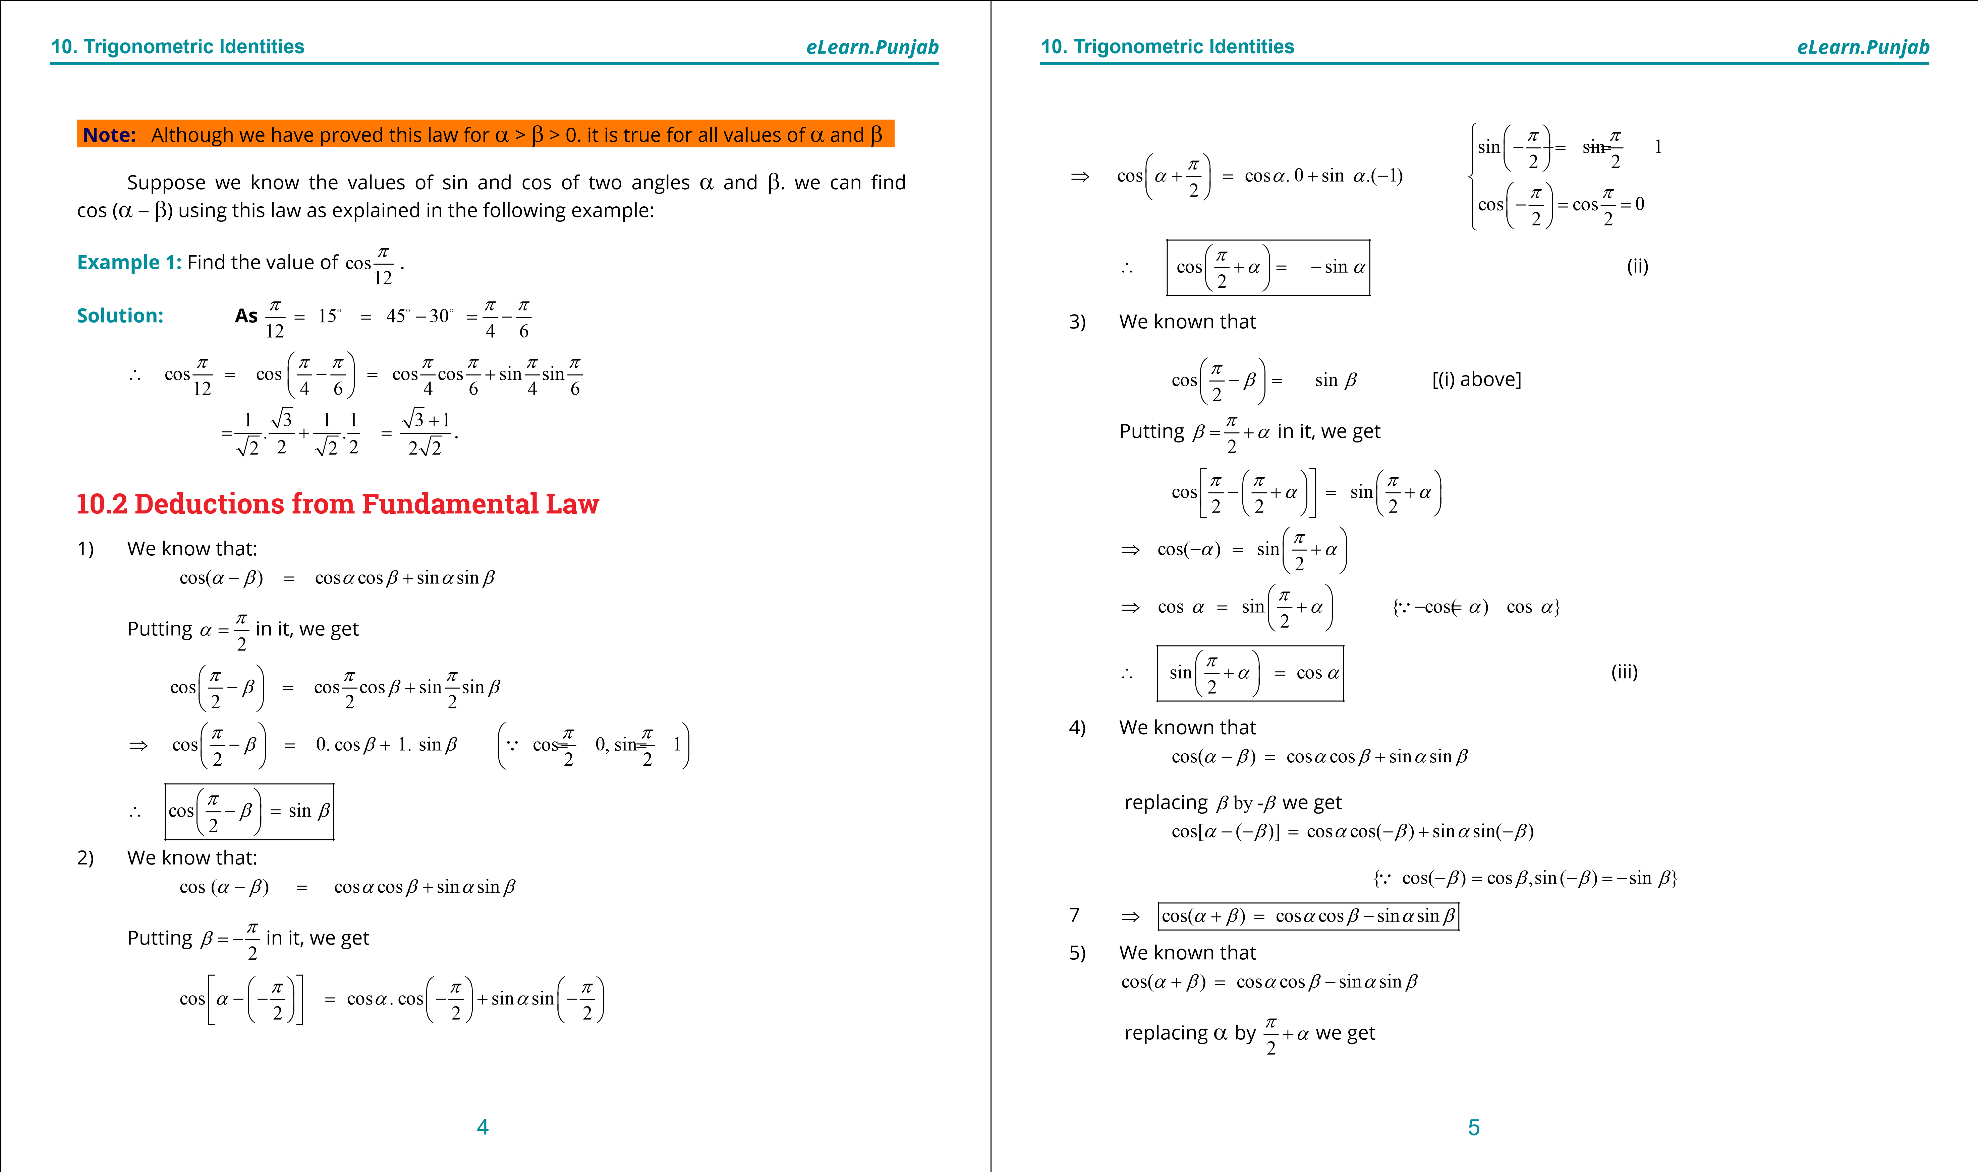

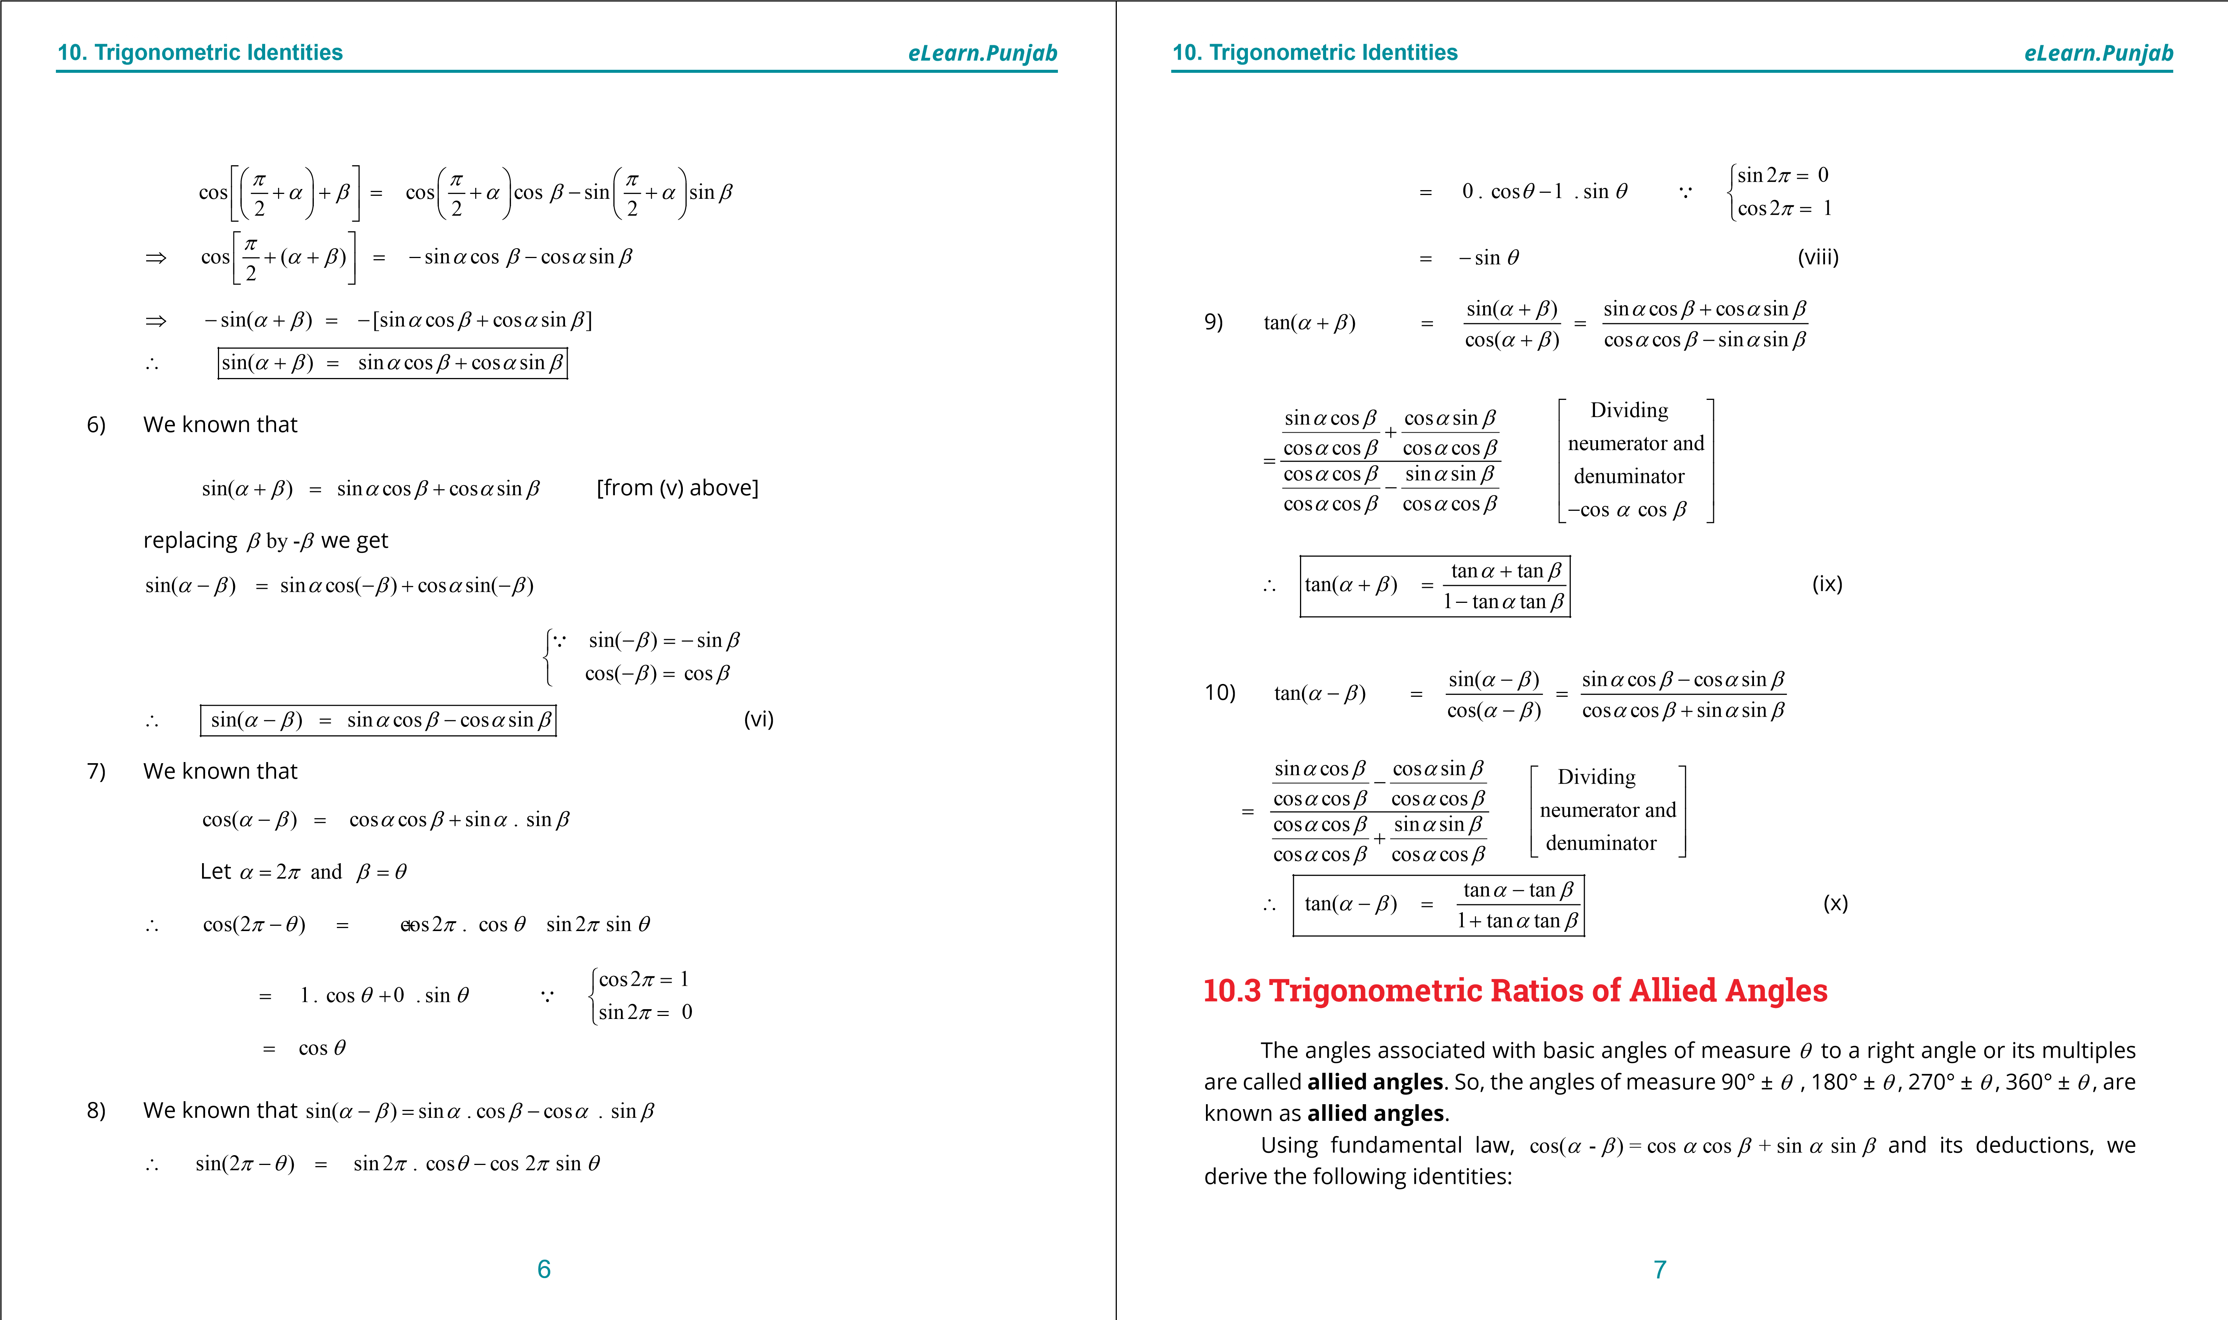

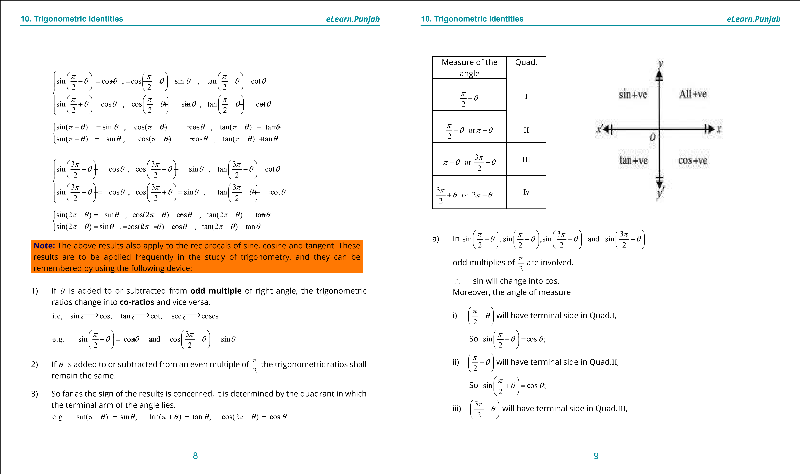

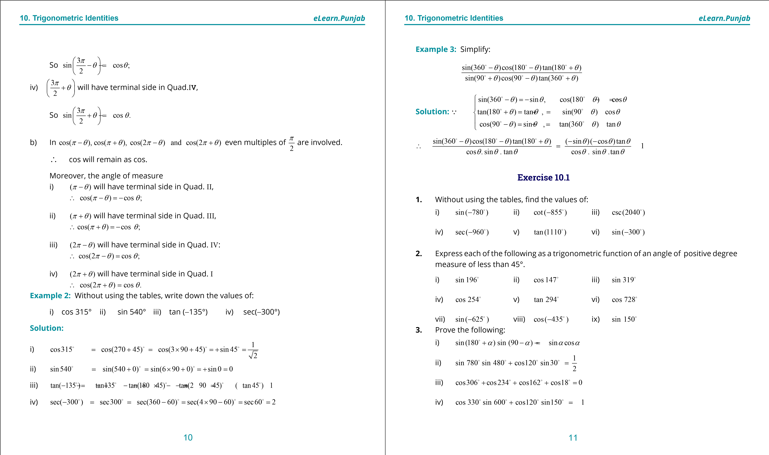

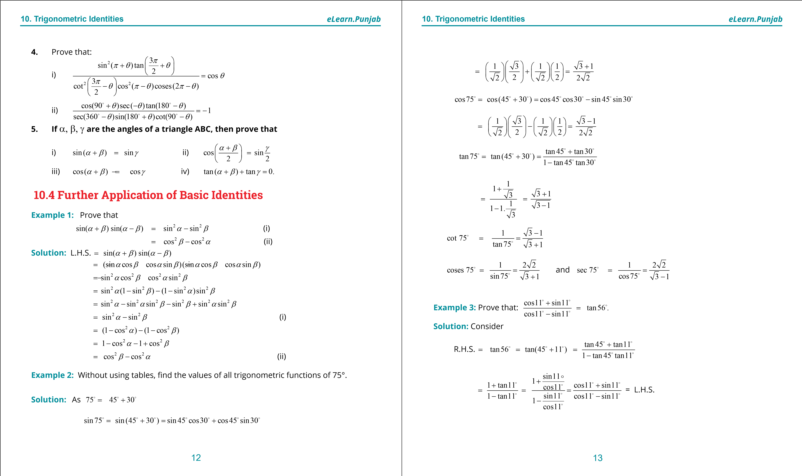

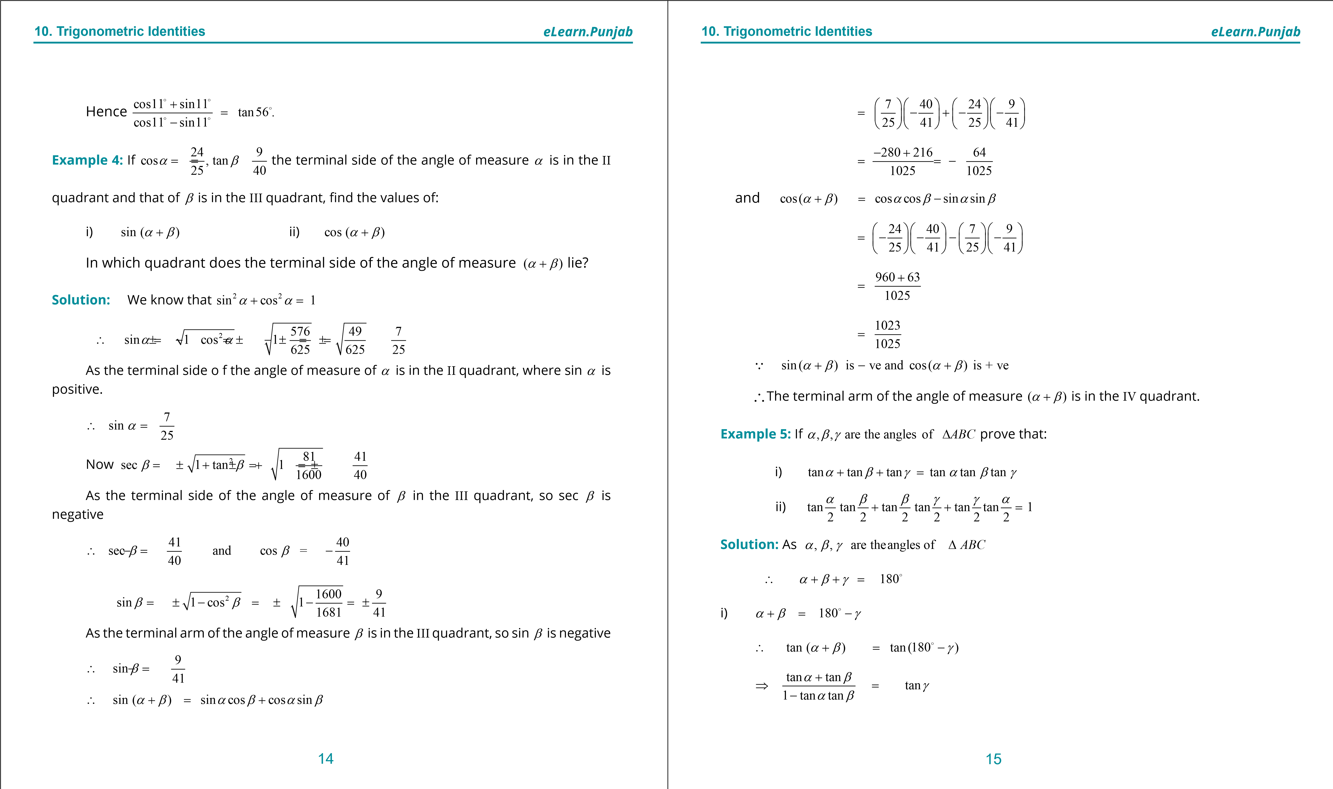

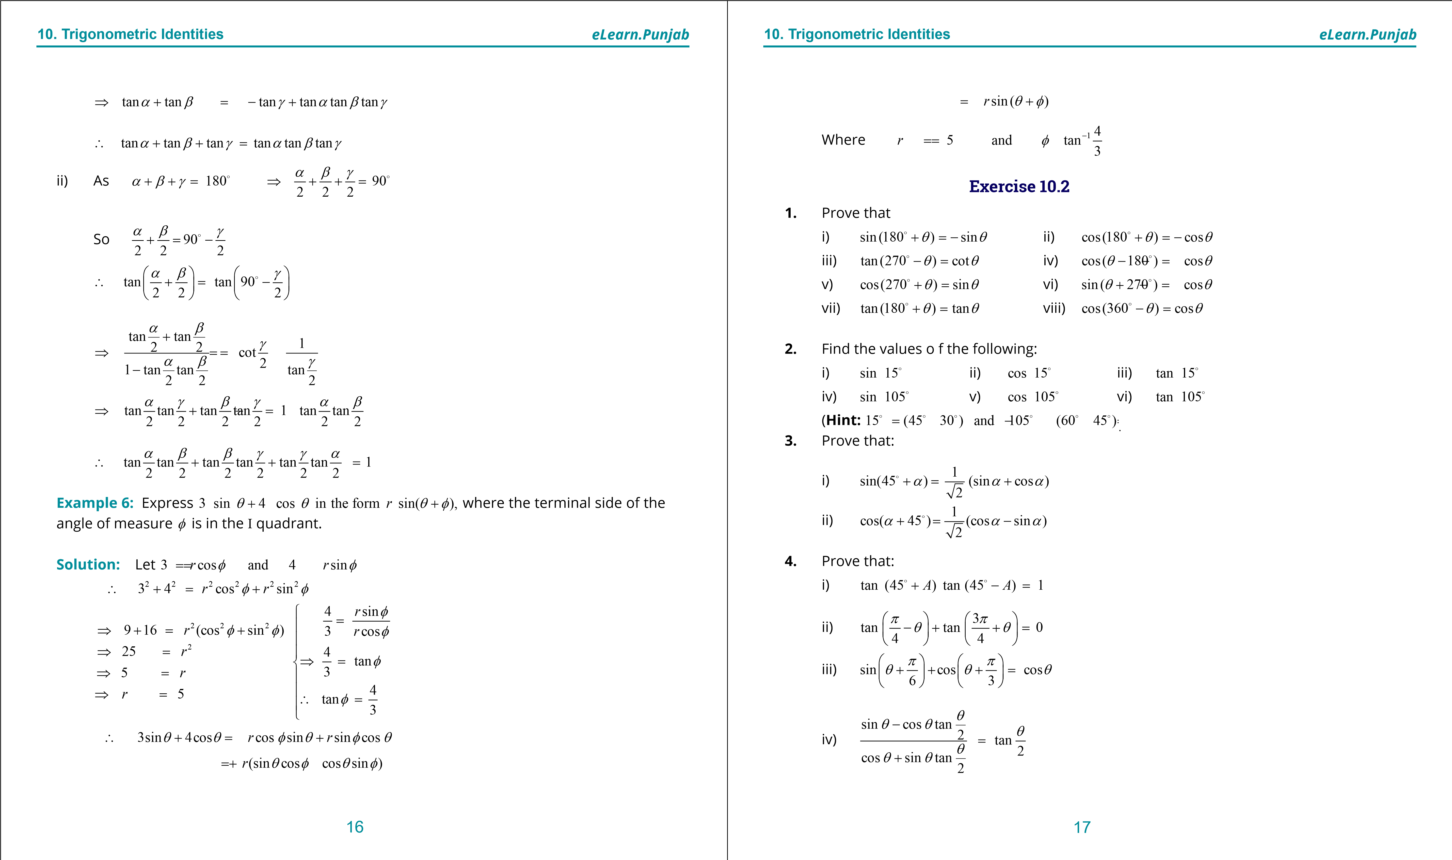

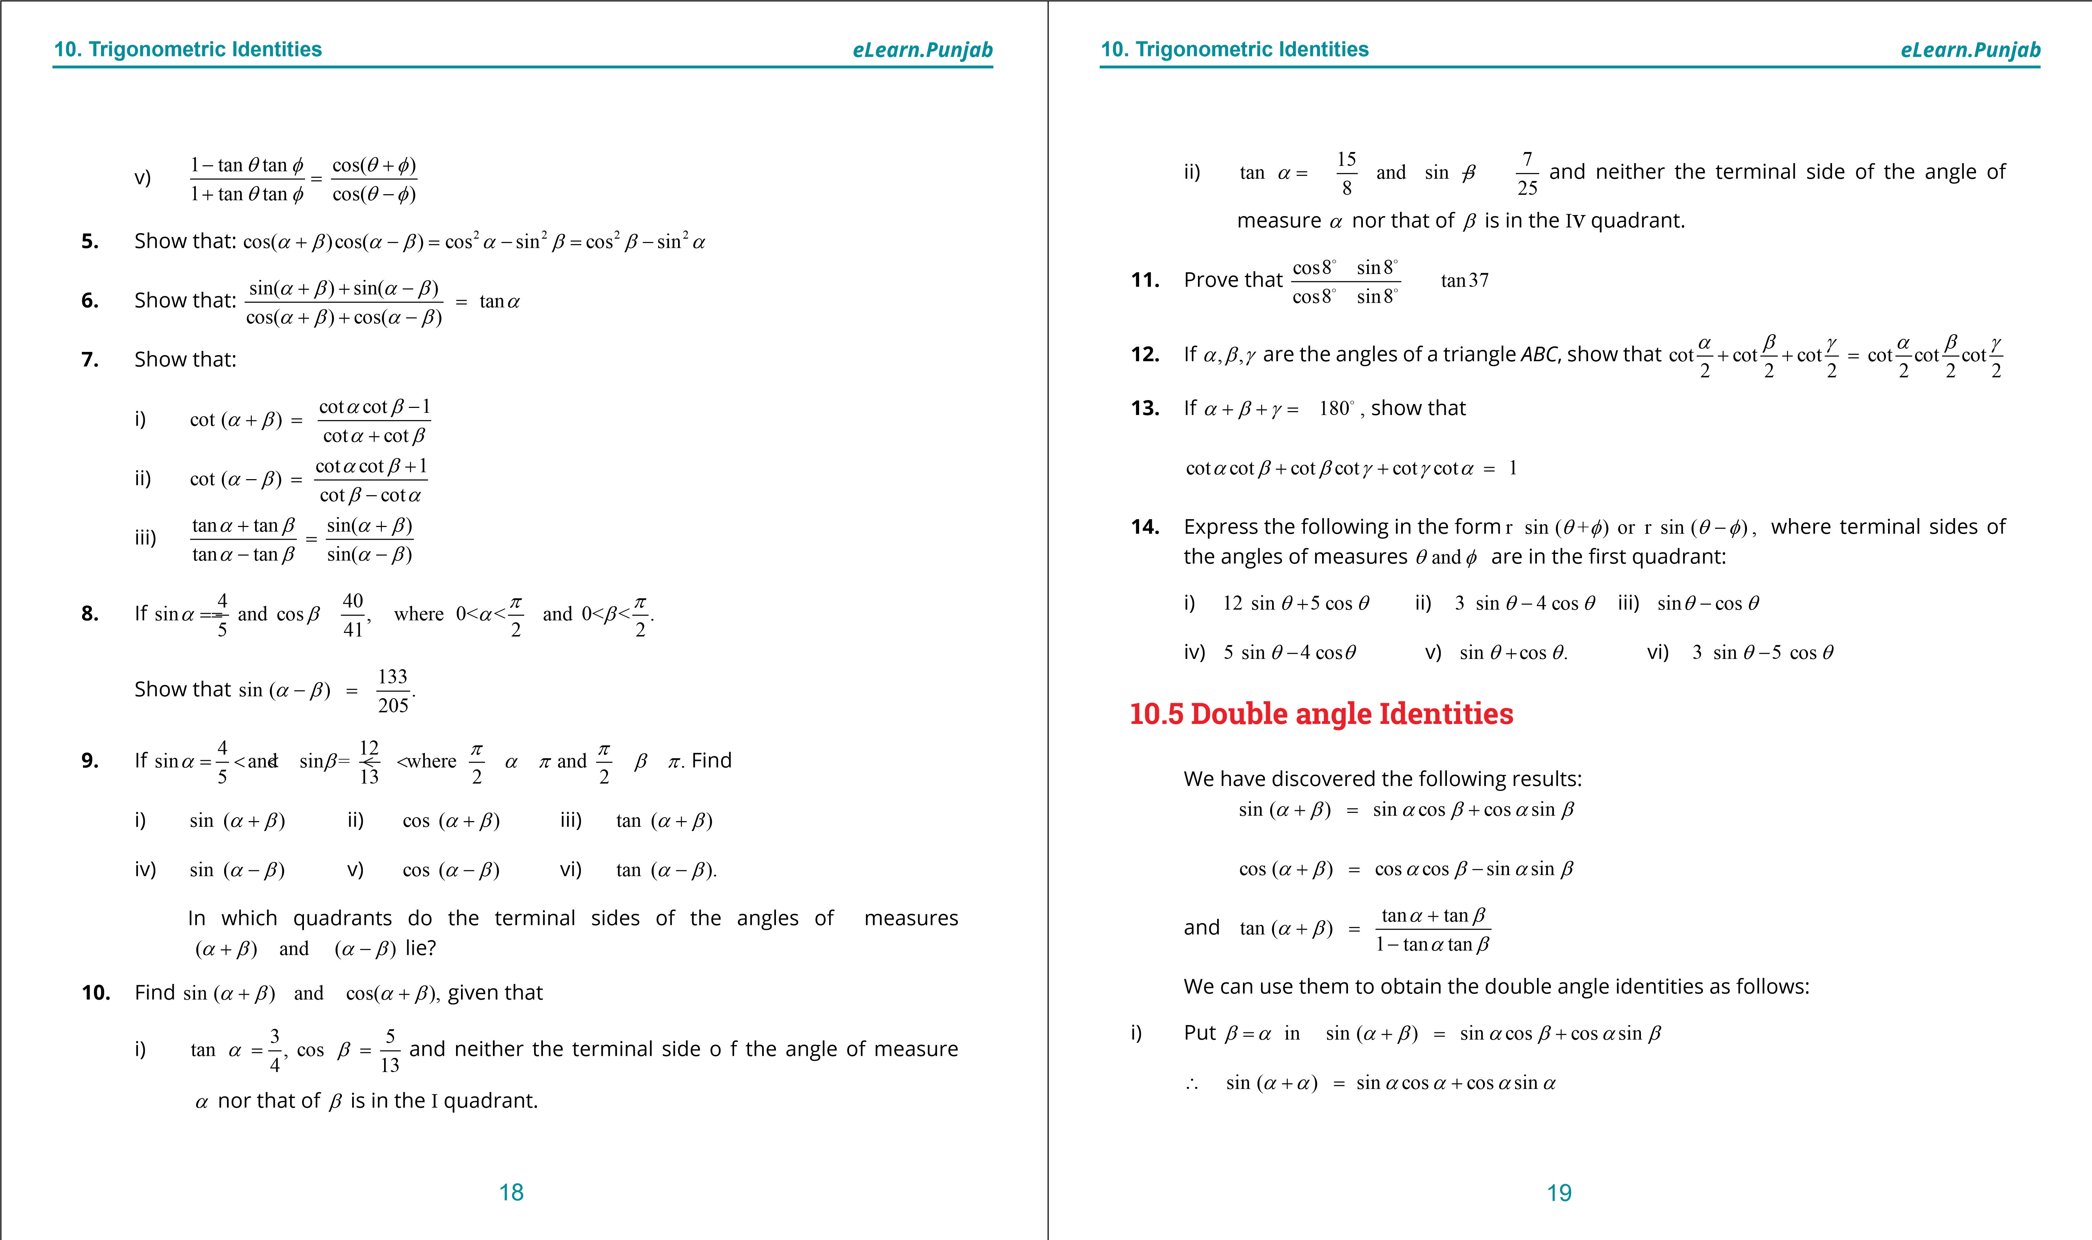

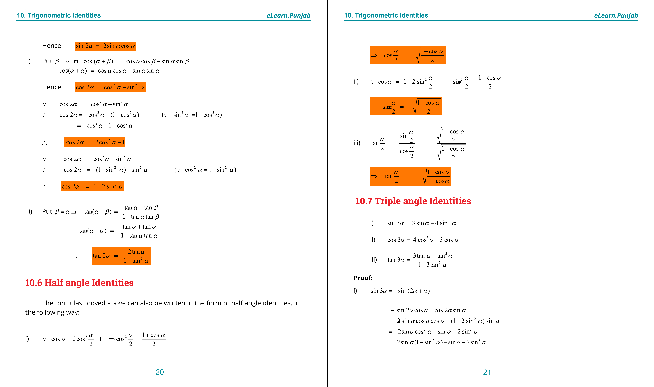

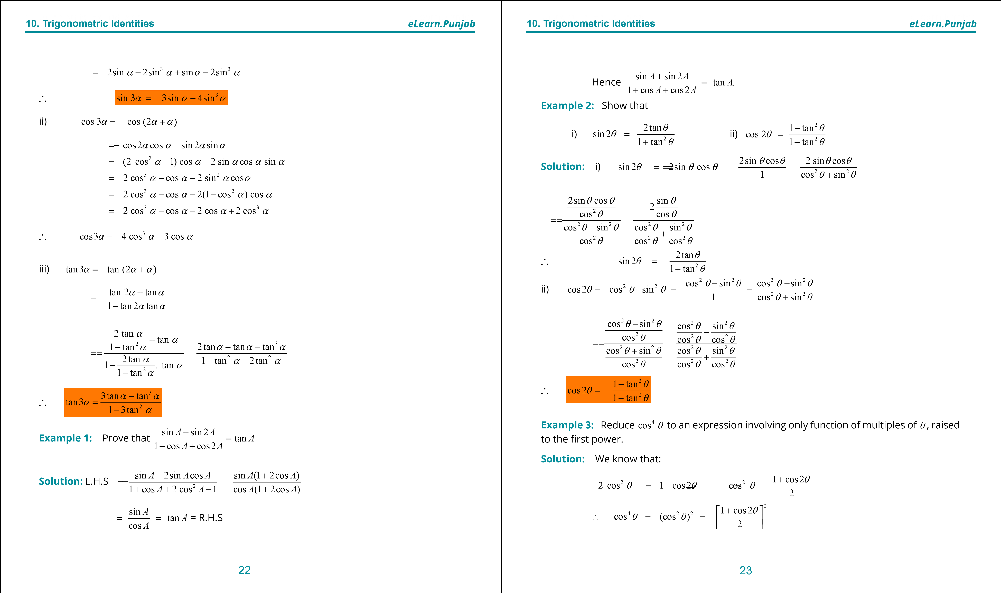

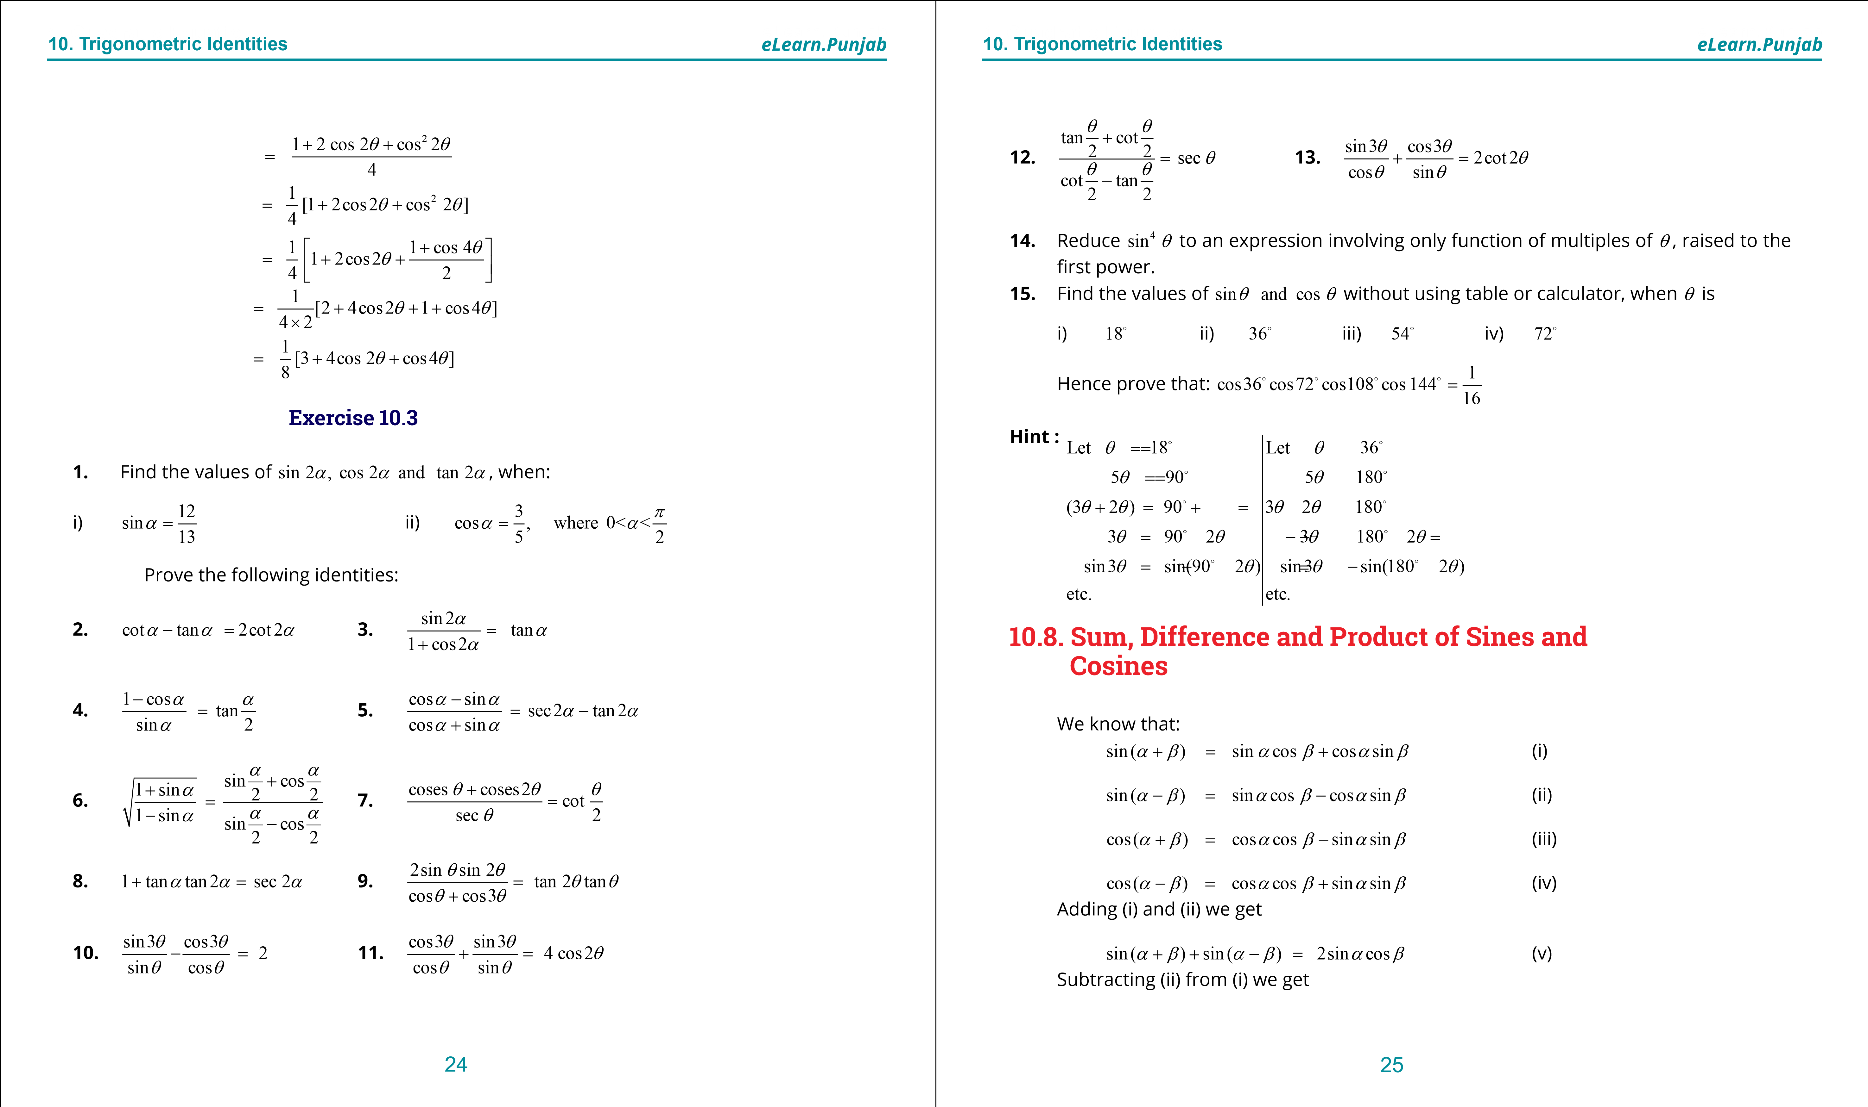

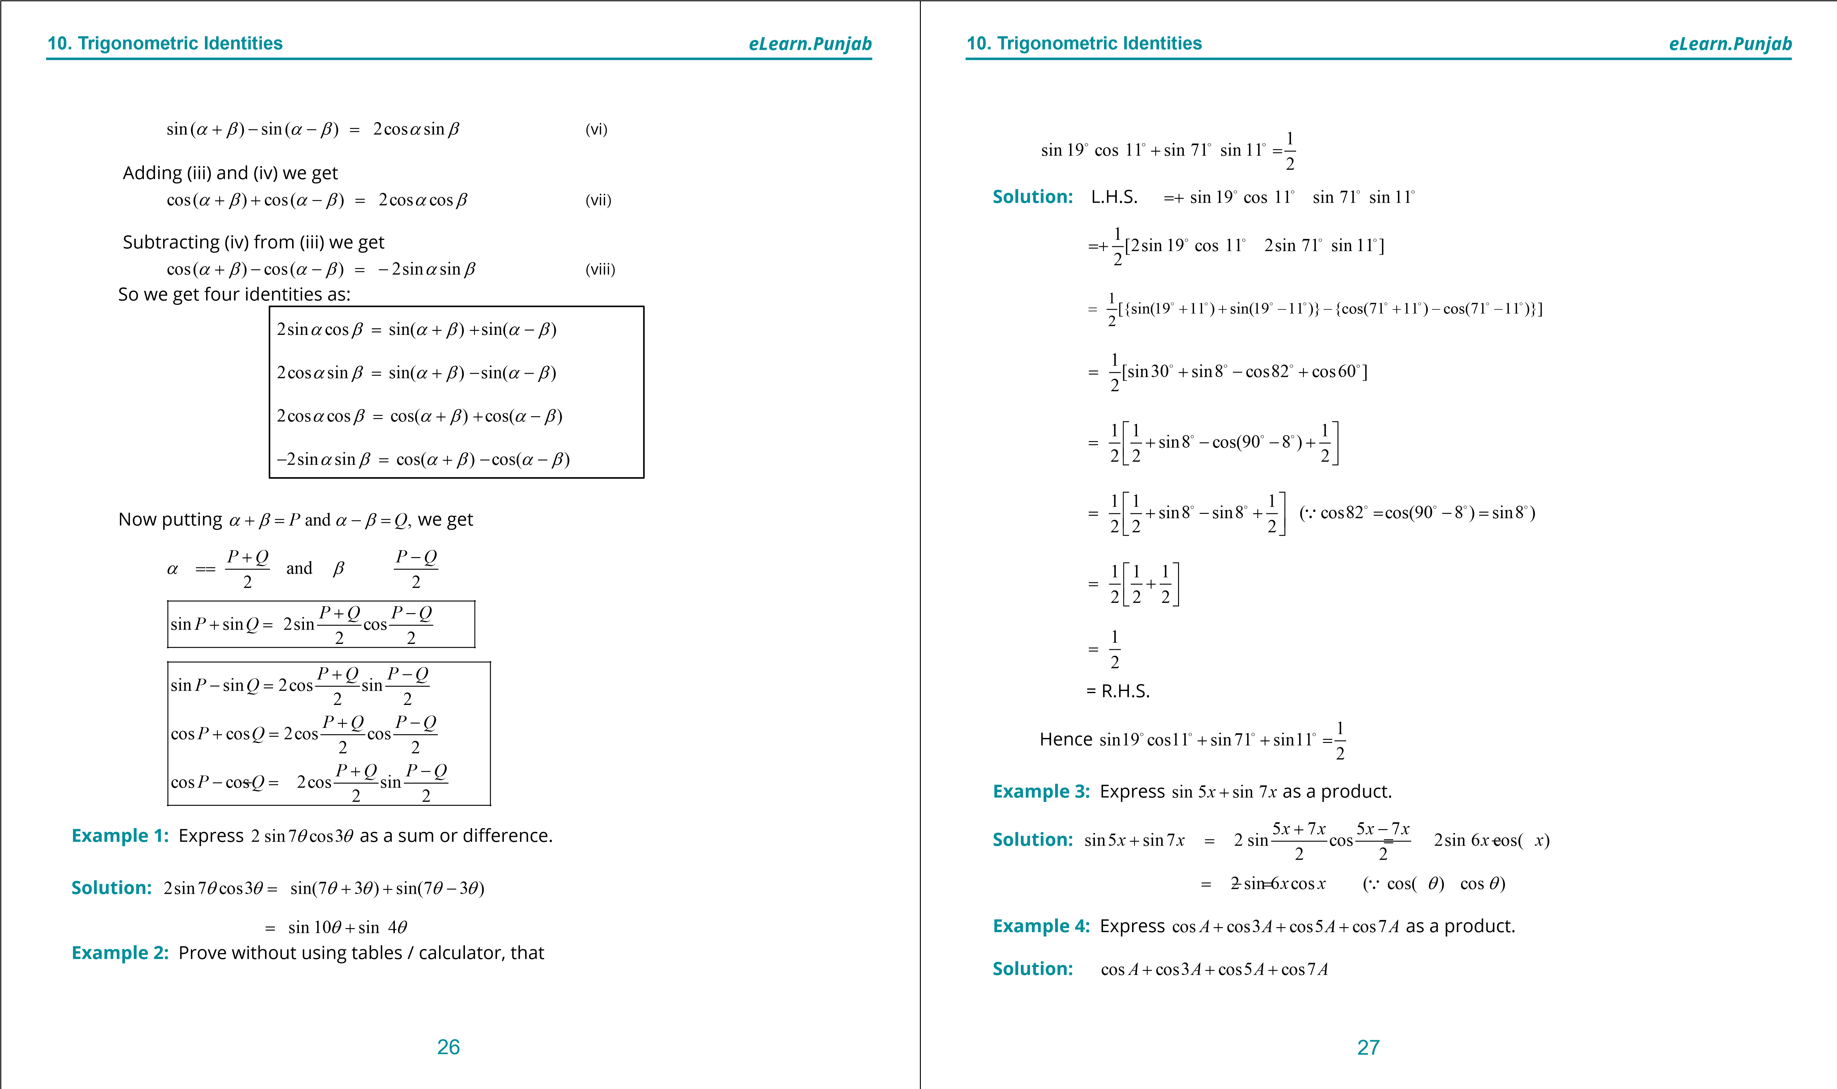

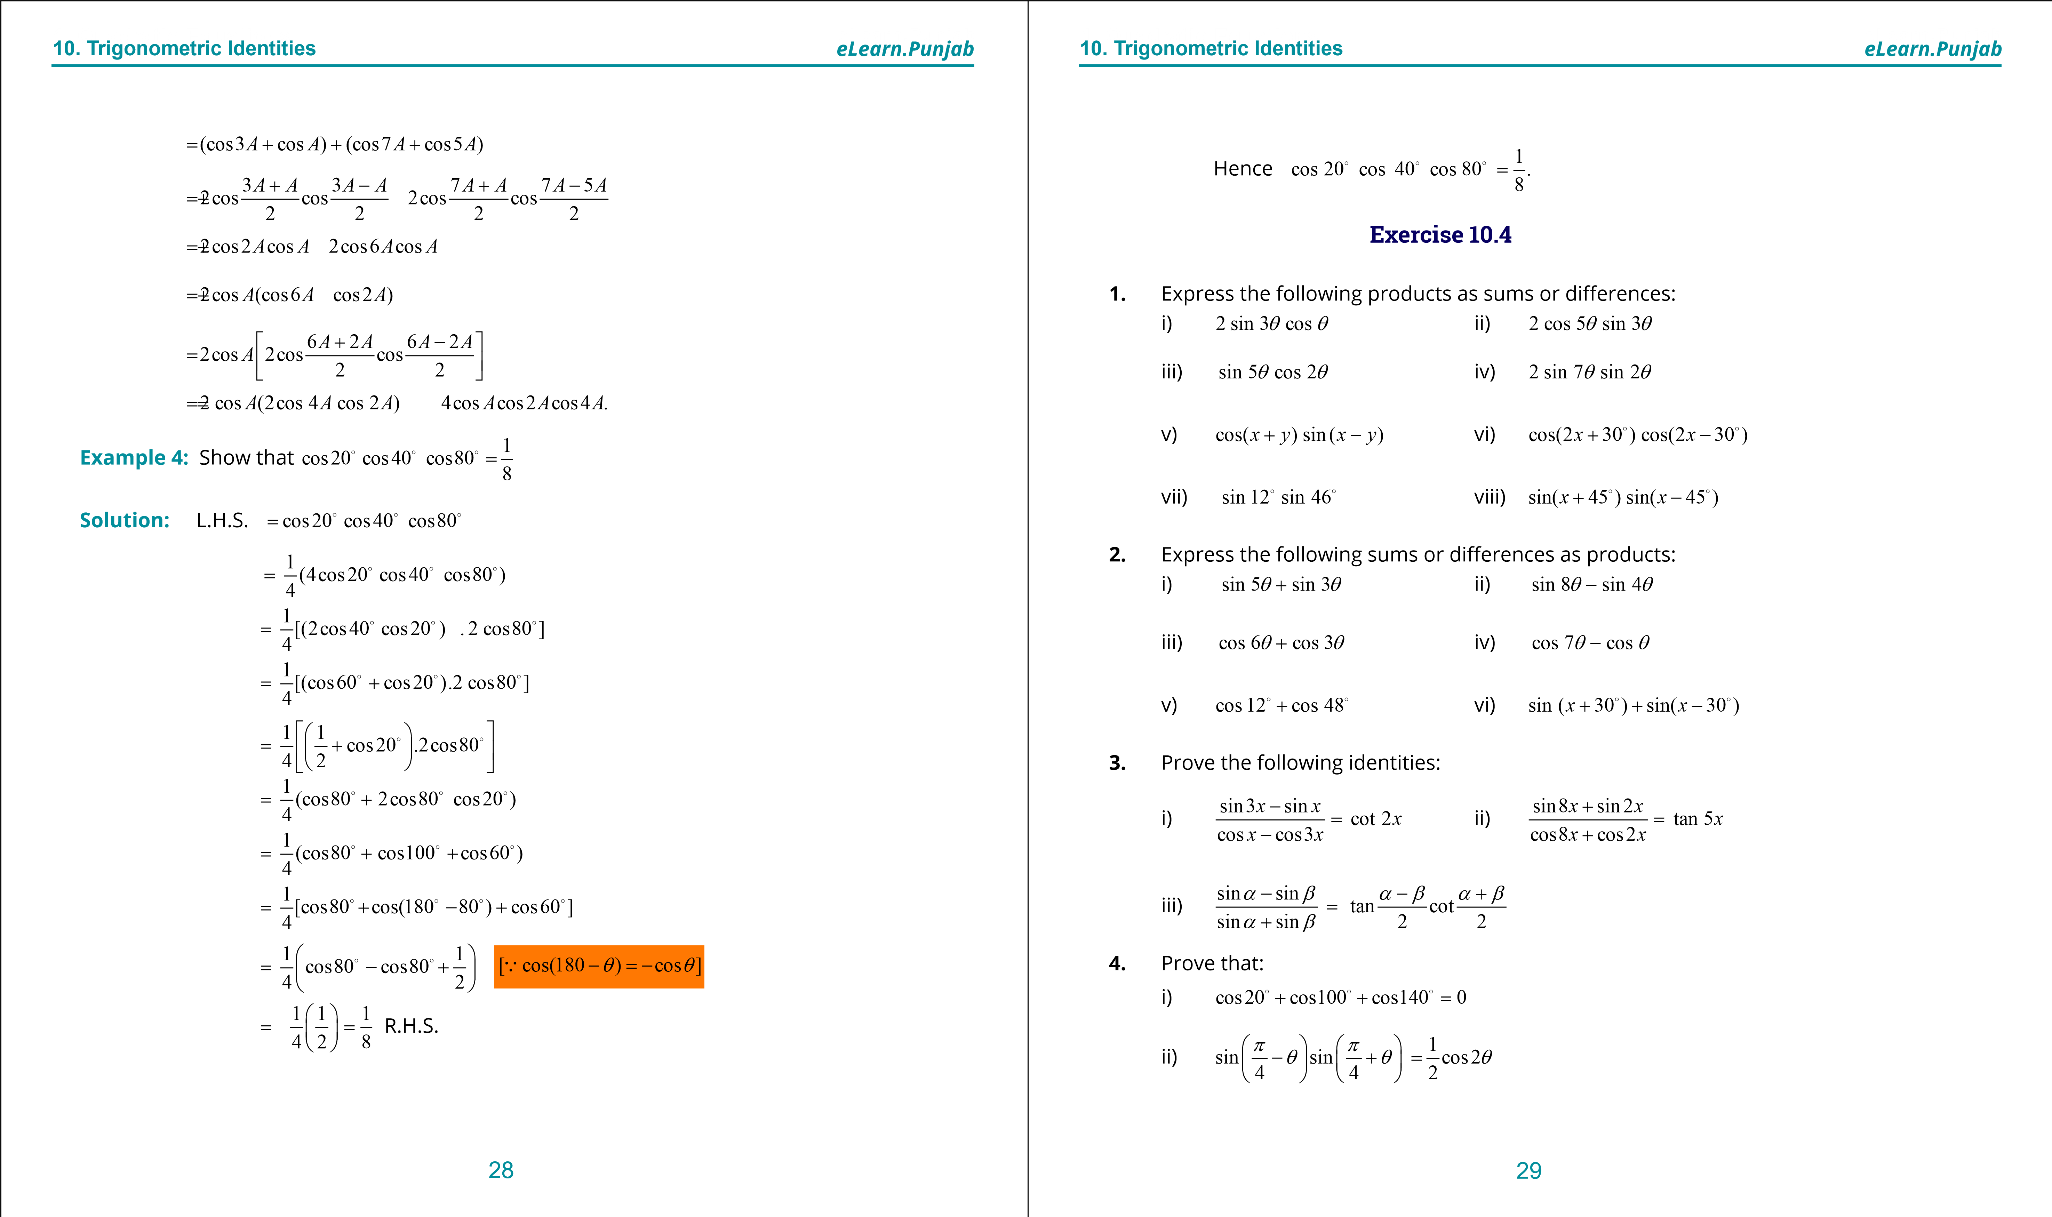

**1**

**. Quadratic Equations**

**eLearn.Punjab**

**10**

**. Trigonometric Identities**

***eLearn.Punjab***

30

iii)

sin

sin3

sin5

sin7

tan4

cos7

cos

cos3

cos5

qqqq

q

q

qq

q

+

+

+

=

+

+

+

**5**

**.**

Prove that:

i)

1

cos20cos40cos60cos80

16

=

□

□

□

□

ii)

4

3

2

sin

sin

sin

sin

9

3

9

16

9

p

p

p

p

=

iii)

1

sin10sin30sin50sin70

16

=

□

□

□

□

***version: 1.1***

CHAPTER

1. Trigonometric Functionsand their Graphs

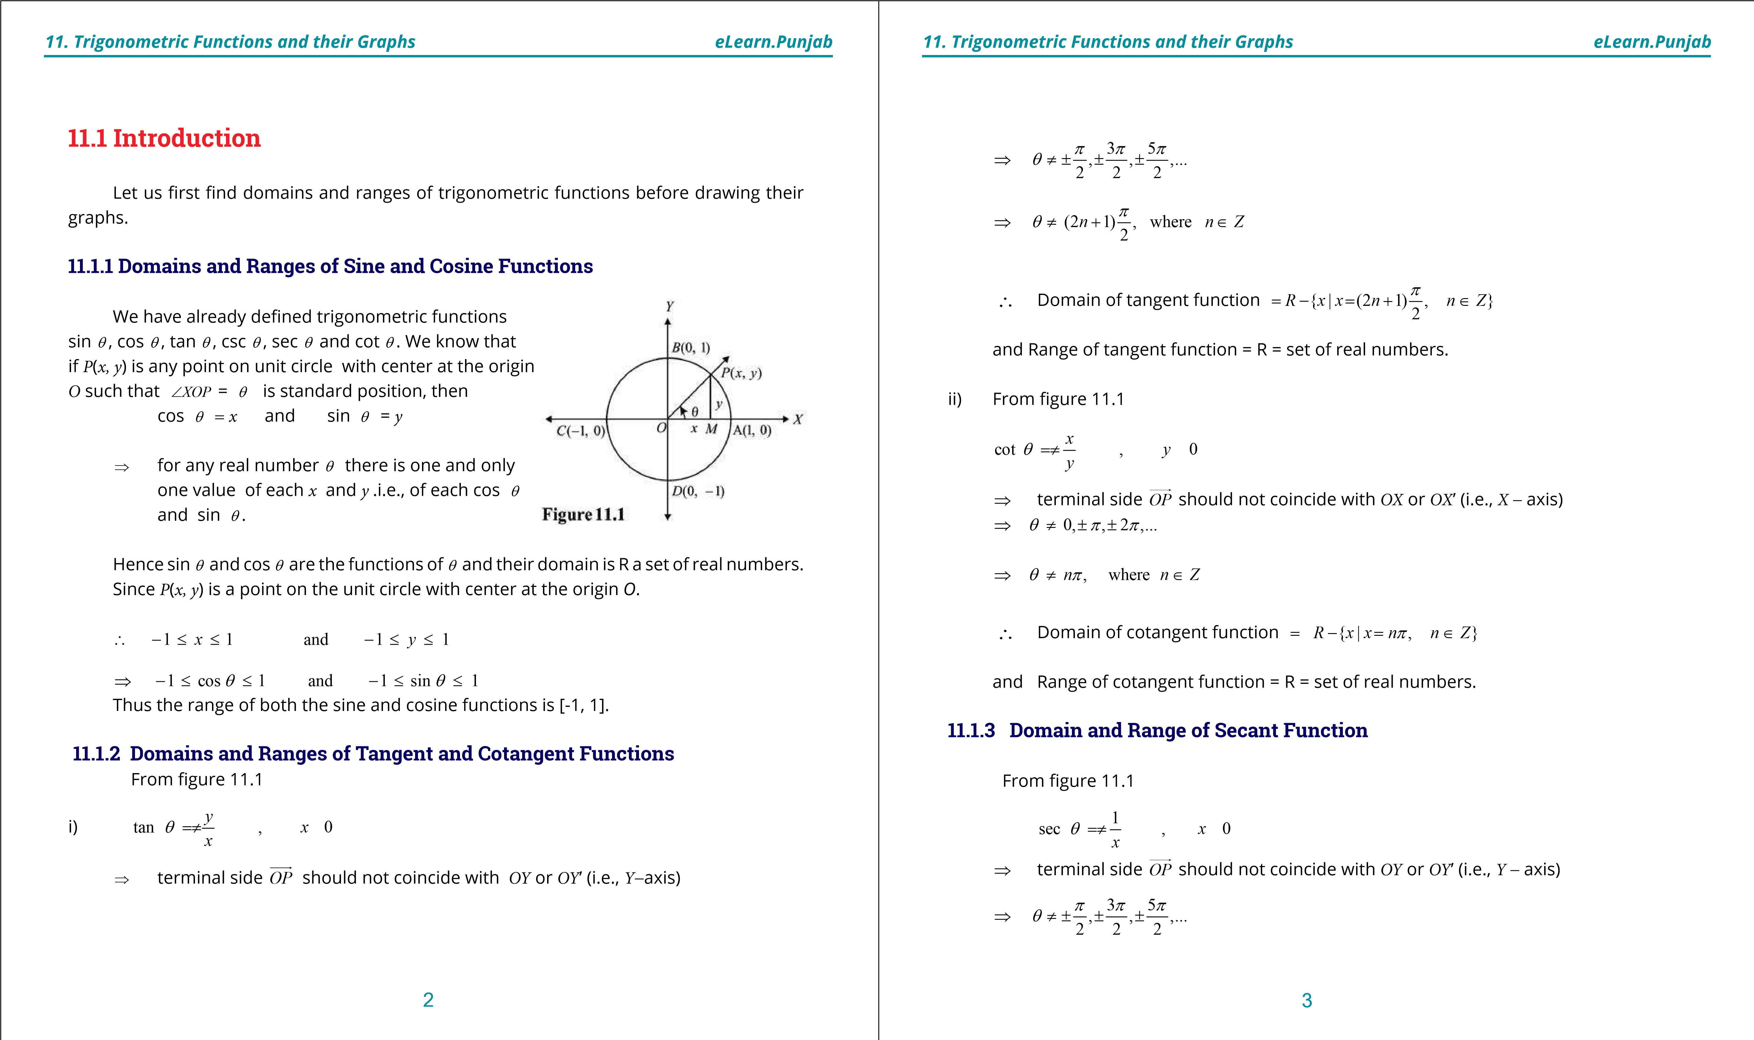

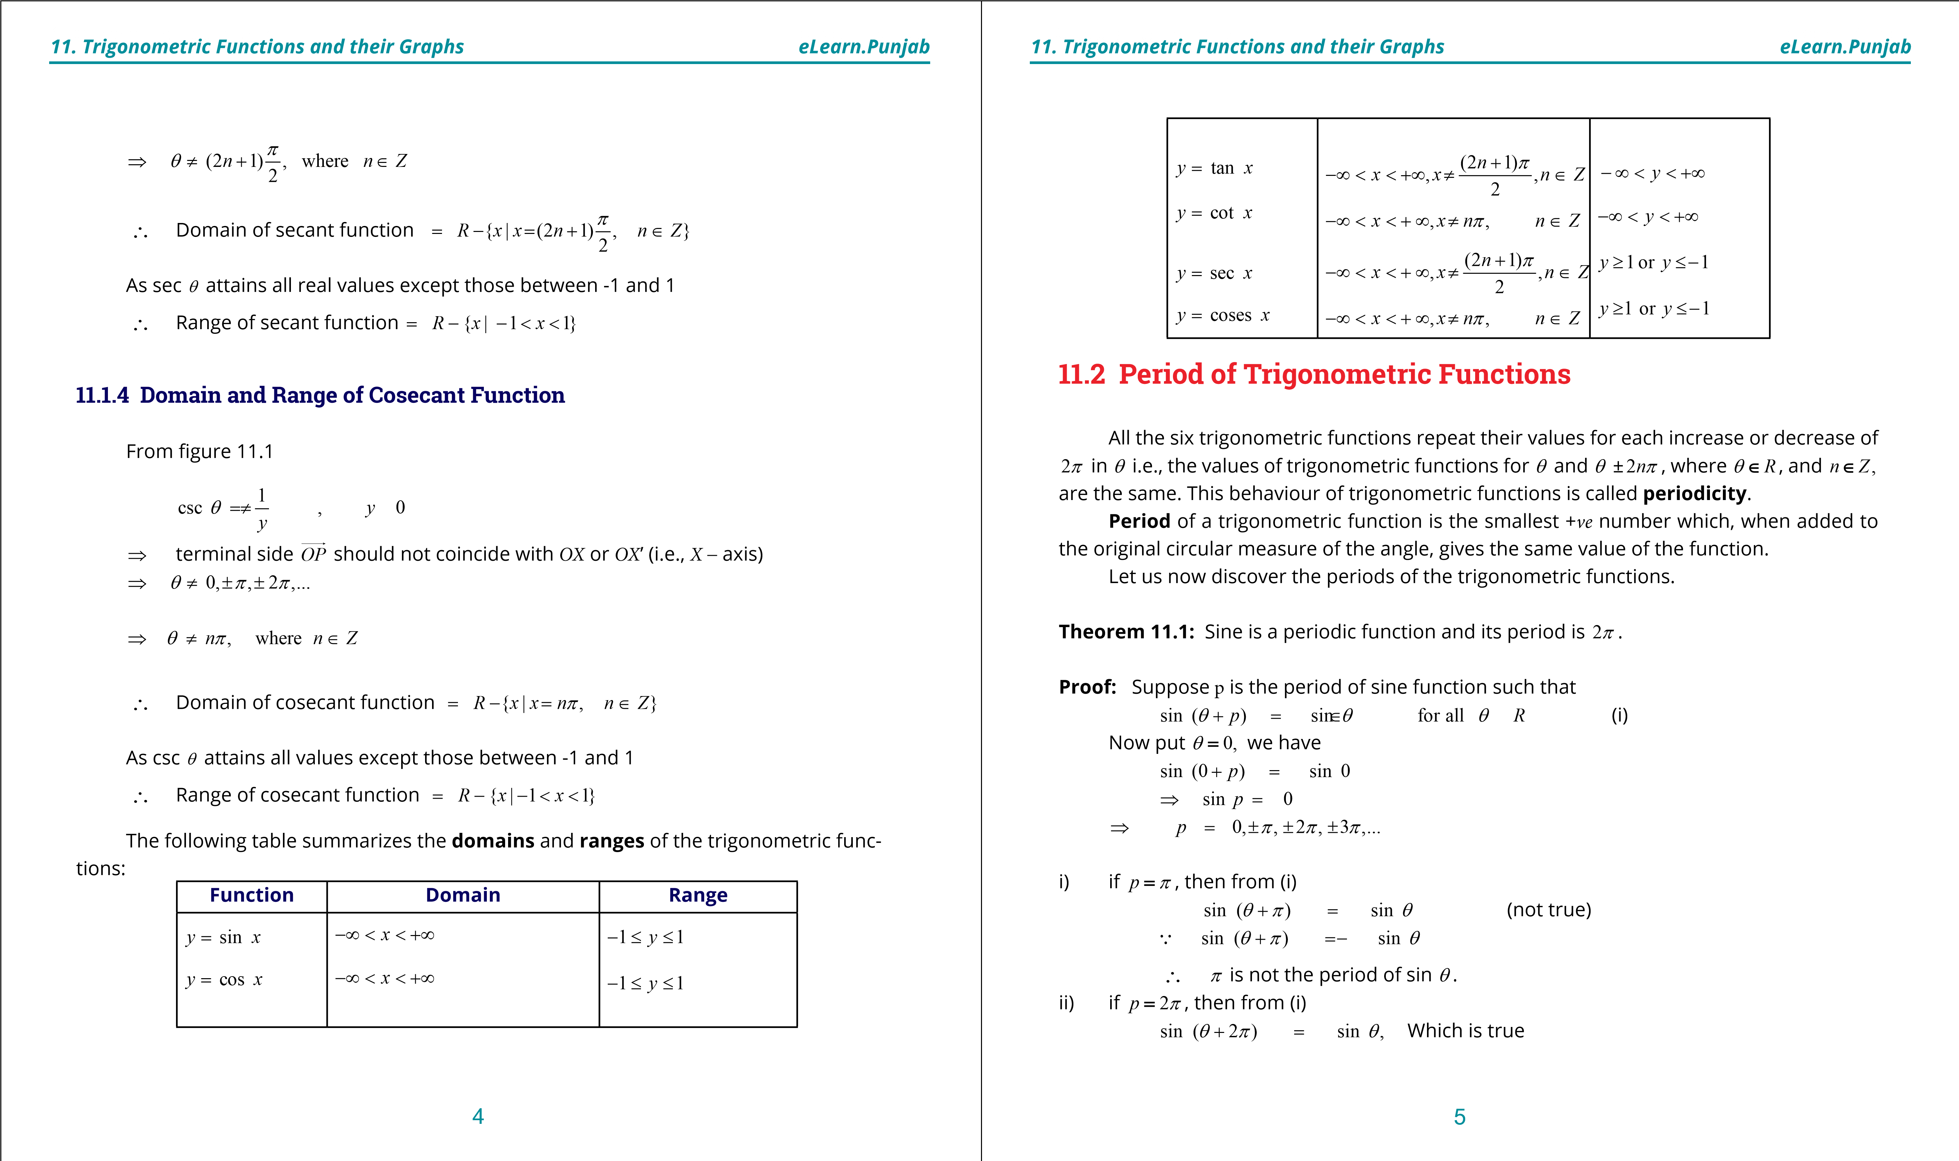

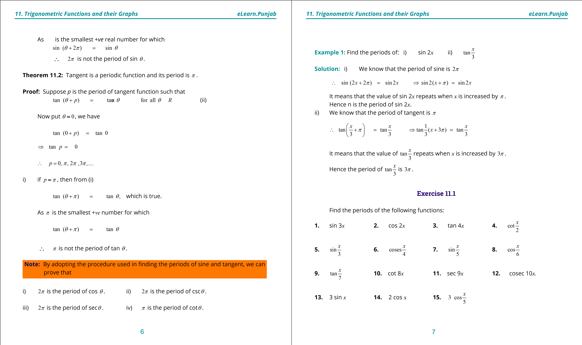

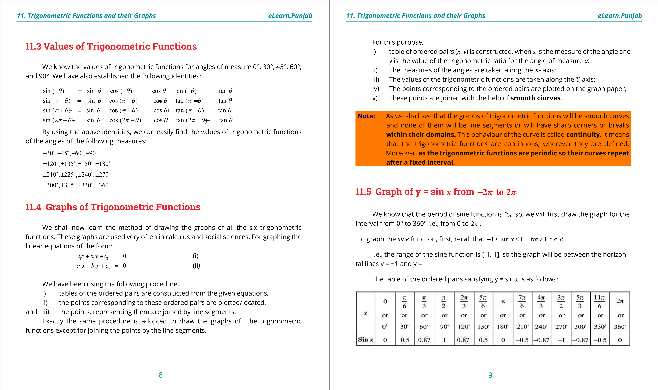

**. Quadratic Equations**

**1**

**eLearn.Punjab**

**1**

**. Quadratic Equations**

**eLearn.Punjab**

***11***

***. Trigonometric Functions and their Graphs***

***11***

***. Trigonometric Functions and their Graphs***

***eLearn.Punjab***

***eLearn.Punjab***

10

11

To draw the graph

Take a convenient scale

i)



=

-





=

-





□

1

side of small square on the x

axis

10

1

side of big square on the y

axis

1

unit

ii)

Draw the coordinate axes.

iii)

Plot the points corresponding to the ordered pairs in the table above i.e., (0, 0),

(30

°, 0.5), (60°, 0.87) and so on,

(

iv)

Join the points with the help of a smooth curve as shown so we get the graph of

y = sin

*x*

from 0 to 360° i.e., from 0 to

2

p

.

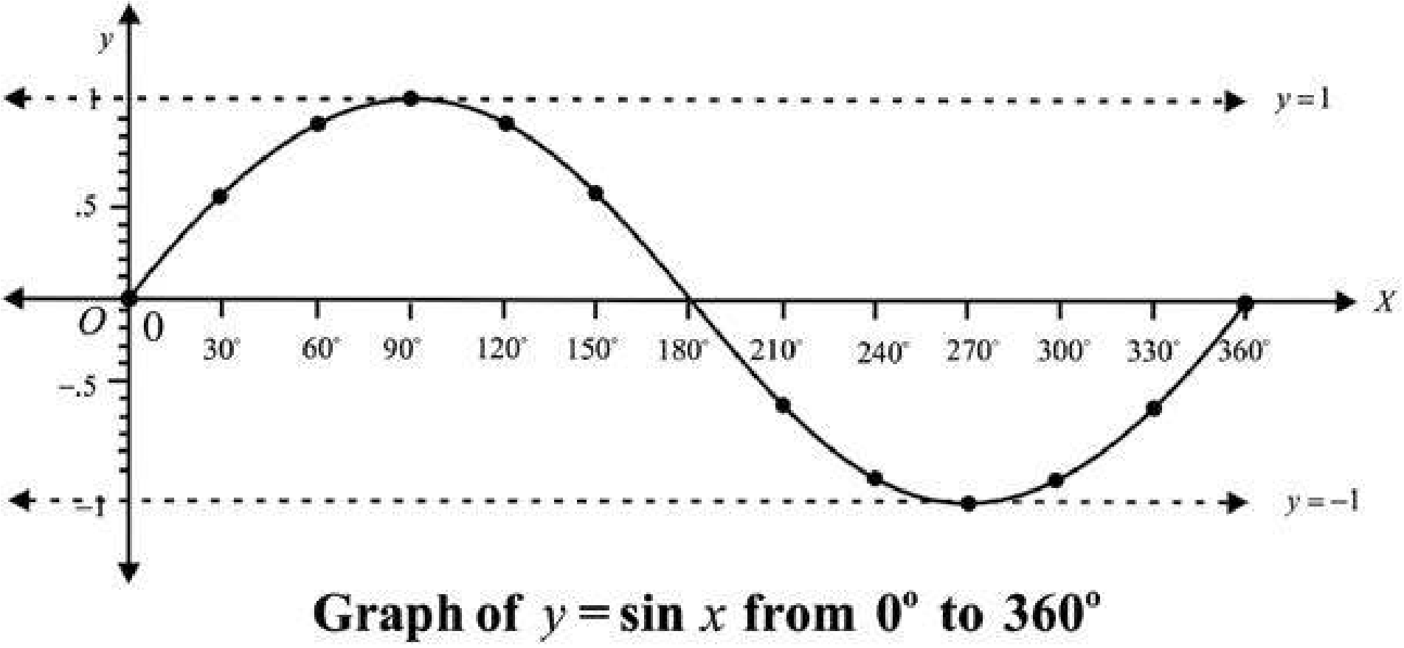

In a similar way, we can draw the graph for the interval from 0° to

-

°. This will

360

complete the graph of y = sin

*x*

from

-

° to 360° i.e. from

360

-

2

p

to

2

p

, which is given below:

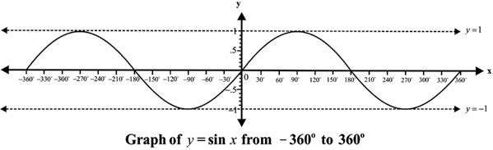

The graph in the interval [0,

2

p

]

is called a cycle. Since the period of sine function is

2

p

,

so the sine graph can be extended on both sides of

*x*

-

a

*x*

is through every interval of

2

p

(360°)

as shown below:

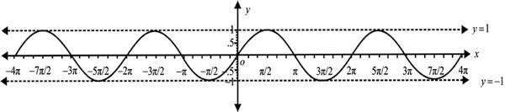

**Graph of y = cos**

**11.6**

***x***

**from**

**2**

**to**

**2**

pp

~~-~~

We know that the period of cosine function is

2

p

so, we will irst draw the graph for the

interval from 0° to 360° i.e., from 0 to

2

p

To graph the cosine function, irst, recall that

sin

1

1

forall

∈

≤

≤

-

*x*

*xR*

i.e., the range of the cosine function is [-1, 1], so the graph will be between the horizontal

lines y = +1 and y =

-

1

The table of the ordered pairs satisfying y = cos

*x*

is as follows:

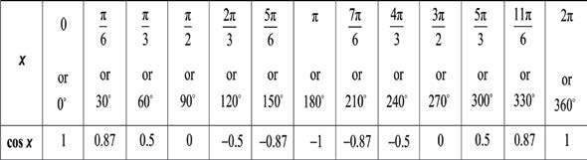

**The graph of y = cos**

***x***

**from 0° to 360° is given below:**

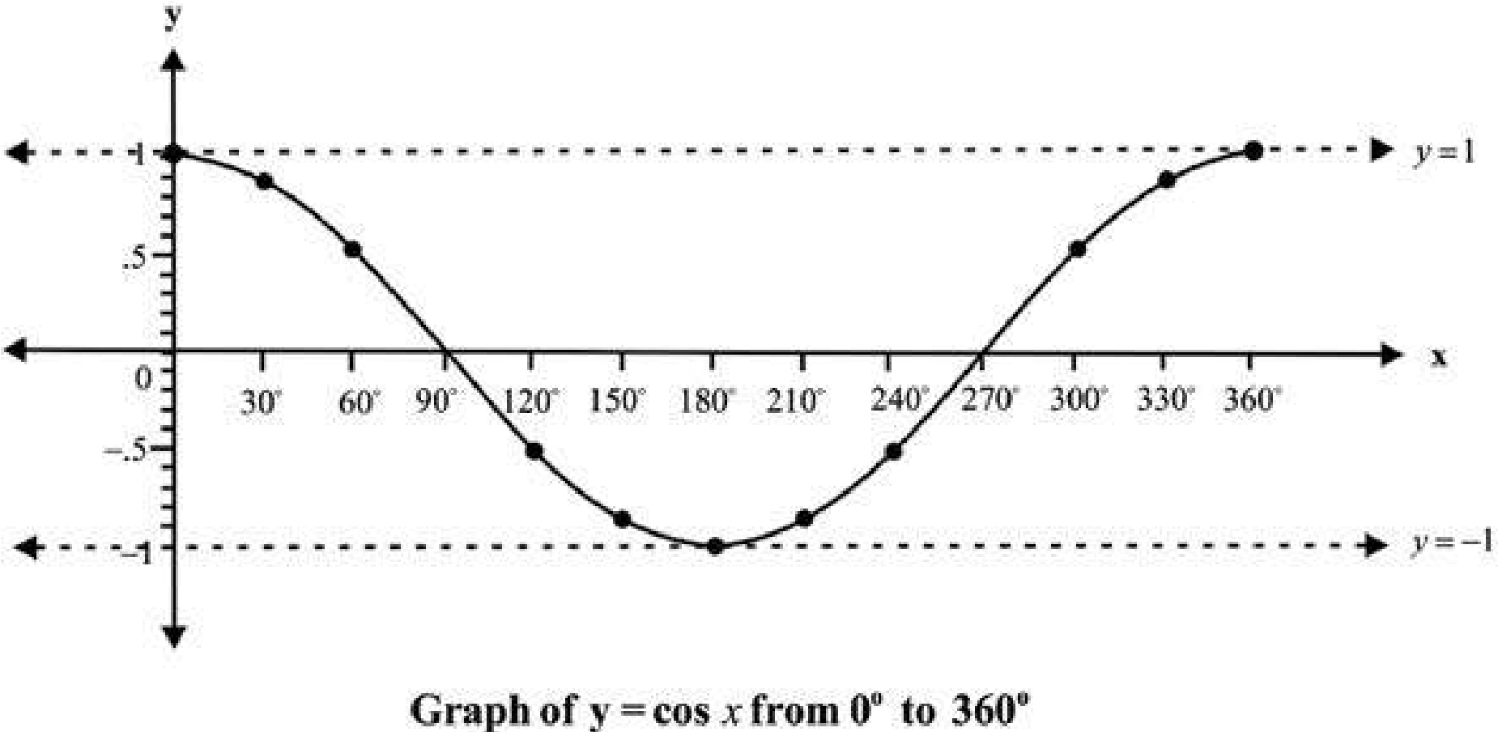

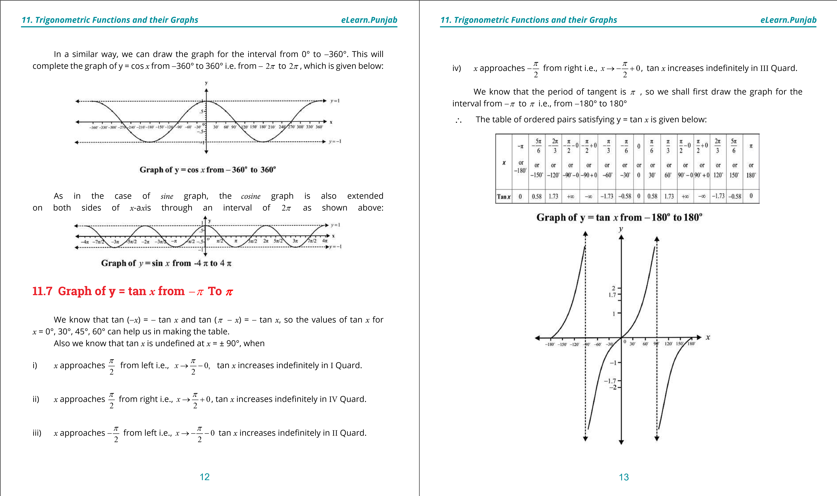

**1**

**. Quadratic Equations**

**eLearn.Punjab**

**. Quadratic Equations**

**1**

**eLearn.Punjab**

***11***

***. Trigonometric Functions and their Graphs***

***11***

***. Trigonometric Functions and their Graphs***

***eLearn.Punjab***

***eLearn.Punjab***

14

15

We know that the period of the tangent function is

p

. The graph is extended on both

sides of

*x*

-

a

*x*

is through an interval of

p

in the same pattern and so we obtain the graph of

y = tan

*x*

from

-

360

° to 360° as shown below

:

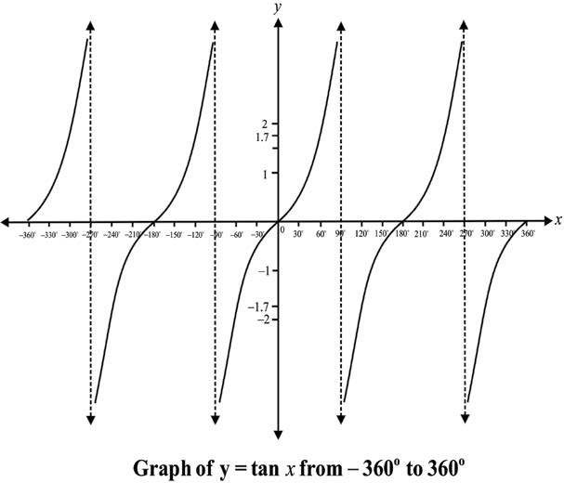

**11.8**

**Graph of y = cot**

***x***

**From**

~~-~~

**2**

**to**

pp

We know that cot (

-

*x*

)

=

-

cot

*x*

and cot (

p

-

*x*

)

=

-

cot

*x*

, so the values of cot

*x*

for

*x*

= 0°, 30°, 45°, 60°, 90° can help us in making the table.

The period of the

*cotangent function*

is also

p

. So its graph is drawn in a similar way of

*tangent*

graph using the table given below for the interval from

-

° to 180°.

180

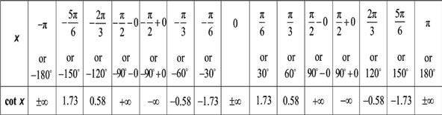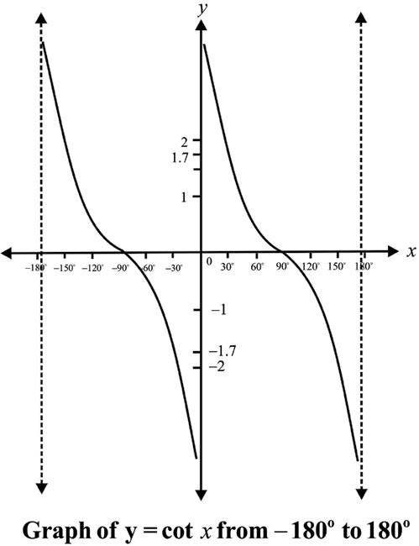

We know that the period of the cotangent function is

p

. The graph is extended on both

**. Quadratic Equations**

**1**

**eLearn.Punjab**

**1**

**. Quadratic Equations**

**eLearn.Punjab**

***11***

***. Trigonometric Functions and their Graphs***

***11***

***. Trigonometric Functions and their Graphs***

***eLearn.Punjab***

***eLearn.Punjab***

16

17

sides of

*x*

-

a

*x*

is through an interval of

p

in the same pattern and so we obtain the graph of

y = cot

*x*

from

from

-

360

° to 360° as shown below

:

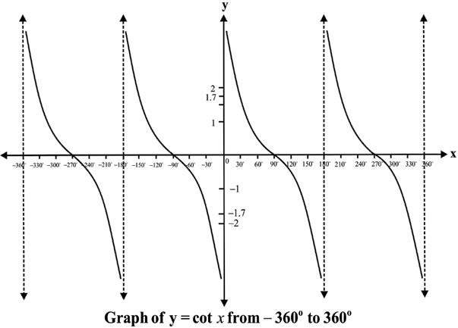

**11.9**

**Graph of y = sec**

***x***

**from**

**2**

**2**

**to**

pp

~~-~~

We know that

sec(

,

sec

)

sec

)

and

sec(

p

--

-

=

=

*x*

*x*

*x*

*x*

So the values of sec

*x*

for

*x*

= 0°, 30°, 45°, 60°, can help us in making the following table

of the ordered pairs for drawing the graph of y = sec

*x*

for the interval 0° to 360°:

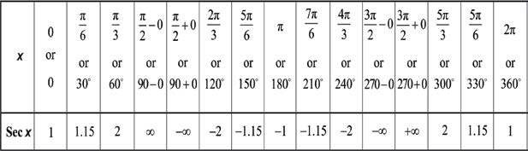

Since the period of sec

*x*

is also

2

p

, so we have the following graph of y = sec

*x*

from

-

360° to 360° i.e., from

-

2

p

to

2

p

:

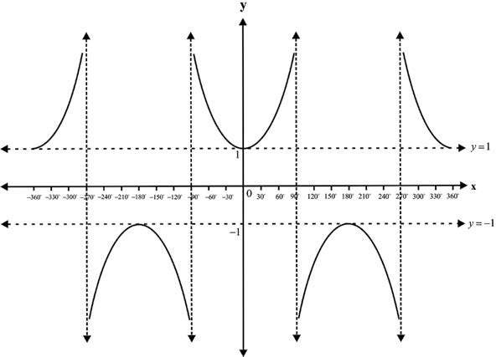

**Graph of y = sec**

*x*

**from**

-

**360° to 360°**

**Graph of y = csc**

**11.10**

***x***

**from**

**2**

**to**

**2**

pp

~~-~~

We know that: csc (

-

*x*

=

)

-

csc

*x*

and csc (

p

-

*x*

= csc

)

*x*

So the values of csc

*x*

for

*x*

= 0°, 30°, 45°, 60°, can help us in making the following

table of the ordered pairs for drawing the graph of y = csc

*x*

for the interval 0° to 360°:

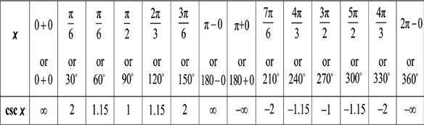

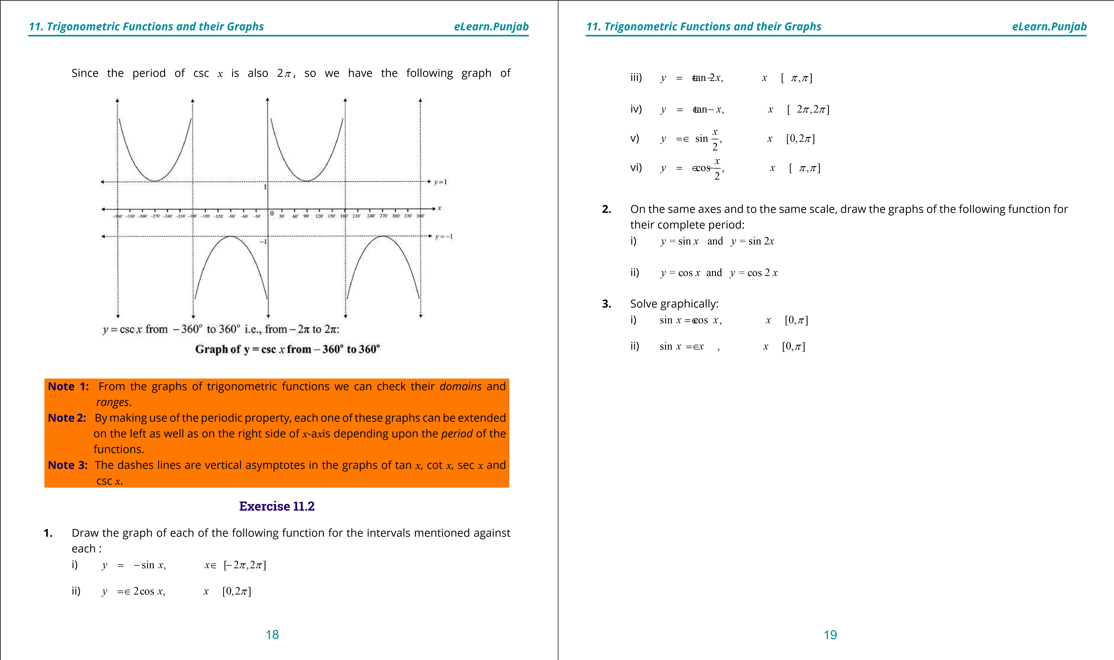

***version: 1.1***

CHAPTER

1. Application of

Trigonometry

**1. Quadratic Equations eLearn.Punjab 1. Quadratic Equations eLearn.Punjab**

1. ***Application of Trigonometry eLearn.Punjab 12. Application of Trigonometry eLearn.Punjab***
   1. **Introduction**

A triangle has six important elements; three angles and three sides. In a triangle *ABC*, the measures of the three angles are usually denoted by a, b, g and the measures of the three sides opposite to them are denoted by *a, b, c* respectively.

If any three out of these six elements, out of which atleast one side, are given, the remaining three elements can be determined This process of inding the unknown elements is called the **solution of the triangle.**

We have calculated the values of the trigonometric functions of the angles measuring 0°, 30°, 45°, 60° and 90°. But in a triangle, the angles are not necessarily of these few measures. So, in the solution of triangles, we may have to solve problems involving angles of measures other than these. In such cases, we shall have to consult natural sin/cos/tan tables or we may use sin , cos , tan keys on the calculator.

Tables/calculator will also be used for inding the measures of the angles when value of trigonometric ratios are given e.g. to ind qwhen sinq = *x*.

* 1. **Tables of Trigonometric Ratios**

Mathematicians have constructed tables giving the values of the trigonometric ratios of large number of angles between 0° and 90°. These are called tables of natural **sines, cosines, tangents** etc. In four-igure tables, the interval is 6 minutes and diference corresponding to 1,2, 3, 4, 5 minutes are given in the **diference columns.**

The following examples will illustrate how to consult these tables.

**Example 1:** Find the value of

* + 1. sin 38° 24’ ii) sin 38° 28’ iii) tan 65° 30’.

**Solution:** In the irst column on the left hand side headed by degrees (in the Natural Sine table) we read the number 38°. Looking along the row of 38° till the minute column number 24’ is reached, we get the number 0.6211.

∴ sin38 24□ ′ = 0.6211

* + 1. To ind sin 38° 28’, we irst ind sin 38° 24’, and then see the right hand column headed by **mean diferences.** Running down the column under 4’ till the row of 38° is reached. We ind 9 as the diference for 4’. Adding 9 to 6211, we get 6220.

∴ sin38 24□ ′ = 0.6220

**Note: 1.** As sin q, sec q and tan q go on increasing as q increases from 0° to 90°, so the numbers in the columns of the diferences for sin q, sec q and tan q are added.

**2.** Since cos q, cosec q and cot q decrease as q increases from 0° to 90°, therefore, for cos q, cosec q and cot q the numbers in the column of the, diferences are subtracted.

iii) Turning to the tables of Natural Tangents read the number 65° in the irst column on the left hand side headed by degrees. Looking along the row of 65° till the minute column under 30’ is reached, we get the number 1943. The integral part of the igure just next to 65° in the horizontal line is 2.

∴ tan65 30□ ′ = 2.1943

**Example 2:**  If sin*x* = 0.5100, ind *x*.

**Solution:** In the tables of Natural Sines, we get the number (nearest to 5100) 5090 which lies at the intersection of the row beginning with 30° and the column headed by 36’. The diference between 5100 and 5090 is 10 which occurs in the row of 30° under the mean diference column headed by 4’. So, we add 4’ to 30° 36’ and get sin (0.5100)-1 = 30 40□ ′

Hence *x* = 30° 40 **Exercise 12.1**

**1.** Find the values of:

i) sin53 40□ ′ii) cos36 20□ ′ iii) tan19 30□ ′

cot33 50□ ′ v) cos42 38□ ′ vi) tan25 34□ ′ iv)

vii) sin18 31□ ′viii) cos5213□ ′ ix)cot89 9□ ′

2 3

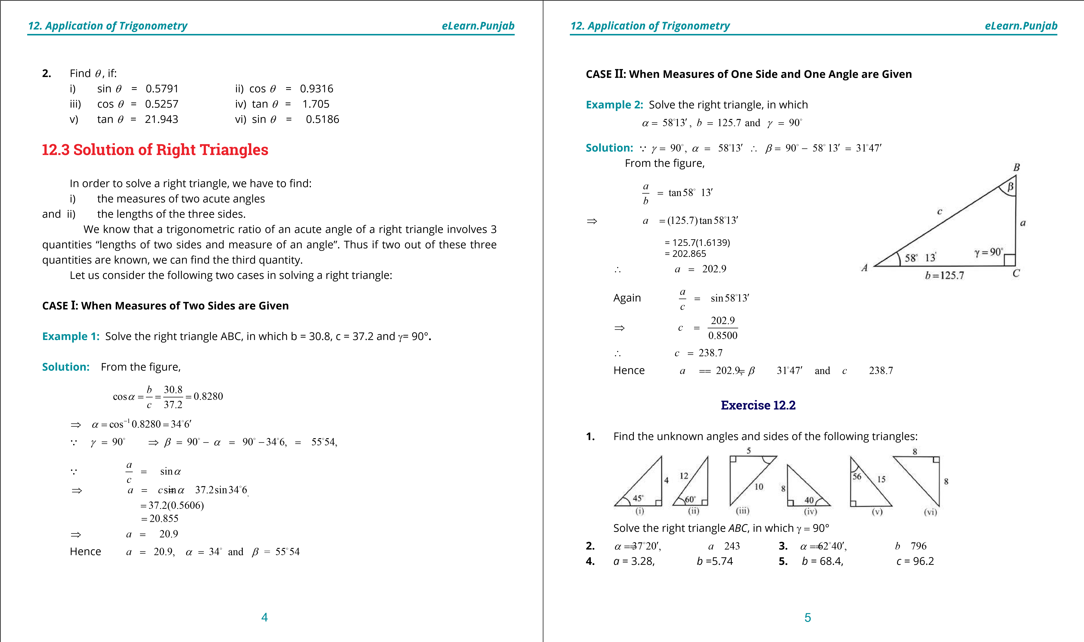

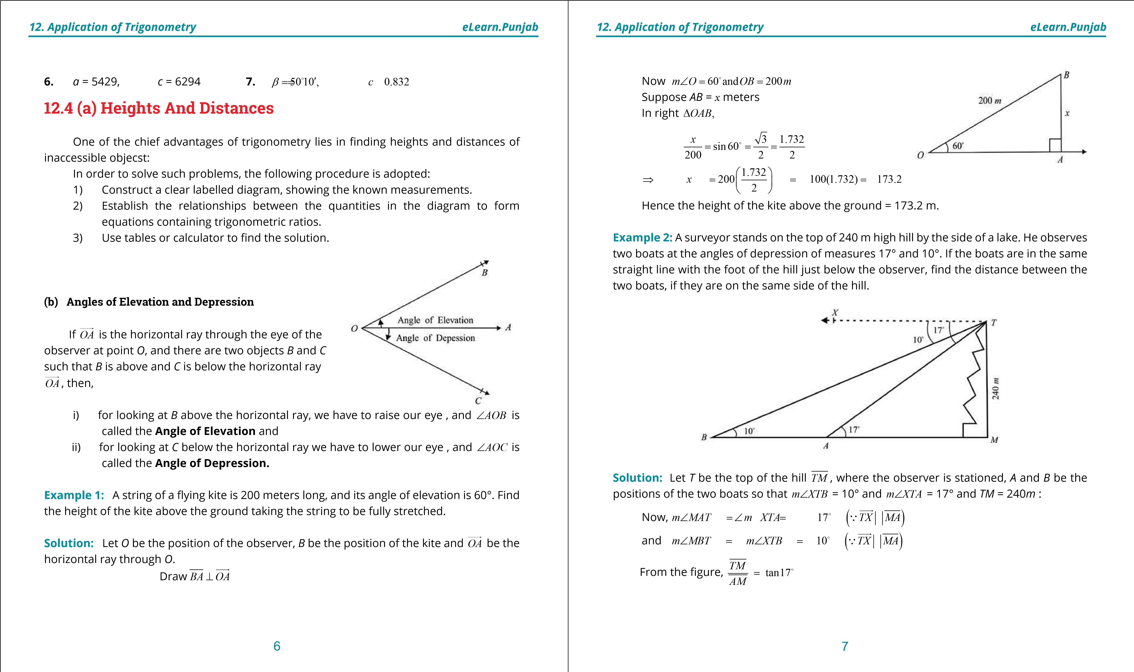

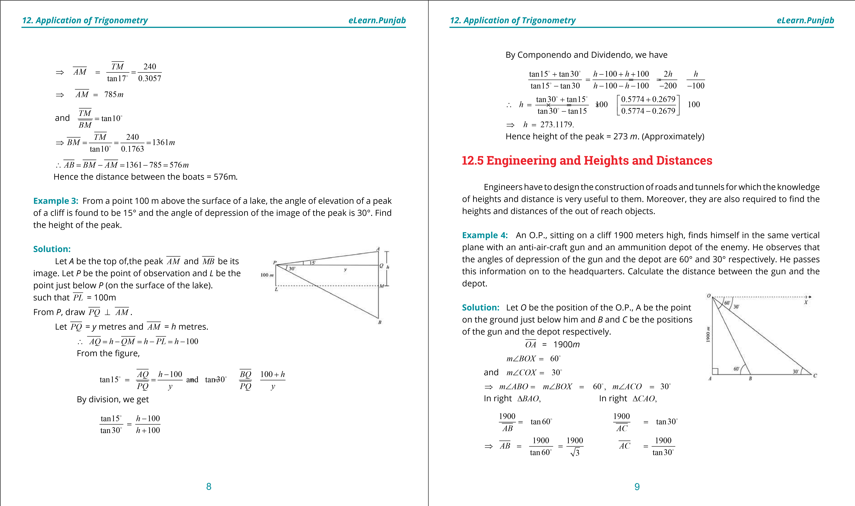

**1. Quadratic Equations eLearn.Punjab 1. Quadratic Equations eLearn.Punjab**

***12. Application of Trigonometry eLearn.Punjab 12. Application of Trigonometry eLearn.Punjab***

Now *BC* = *AC* - *AB* ⇒ *AC* =1900 3

⇒ *BC* = 1900 3 - = 2193.93

∴ Required distance = 2194 meters.

**Exercise 12.3**

1. A vertical pole is 8 m high and the length of its shadow is 6 m. What is the angle of elevation of the sun at that moment?
2. A man 18 dm tall observes that the angle of elevation of the top of a tree at a distance of 12 m from him is 32 . What is the height of the tree?
3. At the top of a clif 80 m high, the angle of depression of a boat is 12°. How far is the boat from the clif?
4. A ladder leaning against a vertical wall makes an angle of 24° with the wall. Its foot is 5m from the wall. Find its length.
5. A kite lying at a height of 67.2 m is attached to a fully stretched string inclined at an angle of 55° to the horizontal. Find the length of the string.
6. When the angle between the ground and the suri is 30°, lag pole casts a shadow of 40m long. Find the height of the top of the lag.
7. A plane lying directly above a post 6000 m away from an anti-aircraft gun observes the gun at an angle of depression of 27°.Find the height of the plane.
8. A man on the top of a 100 m high light-house is in line with two ships on the same side of it, whose angles of depression from the man are 17° and 19° respecting. Find the distance between the ships.
9. *P* and *Q* are two points in line with a tree. If the distance between *P* and *Q* be 30 m and the angles of elevation of the top of the tree at *P* and *Q* be 12° and l5° respectively, ind the height of the tree.

**10** Two men are on the opposite sides of a 100 m high tower. If the measures of the angles of elevation of the top of the tower are 18° and 22°respectively ind the distance between them.

1. A man standing 60 m away from a tower notices that the angles of elevation of the top and the bottom of a lag staf on the top of the tower are 64° and 62° respectively. Find the length of the lag staf.
2. The angle of elevation of the top of a 60 m high tower from a point *A*, on the same level as the foot of the tower, is 25°. Find the angle of elevation of the top of the tower from a point *B*, 20 m nearer to *A* from the foot of the tower.
3. Two buildings *A* and *B* are 100 m apart. The angle of elevation from the top of the building *A* to the top of the building *B* is 20°. The angle of elevation from the base of the building *B* to the top of the building *A* is 50°. Find the height of the building *B*.
4. A window washer is working in a hotel building. An observer at a distance of 20 m from the building inds the angle of elevation of the worker to be of 30°. The worker climbs up 12 m and the observer moves 4 m farther away from the building. Find the new angle of elevatiqn of the worker.

1900

3

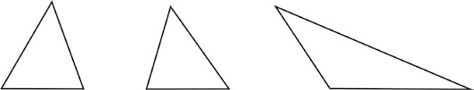

**15** A man standing on the bank of a canal observes that the measure of the angle of elevation of a tree on the other side of the canal, is 60. On retreating 40 meters from the bank, he inds the measure of the angle of elevation of the tree as 30 . Find the height of the tree and the width of the canal.

**12.6 Oblique Triangles**

A triangle, which is not right, is called an oblique triangle. Following triangles are not right, and so each one of them is oblique:

We have learnt the methods of solving right triangles. However, in solving oblique triangles, we have to make use of the relations between the sides *a, b, c* and the angle a,b,g of such triangles, which are called **law of cosine, law of sines** and **law of tangents**.

Let us discover these laws one by one before solving oblique triangles.

10 11

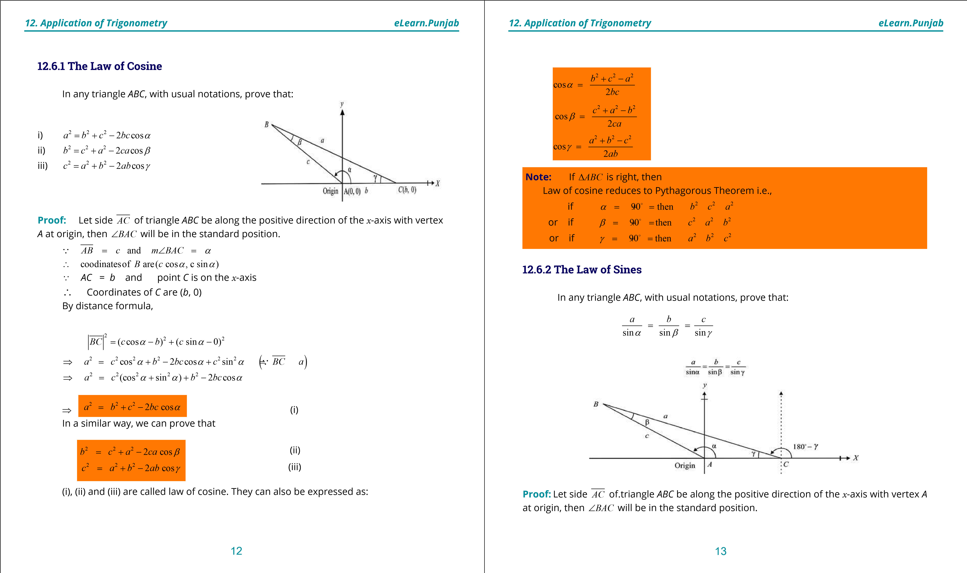

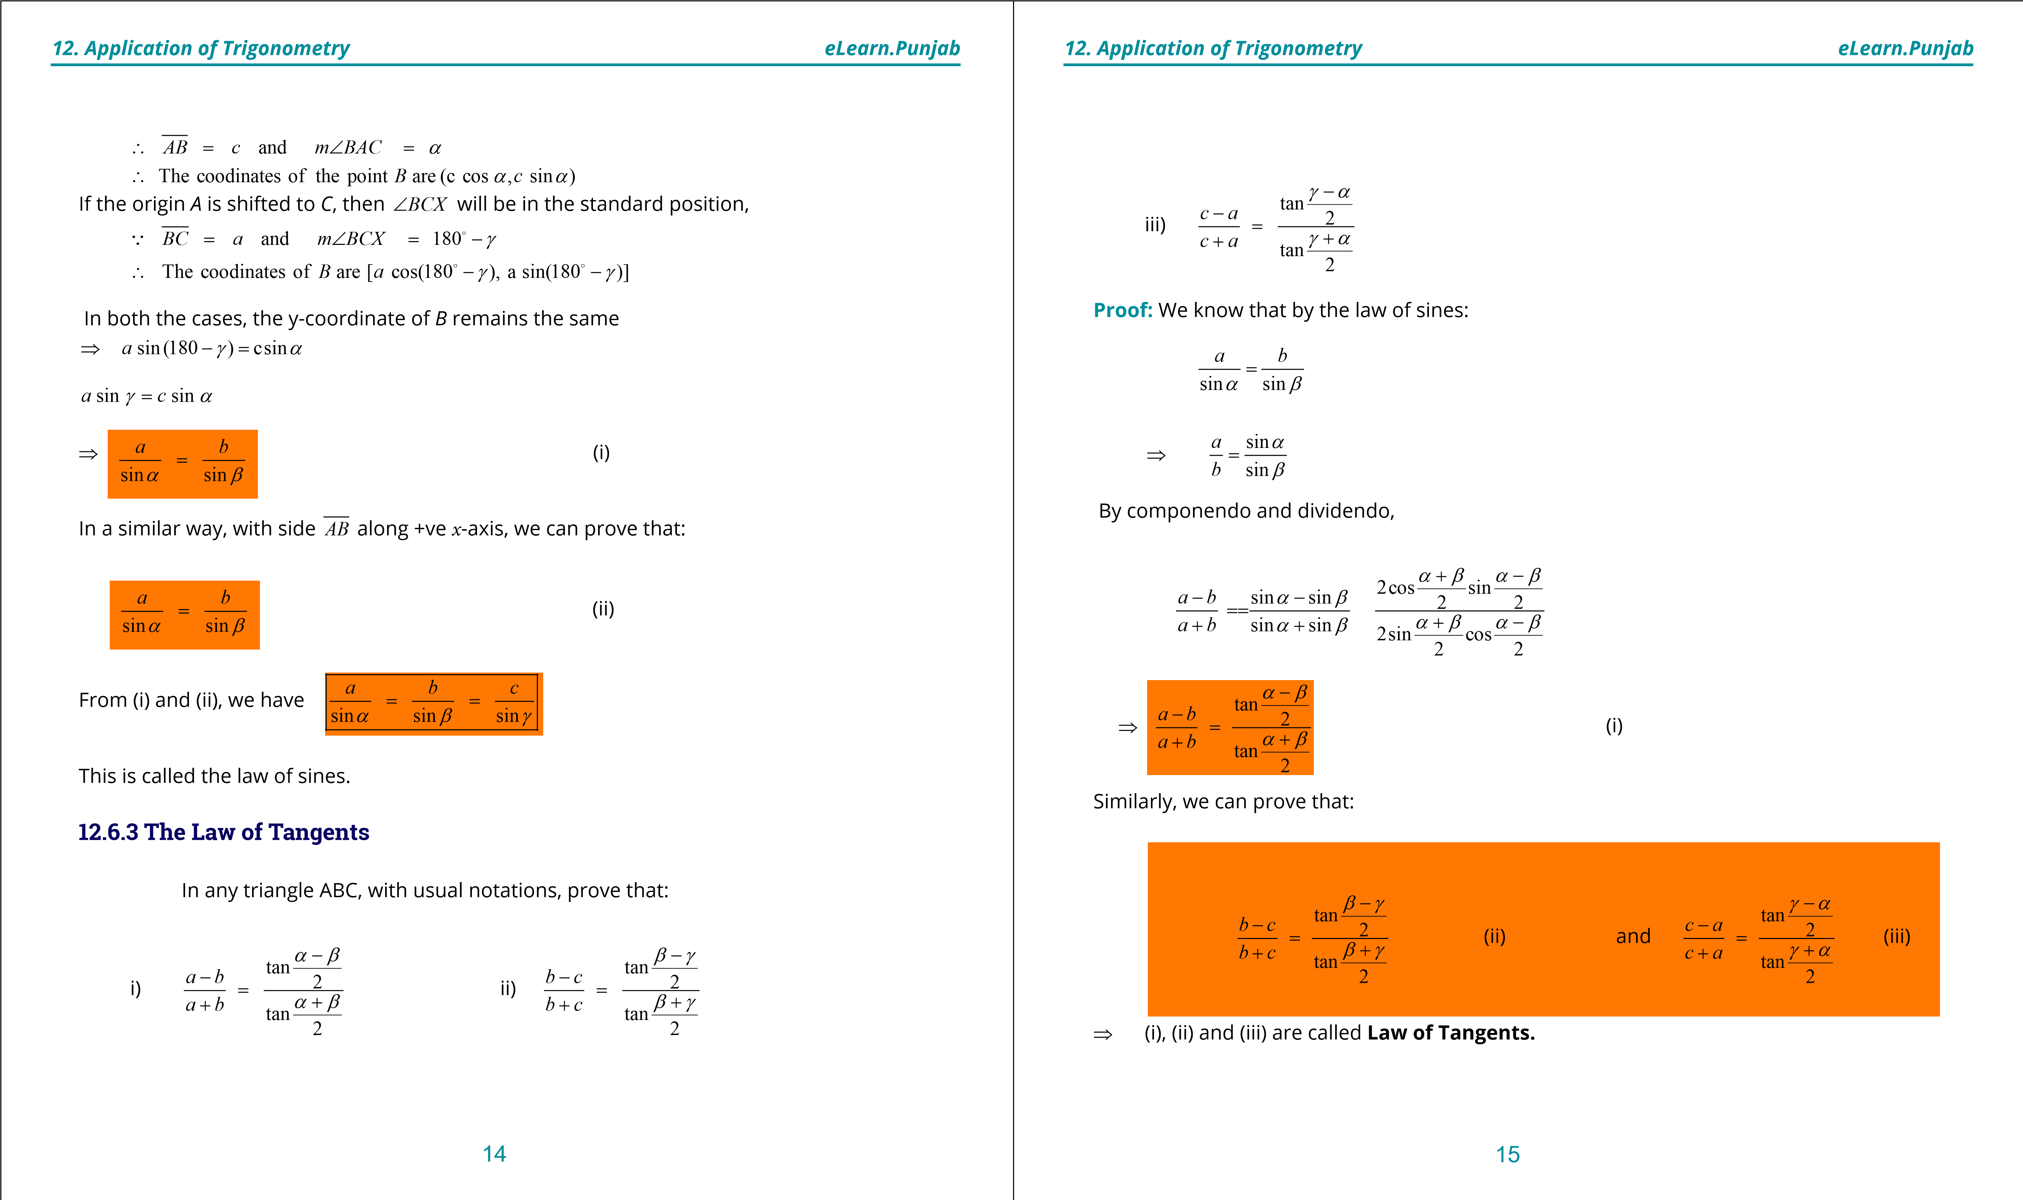

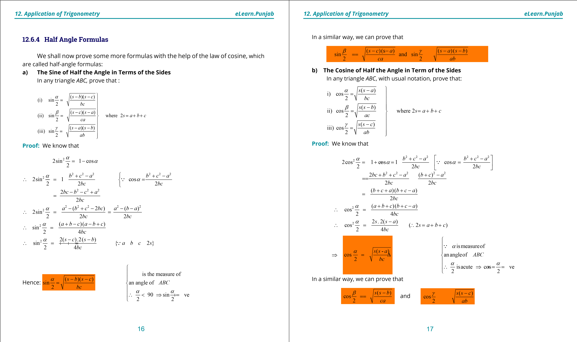

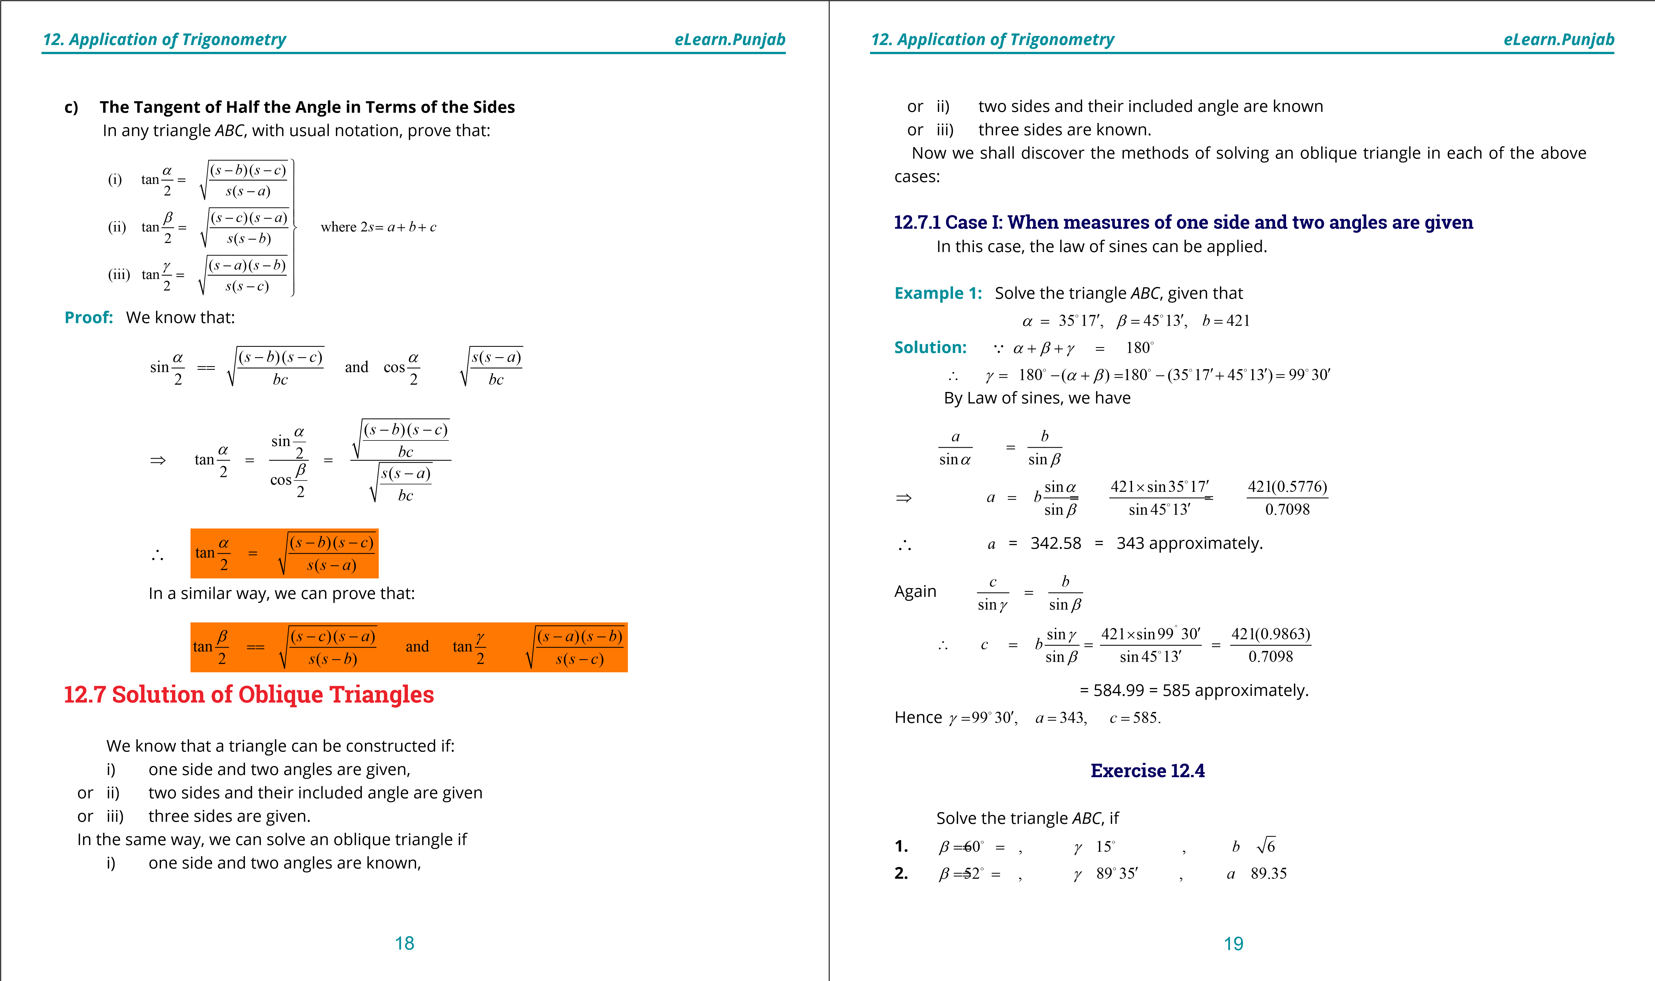

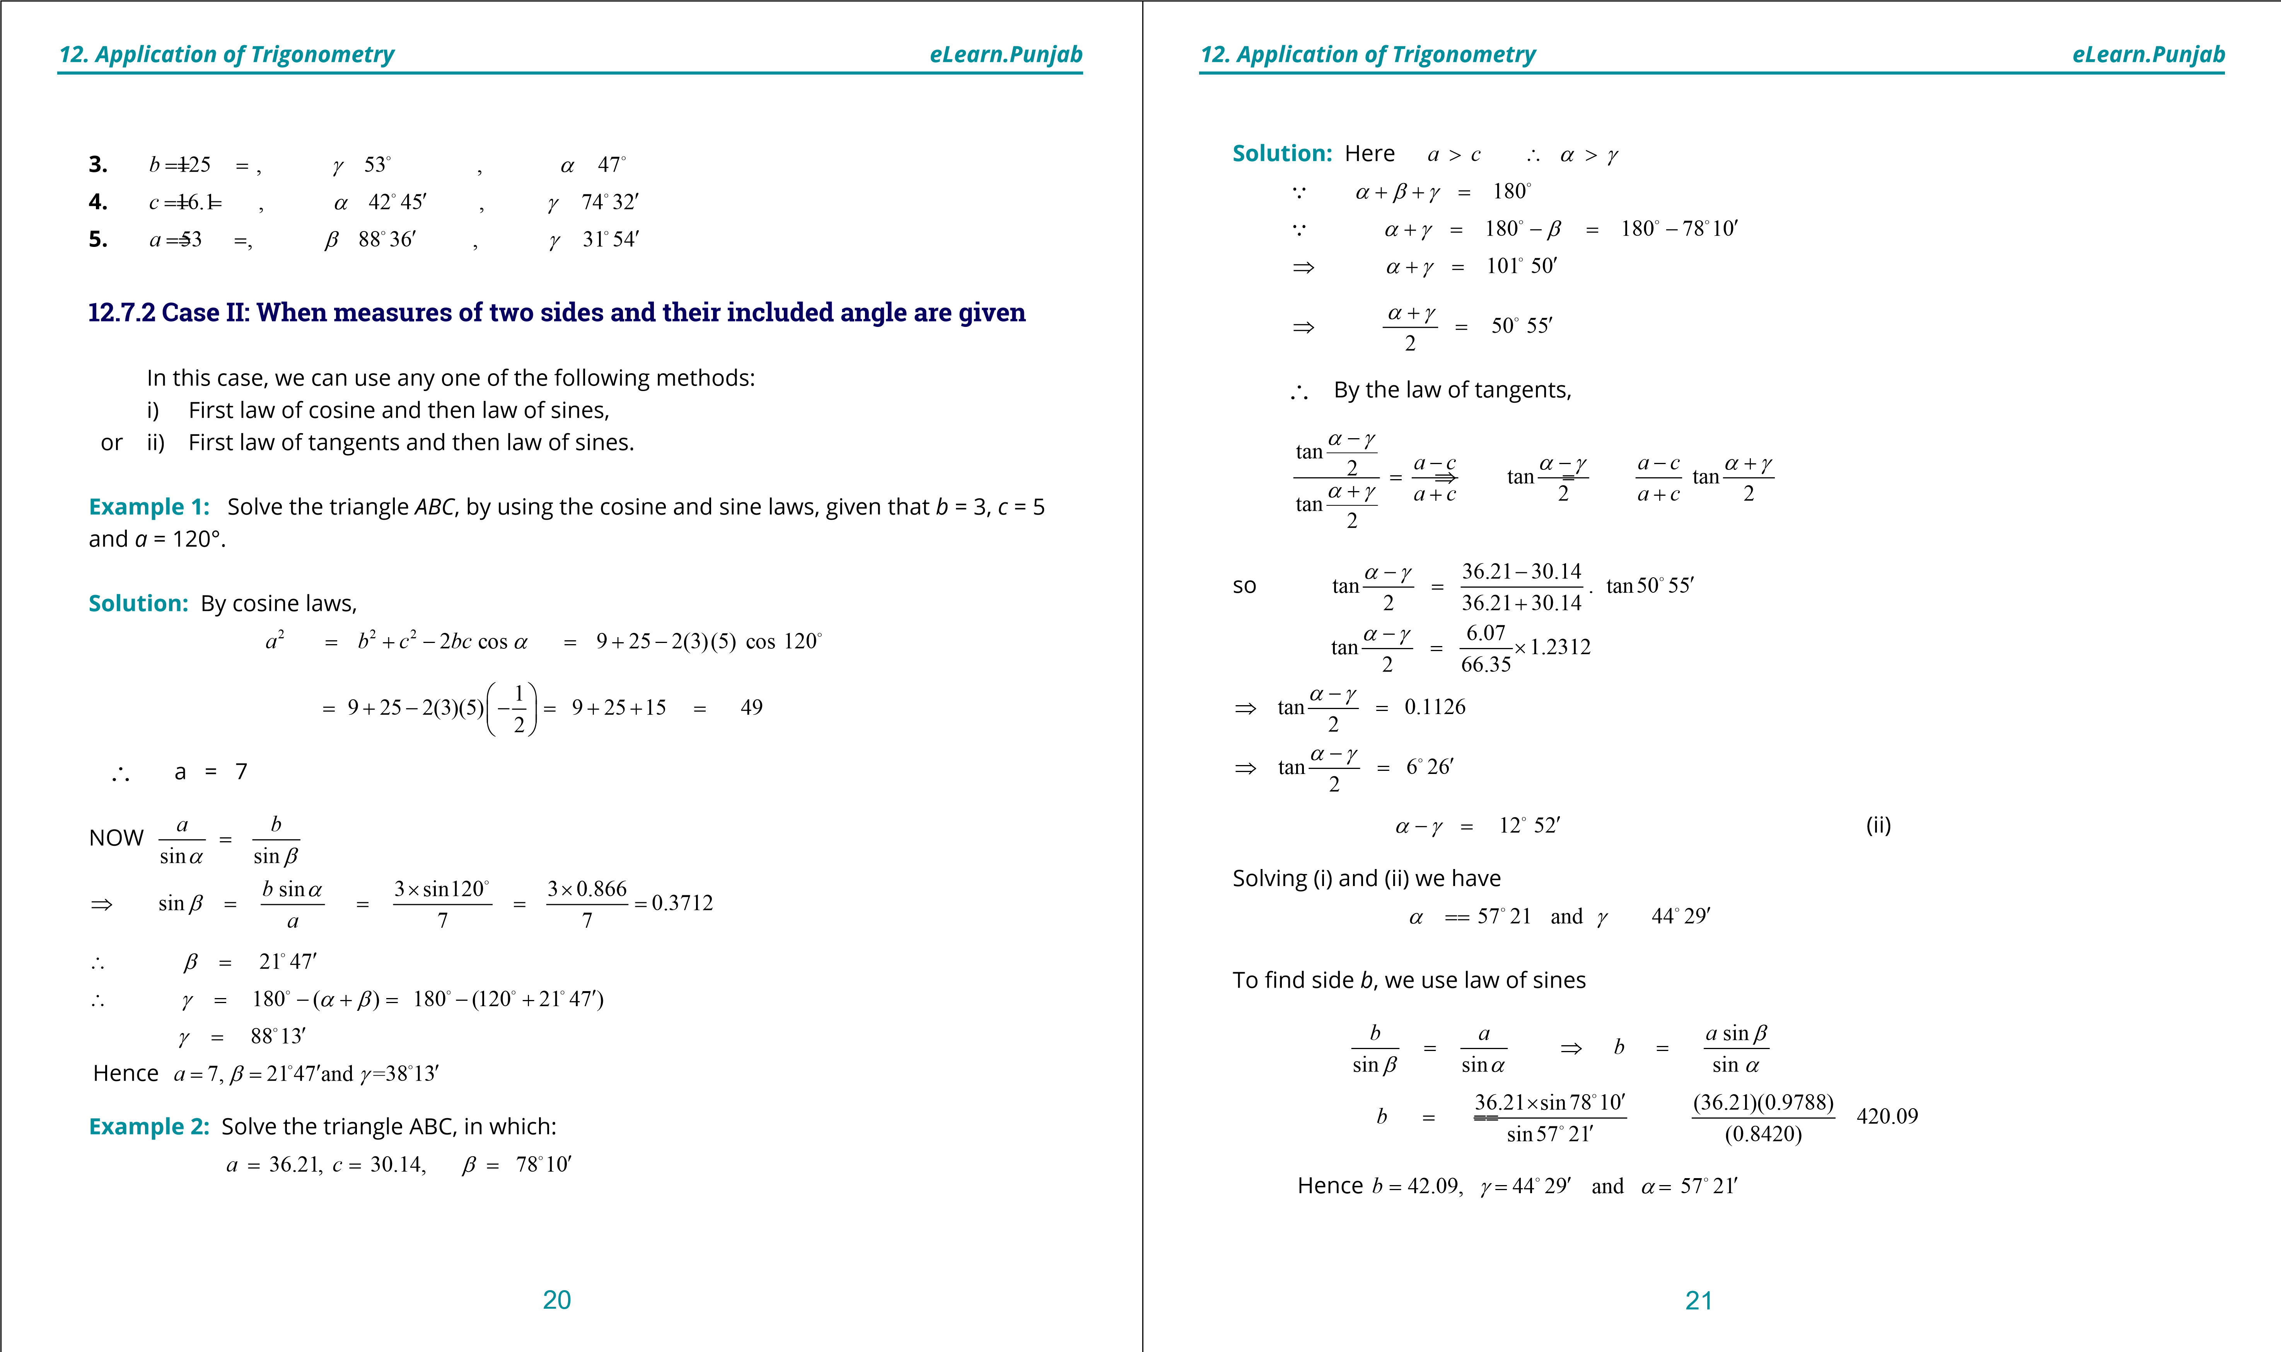

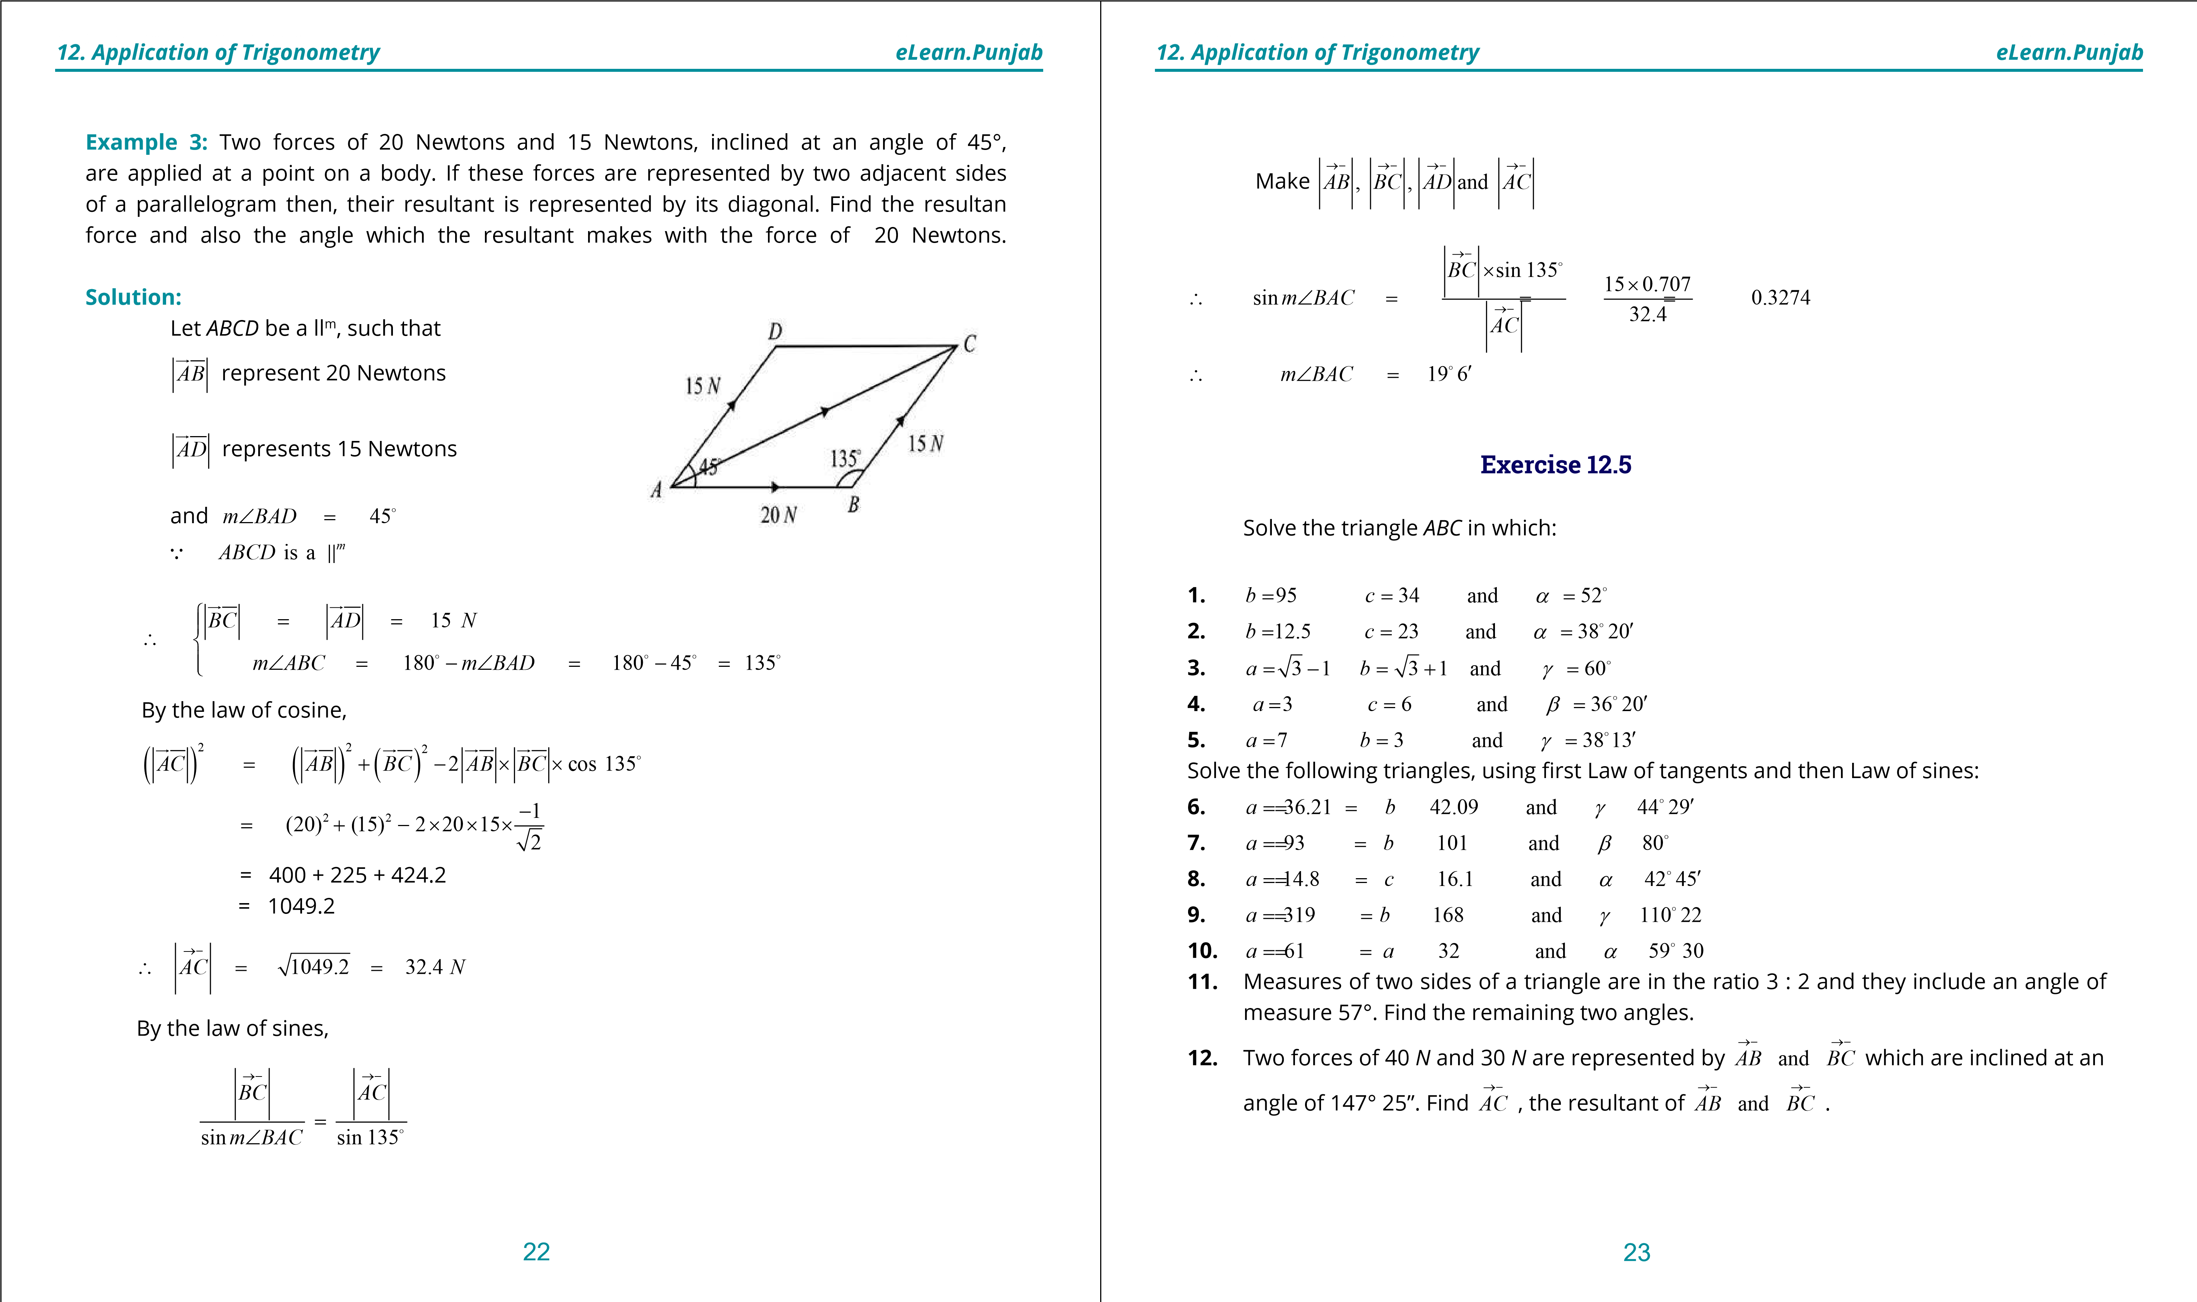

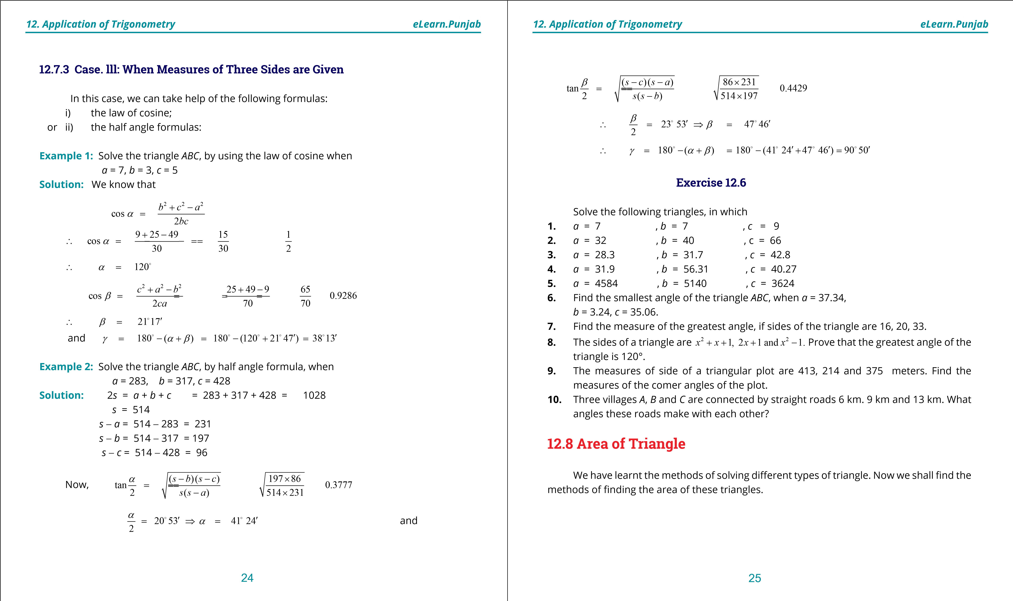

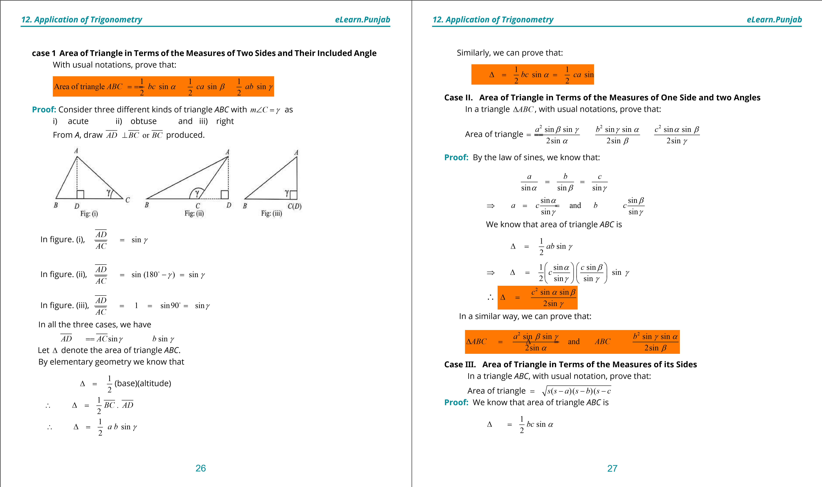

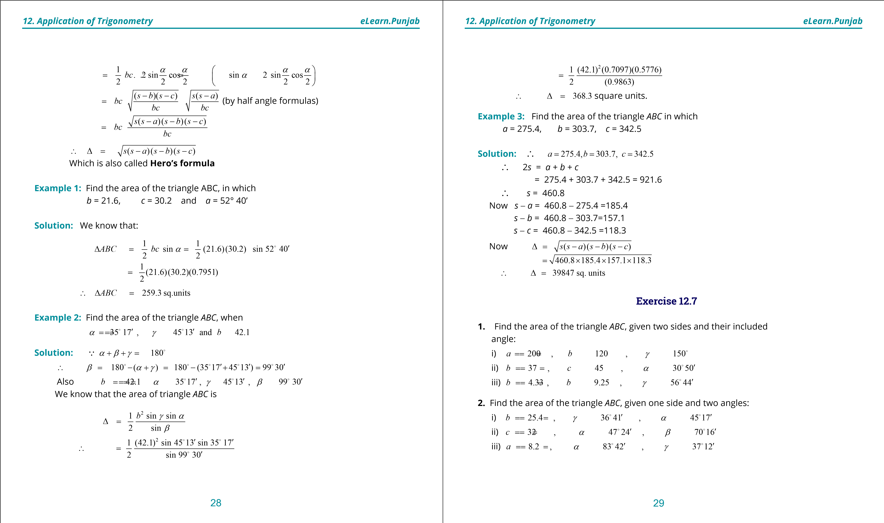

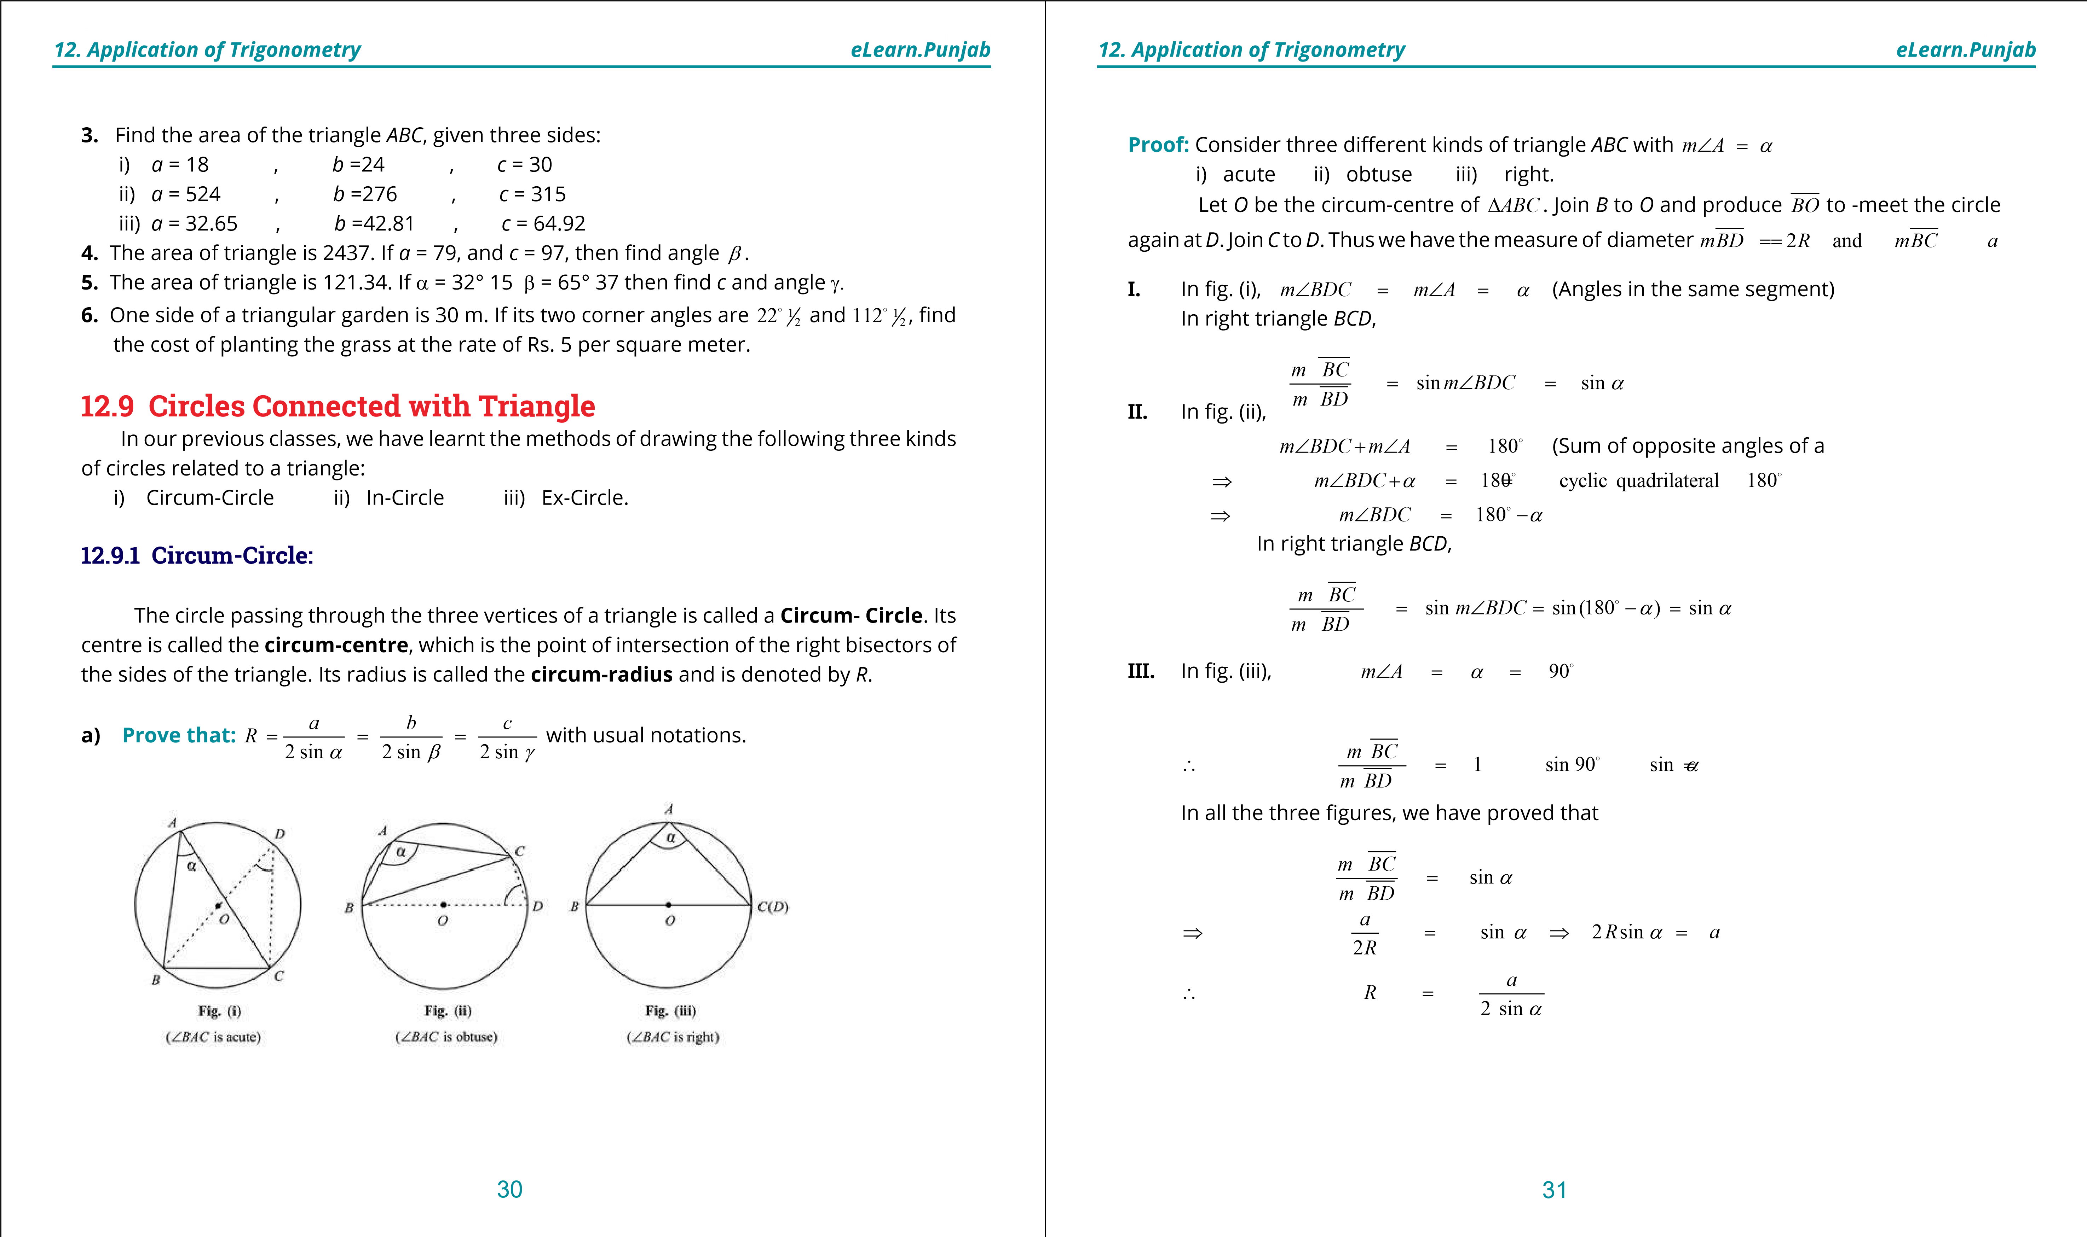

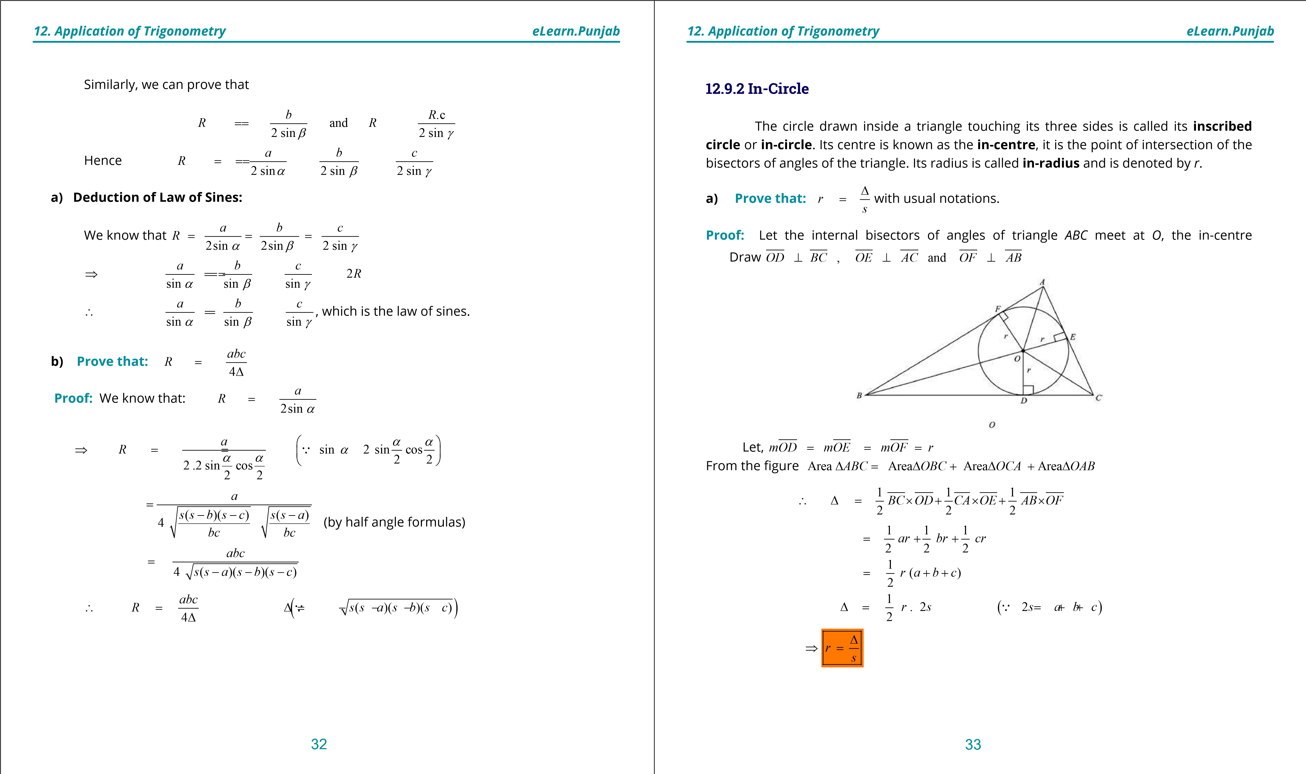

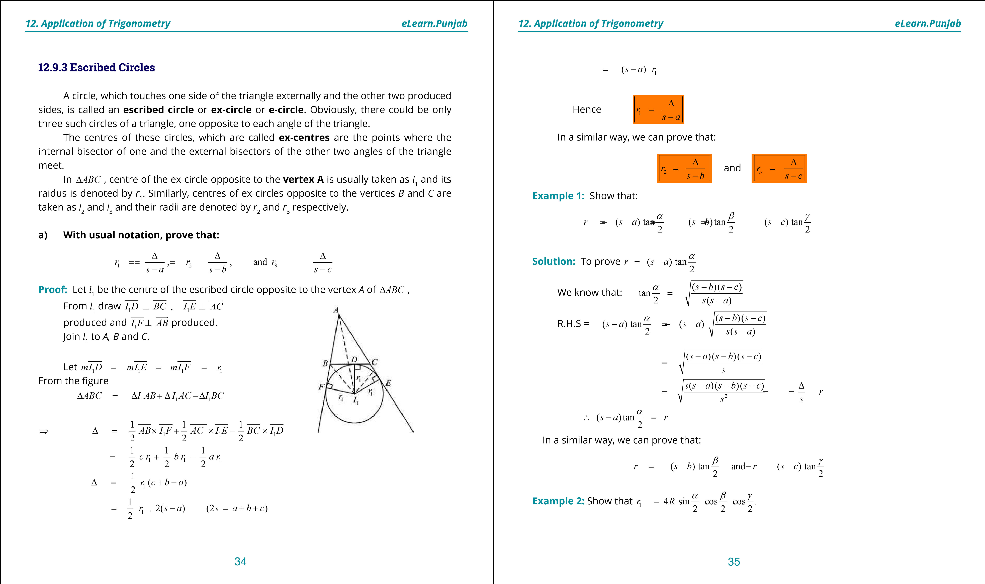

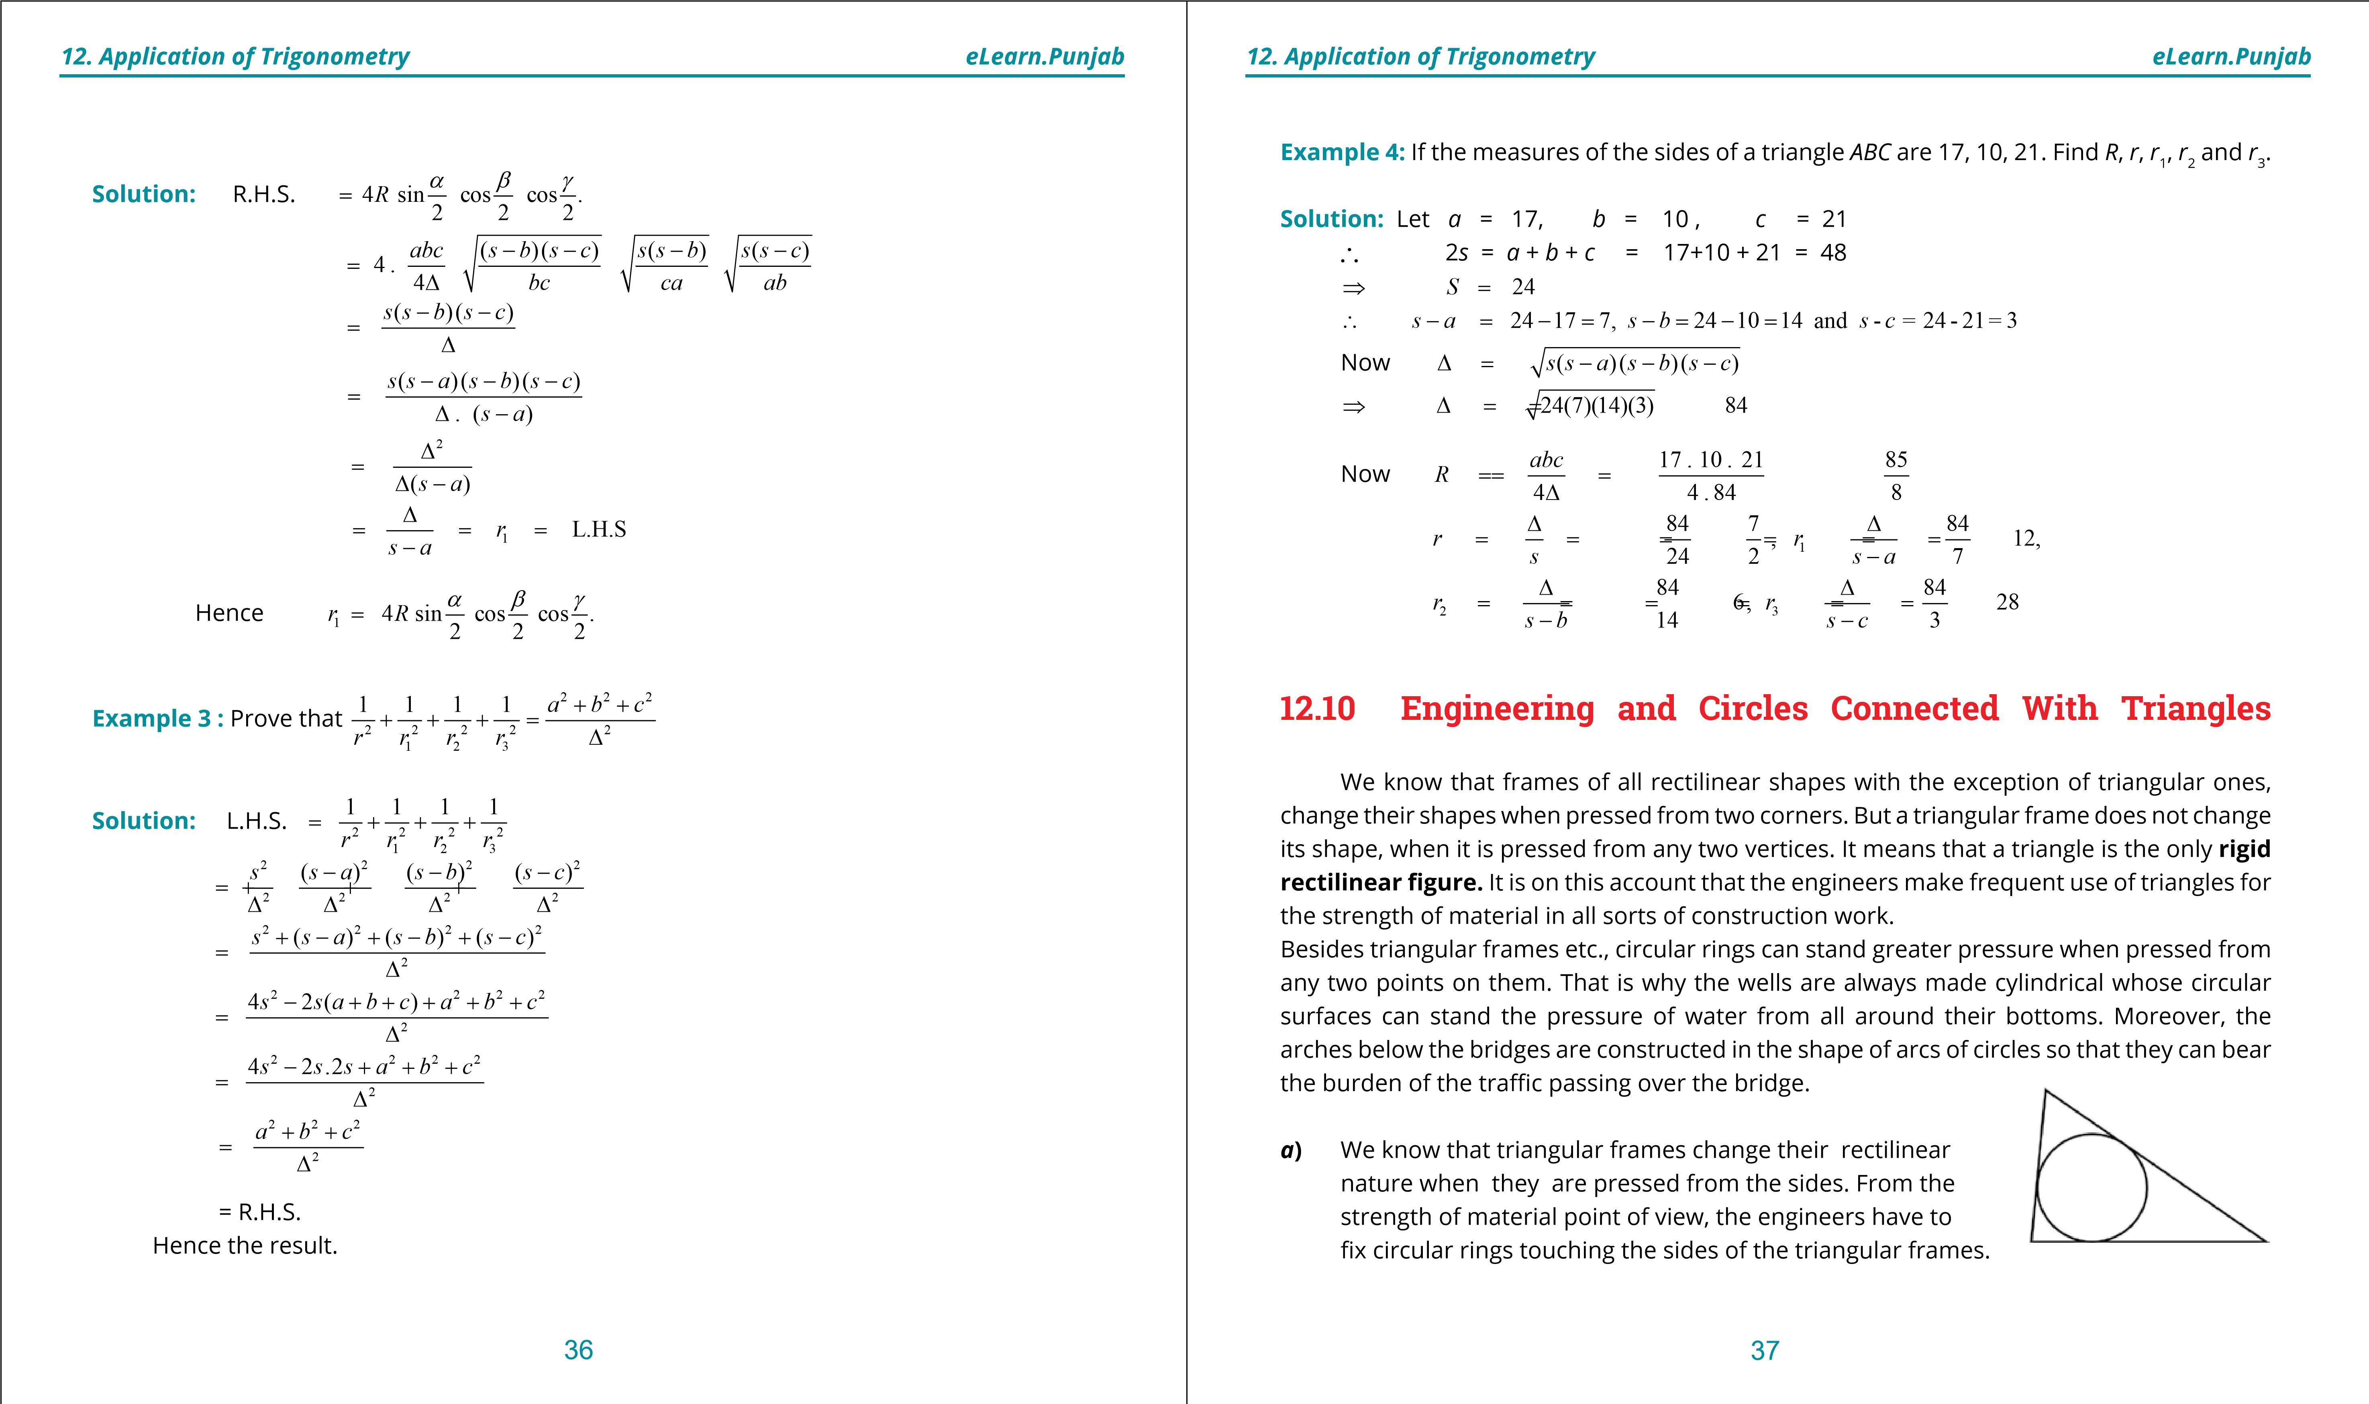

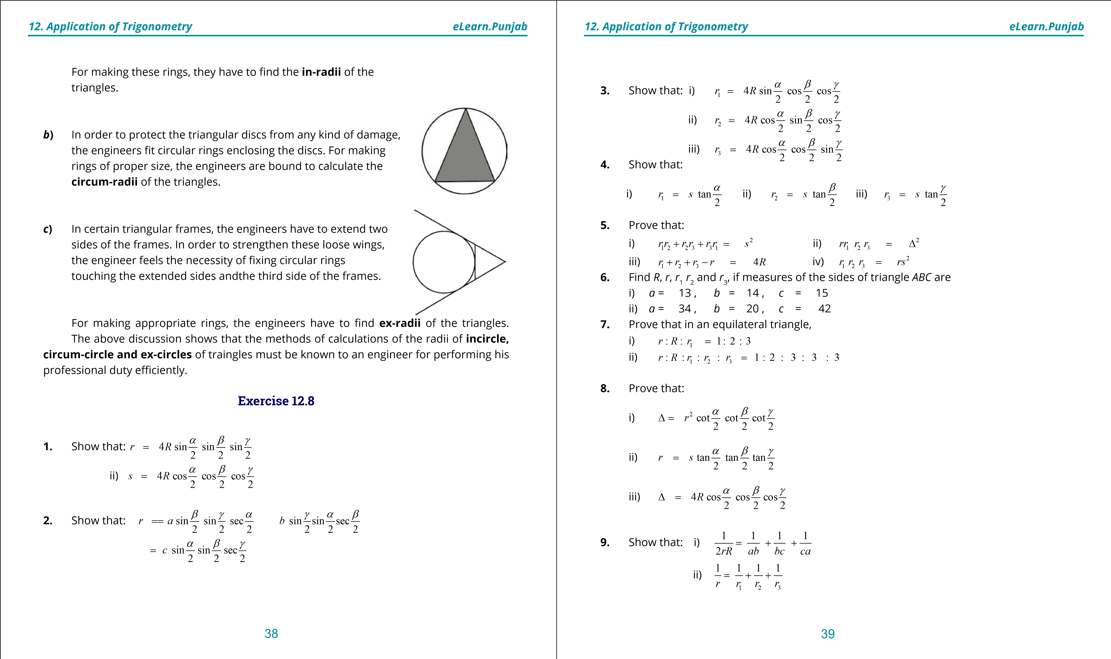

**1**

**. Quadratic Equations**

**eLearn.Punjab**

***12***

***. Application of Trigonometry***

***eLearn.Punjab***

40

**10**

**.**

Prove that:

sin

.sin

sin

.sin

sin

sin

2

2

2

2

2

2

cos

cos

cos

2

2

2

*b*

*c*

*a*

*r*

b

g

a

g

a

b

b

a

g

===

**.**

**11**

Prove that:

(

sin

sin

sin)

4

*abc*

*s*

abg

=

+

+

∆

**.**

**12**

Prove that: i)

2

1

)

.

(

tan

2

*r*

*r*

*c*

g

+

=

ii)

3

(

)

cot

2

*r*

*c*

*r*

g

=

-

***version: 1.1***

CHAPTER

1. Invnerse Trignometric

Functions

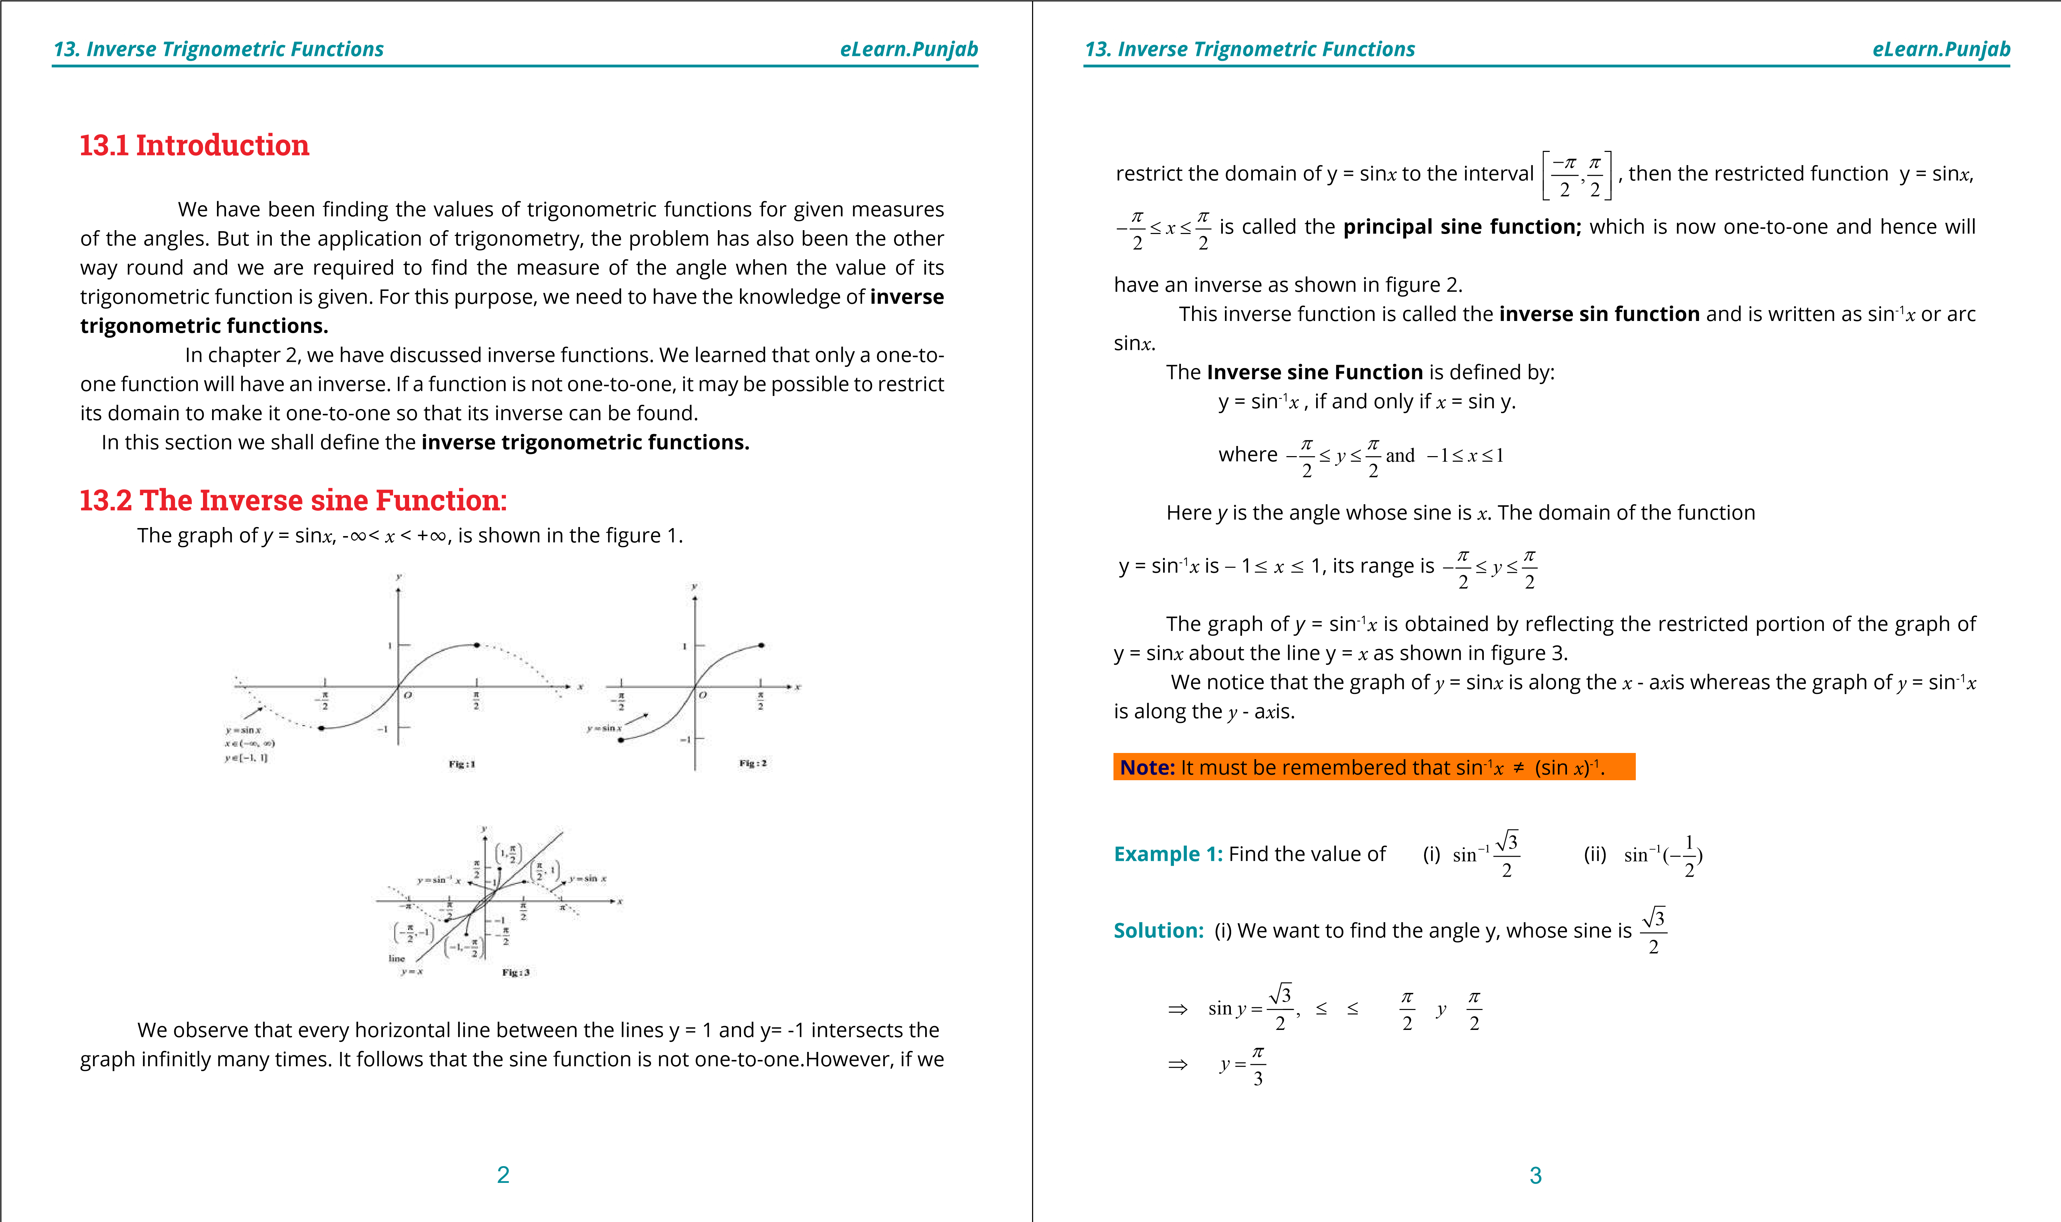

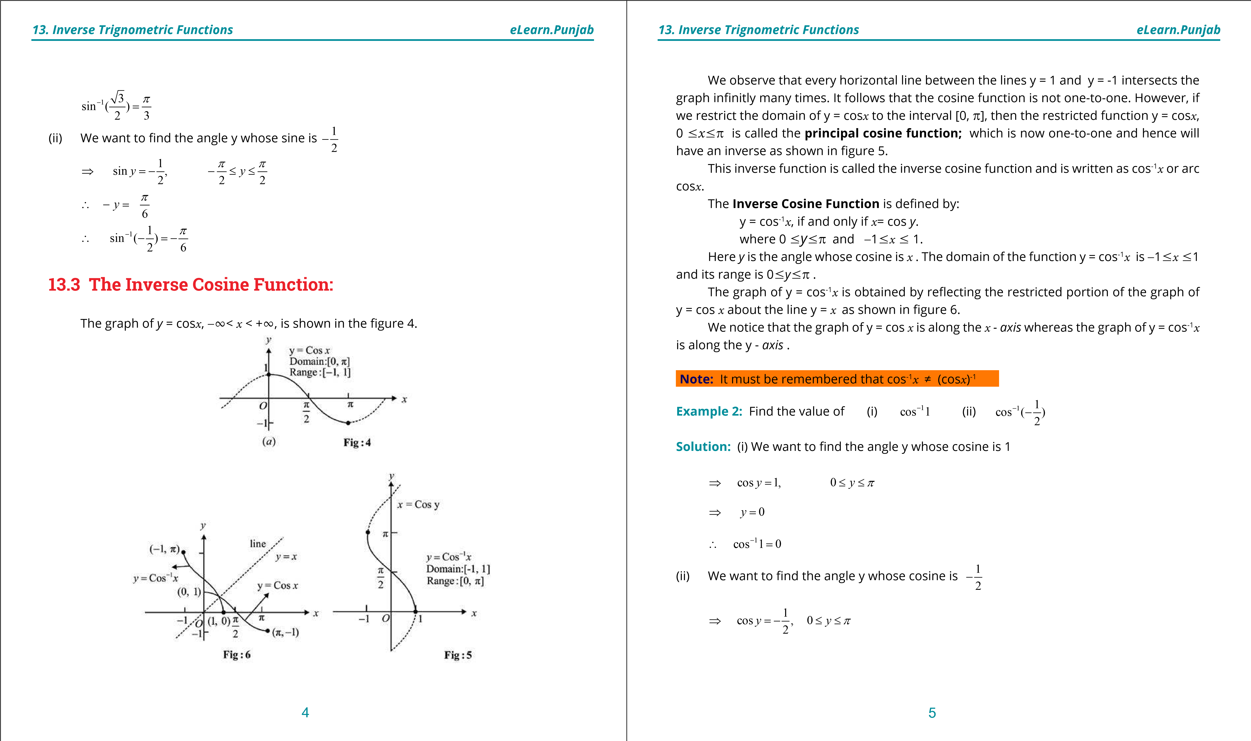

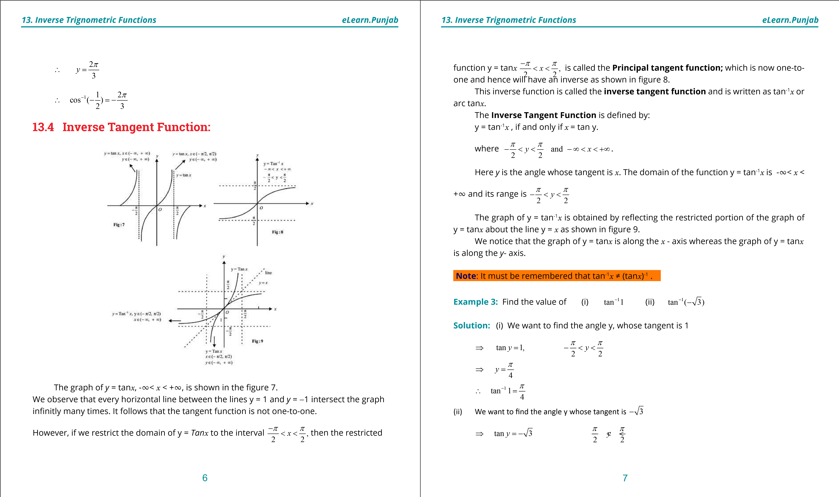

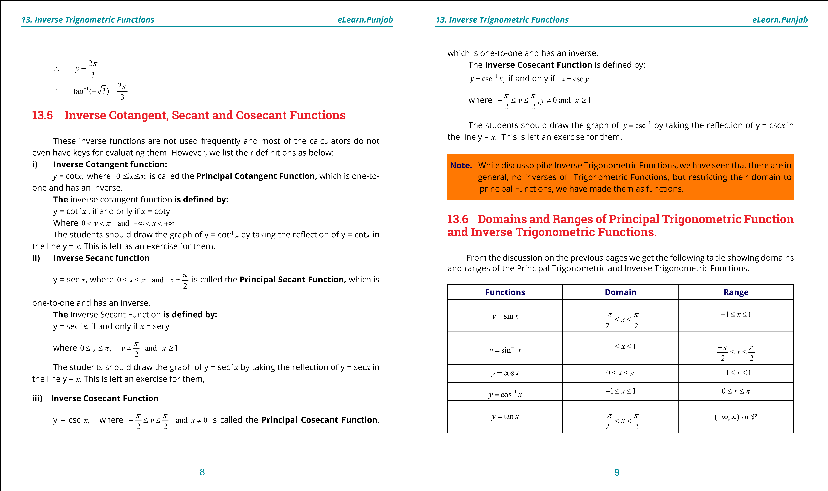

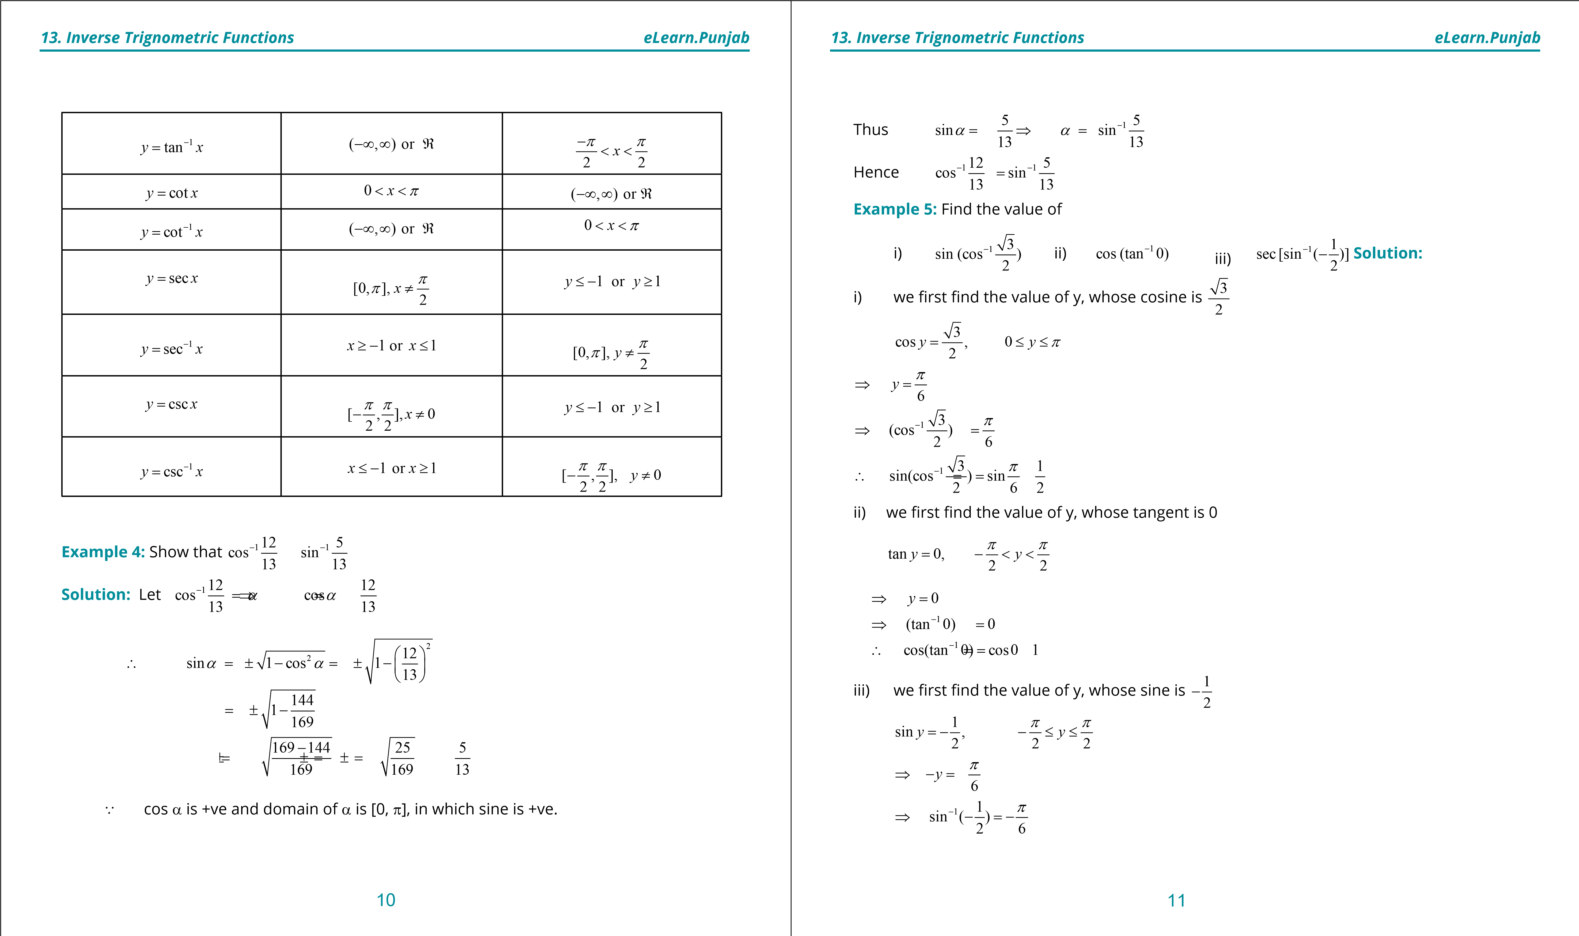

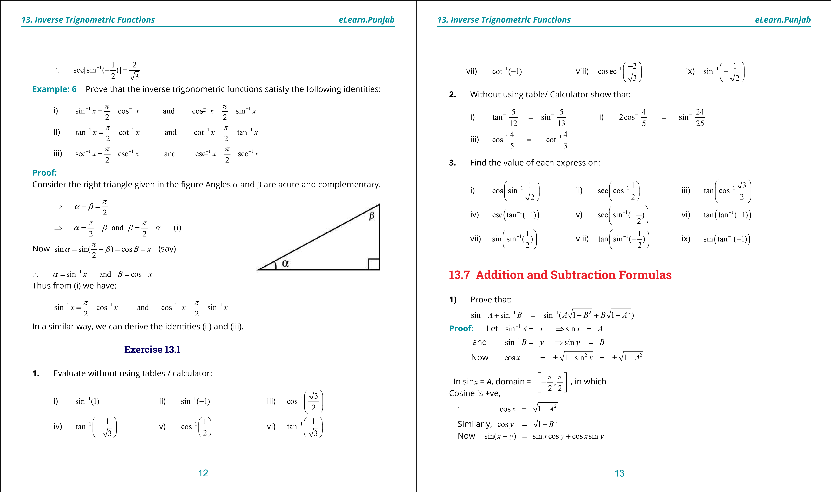

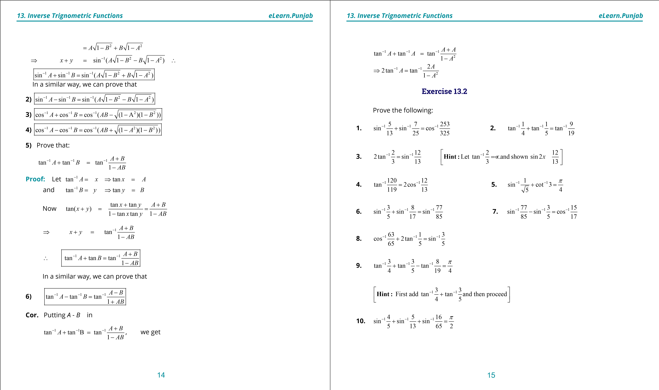

**1**

**. Quadratic Equations**

**eLearn.Punjab**

***. Inverse Trignometric Functions***

***13***

***eLearn.Punjab***

16

**11**

**.**

1

1

1

1

1

1

5

1

tan

tan

tan

tan

11

6

3

2

-

-

-

-

=

+

+

**12**

**.**

1

1

1

1

2

tan

tan

3

7

4

p

-

-

+

=

**.**

**13**

Show that

1

2

)

1

cos(sin

*x*

*x*

-

-

=

**.**

**14**

Show that

2

1

1

2

)

sin(2cos

*x*

*x*

*x*

-

=

-

**15**

**.**

Show that

2

1

cos(2sin

1

2

)

*x*

*x*

-

=-

**.**

**16**

Show that

1

1

)

tan

tan(

*x*

*x*

-

-

-

-

=

**.**

**17**

Show that

1

1

sin(

sin

)

*x*

*x*

-

-

=

--

**18**

**.**

Show that

1

1

cos(

)

cos

*x*

*x*

p

-

-

-

-=

**19**

**.**

Show that

1

2

tan(sin

)

1

*x*

*x*

*x*

-

=

-

**20**

**.**

Given that

1

1

sin

2

*x*

-

=

, ind the values of following trigonometric functions: sin

*x*

, cos

*x*

,

tan

*x*

, cot

*x*

, sec

*x*

and csc

*x*

.

***version: 1.1***

CHAPTER

1. Solutions of Trignometric Equation

